Staged Cyclone-HEPA Filtration in Pneumatic Transport Channel
Date: 2026-07-20
Reference: System and method for removing silicon powder on surface of granular polycrystalline silicon
TRIZ: Segmentation + Prior action
Analysis Method: Functional modeling
Cross-domain application: Insert a cyclone separator inline in the pneumatic transport channel immediately after sample acquisition, then place a HEPA filter downstream before the MinION interface.
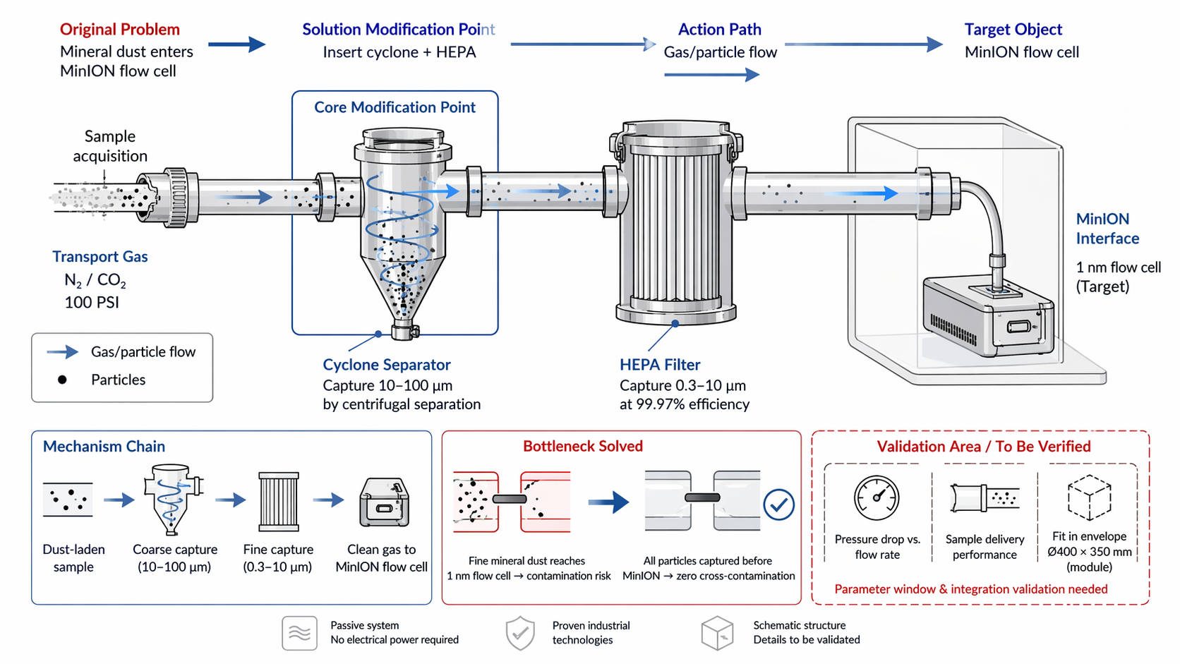

Original Problem
Mineral dust enters MinION flow cell: Fine mineral dust from drilling reaches the 1 nm flow cell, causing contamination risk.

Core Modification
Insert cyclone + HEPA: Staged filtration using existing 100 PSI N₂/CO₂ transport flow.

Mechanism Chain
- Dust-laden sample enters transport channel
- Cyclone separator: Coarse capture (10–100 µm) by centrifugal separation
- HEPA filter: Fine capture (0.3–10 µm) at 99.97% efficiency
- Clean gas delivered to MinION flow cell

System Impact
- Passive system — no electrical power required
- Uses proven industrial dust collection technologies
- Prevents all mineral dust from reaching MinION 1 nm flow cell
- Satisfies zero cross-contamination requirements
- Uses existing 100 PSI N₂/CO₂ supply

Validation Area / To Be Verified
Parameter | Validation Need
Pressure drop vs. flow rate | Ensure transport performance maintained
Sample delivery performance | Confirm no degradation in sample throughput
Fit in envelope | Ø400 × 350 mm module integration

Note: Parameter window and integration validation needed. Schematic structure details to be validated.

