Chassis Integral Boss Integration for Drill and Arm Mounting
Date: 2026-07-21
Reference: DFMA Concept Solution
TRIZ: Function takeover / Assembly simplification
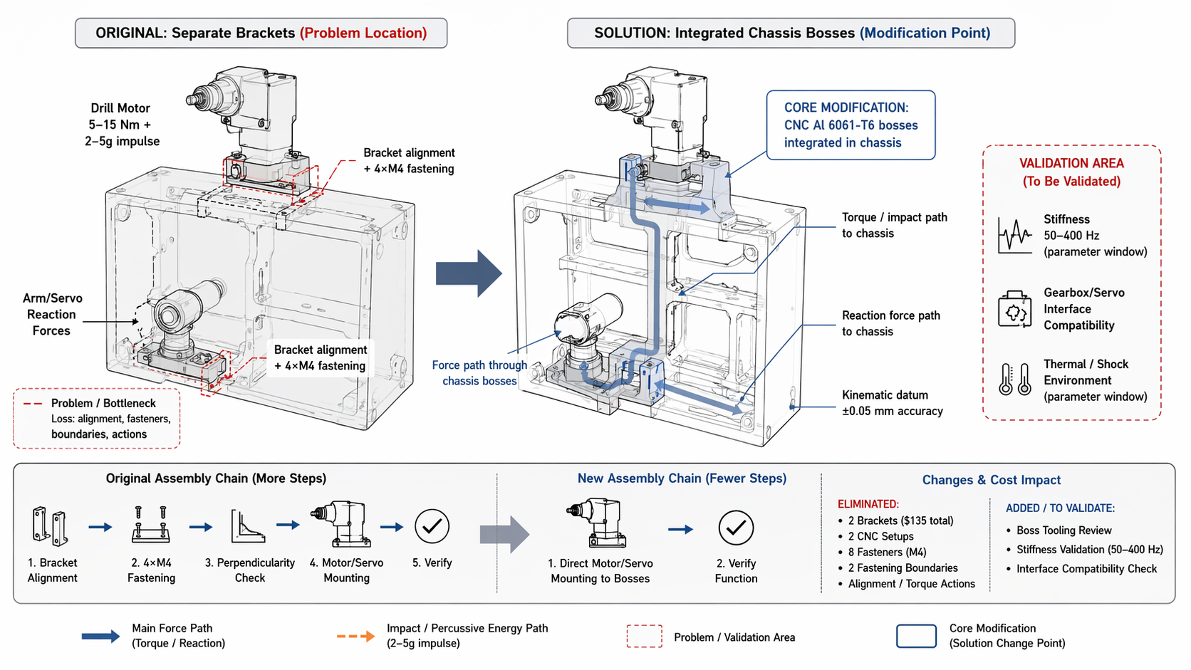
DFMA Concept: Integrate drill mounting bracket and arm base mount bracket into chassis as integral CNC Al 6061-T6 bosses.

Original Configuration
Assembly chain: Separate bracket alignment → 4×M4 fastening per bracket → perpendicularity check → motor/servo mounting.

Final Configuration
Both brackets deleted; chassis bosses directly carry drill 5–15 Nm mineral torque + 2–5g percussion impulse and arm reaction forces + kinematic datum ±0.05mm accuracy.

Function Takeover
- Torsional stiffness (previously bracket)
- Shock absorption (previously bracket)
- Dimensional stability (previously bracket)
- Kinematic datum (previously bracket)

Cost Benefit
Category | Details
Reduced | 2 brackets ($135 total), 2 CNC setups, 8×M4 fasteners, 2 fastening boundaries, 2 alignment/perpendicularity checks, 2 torque-wrench operations
Assembly time | 16–24 sec → 4–8 sec (direct motor/servo mounting)
Added/Offset | Chassis boss tooling review, stiffness validation at 50–400 Hz under NASARAP 2.0×, gearbox/servo housing mount interface compatibility confirmation
Rough savings | ~$100–150 per unit

Note: Assembly chain converges toward direct motor/servo mounting to chassis bosses with fewer alignment steps and single-direction assembly.

