Cup Lid Assembly Deletion via Arm Actuation and Housing Retention
Date: 2026-07-21
Reference: DFMA Concept Solution
TRIZ: Function takeover / Assembly deletion
DFMA Concept: Delete all 12 spring-loaded PEEK cup lid assemblies after transferring open/close function to robotic arm gripper actuation and biohazard sealing to carousel housing integral retention lip with magnetic latch.
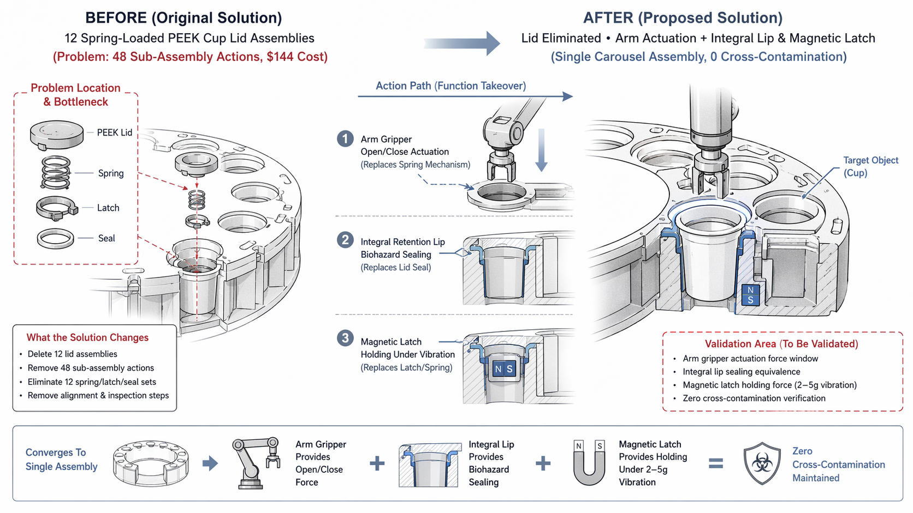

Original Configuration
Assembly chain: 48 sub-assembly actions (4 parts per lid × 12 cups: spring, PEEK lid, latch, seal).

Final Configuration
Cup lids eliminated; arm gripper provides open/close actuation force, carousel housing integral lip provides biohazard sealing equivalence and magnetic latch holding force under 2–5g vibration.

Function Takeover
- Arm gripper replaces spring-loaded mechanism for open/close
- Housing integral lip + magnetic latch replace lid sealing + retention
- Zero MinION cross-contamination maintained

Cost Benefit
Category | Details
Reduced | 12 cup lid assemblies ($144 total), 48 sub-assembly actions, 12 spring/latch/seal sets, 12 alignment/inspection steps
Assembly time | 60–90 sec → 8–12 sec (carousel housing assembly only)
Added/Offset | Arm gripper open/close actuation force validation, carousel housing integral lip biohazard sealing equivalence validation, magnetic latch holding force validation under 2–5g vibration, zero MinION cross-contamination validation
Rough savings | ~$120–160 per unit

Note: Original assembly chain converges toward single carousel housing assembly with integral retention features and arm-actuated open/close operation.

