Servo Bracket and Kinematic Adapter Standardization
Date: 2026-07-21
Reference: DFMA Concept Solution
TRIZ: Modular family / SKU reduction
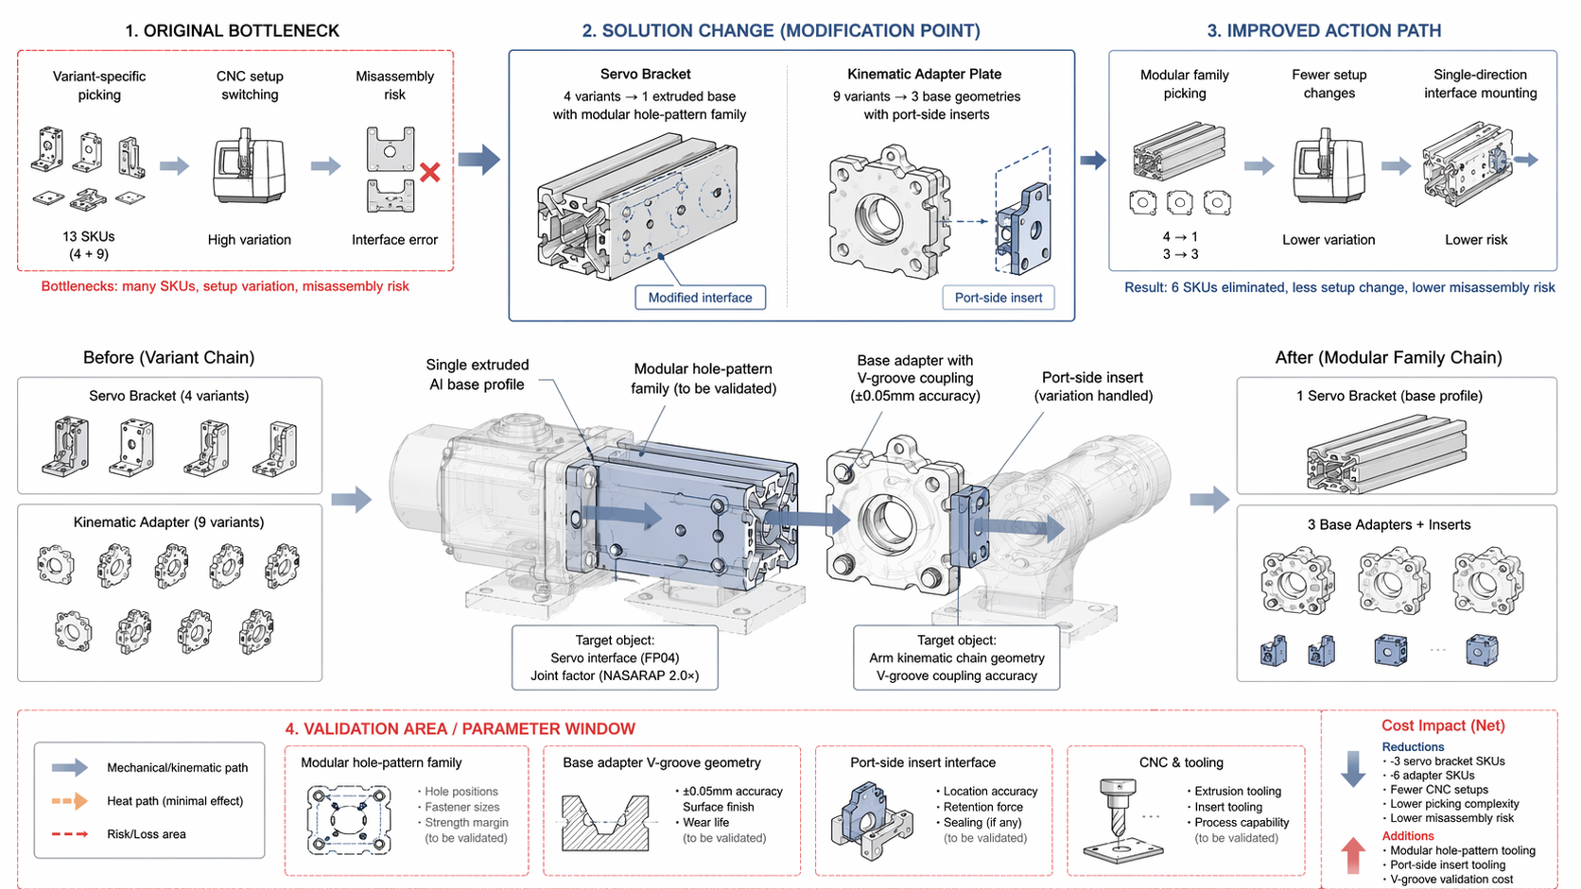
DFMA Concept: Standardize 4 servo joint brackets to single extruded Al base profile with modular hole-pattern family; standardize 9 kinematic adapter plates to 3 base geometries with port-side inserts.

Final Configuration
- Servo brackets share identical extrusion cross-section with modular hole patterns
- Kinematic adapters share identical V-groove coupling geometry (±0.05mm accuracy)
- Instrument-side port variation handled by inserts

Original vs. Final
Aspect | Original | Final
Servo bracket SKUs | 4 variants | 1 extruded base profile
Kinematic adapter SKUs | 9 variants | 3 base geometries + inserts
Assembly | Variant-specific picking, CNC setup switching, misassembly risk | Modular family assembly, fewer variant checks, single-direction mounting

Function Maintained
- FP04 servo interface
- NASARAP 2.0× joint factor
- Arm kinematic chain geometry
- V-groove coupling accuracy (±0.05mm)

Cost Benefit
Category | Details
Reduced | 3 servo bracket variant SKUs, 6 kinematic adapter variant SKUs, CNC setup variation, picking complexity, misassembly risk, variant-specific inspection steps
Added/Offset | Modular hole-pattern family tooling for servo brackets, port-side insert tooling for kinematic adapters, V-groove geometry validation for ±0.05mm accuracy
Rough savings | ~$40–80 per unit (SKU reduction + setup efficiency)

Note: Original assembly chain converges toward modular family assembly with fewer variant checks and single-direction interface mounting.

