Electronic Module Integration for RFID and Power Conversion
Date: 2026-07-21
Reference: DFMA Concept Solution
TRIZ: Module consolidation / Function merger
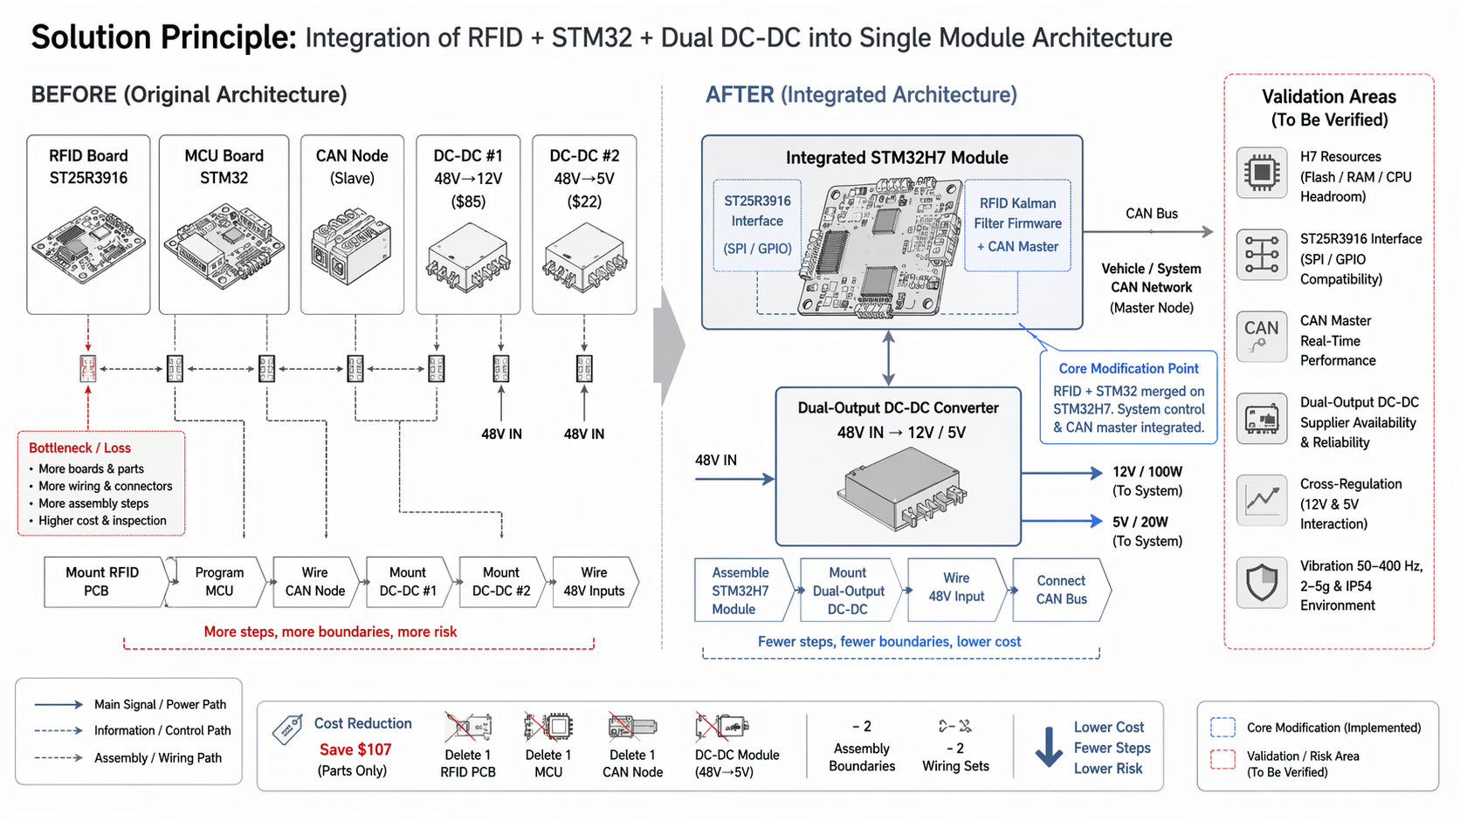
DFMA Concept: Merge RFID reader board ST25R3916+STM32 into existing STM32H7 module MCU and merge 48V→12V + 48V→5V DC-DC converters into single dual-output converter.

Original Configuration
Assembly chain: Separate RFID PCB mounting → MCU programming → CAN node wiring → dual DC-DC module mounting → dual input wiring.

Final Configuration
- RFID PCB and one DC-DC module deleted
- STM32H7 carries RFID Kalman filter firmware + ST25R3916 GPIO/SPI interface as CAN master
- Dual-output converter provides 12V/100W + 5V/20W from 48V input

Function Takeover
- STM32H7: RFID Kalman filter real-time loop + CAN master coordination
- Dual-output converter: Both 12V and 5V rails with cross-regulation

Cost Benefit
Category | Details
Reduced | 1 RFID PCB + 1 MCU, 1 CAN node, 1 DC-DC module ($107 total), 2 assembly boundaries, 2 input wiring sets, 2 mounting/mating operations, 2 inspection steps
Added/Offset | STM32H7 flash/RAM/CPU headroom validation for Kalman filter real-time loop, ST25R3916 GPIO/SPI interface compatibility validation, CAN master real-time performance validation, dual-output converter supplier availability validation, cross-regulation between 12V and 5V rails validation, load regulation validation, 50–400 Hz 2–5g vibration + IP54 environment validation
Rough savings | ~$80–120 per unit

Validation Requirements
- STM32H7 flash/RAM/CPU headroom for Kalman filter real-time loop
- ST25R3916 GPIO/SPI interface compatibility
- CAN master real-time performance
- Dual-output converter supplier availability
- Cross-regulation between 12V and 5V rails
- Load regulation under dynamic load
- 50–400 Hz 2–5g vibration + IP54 environment

Note: Original assembly chain converges toward single STM32H7 module assembly and single dual-output converter mounting with fewer wiring/connector mating steps.

