Asymmetric Pulse Expansion Wave for Residue Layer Stripping in Transport Channel
Date: 2026-07-20
Reference: A method for separating gas components for industrial oxygen production
TRIZ Principles: Mechanical field enhancement (Principle #15 — Dynamics + Principle #10 — Preliminary action)
Analysis Method: Substance-field analysis
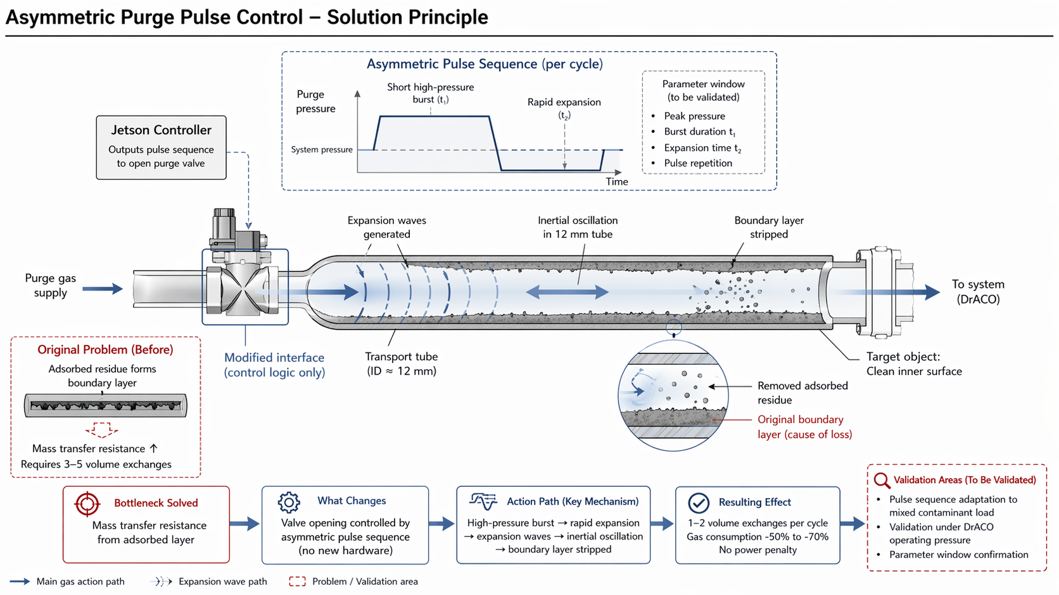

Core Concept
Cross-domain application: Program the Jetson controller to open the purge valve in an asymmetric pulse sequence — short high-pressure burst followed by rapid expansion — generating transient expansion waves that drive inertial oscillation in the 12 mm transport tube and strip the adsorbed residue boundary layer.

Original Problem (Before)
Adsorbed residue forms boundary layer: Contaminants adhere to the inner wall of the 12 mm transport tube, creating a stagnant boundary layer that increases mass transfer resistance.
Consequence: Requires 3–5 volume exchanges per purge cycle to achieve acceptable cleanliness.

Bottleneck Solved
Mass transfer resistance from adsorbed layer: The boundary layer acts as a diffusion barrier, preventing efficient removal of residues by steady purge flow.

What Changes
Modified interface (control logic only): Valve opening controlled by asymmetric pulse sequence — no new hardware required.
Jetson Controller: Outputs pulse sequence to open purge valve.

Asymmetric Pulse Sequence (Per Cycle)
Phase | Description | Duration | Effect
Short high-pressure burst (t₁) | Valve opens to deliver high-pressure purge gas | Burst duration t₁ | Generates expansion waves
Rapid expansion (t₂) | Valve closes, pressure drops rapidly | Expansion time t₂ | Creates inertial oscillation in tube
Decay / repeat | System returns to baseline pressure | Pulse repetition interval | Boundary layer stripped, ready for next cycle
Parameter window (to be validated):
- Peak pressure
- Burst duration t₁
- Expansion time t₂
- Pulse repetition rate

Action Path (Key Mechanism)
- High-pressure burst enters 12 mm transport tube
- Rapid expansion generates expansion waves
- Expansion waves drive inertial oscillation in tube
- Inertial oscillation disrupts adsorbed boundary layer
- Residue stripped from wall and entrained in gas flow
- Clean inner surface achieved
Target object: Clean inner surface of transport tube.

Resulting Effect
- 1–2 volume exchanges per cycle (vs. 3–5 before)
- Gas consumption reduction of 50–70%
- No power penalty — same total gas, asymmetric delivery
- No new hardware — control logic modification only

Performance Comparison
Parameter | Steady Flow (Before) | Asymmetric Pulse (After)
Volume exchanges per cycle | 3–5 exchanges | 1–2 exchanges
Gas consumption | Baseline (100%) | 30–50% (50–70% reduction)
Flow mechanism | Steady laminar flow | Transient expansion waves + inertial oscillation
Hardware change | None | None — control logic only
Power penalty | None | None — asymmetric delivery of same total gas
Mass transfer resistance | High — boundary layer intact | Low — boundary layer stripped

Validation Areas (To Be Validated)
Validation Area | Description
Pulse sequence adaptation | Tune asymmetric pulse parameters (t₁, t₂, peak pressure, repetition) to mixed contaminant load and tube geometry
Validation under DrACO operating pressure | Confirm expansion wave generation and inertial oscillation effectiveness at actual system operating pressure
Parameter window confirmation | Experimentally validate optimal peak pressure, burst duration, expansion time, and repetition rate for target residue types

TRIZ Principles Applied
#15 Dynamics — Make an object or system dynamically adapt to changing conditions. The asymmetric pulse sequence introduces dynamic, time-varying pressure into the transport channel. By alternating between high-pressure burst and rapid expansion, the system creates transient mechanical forces (expansion waves and inertial oscillation) that a steady flow cannot produce. This dynamic approach breaks the static adhesion bottleneck.
#10 Preliminary Action — Perform required changes to an object completely or partially in advance. The high-pressure burst phase (t₁) prepares the boundary layer by loosening residue adhesion before the rapid expansion phase (t₂) completes the stripping action. The asymmetric timing ensures the preliminary mechanical disturbance is followed immediately by the main removal force, maximizing efficiency.

System Flow
Purge gas supply → Solenoid valve (asymmetric pulse control) → 12 mm transport tube → Expansion waves + inertial oscillation → Boundary layer stripped → Residue entrained → To system (DrACO)

Legend
- Solid blue arrow: Main gas action path
- Dashed blue arrow: Expansion wave path
- Dashed red box: Problem / Validation area

Note: All parameters to be validated. Pulse sequence adaptation to mixed contaminant load and validation under DrACO operating pressure are the largest unknowns requiring experimental confirmation.

