Document Date: July 20, 2026

Conductive Gasket Sealing at CF Housing Apertures
Continuous X-Band Shielding Path — Dual-Function EMI & Environmental Sealing
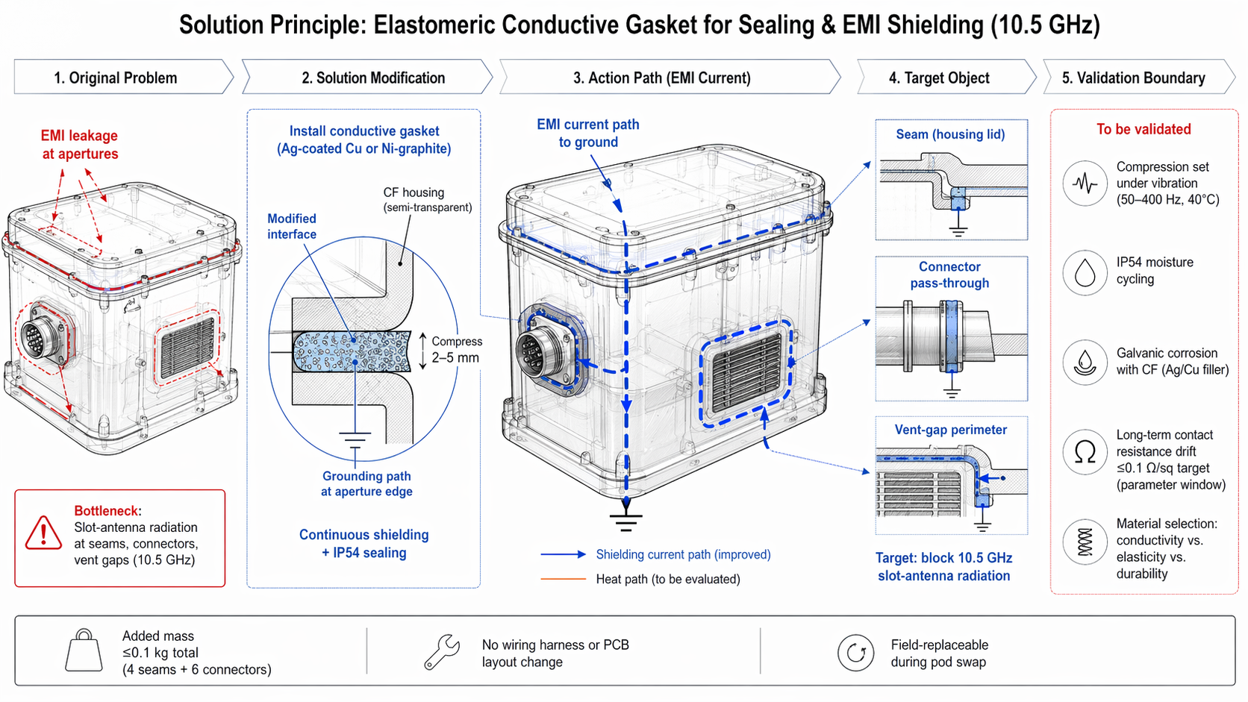

Executive Summary
This document describes the installation of elastomeric conductive gaskets at all carbon fiber (CF) housing apertures — seams, connector pass-throughs, and vent-gap perimeters. The gasket creates a continuous electromagnetic shielding path that blocks 10.5 GHz slot-antenna radiation while simultaneously maintaining IP54 environmental sealing. At ≤0.1 kg total added mass (4 seams + 6 connectors), the solution requires no wiring harness or PCB layout changes and remains field-replaceable during pod swap operations.

1. Problem Statement
The carbon fiber housing contains multiple apertures that act as slot antennas at X-band frequencies (10.5 GHz), creating electromagnetic interference (EMI) leakage paths. The primary bottleneck is:
- Slot-Antenna Radiation at Apertures
- Seams between housing sections, connector pass-throughs, and vent gaps form electrically discontinuous boundaries. At 10.5 GHz, these gaps behave as slot antennas, radiating internal EM energy and allowing external interference to enter the enclosure.
The aperture leakage undermines the effectiveness of any internal EMI shielding (e.g., the three-layer composite coating) by providing bypass paths around the shielded boundary. Without continuous electrical contact at all apertures, the housing Faraday integrity is compromised.

2. Solution Principle
Install elastomeric conductive gaskets at all CF housing apertures to create a continuous shielding current path to ground. The gasket serves a dual function:
- EMI Shielding: The conductive filler (Ag-coated Cu or Ni-graphite) provides a low-impedance electrical path across the aperture, shorting slot-antenna radiation and grounding high-frequency currents at the aperture edge.
- Environmental Sealing: The elastomeric substrate compresses to form a watertight/dust-tight seal, maintaining IP54 ingress protection at all joints.
Parameter | Specification | Purpose
Material | Ag-coated Cu or Ni-graphite filler in elastomeric matrix | High conductivity + environmental resilience
Compression Range | 2–5 mm | Accommodates manufacturing tolerance; ensures contact under vibration
Surface Resistivity | ≤0.1 Ω/sq | Low impedance for 10.5 GHz current grounding
Added Mass | ≤0.1 kg total (4 seams + 6 connectors) | Minimal impact on pod mass budget

3. System Architecture

3.1 Gasket Locations
Location | Quantity | Function
Housing Seams (lid joints) | 4 seams | Primary enclosure closure; largest aperture area
Connector Pass-Throughs | 6 connectors | Signal/power entry points; cylindrical aperture radiation
Vent-Gap Perimeters | Per design | Thermal ventilation slots; linear slot antennas

3.2 Action Path (EMI Current)
Shielding Current Path (improved — blue arrows):
- Internal EMI currents encounter the aperture gap.
- The conductive gasket provides a continuous low-impedance path across the gap.
- High-frequency currents are diverted to the CF housing ground plane at the aperture edge.
- Slot-antenna radiation is suppressed; EM energy is contained within the housing.
Heat Path (to be evaluated — orange arrows):
The gasket thermal conductivity and its effect on heat transfer across seams requires evaluation, particularly for vent-gap perimeters where thermal management and EMI shielding intersect.

4. Detail Callouts

4.1 Seam (Housing Lid)
The gasket is installed in a groove machined into the lid flange. When the lid is bolted down, the gasket compresses 2–5 mm, creating both an electrical short across the seam and a compression seal. The grounding path runs from the lid, through the gasket, to the main housing body.

4.2 Connector Pass-Through
A conductive gasket ring is installed between the connector flange and the housing wall. The gasket grounds the connector shell to the housing, preventing cylindrical aperture radiation around the connector body while maintaining the environmental seal.

4.3 Vent-Gap Perimeter
Ventilation slots are surrounded by a conductive gasket frame. The gasket blocks EM leakage through the slot while allowing air flow. The grounding path connects the vent frame to the housing ground plane.

5. Performance Target
Target: Block 10.5 GHz slot-antenna radiation at all apertures.
The conductive gasket must provide sufficient shielding effectiveness at 10.5 GHz to reduce slot-antenna radiation below the system EMI compliance threshold. The ≤0.1 Ω/sq surface resistivity ensures that the gasket impedance is negligible compared to the slot radiation impedance (~377 Ω for free space), effectively shorting the aperture.

6. Design Constraints & Advantages
Constraint / Feature | Requirement / Benefit
Added Mass | ≤0.1 kg total (4 seams + 6 connectors)
Wiring Harness / PCB | No layout change required
Field Serviceability | Field-replaceable during pod swap
Environmental Rating | Maintain IP54 at all gasketed joints

7. TRIZ / Systematic Innovation Principles
The physical contradiction addressed: the housing apertures must be open (for assembly, connector access, and ventilation) and closed (for EMI shielding and environmental sealing).

7.1 Principle #1 — Segmentation
The monolithic housing boundary is segmented into discrete functional zones:
- Sealed zones: Gasketed seams and connector joints that are closed during operation.
- Open zones: Ventilation gaps that remain open but are surrounded by conductive gasket frames.
Each aperture is treated as a separate segment with its own gasket solution, allowing localized optimization rather than a one-size-fits-all approach.

7.2 Functional Modeling
The functional model is restructured to combine two previously separate functions into a single component:
- Function A (EMI shielding): Previously performed by internal shielding coatings or external Faraday cages.
- Function B (Environmental sealing): Previously performed by rubber O-rings or silicone seals.
The conductive gasket performs both functions simultaneously: the conductive filler provides EMI shielding, and the elastomeric substrate provides environmental sealing. This functional integration reduces part count, assembly time, and mass.

8. Bottleneck Solved
The conductive gasket sealing resolves the following critical bottlenecks:
- Slot-Antenna Radiation Blocked
- The continuous conductive path across all apertures suppresses 10.5 GHz slot-antenna radiation, restoring Faraday integrity to the CF housing.
- IP54 Sealing Maintained
- The elastomeric compression seal prevents dust and water ingress at all joints, maintaining the environmental protection rating without additional seals.
- Zero Layout Impact
- No changes to wiring harness routing or PCB layout are required. The gasket is a drop-in solution at existing mechanical interfaces.
- Field Serviceability
- Gaskets are replaceable during pod swap operations, enabling rapid maintenance without specialized tooling or recalibration.

9. Validation & Verification Plan
Validation Item | Test Condition / Target | Verification Method
Compression Set | Under vibration (50–400 Hz) at 40°C | Dynamic compression test; measure permanent deformation after vibration exposure
IP54 Moisture Cycling | Cyclic humidity + water spray per IEC 60529 | Dust ingress + water spray testing after thermal cycling
Galvanic Corrosion | Ag/Cu filler with CF substrate in salt atmosphere | ASTM B117 salt fog test; measure corrosion rate and contact resistance change
Long-Term Contact Resistance | ≤0.1 Ω/sq target (parameter window) | Four-point probe measurement before and after environmental aging
Material Selection | Balance conductivity vs. elasticity vs. durability | Trade study: test Ag-coated Cu, Ni-graphite, and hybrid fillers; downselect based on combined score

10. References
- [1] Patent/Citation — Connecting seat, connector and electronic equipment (connector grounding and sealing reference)
- [2] Altshuller, G. — TRIZ: 40 Principles of Inventive Problem Solving (Principle #1: Segmentation)
- [3] IEC 60529 — Degrees of Protection Provided by Enclosures (IP Code) for IP54 validation
- [4] ASTM B117 — Standard Practice for Operating Salt Spray (Fog) Apparatus for corrosion testing
- [5] MIL-DTL-83528 — Gasket Material, Conductive, Shielding, Elastomer, EMI/RFI (material specification reference)
— Document generated July 20, 2026 —

