TECHNICAL DESIGN SPECIFICATION
Dual-Layer Active Vibration Cancellation
Embedded in Optical Bench
Active Piezo & Voice Coil Actuator Integration for Precision Optronics

1. Executive Summary & Solution Principle
This technical specification outlines the design and integration of an embedded dual-layer active vibration isolation system within an airborne optical bench assembly. The system decouples structural vibration isolation from optical alignment stiffness by incorporating two distinct layers of active actuators directly beneath critical sensor mounting nodes. This configuration eliminates the traditional shared mechanical path associated with passive elastomer damper mounts, thereby avoiding the heavy mass and space penalties of an external gyrostabilization platform.
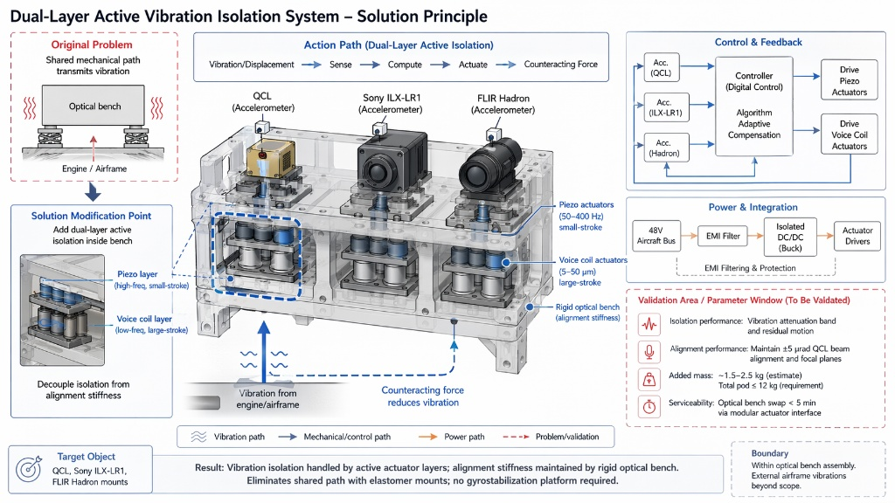
Figure 1: Dual-Layer Active Vibration Isolation System – Architecture and Solution Principle

2. System Architecture & Action Path
The active isolation system targets three primary optical payloads: the Quantum Cascade Laser (QCL), the Sony ILX-LR1 camera, and the FLIR Hadron thermal core. Structural disturbances originating from the aircraft engine and airframe flow through the system along a deterministic control loop:
Action Path Flow:
Vibration/Displacement → Sense (Accelerometers) → Compute (Digital Controller) → Actuate → Counteracting Force

3. Dual-Layer Actuator Specifications
Actuator Layer | Operating Spectrum / Stroke | Primary Objective
Piezoelectric Layer | 50–400 Hz  Small-stroke | Counteracts high-frequency engine-induced vibrations and structural micro-harmonics.
Voice Coil Layer | 5–50 µm  Large-stroke | Corrects low-frequency, large-displacement transient micro-movements to preserve alignment.

4. Control, Feedback & Power Integration
Each mounting node is equipped with dedicated, high-bandwidth co-located accelerometers (QCL, Sony ILX-LR1, and FLIR Hadron). These sensors feed real-time acceleration data into a centralized Digital Control Unit. The controller executes an Adaptive Compensation Algorithm to calculate precise counteracting forces, driving the piezo and voice coil actuators synchronously.
The subsystem is powered directly from the standard 48V Aircraft Bus. To guarantee signal integrity and prevent electromagnetic interference from corrupting sensor data, the power architecture incorporates a highly specialized integration chain:
- EMI Filtering & Protection: Suppresses high-frequency ripple and electrical transients from the aircraft grid.
- Isolated DC/DC Buck Converter: Steps down voltage to appropriate operating levels while providing complete galvanic isolation.
- Actuator Drivers: High-fidelity drivers optimized for low-latency command execution.
5. Validation Window & Physical Constraints
Parameter / Validation Area | Target Requirement Window
Isolation Performance | Verification of specified vibration attenuation bands and minimization of residual motion.
Alignment Performance | Maintain strictly ≤ ±5 µrad QCL beam alignment and stabilize camera focal planes.
Mass Budget Allocation | Added active actuator mass: ~1.5–2.5 kg (estimated).  Total pod weight: ≤ 12 kg (strict maximum requirement).
Serviceability & Maintenance | Optical bench hot-swap capability < 5 minutes facilitated by a highly modular actuator mounting interface.

6. Innovation & Cross-Domain Design Reference
This design directly resolves traditional physical contradictions in optical payloads using architectural innovations derived from TRIZ methodology. Specifically, the design leverages Principle #1 (Segmentation) and Principle #15 (Dynamics). Instead of relying on a uniform structural frame or standard elastomer mounts (which force an engineering trade-off between stiffness and damping), the system breaks the support structure into decoupled active layers that dynamically adapt to real-time inputs. The boundary of this solution is contained strictly within the optical bench assembly; external airframe modifications remain out of scope.

