Document Date: July 19, 2026

Gradient-Thickness Composite Shielding Layer Integrated into Carbon Fiber Housing
Broadband EMI Attenuation ≥40 dB (10 kHz–10.5 GHz) — Impedance-Matched Graded Composite
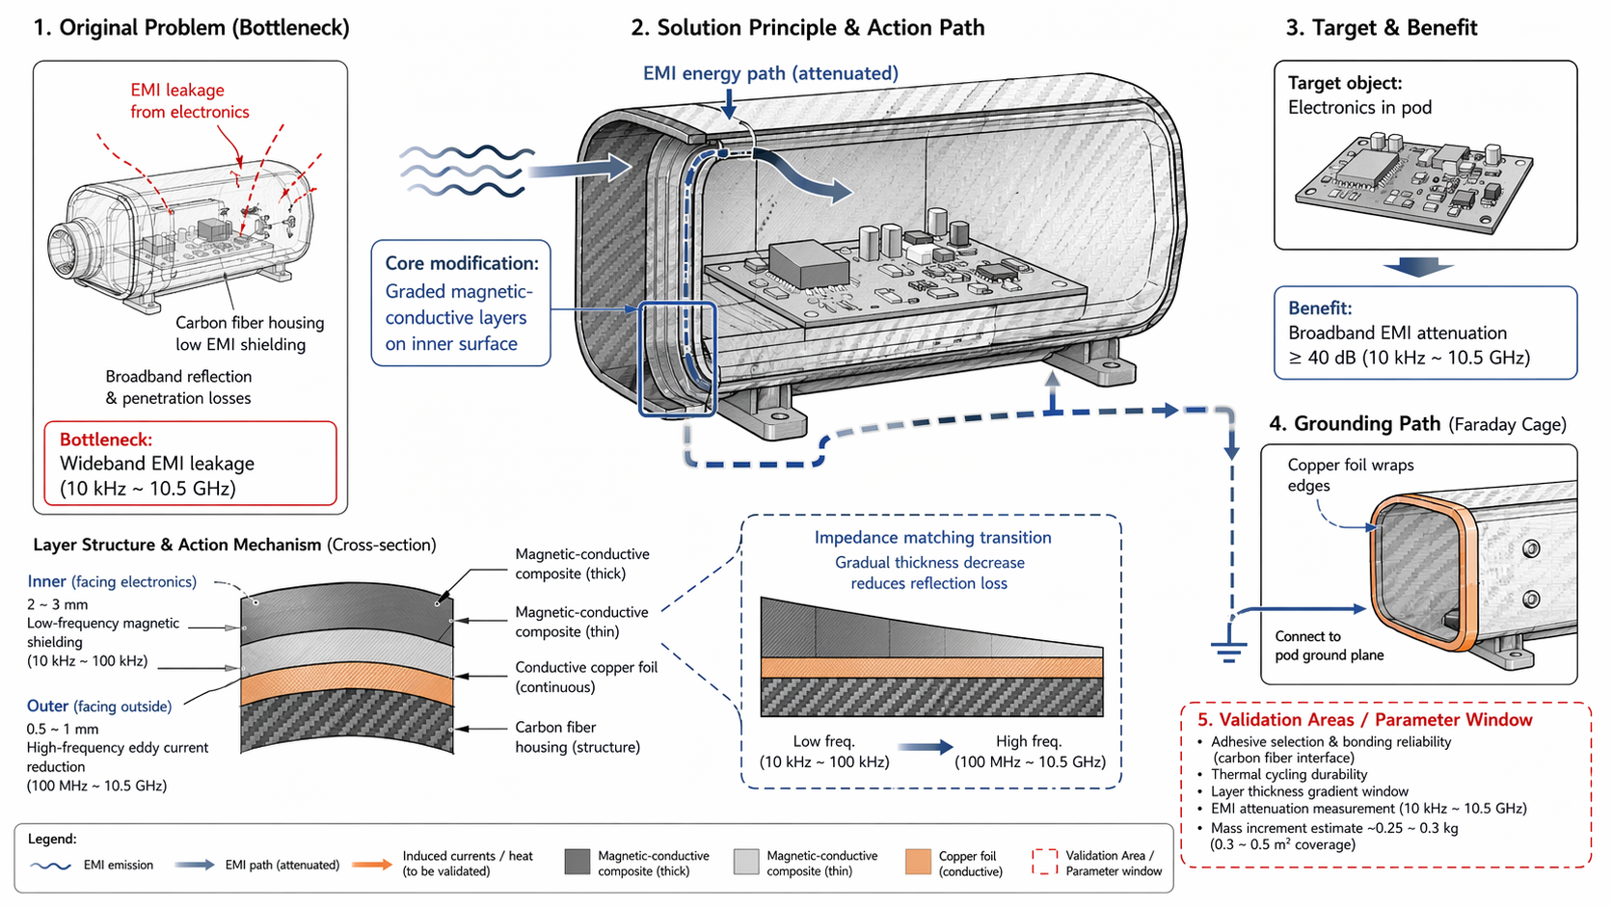

Executive Summary
This document describes the lamination of alternating magnetic-conductive composite layers onto the inner surface of the carbon fiber housing, with a gradient thickness profile that transitions from thick inner layers (2–3 mm) for low-frequency magnetic shielding to thin outer layers (0.5–1 mm) for high-frequency eddy current reduction. This graded structure forms an impedance matching transition that reduces reflection loss and achieves ≥40 dB broadband attenuation across 10 kHz–10.5 GHz. Conductive copper foil wraps the edges and connects to the pod ground plane, forming a continuous Faraday cage without separate enclosures or PCB rework.

1. Problem Statement
The carbon fiber housing provides structural rigidity but offers poor electromagnetic interference (EMI) shielding across the full operational spectrum. The primary issues are:
- Broadband EMI Leakage (10 kHz–10.5 GHz)
- The carbon fiber weave is electrically conductive but electromagnetically porous. Low-frequency magnetic fields (10 kHz–100 kHz) from buck converters and electronic speed controllers (ESCs) penetrate the CF structure with minimal attenuation. High-frequency emissions (100 MHz–10.5 GHz) from the Jetson AGX Thor and radar systems radiate through the weave gaps, causing both internal crosstalk and external emissions.
- Reflection Loss at Layer Interfaces
- Traditional homogeneous shielding layers create abrupt impedance mismatches at the air-shield and shield-substrate boundaries, causing significant reflection of incident EM energy back into the electronics compartment rather than absorption.
- Mass and Integration Constraints
- Full-metal enclosures or thick homogeneous shielding layers add excessive mass (1.5–3 kg) and require separate mechanical integration. PCB-level shielding requires layout rework and compromises field repairability.

2. Solution Principle
Laminate alternating magnetic-conductive composite layers onto the inner surface of the carbon fiber housing with a gradient thickness profile. The graded structure provides frequency-dependent shielding optimized for the electromagnetic threat spectrum at each depth.
Layer | Position | Thickness | Frequency Band | Shielding Mechanism
Inner Layer 1 | Facing electronics (innermost) | 2–3 mm | 10 kHz–100 kHz | Low-frequency magnetic shielding (high permeability)
Inner Layer 2 | Intermediate | 1–2 mm | 100 kHz–100 MHz | Magnetic-conductive composite (medium permeability + conductivity)
Outer Layer | Facing CF housing (outermost) | 0.5–1 mm | 100 MHz–10.5 GHz | High-frequency eddy current reduction (high conductivity)
Copper Foil | Continuous wrap | 0.05–0.1 mm | DC–10.5 GHz | Electrical ground plane; Faraday cage continuity

Impedance Matching Transition: The gradual thickness decrease from inner to outer layers creates a smooth impedance gradient. Low-frequency magnetic waves encounter high-permeability thick layers first, while high-frequency electromagnetic waves penetrate to the thinner, more conductive outer layers. This graded transition reduces reflection loss at each interface and maximizes energy absorption across the full spectrum.

3. Layer Structure & Action Mechanism

3.1 Inner Layer — Low-Frequency Magnetic Shielding (10 kHz–100 kHz)
Material: Thick magnetic-conductive composite (2–3 mm), high magnetic permeability (μr > 1000), moderate electrical conductivity.
Mechanism: Low-frequency magnetic fields from buck converters and ESCs induce magnetization in the high-permeability composite. The magnetic flux is redirected around the shielded volume (electronics compartment) rather than penetrating through it. The thick layer provides sufficient magnetic path length to achieve high attenuation at low frequencies where skin depth is large.

3.2 Intermediate Layer — Broadband Transition (100 kHz–100 MHz)
Material: Medium-thickness magnetic-conductive composite (1–2 mm), balanced permeability and conductivity.
Mechanism: This layer serves as a transition zone where both magnetic and conductive shielding mechanisms are active. The composite absorbs energy through a combination of magnetic hysteresis loss and eddy current damping. The intermediate thickness ensures that neither magnetic saturation nor excessive eddy current cancellation dominates.

3.3 Outer Layer — High-Frequency Eddy Current Reduction (100 MHz–10.5 GHz)
Material: Thin magnetic-conductive composite (0.5–1 mm), high electrical conductivity, moderate permeability.
Mechanism: High-frequency EM waves from the Jetson AGX Thor and radar systems induce strong eddy currents in the conductive outer layer. These eddy currents generate opposing magnetic fields that cancel the incident wave (Lenz's law). The thin layer is sufficient because skin depth at these frequencies is extremely small (<< 1 mm), so all energy absorption occurs within the first few hundred microns of the layer.

3.4 Copper Foil — Ground Plane & Faraday Cage Continuity
Material: Continuous copper foil wrap (0.05–0.1 mm) around all edges and seams.
Mechanism: The copper foil provides a low-impedance electrical path that connects all composite layers to the pod ground plane. This ensures that induced currents in the shielding layers have a defined return path, preventing charge buildup and maintaining Faraday cage integrity. The foil also bridges any gaps or seams in the composite lamination, eliminating slot-antenna radiation paths.

4. Impedance Matching Transition
The gradient thickness profile creates an impedance matching transition that addresses the fundamental problem of reflection loss in homogeneous shields:
- Problem with Homogeneous Shields:
- Abrupt impedance mismatch at the air-shield boundary causes ~50% or more of incident energy to reflect back into the source region rather than being absorbed.
- Solution with Graded Composite:
- The gradual transition from thick (high permeability, low conductivity) to thin (low permeability, high conductivity) creates a smooth impedance gradient.
- At each sub-layer interface, the impedance mismatch is small, so reflection is minimized and transmission is maximized.
- Energy propagates through the graded structure, being progressively absorbed by magnetic loss (inner layers) and eddy current damping (outer layers).
The impedance matching transition is analogous to an optical anti-reflection coating, where graded refractive index minimizes reflection at lens surfaces. In the EM shielding context, the graded magnetic-conductive properties minimize reflection and maximize absorption across the 10 kHz–10.5 GHz spectrum.

5. Grounding Path (Faraday Cage)
The composite shielding layer forms a continuous Faraday cage through the following grounding architecture:
- Copper Foil Edge Wrap
- Copper foil strips wrap around all edges of the housing (lid seams, connector openings, vent gaps), bridging the inner composite layer to the outer CF structure.
- Pod Ground Plane Connection
- The copper foil is electrically bonded to the pod ground plane at multiple points (typically 4–6 locations around the housing perimeter). This provides a low-impedance return path for induced shielding currents.
- Continuous Electrical Path
- The combination of composite layers (conductive) and copper foil (highly conductive) creates a continuous electrical enclosure with no galvanically isolated sections. Any induced current can flow to ground without creating potential differences that would drive secondary radiation.
Result: A self-contained Faraday cage that requires no separate metal enclosure, no PCB ground plane extension, and no additional shielding hardware. The housing itself becomes the shield.

6. Performance Targets & Mass Budget
Parameter | Target / Value | Rationale
EMI Attenuation | ≥40 dB @ 10 kHz–10.5 GHz | Broadband compliance for all onboard EMI sources
Coverage Area | 0.3–0.5 m² (inner housing surface) | Sufficient to cover electronics compartment walls
Mass Increment | ~0.25–0.3 kg | Within ≤0.5 kg EMI mitigation budget
Integration Method | Laminated onto CF inner surface | No separate enclosures; no PCB rework

7. TRIZ / Systematic Innovation Principles
The physical contradiction addressed: the shielding must be thick and permeable (for low-frequency magnetic shielding) and thin and conductive (for high-frequency eddy current shielding), but these properties are spatially incompatible in a homogeneous material.

7.1 Principle #40 — Composite Materials
The solution uses a composite of multiple materials rather than a single homogeneous shield:
- Magnetic-conductive composites with varying permeability/conductivity ratios at different depths.
- Copper foil for electrical continuity and ground connection.
- Carbon fiber housing as the structural substrate.
The composite achieves properties that no single material can provide: broadband shielding from 10 kHz to 10.5 GHz at minimal mass.

7.2 Principle #3 — Local Quality
The solution changes the quality of the shielding from uniform to locally optimized:
- Inner surface (facing electronics): Thick, high-permeability layers optimized for low-frequency magnetic fields.
- Outer surface (facing CF housing): Thin, high-conductivity layers optimized for high-frequency eddy currents.
Each local region is optimized for the specific frequency band and threat direction, rather than compromising across the full spectrum.

7.3 Space Separation
The contradiction is resolved by separating the opposing requirements in space (depth):
- Low-frequency magnetic shielding occupies the inner spatial region (thick layers).
- High-frequency conductive shielding occupies the outer spatial region (thin layers).
The spatial separation allows both functions to coexist within the same total thickness without mutual interference.

8. Bottleneck Solved
The gradient-thickness composite shielding layer resolves the following critical bottlenecks:
- Wideband EMI Leakage Eliminated
- The graded composite provides ≥40 dB attenuation from 10 kHz to 10.5 GHz, covering all onboard EMI sources (buck/ESC low-frequency emissions, Jetson/radar high-frequency emissions) in a single integrated solution.
- Reflection Loss Minimized
- The impedance matching transition reduces reflection at layer interfaces, ensuring that incident EM energy is absorbed rather than reflected back into the electronics compartment.
- No Separate Enclosures or PCB Rework
- The shielding is integrated into the housing itself. No additional metal enclosures, PCB ground plane extensions, or layout changes are required. This preserves field repairability and reduces integration complexity.
- Mass Budget Maintained
- At ~0.25–0.3 kg for 0.3–0.5 m² coverage, the composite layer consumes only 50–60% of the EMI mitigation mass budget, leaving margin for additional suppression components (ferrite cores, conductive gaskets).

9. Validation & Verification Plan
Validation Item | Parameter Window / Target | Verification Method
Adhesive Selection & Bonding | Reliable adhesion to carbon fiber; peel strength > 5 N/cm | 90° peel test per ASTM D6862; thermal shock cycling
Thermal Cycling Durability | No delamination after -40°C to +60°C cycles | Thermal chamber testing (500 cycles); inspect for cracking/peeling
Layer Thickness Gradient | Inner: 2–3 mm → Outer: 0.5–1 mm (smooth transition) | Cross-sectional microscopy; CMM thickness mapping
EMI Attenuation | ≥40 dB @ 10 kHz–10.5 GHz | MIL-STD-285 or IEEE 299 shielding effectiveness test; dual-chamber method
Mass Verification | ~0.25–0.3 kg for 0.3–0.5 m² coverage | Precision weighing; compare against EMI mitigation budget

10. References
- [1] Patent/Citation — Electromagnetic isolation device based on composite shielding (graded composite shielding reference)
- [2] Altshuller, G. — TRIZ: 40 Principles of Inventive Problem Solving (Principle #3: Local Quality; Principle #40: Composite Materials)
- [3] MIL-STD-285 — Military Standard: Attenuation Measurements for Enclosures, Electromagnetic Shielding, for Electronic Test Purposes
- [4] IEEE 299 — Standard Method for Measuring the Effectiveness of Electromagnetic Shielding Enclosures
- [5] ASTM D6862 — Standard Test Method for 90 Degree Peel Resistance of Adhesives
— Document generated July 20, 2026 —

