Lightweight FPC Harness with Integrated Shielding Film for Analog Signal EMI Protection
Date: 2026-07-20
Reference: FPC light weight wire harness for automobile
TRIZ Principle: Composite materials (Principle #40)
Analysis Method: Functional modeling
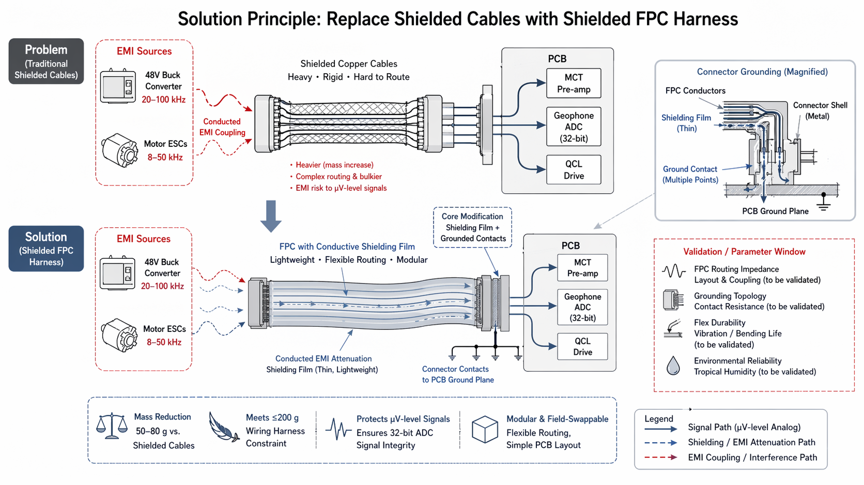

Core Concept
Cross-domain application: Replace traditional shielded copper cables for analog signal routing with a flexible FPC harness wrapped in thin conductive shielding film, grounded to the PCB ground plane via connector contacts.

1. Problem — Traditional Shielded Cables
EMI Source | Frequency Range | Coupling Mechanism
48V Buck Converter | 20–100 kHz | Conducted EMI coupling to analog signals
Motor ESCs | 8–50 kHz | Conducted EMI coupling to analog signals
Issues with traditional shielded copper cables:
- Heavier (mass increase)
- Rigid and hard to route in compact pod topology
- Complex routing and bulkier installation
- EMI risk to µV-level analog signals (MCT pre-amp, Geophone ADC, QCL Drive)

2. Solution — Shielded FPC Harness
Core Modification: Shielding Film + Grounded Contacts
Replace heavy shielded copper cables with:
- FPC (Flexible Printed Circuit) main wire — routes µV-level analog signals
- Thin conductive shielding film — wraps FPC for EMI attenuation
- Grounded connector contacts — bond shielding film to PCB ground plane at multiple points

Analog Signal Routing (Protected Circuits)
- MCT Pre-amp
- Geophone ADC (32-bit)
- QCL Drive
All three circuits handle µV-level analog signals requiring high integrity and low noise.

Connector Grounding (Magnified Detail)
Component | Function
FPC Conductors | Carry µV-level analog signals
Shielding Film (Thin) | Attenuates conducted EMI from power sources
Connector Shell (Metal) | Provides mechanical shielding continuity
Ground Contact (Multiple Points) | Bonds shield to PCB ground plane for low-impedance return
PCB Ground Plane | Reference ground for entire shielding system

Key Performance Metrics
Metric | Value
Mass reduction | 50–80 g vs. shielded copper cables
Wiring harness constraint | Meets ≤200 g total budget
Signal integrity | Protects µV-level signals, ensures 32-bit ADC accuracy
Routing flexibility | Flexible FPC preserves compact pod layout
Modularity | Field-swappable, simple PCB layout
EMI attenuation | Shielding film attenuates 8–100 kHz conducted noise

Advantages vs. Traditional Shielded Copper Cables
Traditional (Shielded Cables) | This Solution (FPC Harness) | Benefit
Heavy copper braid shield | Thin conductive film on lightweight FPC | 50–80 g mass reduction
Rigid, hard to route | Flexible routing in tight pod topology | Simplified mechanical layout
Bulky connectors | Compact grounded connector contacts | Preserves field-swap modularity
Fixed cable lengths | Custom FPC layout per PCB design | Simple PCB layout, no extra enclosures
Potential ground loops | Multiple grounded contact points to PCB GND | Controlled low-impedance return path

Validation / Parameter Window (To Be Validated)
Validation Area | Description
FPC Routing Impedance | Layout & coupling validation to ensure controlled impedance for µV-level analog signals
Grounding Topology | Contact resistance measurement and multi-point ground integrity verification
Flex Durability | Vibration and bending life testing under operational mechanical loads
Environmental Reliability | Tropical humidity exposure and long-term adhesion of shielding film

TRIZ Principle Applied
#40 Composite Materials — Transition from homogeneous to heterogeneous materials. The solution combines a flexible polymer substrate (FPC) with a thin conductive shielding film to create a composite harness that achieves functions no single material can provide alone: lightweight flexibility plus electromagnetic shielding. This replaces a homogeneous heavy copper cable with a heterogeneous composite that optimizes mass, flexibility, and EMI protection simultaneously.

Legend
- Solid blue arrow: Signal Path (µV-level Analog)
- Dashed blue arrow: Shielding / EMI Attenuation Path
- Dashed red arrow: EMI Coupling / Interference Path

Note: All parameters require validation. FPC routing design, connector grounding topology, and flex durability under vibration and tropical humidity are to be confirmed through testing.

