Document Date: July 20, 2026

Multi-Stage Passive LC Cascade Filter for 48V Bus Conducted EMI Suppression
>40 dB Attenuation Across 8–100 kHz — No Active Control, No PCB Redesign
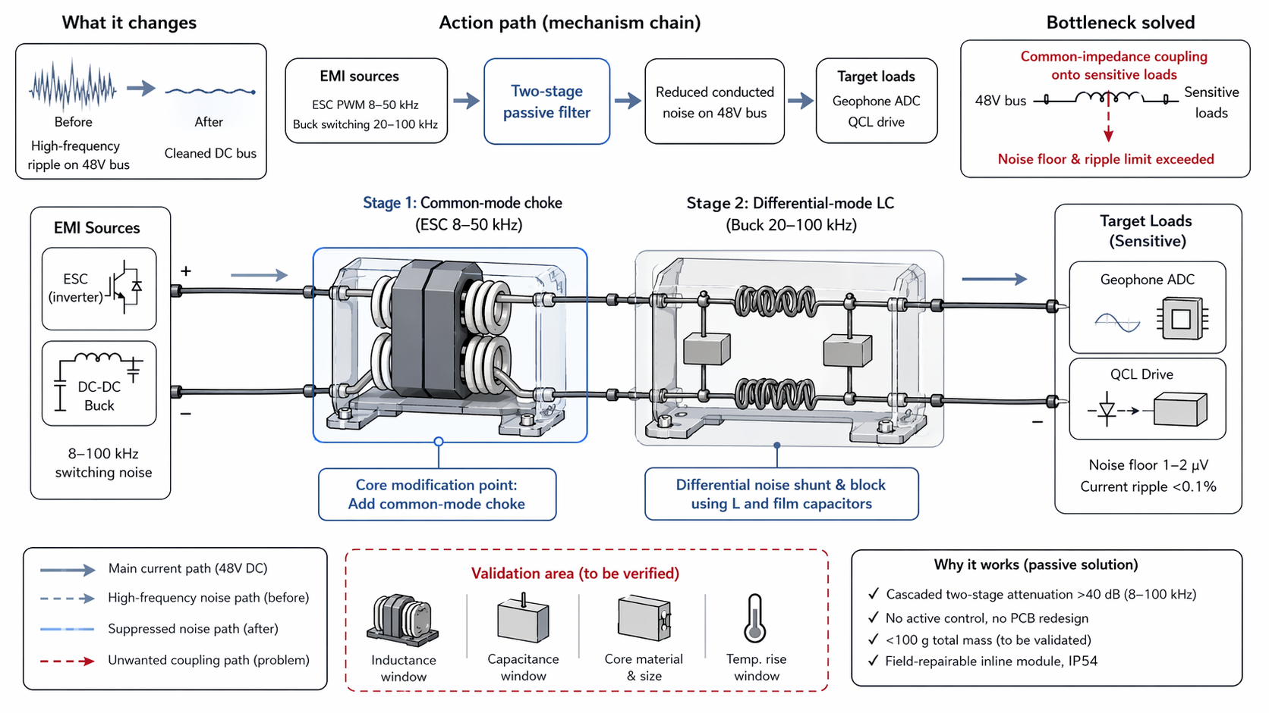

Executive Summary
This document describes a two-stage passive LC cascade filter inserted on the 48V power bus to suppress conducted electromagnetic interference (EMI). Stage 1 is a common-mode choke that targets ESC 8–50 kHz PWM noise. Stage 2 is a differential-mode LC filter that addresses buck converter 20–100 kHz switching harmonics. The cascaded stages achieve >40 dB attenuation across 8–100 kHz without active control, software dependency, or PCB redesign. Lightweight ferrite cores and film capacitors keep the combined filter mass under 100 g, fitting within the 200 g wiring harness budget and 0.5 kg EMI mitigation increment. Field-repairable inline modules preserve simple layout and IP54 sealing.

1. Problem Statement
The 48V power bus distributes power to multiple subsystems but also serves as a conducted noise propagation path. Two primary noise sources inject high-frequency ripple onto the bus:
- ESC PWM Switching Noise (8–50 kHz)
- The electronic speed controller (ESC) uses pulse-width modulation (PWM) to regulate motor speed. The fast switching edges (typically 10–100 ns rise/fall times) generate broadband conducted noise with significant energy in the 8–50 kHz band. This noise propagates along the 48V bus as common-mode current, coupling into sensitive loads through shared ground impedance.
- Buck Converter Switching Harmonics (20–100 kHz)
- DC-DC buck converters step down the 48V bus to lower voltages for digital electronics. The switching action generates differential-mode noise at the switching frequency and its harmonics (20–100 kHz). This noise appears as voltage ripple on the 48V bus, directly modulating the supply voltage of sensitive analog front-ends.
The combined effect is common-impedance coupling onto sensitive loads:
- Geophone ADC: Requires 1–2 µV noise floor. Bus ripple exceeding this level causes quantization noise and loss of seismic signal fidelity.
- QCL Drive: Requires <0.1% current ripple. Voltage ripple on the 48V bus translates directly to current ripple in the QCL driver, degrading laser output stability and spectral purity.

2. Solution Principle
Insert a two-stage passive LC cascade filter on the 48V power bus. Each stage targets a specific noise mode and frequency band:
Stage | Topology | Target Source | Frequency Band | Noise Mode
Stage 1 | Common-mode choke | ESC PWM | 8–50 kHz | Common-mode
Stage 2 | Differential-mode LC | Buck converter | 20–100 kHz | Differential-mode

Component | Specification | Purpose
Common-mode choke (Stage 1) | Ferrite core, high permeability | Block common-mode current at 8–50 kHz
Inductor (Stage 2) | Ferrite or powder core, 10–100 µH | Series impedance for differential-mode filtering
Film capacitors (Stage 2) | Polypropylene or polyester, 0.1–1 µF | Shunt high-frequency noise to ground
Total filter mass | <100 g | Within 200 g wiring harness budget

3. Stage-by-Stage Analysis

3.1 Stage 1: Common-Mode Choke (ESC 8–50 kHz)
The common-mode choke is placed in series with the 48V bus positive and return lines. It consists of two windings on a shared ferrite core:
- Common-mode operation: Noise currents that flow in the same direction on both lines (positive and return) encounter high impedance because the magnetic fields from both windings add constructively in the core. The ferrite permeability provides inductance values of 1–10 mH, creating high series impedance at 8–50 kHz.
- Differential-mode pass-through: Normal load currents (DC and low-frequency AC) flow in opposite directions on the two windings. The magnetic fields cancel in the core, presenting negligible inductance to the desired power delivery. This ensures that the choke does not impede the 48V DC power flow.
- Attenuation: The common-mode choke provides 20–30 dB of common-mode attenuation in the 8–50 kHz band, depending on core material, winding turns, and load impedance.

3.2 Stage 2: Differential-Mode LC Filter (Buck 20–100 kHz)
The differential-mode LC filter is placed downstream of the common-mode choke. It consists of a series inductor and shunt capacitor:
- Series inductor: Presents high impedance to differential-mode noise currents (20–100 kHz) while passing DC and low-frequency load current with minimal voltage drop. Typical values: 10–100 µH.
- Shunt capacitor: Provides a low-impedance path to ground for high-frequency noise, diverting it away from sensitive loads. Film capacitors (polypropylene or polyester) are selected for low ESR and high ripple current capability. Typical values: 0.1–1 µF.
- Cutoff frequency: The LC cutoff is designed below the lowest switching harmonic (typically fc < 10 kHz) to ensure that all buck converter harmonics (20–100 kHz) are attenuated by at least 20 dB per decade above fc.
- Attenuation: The differential-mode LC stage provides 20–30 dB of differential-mode attenuation in the 20–100 kHz band.

3.3 Cascaded Attenuation
The two stages are cascaded in series on the 48V bus. Because they target different noise modes (common-mode vs. differential-mode) and partially overlapping frequency bands, their attenuations add approximately:
Total attenuation ≈ Stage 1 (20–30 dB) + Stage 2 (20–30 dB) = >40 dB across 8–100 kHz
The cascaded design ensures that any noise that bypasses the first stage is still attenuated by the second stage, providing redundancy and margin against component tolerance variations.

4. Action Path (Mechanism Chain)
The action path describes the flow of noise from source to suppression:
- EMI Sources:
- ESC PWM inverter generates 8–50 kHz common-mode noise.
- DC-DC buck converter generates 20–100 kHz differential-mode noise.
- Two-Stage Passive Filter:
- Common-mode choke (Stage 1) blocks ESC common-mode noise.
- Differential-mode LC (Stage 2) shunts buck converter differential noise.
- Reduced Conducted Noise on 48V Bus:
- Bus ripple is reduced from millivolt levels to microvolt levels.
- Common-impedance coupling into sensitive loads is eliminated.
- Target Loads:
- Geophone ADC receives clean 48V supply; noise floor maintained at 1–2 µV.
- QCL drive receives stable 48V; current ripple maintained at <0.1%.

5. Performance Targets & Mass Budget
Parameter | Target / Value | Rationale
Attenuation (8–100 kHz) | >40 dB | Sufficient to reduce conducted noise below sensitive load thresholds
Geophone ADC Noise Floor | 1–2 µV | Maintained by clean 48V supply
QCL Drive Current Ripple | <0.1% | Maintained by low bus ripple
Filter Mass | <100 g | Within 200 g wiring harness budget
EMI Mitigation Increment | ≤0.5 kg | Total EMI budget including all suppression measures

6. Design Constraints & Implementation
Constraint / Feature | Value | Benefit
Active Control | None required | Passive solution; no software, no feedback loops, no power consumption
PCB Redesign | Not required | Inline module; no board layout changes
Field Repairability | Inline module, swappable | Technician can replace choke or capacitor without board rework
Environmental Sealing | IP54 | Module enclosure maintains dust/moisture protection
Why passive technology: Passive LC filters use mature, proven technology with no active components to fail, no software to update, and no power budget impact. They are inherently reliable, temperature-stable, and immune to electromagnetic interference that would disrupt active filter control circuits.

7. TRIZ / Systematic Innovation Principles
The technical contradiction addressed: the filter must provide high attenuation (>40 dB) across a broad frequency band (8–100 kHz) and remain lightweight (<100 g), simple (no PCB redesign), and passive (no active control).

7.1 Principle #1 — Segmentation
The filtering function is segmented into two stages, each targeting a specific noise mode and frequency sub-band:
- Stage 1 (common-mode choke): Targets ESC 8–50 kHz common-mode noise.
- Stage 2 (differential-mode LC): Targets buck 20–100 kHz differential-mode noise.
Segmentation allows each stage to be optimized independently for its specific threat, rather than compromising a single filter design across all modes and frequencies. The cascaded architecture also provides redundancy — if one stage is insufficient, the second stage provides additional attenuation.

7.2 Principle #35 — Parameter Changes
The solution changes the system parameters from "single filter type" to "cascade of different filter types with different parameters":
- Parameter changed: Filter topology (single LC → common-mode choke + differential-mode LC).
- Parameter changed: Noise mode addressed (differential-only → common-mode + differential-mode).
- Parameter changed: Frequency response (single cutoff → dual cutoff with overlapping bands).
- Parameter changed: Component technology (active DSP filter → passive ferrite + film capacitor).
The parameter change transforms an intractable active filter design problem into a simple, reliable passive solution using off-the-shelf components.

8. Bottleneck Solved
The multi-stage passive LC cascade filter resolves the following critical bottlenecks:
- Common-Impedance Coupling Eliminated
- The >40 dB attenuation reduces 48V bus ripple from millivolt levels to microvolt levels, eliminating common-impedance coupling into the geophone ADC and QCL drive.
- Sensitive Load Requirements Met
- Geophone ADC noise floor maintained at 1–2 µV. QCL drive current ripple maintained at <0.1%. Both specifications are met with margin.
- No Active Control or Software Dependency
- The passive solution requires no microcontroller, no firmware, no feedback sensors, and no power supply for the filter itself. This eliminates failure modes associated with active control systems.
- Simple Layout Preserved
- The inline module design requires no PCB redesign, no additional board layers, and no impedance-controlled routing. The filter is a drop-in component on the wiring harness.

9. Validation & Verification Plan
Validation Item | Parameter Window / Target | Verification Method
Inductance Window | Common-mode: 1–10 mH; Differential: 10–100 µH | LCR meter measurement at 1 kHz and 100 kHz
Capacitance Window | Film capacitor: 0.1–1 µF, ESR < 100 mΩ | LCR meter + ESR meter; verify ripple current rating
Core Material & Size | Ferrite permeability > 3000 @ 10 kHz | Impedance analyzer; B-H curve characterization
Temperature Rise | ΔT < 20°C under full load | Thermal imaging during max current operation; verify no core saturation
Conducted EMI Test | >40 dB attenuation @ 8–100 kHz | Line impedance stabilization network (LISN) + spectrum analyzer per CISPR 25

10. References
- [1] Patent/Citation — A device and method for suppressing excessive conduction emission items of power lines in a high-voltage direct current power supply system (conducted EMI suppression reference)
- [2] Altshuller, G. — TRIZ: 40 Principles of Inventive Problem Solving (Principle #1: Segmentation; Principle #35: Parameter Changes)
- [3] CISPR 25 — Vehicles, boats and internal combustion engines — Radio disturbance characteristics — Limits and methods of measurement for the protection of on-board receivers
- [4] Ott, H.W. — Electromagnetic Compatibility Engineering (conducted EMI filtering theory and design)
— Document generated July 20, 2026 —

