Passive-Active Hybrid Vibration Suppression System

Saturday, July 11, 2026

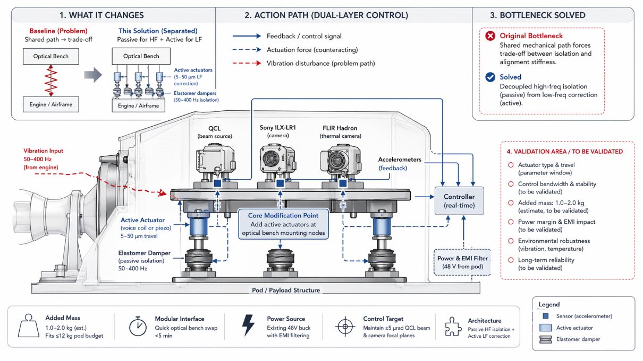

Passive-Active Hybrid Vibration Suppression with Frequency-Separated Isolation and Active Displacement Correction

Overview
This document describes a cross-domain vibration suppression architecture combining passive elastomeric isolation with active low-frequency displacement correction. The system is designed for airborne optical payloads requiring high-fidelity beam alignment and stable focal plane positioning without the mass, complexity, or integration burden of a full gyrostabilized platform.

1. System Concept

1.1 Frequency-Separated Vibration Management
- Passive Isolation (50-400 Hz): Existing Copterlab elastomer damper mounts are retained to attenuate high-frequency engine and airframe vibration.
- Active Correction (Low-Frequency 5-50 μm Displacement): Voice-coil or piezoelectric actuators mounted at optical bench nodes counteract residual micro-displacement.
- Condition-Based Separation: High-frequency vibration is mechanically decoupled from low-frequency displacement correction, eliminating the traditional trade-off between isolation effectiveness and optical alignment stiffness.

1.2 Cross-Domain Integration
- Optical, mechanical, and control subsystems operate in a coordinated loop.
- Real-time sensor feedback ensures alignment stability across QCL, Sony ILX-LR1, and FLIR Hadron modules.

2. Sensors and Feedback Architecture

2.1 Accelerometer Placement
- QCL Mounting Node: Tracks micro-radian beam deviation.
- Sony ILX-LR1 Node: Monitors focal plane stability.
- FLIR Hadron Node: Ensures thermal camera alignment.

2.2 Control Loop
- Accelerometer data feeds into a vibration controller.
- Controller computes counteracting forces for actuators.
- Actuators maintain ±5 μrad QCL beam alignment and stable camera focal planes.

3. Actuator Subsystem

3.1 Actuator Types
- Voice Coil Actuators: High bandwidth, smooth force output.
- Piezoelectric Actuators: High precision, compact form factor.

3.2 Mechanical Integration
- Modular actuator mounting interface supports <5 min optical bench swap.
- Actuators add 1.0-2.0 kg total mass.
- Fits within ≤12 kg pod budget.

3.3 Electrical Integration
- Powered by existing 48V buck converter.
- EMI filtering ensures compatibility with sensitive optical electronics.

4. Passive Isolation Layer

4.1 Elastomer Damper Characteristics
- Designed for 50-400 Hz vibration attenuation.
- Provides baseline isolation without compromising structural stiffness.

4.2 Mechanical Path Decoupling
- Passive dampers handle high-frequency vibration.
- Active actuators correct low-frequency displacement.
- Eliminates shared mechanical path that typically forces design compromises.

5. Performance Benefits

5.1 Optical Stability
- Maintains ±5 μrad beam alignment for QCL.
- Preserves camera focal plane stability across imaging modalities.

5.2 Mechanical Efficiency
- No gyrostabilization platform required.
- Reduced mass, complexity, and maintenance.

5.3 Operational Flexibility
- Modular bench interface supports rapid payload swaps.
- Compatible with multi-sensor airborne pods.

6. Reference System
Satellite vibration suppression system and method, storage medium and computer program product
- Provides conceptual precedent for multi-layer vibration suppression.

7. TRIZ Analysis

7.1 Physical Contradictions Addressed
- Need for high isolation vs. need for high stiffness.
- Need for low mass vs. need for high precision alignment.

7.2 TRIZ Principles Applied
- Principle #1: Segmentation - Separating vibration management into passive and active layers.
- Principle #40: Composite Materials - Combining elastomeric isolation with precision actuators.

8. Summary
This hybrid vibration suppression architecture provides a robust, modular, and lightweight solution for stabilizing airborne optical payloads. By separating high-frequency isolation from low-frequency displacement correction, the system achieves superior alignment stability without the complexity of gyrostabilized platforms.

