Pulsed Gas Flow for Boundary Layer Disruption in Transport Channel Purge
Date: 2026-07-20
Reference: Wastewater discharge system based on ternary positive electrode material and configuration method
TRIZ Physical Contradiction: Time separation (based on Principle #15 — Dynamics)
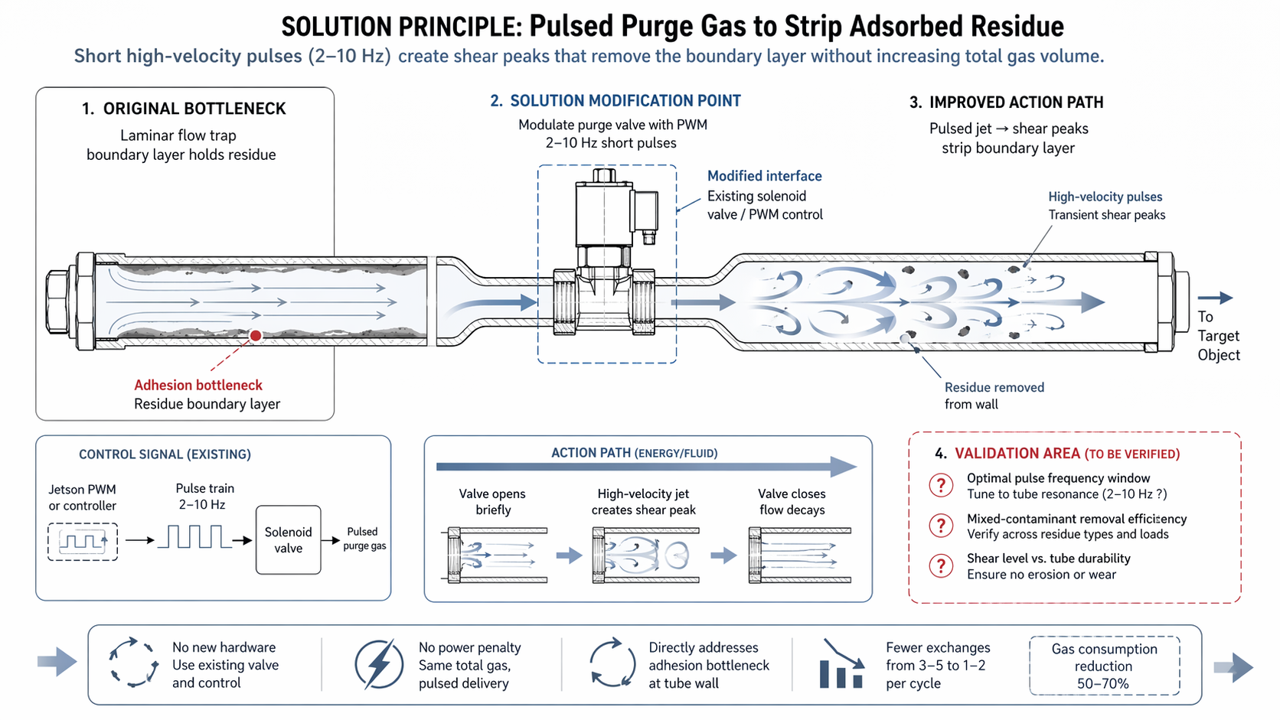

Core Concept
Cross-domain application: Modulate the purge gas flow into short high-velocity pulses at 2–10 Hz using the existing solenoid valve or Jetson PWM control, creating transient shear stress peaks that strip the adsorbed residue boundary layer from tube walls.

1. Original Bottleneck
Problem: Laminar flow trap — the boundary layer of adsorbed residue holds firmly to the tube wall under steady, low-velocity purge conditions. The laminar flow profile creates a stagnant region near the wall where residues resist removal, requiring 3–5 volume exchanges per cycle.

2. Solution Modification Point
Core Modification: Modulate purge valve with PWM — 2–10 Hz short pulses.
Modified interface: Existing solenoid valve / PWM control. No new hardware required.
Control signal path: Jetson PWM or controller → Pulse train (2–10 Hz) → Solenoid valve → Pulsed purge gas

3. Improved Action Path
- Valve opens briefly — high-velocity jet enters tube
- Transient shear peaks strip boundary layer from wall
- Residue dislodged and entrained in gas flow
- Valve closes — flow decays, carrying residue to target
- Residue removed from wall with fewer total exchanges
Key mechanism: Pulsed jet → shear peaks → boundary layer stripped. The transient high-velocity pulses disrupt the laminar flow trap without increasing total gas volume.

Action Path (Energy/Fluid) Sequence
Phase | State | Effect
Valve opens briefly | High-velocity jet enters tube | Creates transient shear peak at wall
Peak shear | Boundary layer disrupted | Adsorbed residue stripped from surface
Flow propagation | Residue entrained in gas | Carried toward tube exit
Valve closes | Flow decays | No additional gas consumed during decay

Performance Comparison
Parameter | Steady Flow (Before) | Pulsed Flow (After)
Volume exchanges per cycle | 3–5 exchanges | 1–2 exchanges
Gas consumption | Baseline (100%) | 30–50% (50–70% reduction)
Flow regime | Laminar — boundary layer trapped | Transient turbulent — boundary layer stripped
Hardware required | Existing valve and control | Same — no new hardware
Power penalty | None | None — same total gas, pulsed delivery
Adhesion bottleneck | Unaddressed | Directly targeted at tube wall

Key Benefits
- No new hardware — uses existing solenoid valve and Jetson PWM control
- No power penalty — same total gas volume, delivered in pulses
- Directly addresses adhesion bottleneck at tube wall
- Fewer exchanges per cycle — from 3–5 down to 1–2
- Gas consumption reduction of 50–70% per purge cycle
- Preserves existing pneumatic architecture and control logic

4. Validation Area (To Be Verified)
Validation Item | Description | Status
Optimal pulse frequency window | Tune to tube resonance (2–10 Hz ?) — determine frequency that maximizes shear without exciting structural modes | To be verified
Mixed-contaminant removal efficiency | Verify across residue types and loads — biological, chemical, and mixed contaminants | To be verified
Shear level vs. tube durability | Ensure no erosion or wear from repeated high-velocity pulses on tube interior | To be verified

TRIZ Principle Applied
#15 Dynamics — Make an object or system dynamically adapt to changing conditions. By converting steady purge flow into pulsed high-velocity jets, the system dynamically alternates between high-shear (valve open) and low-flow (valve closed) states. This time-separated approach breaks the laminar flow trap without requiring continuous high flow rates. The physical contradiction — needing high velocity to strip residue but low total gas volume to conserve supply — is resolved by separating these requirements in time: high velocity occurs only during brief pulses, while the total integrated flow remains low.

System Architecture Summary
Gas supply → Solenoid valve (PWM modulated, 2–10 Hz) → Pulsed high-velocity jet → Tube (boundary layer stripped) → Residue entrained in flow → To target object / next module

Note: All parameters to be validated. Pulse frequency tuning, mixed-contaminant efficiency, and tube durability under repeated shear cycles require experimental confirmation.

