Segmented Ground Plane PCB Topology with Polarization Channels

Saturday, July 11, 2026

Segmented Ground Plane PCB Topology with Polarization Channels for Conducted EMI Isolation

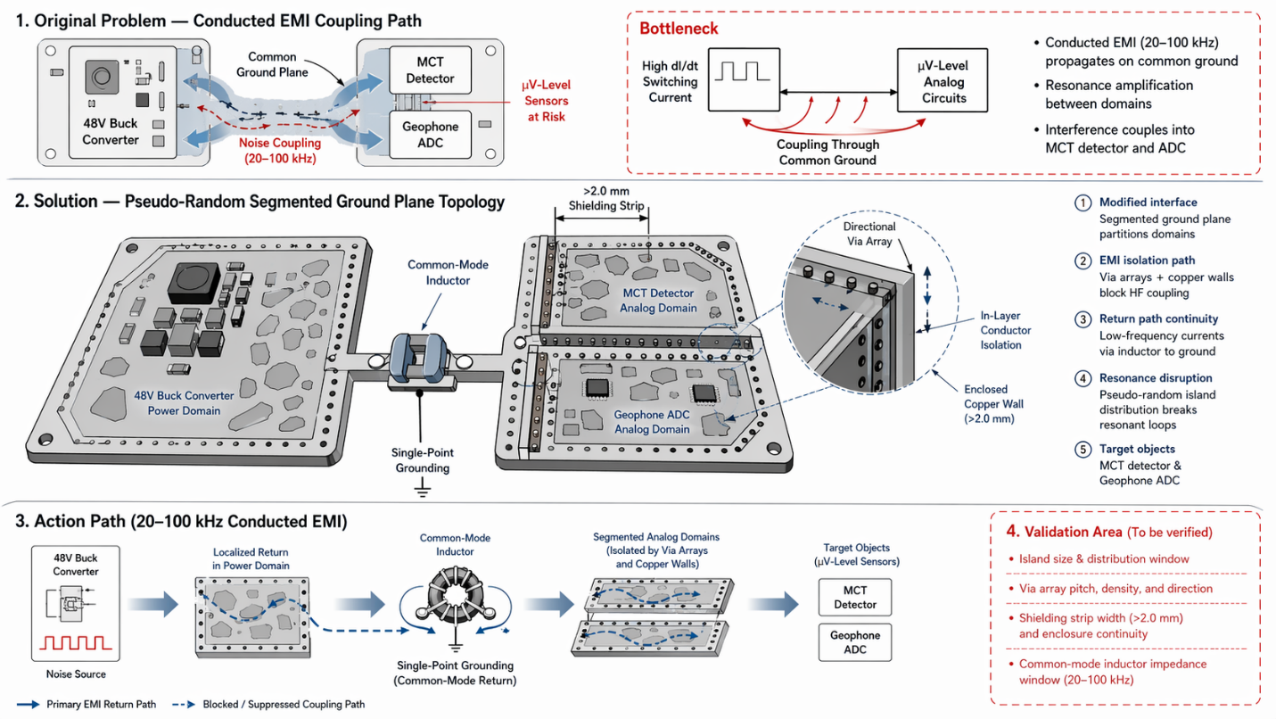

Overview
This document defines a cross-domain PCB-level electromagnetic interference (EMI) suppression architecture using pseudo-random segmented ground planes, polarization channels, and controlled return-path topology. The design isolates high-frequency conducted EMI (20-100 kHz) generated by a 48V buck converter from μV-level analog sensors such as the MCT detector and geophone ADC, without adding mass, calibration burden, or mechanical complexity.

1. System Concept

1.1 Frequency-Domain Separation
- Power Domain (48V Buck Converter): High di/dt switching currents generate conducted EMI.
- Analog Domains (MCT Detector, Geophone ADC): Sensitive μV-level circuits require isolation from switching noise.
- Single-Point Grounding: Domains connect only through a common-mode inductor, ensuring low-frequency return continuity while blocking high-frequency noise.

1.2 Spatial-Domain Segmentation
- Ground plane is partitioned into non-periodic islands.
- Copper walls and via arrays form polarization channels that direct and attenuate EMI.
- Segmentation disrupts resonance conditions that amplify switching noise.

2. Segmented Ground Plane Architecture

2.1 Pseudo-Random Island Distribution
- Non-periodic segmentation prevents standing-wave formation.
- Island size and spacing tuned to break resonant loops in the 20-100 kHz band.

2.2 Copper Walls and Shielding Strips
- >2.0 mm shielding strips between domains.
- Enclosed copper walls block direct coupling paths.
- Zero added mass compared to external shielding.

2.3 Directional Via Arrays (Polarization Channels)
- Via arrays create anisotropic conduction paths.
- High-frequency currents are forced into controlled dissipation routes.
- Low-frequency return paths remain continuous through the common-mode inductor.

3. Conducted EMI Isolation Mechanisms

3.1 High-Frequency Blocking
- Segmentation increases impedance for 20-100 kHz noise.
- Polarization channels redirect switching noise away from analog domains.

3.2 Low-Frequency Continuity
- Common-mode inductor maintains DC and low-frequency return integrity.
- Prevents floating-ground conditions in analog circuits.

3.3 Resonance Disruption
- Pseudo-random topology eliminates periodicity.
- Reduces amplification of switching harmonics.

4. Integration with Existing Pod Architecture

4.1 Mechanical and Electrical Compatibility
- No changes to pod structure or thermal venting.
- No impact on radiated RF isolation.
- Fully compatible with modular quick-swap interface.

4.2 Zero Calibration Requirement
- Purely PCB-level modification.
- No sensor recalibration or alignment procedures needed.

4.3 Mass and Power Impact
- Adds zero mass.
- No additional power consumption.

5. Reference System
Vehicle-mounted controller partition PCB layout and system for suppressing electromagnetic interference
- Provides precedent for domain partitioning and EMI suppression.

6. TRIZ Analysis

6.1 Technical Contradictions Addressed
- Need for high isolation vs. need for continuous return path.
- Need for low mass vs. need for high shielding effectiveness.

6.2 TRIZ Principles Applied
- Segmentation (#1) - Partitioning ground plane into isolated islands.
- Dynamicity (#15) - Polarization channels adapt EMI flow direction.
- Parameter Change (#3) - Adjusting island size, via density, and shielding width.

7. Summary
This segmented ground plane topology provides a robust, massless, calibration-free solution for conducted EMI suppression in mixed-signal airborne sensor pods. By combining pseudo-random segmentation, polarization channels, and single-point grounding through a common-mode inductor, the design isolates high-frequency switching noise while preserving low-frequency return integrity and full compatibility with existing pod architecture.

