Spatial Segmentation of ESC and Buck Converter for Near-Field EMI Isolation
Date: 2026-07-20
Reference: Anti-electromagnetic interference design method for wheel-foot humanoid robot in industrial scene
TRIZ Technical Contradictions: Segmentation (#1), Intermediary (#24)

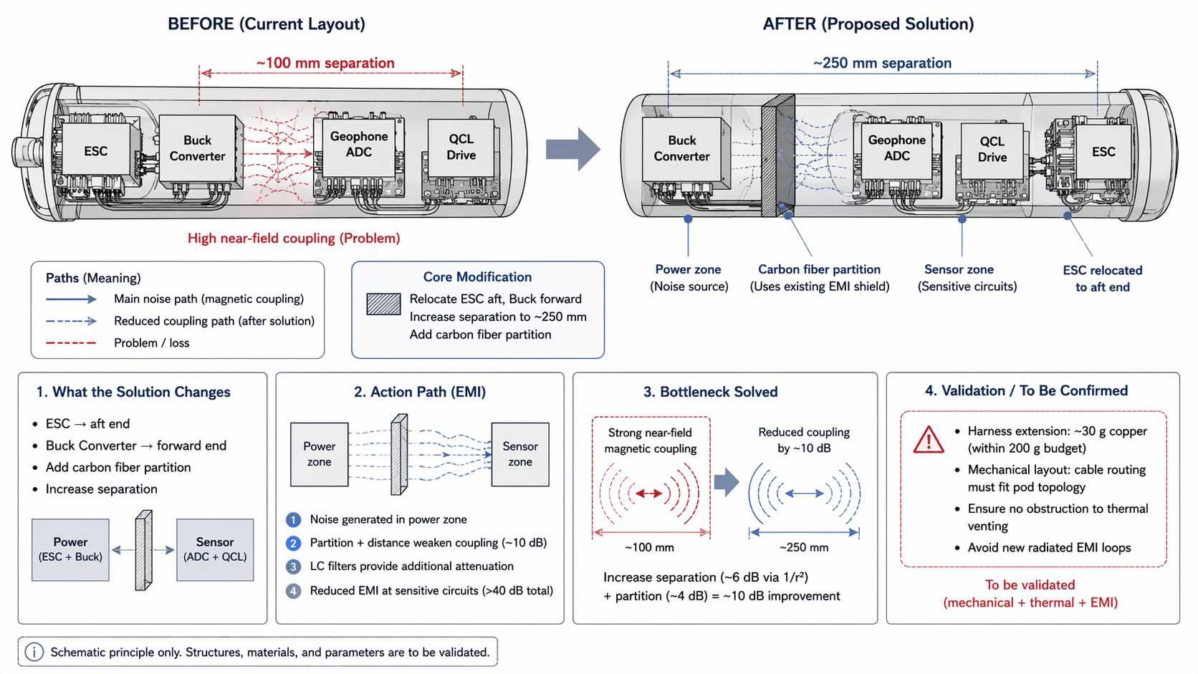

Key Design Points
Modification | Detail | Benefit
ESC relocated | Aft end of pod | Maximizes distance from sensor zone
Buck Converter relocated | Forward end of pod | Isolates primary switching noise source
Separation increased | ~100 mm → ~250 mm | ~6 dB reduction via 1/r² near-field scaling
Carbon fiber partition | Between power & sensor zones | Additional ~4 dB from existing EMI shield layers
Combined gain | Spatial + partition | ~10 dB improvement
Total attenuation | + passive LC filters | >40 dB cumulative

Validation Checklist (To Be Confirmed)
- Harness extension adds ~30 g copper (within 200 g budget)
- Cable routing must fit pod topology
- No obstruction to thermal venting
- Avoid new radiated EMI loops from extended harness

TRIZ Principles Applied
#1 Segmentation — Dividing the pod into independent power and sensor zones
#24 Intermediary — Inserting the carbon fiber partition as a shielding mediator between conflicting fields

