Thermal-Enhanced Gas Purge for Transport Channel Residue Desorption
Date: 2026-07-20
Reference: Pipeline integrated board based on automatic switch valve
TRIZ Principle: Thermal field enhancement (Principle #35 — Parameter changes)
Analysis Method: Substance-field analysis
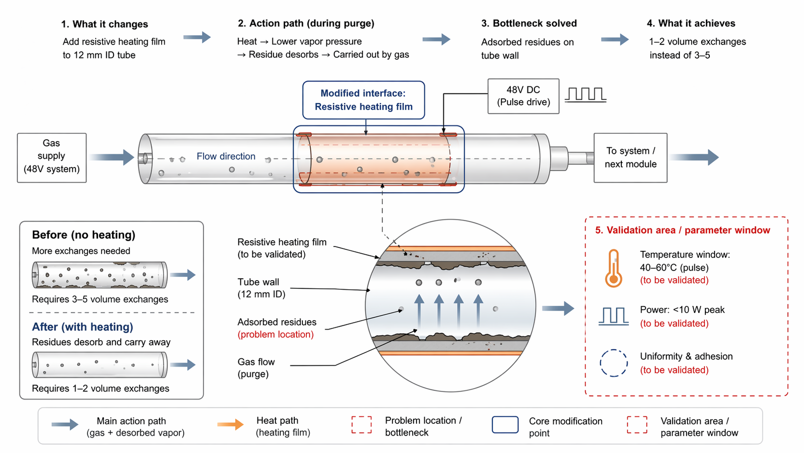

Core Concept
Cross-domain application: Wrap the 12 mm ID pneumatic transport channel with a thin resistive heating film powered from the 48V bus, pulsing to 40–60°C during purge cycles to accelerate residue desorption.

1. What it Changes
Core Modification: Add resistive heating film to 12 mm ID tube.
The heating film is bonded to the exterior tube wall and powered by 48V DC pulse drive, creating a localized thermal field that raises tube wall temperature during purge operations.

2. Action Path (During Purge)
- Heat → Lower vapor pressure of adsorbed residues
- Residue desorbs from tube wall into gas phase
- Desorbed vapor carried out by purge gas flow
- Clean tube achieved with minimal volume exchanges
Heat path: 48V DC (Pulse drive) → Resistive heating film → Tube wall → Adsorbed residues
Main action path: Gas supply → Flow through heated tube → Carries desorbed vapor → To system / next module

Before vs. After Comparison
Parameter | Before (No Heating) | After (With Heating)
Volume exchanges required | 3–5 exchanges | 1–2 exchanges
Residue state | Adsorbed on tube wall (bottleneck) | Desorbed and carried away
Purge efficiency | Low — residues resist removal at ambient temp | High — thermal energy overcomes adsorption
Power consumption | None (passive purge only) | <10 W peak (pulse heating)
Tube geometry | Standard 12 mm ID | Preserved — no structural change
Gas supply allocation | Higher consumption for repeated exchanges | Reduced — fewer exchanges needed

3. Bottleneck Solved
Problem: Adsorbed residues on tube wall — biological and chemical contaminants adhere to the 12 mm ID tube interior, resisting removal by passive gas purge at ambient temperature.
Solution: Elevated temperature (40–60°C pulse) lowers the vapor pressure of adsorbed residues, promoting desorption into the gas phase where purge flow can carry them out. This directly attacks the adsorption bottleneck without requiring new consumables or structural changes.

4. What it Achieves
- 1–2 volume exchanges instead of 3–5 — 50–67% reduction in purge gas consumption
- Faster cycle time between sample runs
- Improved cleanliness assurance for µV-level sensor measurements
- No new consumables or structural modifications required

Tube Cross-Section Detail (Magnified)
Component | Description
Resistive heating film | Thin film bonded to tube exterior (to be validated)
Tube wall | 12 mm ID transport channel
Adsorbed residues | Problem location — biological/chemical contaminants on interior wall
Gas flow (purge) | Carrier gas that removes desorbed residues

5. Validation Area / Parameter Window (To Be Validated)
Parameter | Target Window | Validation Need
Temperature window | 40–60°C (pulse) | Verify residue desorption rate vs. temperature for target contaminants
Power consumption | <10 W peak | Confirm heating film resistance and duty cycle meet power budget
Uniformity & adhesion | Consistent film bonding | Validate thermal uniformity along tube length and film adhesion under thermal cycling

Key Advantages
- Directly attacks adsorption bottleneck — no workaround or masking
- Preserves tube geometry and gas supply allocation
- Low power overhead (<10 W peak from existing 48V bus)
- No new consumables or structural changes required
- Compatible with existing 48V system architecture
- Scalable to other transport channels in the system

TRIZ Principle Applied
#35 Parameter Changes — Change the physical or chemical parameters of an object or system. By raising the tube wall temperature from ambient to 40–60°C during purge, the vapor pressure of adsorbed residues is increased, changing the equilibrium state from adsorption to desorption. This thermal field enhancement transforms a passive purge process into an active, thermally-assisted cleaning cycle, achieving the same cleanliness with fewer volume exchanges.

Legend
- Solid grey arrow: Main action path (gas + desorbed vapor)
- Orange arrow: Heat path (heating film)
- Dashed red box: Problem location / bottleneck
- Blue box: Core modification point
- Dashed red border: Validation area / parameter window

Note: All parameters to be validated. Temperature window, power consumption, and film uniformity require experimental confirmation for target residue types and operating conditions.

