Document Date: July 20, 2026

Three-Layer Composite EMI Coating on CF Housing Inner Surface
≥40 dB X-Band Shielding — Reflection + Absorption Stacked Composite
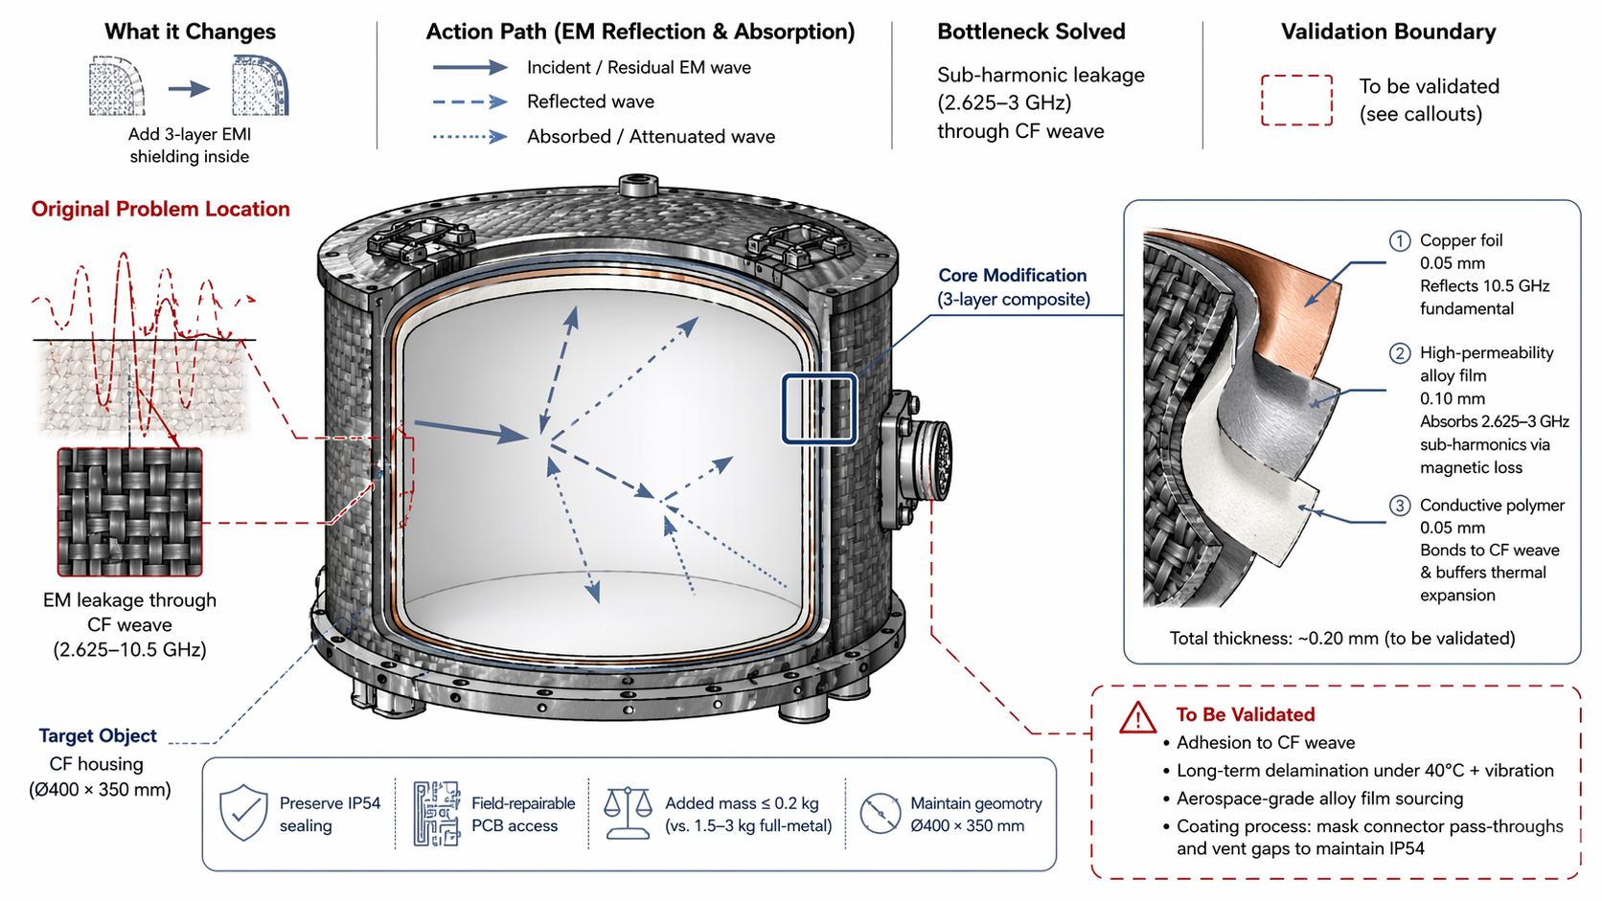

Executive Summary
This document describes the deposition of a three-layer composite EMI shielding coating onto the inner surface of a carbon fiber (CF) housing. The composite stacks reflection and absorption mechanisms to achieve ≥40 dB attenuation across 2.625–10.5 GHz. At a total thickness of ~0.20 mm and added mass ≤0.2 kg, the solution provides comparable shielding performance to a 1.5–3 kg full-metal Faraday cage while preserving housing geometry, IP54 sealing, and field-repairable PCB access.

1. Problem Statement
The carbon fiber weave housing (Ø400 × 350 mm) exhibits electromagnetic (EM) leakage across the 2.625–10.5 GHz frequency band due to the electrically conductive but electromagnetically porous nature of the CF weave structure. This creates two critical issues:
- Sub-Harmonic Leakage (2.625–3 GHz)
- Lower-frequency sub-harmonics penetrate the CF weave gaps, causing interference with sensitive onboard electronics and potential emissions compliance failures.
- Fundamental Frequency Leakage (10.5 GHz)
- Higher-frequency components reflect off the CF surface with insufficient attenuation, allowing residual EM energy to escape the housing and couple with external systems.
A full-metal Faraday cage solution would add 1.5–3 kg of mass, alter the Ø400 × 350 mm geometry, and eliminate field-repairable PCB access — all unacceptable trade-offs for the pod application.

2. Solution Principle
Deposit a thin three-layer composite coating onto the CF housing inner surface. Each layer is engineered for a specific electromagnetic function, creating a stacked reflection-absorption-bonding architecture:
Layer | Material | Thickness | EM Function | Mechanical Function
Layer 1 (Inner) | Copper foil | 0.05 mm | Reflects 10.5 GHz fundamental frequency | Primary EM barrier; high electrical conductivity
Layer 2 (Middle) | High-permeability alloy film | 0.10 mm | Absorbs 2.625–3 GHz sub-harmonics via magnetic loss | Magnetic damping; eddy current suppression
Layer 3 (Outer) | Conductive polymer | 0.05 mm | Secondary absorption; impedance matching | Bonds to CF weave; buffers thermal expansion mismatch

Total composite thickness: ~0.20 mm (to be validated)

3. System Architecture

3.1 Housing Geometry
Target housing: Carbon fiber cylindrical shell, Ø400 mm diameter × 350 mm height. The coating is applied to the entire inner surface except for masked regions around connector pass-throughs and vent gaps.

3.2 Action Path (EM Reflection & Absorption)
Incident / Residual EM Wave (solid arrow):
- External or internally generated EM energy approaches the CF housing inner surface.
Reflected Wave (dashed arrow):
- The copper foil layer (Layer 1) reflects the majority of the 10.5 GHz fundamental frequency due to its high electrical conductivity and low skin depth at X-band.
Absorbed / Attenuated Wave (dotted arrow):
- Residual energy that penetrates the copper layer encounters the high-permeability alloy film (Layer 2), which absorbs 2.625–3 GHz sub-harmonics through magnetic hysteresis and eddy current losses. The conductive polymer (Layer 3) provides additional absorption and impedance matching to the CF substrate.
The multi-mechanism approach ensures that no single frequency band can penetrate all three layers, achieving the ≥40 dB target across the full 2.625–10.5 GHz spectrum.

4. Layer-by-Layer Functional Analysis

4.1 Layer 1 — Copper Foil (0.05 mm)
Material: High-purity copper foil, 0.05 mm thickness.
EM Function: The skin depth of copper at 10.5 GHz is approximately 0.64 µm. At 0.05 mm (50 µm), the copper layer is ~78 skin depths thick, providing near-total reflection of the fundamental frequency. The reflection coefficient at the air-copper interface exceeds 99.9% for normal incidence.
Mechanical Function: The thin foil conforms to the CF weave surface texture without adding significant stiffness. It serves as the primary electrical ground plane for the shielding system.

4.2 Layer 2 — High-Permeability Alloy Film (0.10 mm)
Material: Aerospace-grade high-permeability alloy (e.g., Mu-metal or similar Ni-Fe alloy), 0.10 mm thickness.
EM Function: At 2.625–3 GHz, the magnetic permeability of the alloy provides high magnetic loss (tan δm > 0.5), converting magnetic field energy into heat through domain wall motion and eddy currents. The 0.10 mm thickness is selected to match the magnetic skin depth at sub-harmonic frequencies for optimal absorption.
Mechanical Function: The alloy film is flexible enough to conform to the CF curvature while providing magnetic shielding. Its intermediate position prevents direct galvanic corrosion with the copper layer.

4.3 Layer 3 — Conductive Polymer (0.05 mm)
Material: Carbon-filled or intrinsically conductive polymer, 0.05 mm thickness.
EM Function: The conductive polymer provides impedance matching between the alloy layer and the CF substrate, reducing reflections at layer interfaces. It also absorbs residual broadband energy through dielectric loss.
Mechanical Function: The polymer layer bonds chemically and mechanically to the CF weave surface, accommodating the thermal expansion coefficient mismatch between metal layers (copper: ~17 ppm/°C, alloy: ~12 ppm/°C) and carbon fiber (~0–2 ppm/°C). The polymer acts as a strain buffer, preventing delamination under thermal cycling.

5. Performance Targets & Design Constraints
Parameter | Target / Requirement | Rationale
Shielding Effectiveness | ≥40 dB @ 2.625–10.5 GHz | X-band compliance; prevents EMI with onboard electronics
Total Added Mass | ≤0.2 kg | vs. 1.5–3 kg full-metal Faraday cage; critical for airborne pod
Housing Geometry | Preserve Ø400 × 350 mm | No dimensional change; coating is internal
Environmental Sealing | Maintain IP54 | Coating process must mask connector pass-throughs and vent gaps
Serviceability | Field-repairable PCB access | Coating must not obstruct removable panels or connectors

6. Mass Budget Comparison
Solution | Mass | Thickness | Trade-off
Full-Metal Faraday Cage | 1.5–3.0 kg | 1–3 mm | Heavy; alters geometry; no field access
3-Layer Composite Coating | ≤0.2 kg | ~0.20 mm | Lightweight; preserves geometry; field-repairable
Mass savings: The composite coating achieves 87–93% mass reduction compared to a full-metal Faraday cage while meeting the same shielding effectiveness target.

7. TRIZ / Systematic Innovation Principles
The physical contradiction addressed: the EMI shielding must be thick and heavy (for high attenuation) and thin and light (for mass and geometry constraints).

7.1 Principle #40 — Composite Materials
Instead of a single homogeneous material (e.g., solid metal), the solution uses a composite of three distinct materials, each optimized for a specific function:
- Copper for electrical reflection (high conductivity).
- High-permeability alloy for magnetic absorption (high permeability + loss).
- Conductive polymer for bonding and thermal buffering (adhesion + compliance).
The composite achieves properties that no single material can provide: high shielding effectiveness at extremely low mass and thickness.

7.2 Substance-Field Analysis
The substance-field (Su-Field) model of the original problem:
- Substance 1 (S1): CF housing (porous to EM energy).
- Substance 2 (S2): EM radiation (unwanted field).
- Field (F): Electromagnetic field (transmits through S1).
The harmful interaction (EM leakage through CF) is resolved by introducing a third substance (S3: the three-layer composite) that modifies the field transmission. The composite acts as a "filter" substance that transforms the harmful field into a harmless one (attenuated/reflected energy).

8. Bottleneck Solved
The three-layer composite coating resolves the following critical bottlenecks:
- Sub-Harmonic Leakage Eliminated
- The high-permeability alloy layer absorbs 2.625–3 GHz sub-harmonics that previously penetrated the CF weave, preventing low-frequency EMI coupling with sensitive electronics.
- Fundamental Frequency Reflected
- The copper foil layer reflects 10.5 GHz fundamental energy with >99.9% efficiency, eliminating high-frequency emissions from the housing.
- Mass Reduction Achieved
- At ≤0.2 kg, the composite adds only 6–13% of the mass of a full-metal Faraday cage, preserving the pod's flight performance and payload capacity.
- Geometry & Serviceability Preserved
- The 0.20 mm internal coating does not alter the external Ø400 × 350 mm geometry. Field-repairable PCB access is maintained by masking coating around access panels and connectors.

9. Validation & Verification Plan
Validation Item | Parameter / Requirement | Verification Method
Adhesion to CF Weave | Peel strength > 5 N/cm | 90° peel test per ASTM D6862
Long-Term Delamination | No delamination after 40°C + vibration | Thermal cycling (-40°C to +60°C) + random vibration (5–2000 Hz) for mission life equivalent
Aerospace-Grade Alloy Sourcing | Meet AMS or MIL spec for permeability and thickness | Supplier qualification; material certification review
Coating Process — Connector Masking | Maintain IP54 at all pass-throughs | Dust ingress + water spray testing per IEC 60529 after coating application
Shielding Effectiveness | ≥40 dB @ 2.625–10.5 GHz | MIL-STD-285 or IEEE 299 shielding effectiveness test in anechoic chamber

10. References
- [1] Patent/Citation — Anti-interference optimization method, device and equipment for FPC high-performance computing chip interface
- [2] Altshuller, G. — TRIZ: 40 Principles of Inventive Problem Solving (Principle #40: Composite Materials)
- [3] MIL-STD-285 — Military Standard: Attenuation Measurements for Enclosures, Electromagnetic Shielding, for Electronic Test Purposes
- [4] IEC 60529 — Degrees of Protection Provided by Enclosures (IP Code) for IP54 validation
- [5] ASTM D6862 — Standard Test Method for 90 Degree Peel Resistance of Adhesives
— Document generated July 20, 2026 —

