Cars EDA
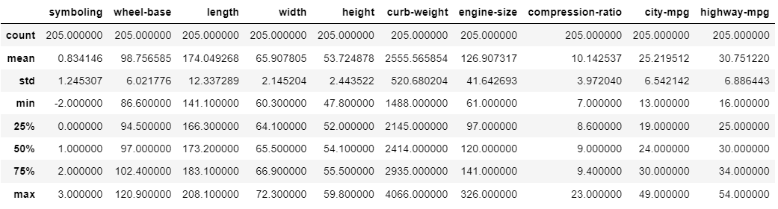
Summary of the cars data set:

DATA CLEANING
- No duplicates found:
No duplicate rows exist in the pandas dataframe.

Missing Data
- No null values were found:
The data was searched for any null cell values in the pandas dataframe however no such values were found.
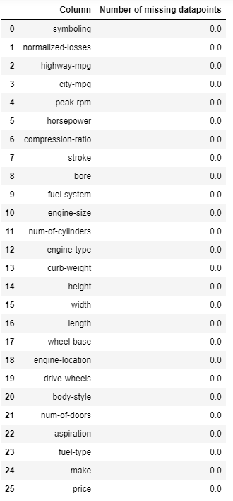

- Unconventional “?” patterns found across multiple columns
The investigation showed that several columns including normalized-losses,num-of-doors,bore, stroke, horsepower, peak-rpm and price contained ‘?’ values indicating that data was incomplete and instead of nulls the ‘?’ was a placeholder for missing information. To remediate this issue, mean imputation was used for all quantitative fields except num-of-doors as this is a dichotomous variable. By using mean imputation, we do not impact the distribution of the data in any way.

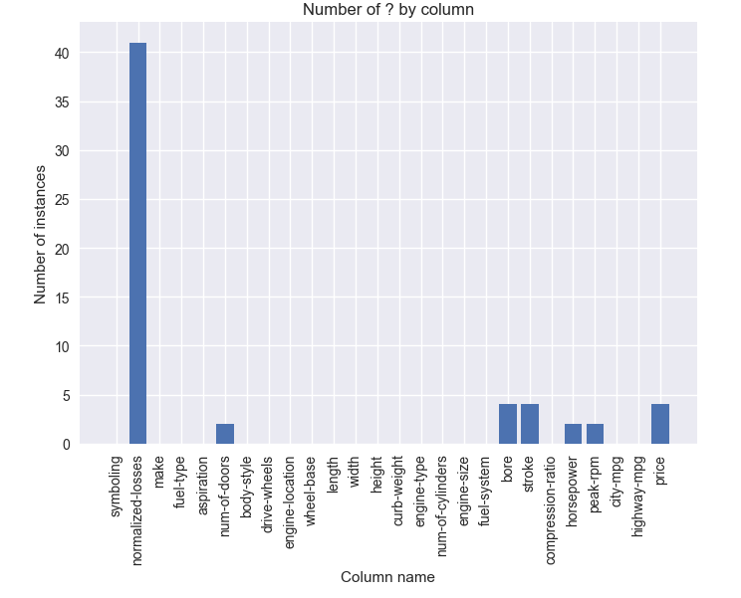

DATA STORIES AND VISUALISATIONS
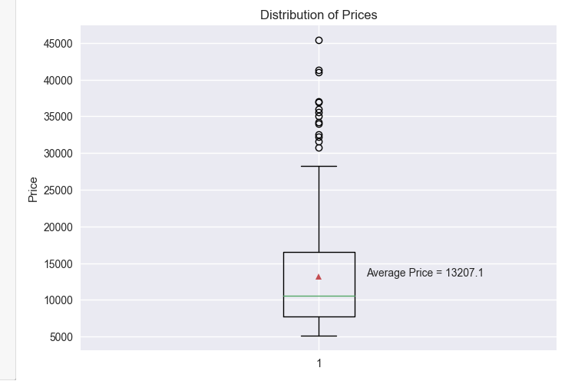
The boxplot shows the distribution of prices of cars in the dataset. We can see that distribution is skewed to the left as the average price ($13207) is greater than the median value. We can see that 50% of the prices are between 16000 and 6000. There are a significant number of prices that are greater than 1.5 * interquartile range indicating that these are outliers. The chart tells us that is there is a lot of variation in the data given the IQR and existence of several outliers.

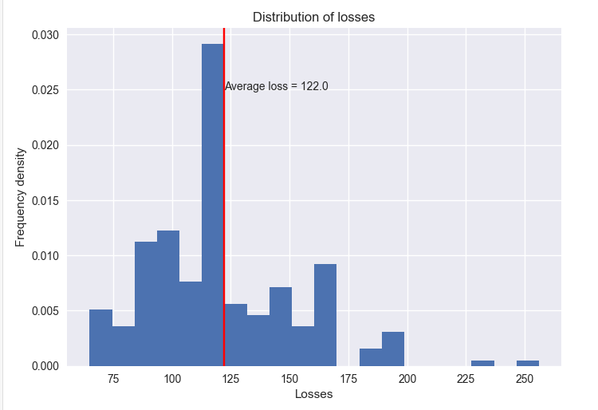

The histogram tells us about the distribution of losses. The distribution of losses resembles a normal distribution as the average loss is roughly around the median loss. There is considerable variation/spread in the loss data. The distribution has light tails indicating that kurtosis is high.

The below 2 charts display the distribution of miles per gallon used in the city compared to highway:
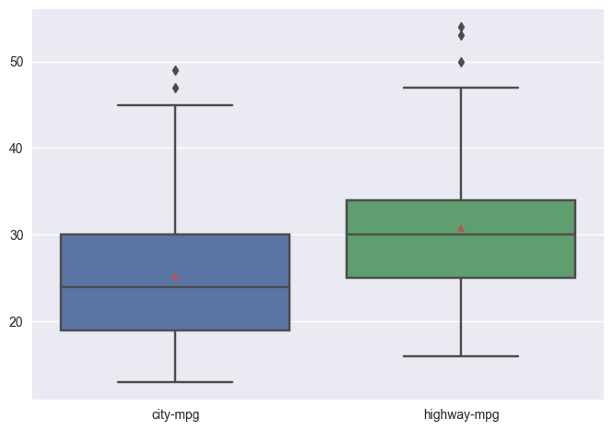
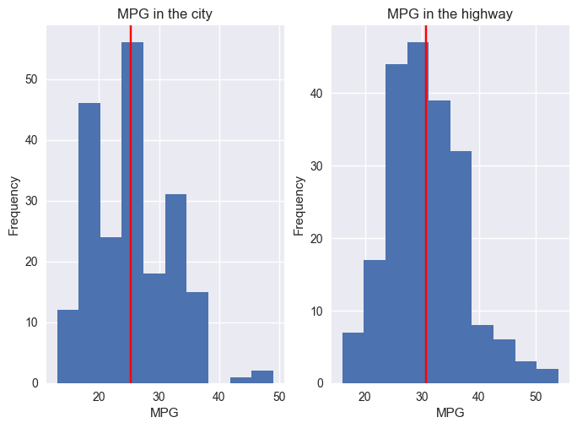

The distribution of mpg in the city displays an average value of 25mpg while the average miles per gallon in the highway is around 31 mpg. Both distributions have their means greater than their median values indicating both are skewed to the right. There is a lot more variation in the city mpg as the interquartile range is much large than the interquartile range of highway mpg. The highway mpg distribution is much more skewed to the right indicating that it is generally more fuel efficient to drive on highway roads than inner city roads. The obvious explanation would be the lack of slow-moving traffic in highways relative to cities. The distribution of mpg in the city has heavier tails than highway mpg indicating that the distribution is not very peaked which relates to its larger IQR.

The engine sizes have a left-skewed distribution even though mean is greater than the median size. There is some variation in the engine sizes with light tails.

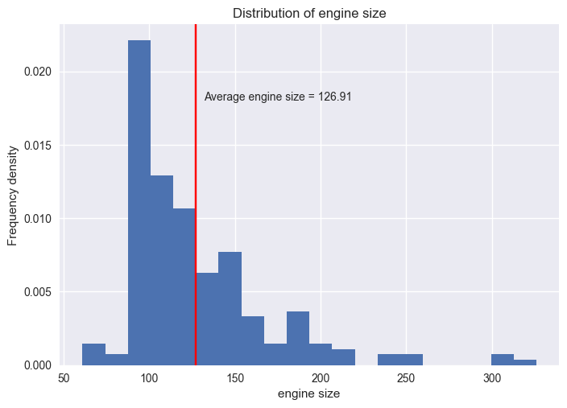

Relationships between variables:
Quality:
The boxplot shows horsepower data by manufacturer. We can see that most manufacturers produce engines with horsepower between 50 – 150 horsepower. Jaguar and Porsche seem to be the only manufacturers who produce cars with over 200 horsepower. The lowest horsepower interquartile ranges are from low end manufacturers such as Chevrolet, Mazda, Toyota and Volkswagen as they generally produce cars used by working/middle class households.
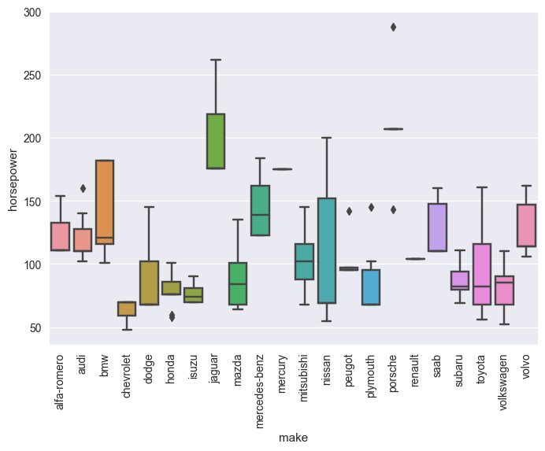

Market Analysis
- Price & Quantity:
The chart on the left shows the number of cars sold by each manufacturer. We can see that Toyota has sold the most cars followed by Nissan and Mazda. On the other hand, Renault, Mercury and Chevrolet have sold the least number of cars.
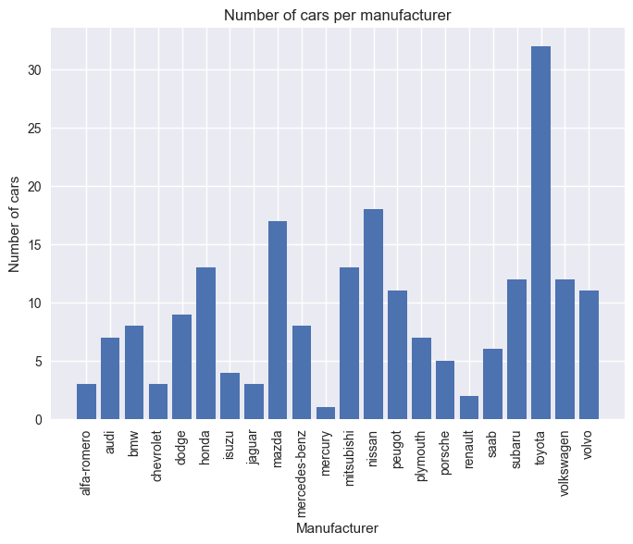
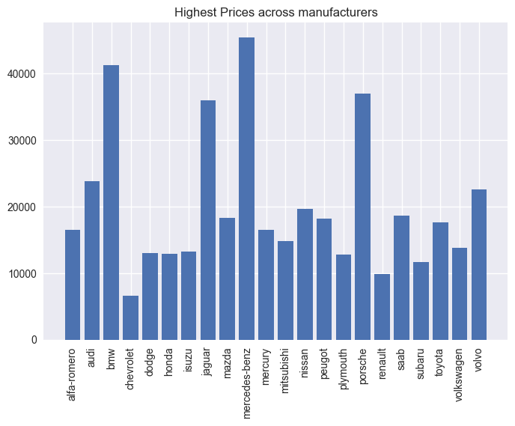
The chart on the right shows the highest price charged by each manufacturer for a particular car and Mercedez Benz has the highest price in the market and Chevrolet has the least.

Furthermore, if we look at the distribution of prices among manufacturers, we find that high end brands have the highest median and upper quartile of prices e.g. bmw, Porsche and Mercedez. Interestingly, bmw has the greatest spread among the high end brands. The low end brands tend to have smaller interquartile ranges meaning that the dispersion of prices is lower and prices are generally low. This is because low end brands follow a sales maximisation strategy while high end brands follow a profit maximisation strategy.
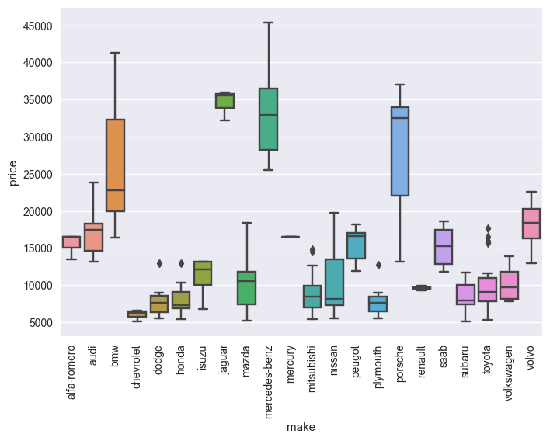

Market Share:

The pie chart shows the market share of companies within the car market. The company with the largest market share is toyota who follow a sales maximisation strategy (low prices, high quantities) followed by Mercedes-benz who have a profit maximisation strategy. Both strategies seem to be successful, however, it is likely that Toyota is successful due to the demand for cheap, reliable cars is higher than high end brands. This demand is driven by buyer’s incomes, expensive alternatives, and low opportunity cost of other transport systems.

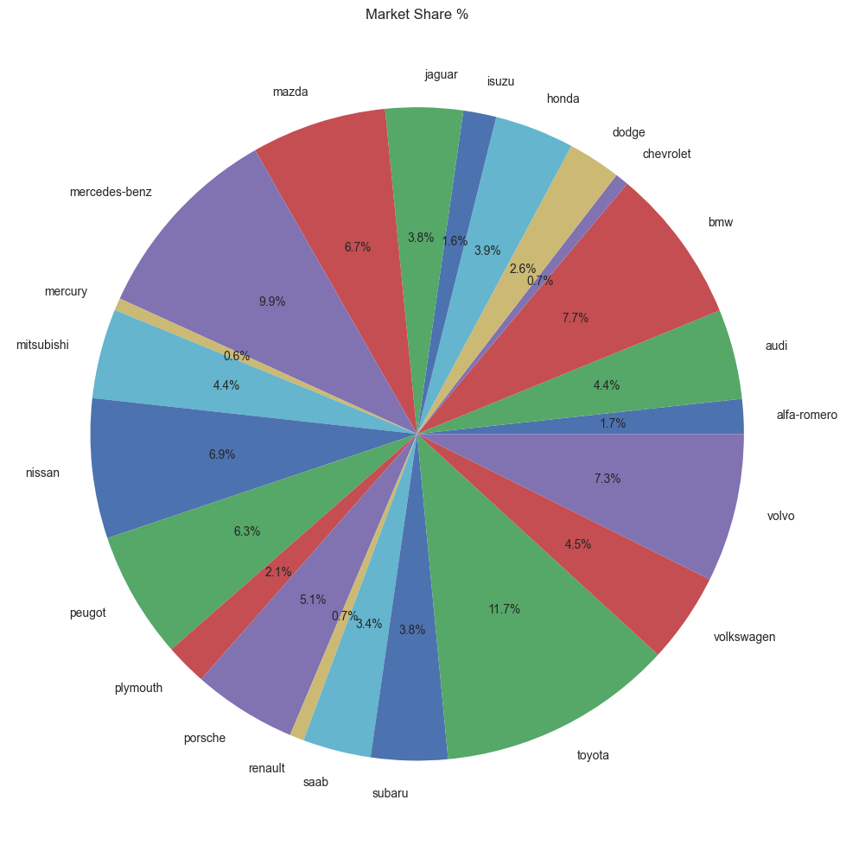

Econometric Analysis of Prices and its determinants:

The chart below shows the relationships between prices and all other fields present in the dataset. Generally all correlations except symbolling are strong. We see strong positive relationship between prices and car characteristics e.g. wheel-base, length, width, curb-weight, engine size, bore, and horsepower.

There is a strong negative relationship between mpg (city or highway) and prices. This means that the higher the prices, the less fuel efficient the car tends to be.
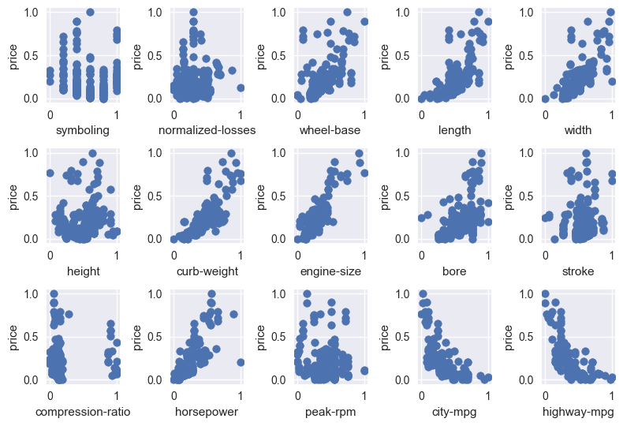

Q) Which variables play a statistically significant role in determining prices?
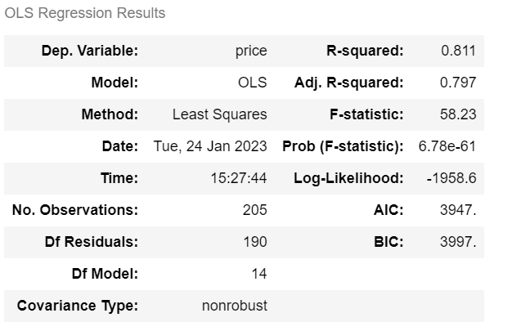
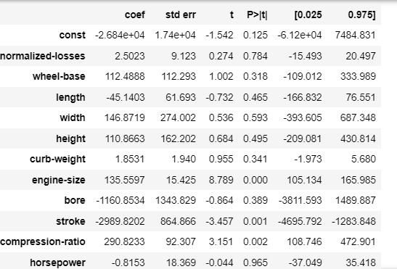
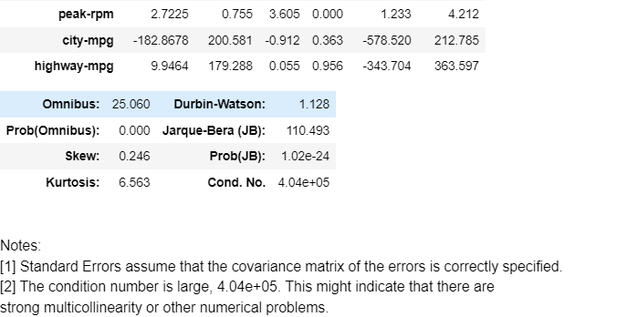

The regression model above is an ordinary least squared specification which aims to understand the predictive power of all the variables in the cars dataset in helping determine price. Notice that in this specification only engine size, compression ratio and stroke are statistically significant as there p-value is less than 5%. However, the warning below indicates that the regression formulation may be incorrect as there is high levels of multicollinearity. In other words explanatory variables may be linear combinations of one another e.g. length and weight.

We investigate the multicollinearity by assessing the variance inflation factor statistic which is calculated by regressing an explanatory variable against all other explanatory variables and calculating 1/(1-R^2). In general any VIF above 10 indicates high multi-collinearity which is the case for curb-weight,city-mpg, and highway-mpg.
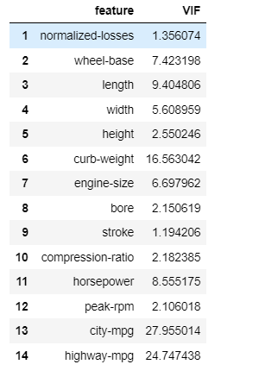

We can also assess the correlation matrix below and see that the following pairs may be subject to high multi-collinearity which impacts the statistical significance of outputs:

- Engine size and horsepower
- city mpg and highway mpg
- engine size and curb weight
- wheelbase and length
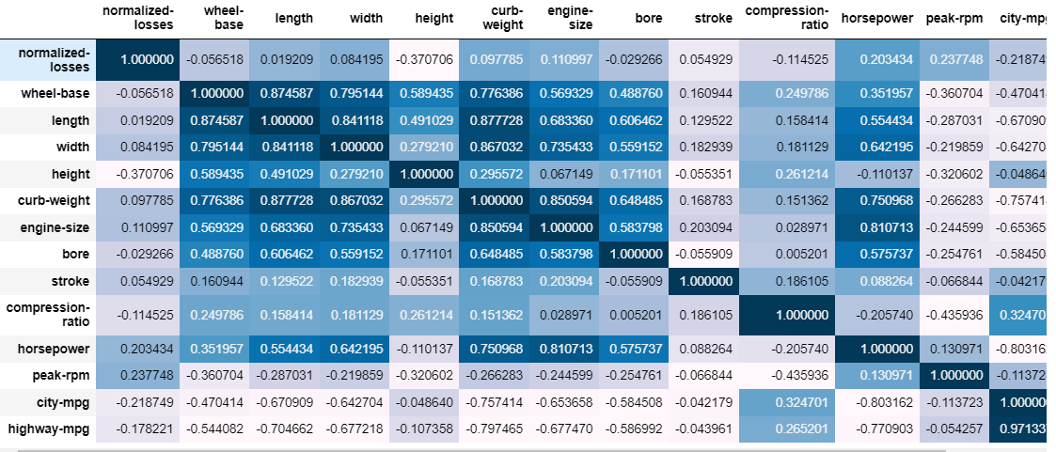

Model 2:
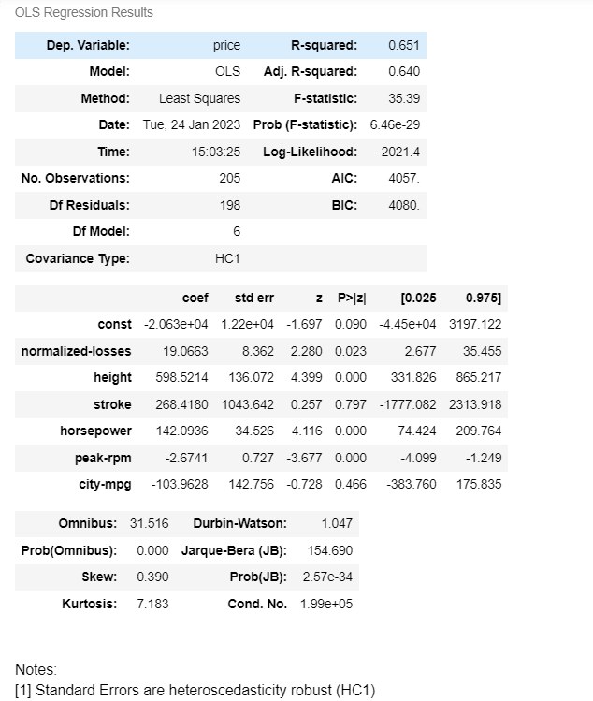
To remediate this issue, we will perform another regression but this time removing one of each of these pairs.

The regression analysis indicates that horsepower, rpm, height, and losses are statistically significant at the 10% level in explaining the variation in prices. Generally, a 1 unit increase in horsepower leads to $ 142 increase in price. Similar patterns can be seen with height and stroke as larger cars tend to be more expensive. Noticeably, a 1 unit decrease in mpg would increase the price by $103.96 which again indicates that more expensive cars have lower fuel efficiency as they focus more on power and speed as indicated by horsepower.

This analysis is still not fully complete as rpm has an unexpected impact on price and there is still multicollinearity present. Generally however, this model has much lower multicollinearity impacting it as can be seen by the matrix below.

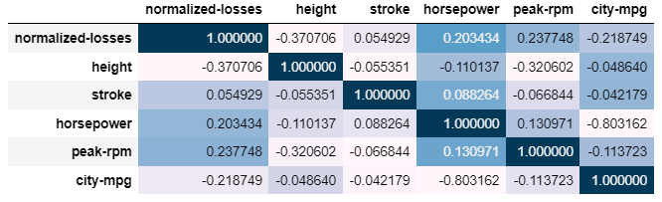

THIS REPORT WAS WRITTEN BY : ZAFAR HASSAN

