Artificial Intelligence for Fuel Design: A Review from Molecular Property Prediction to Explainable, Uncertainty-Aware Inverse Design and Fuel–Engine Integration
Authors: [to be completed]
Affiliations: [to be completed]
Corresponding author: [to be completed]
Target journal: Proceedings of the Combustion Institute

Abstract
Decarbonizing combustion-based transport requires fuels and engines to be designed together. Conventional fuel design is sequential, empirical and limited by the size of the chemical space, and linear structure–property models handle non-linear blends poorly. Machine learning (ML) now predicts fuel properties from molecular structure and generative models propose molecules and blends for target properties, yet existing reviews cover only parts of this chain. This review follows the complete chain: molecular representation, property prediction, generative inverse design, explainable AI (XAI), uncertainty quantification (UQ), and fuel–engine integration, with an explicit analysis of the limits at each stage. It identifies the failure modes that limit trust in AI-designed fuels: scarce and heterogeneous data, extrapolation beyond the training domain, predictor errors that generators exploit, and the near absence of experimental validation, illustrated by a high-octane candidate whose measured octane ratings fell below prediction. Its original contributions are a minimal validation protocol for AI-designed fuels, requirements for fuel–engine digital twins with propagated uncertainty, and a roadmap linking each limitation to a research direction: physics-informed and chemistry-aware models, multiscale integration, closed-loop autonomous discovery, and open data infrastructure. It closes with five recommendations for the community.
Keywords: Fuel design; Inverse molecular design; Machine learning; Explainable AI; Uncertainty quantification; Fuel–engine co-optimization

1. Introduction

1.1 Global energy context and decarbonization imperative
Global energy demand fell by 3.1% in 2020 because of COVID-19, then rebounded by 4.9% in 2021 and 2.1% in 2022. Both rises exceeded the previous decade’s average annual growth of 1.4%. Energy-related CO₂ emissions grew by 2.5% in 2022, down from 6% in 2021 but still more than double the decade average of 1%, and reached a record of more than 33.8 GtCO₂ (Fig. 1) [1]. Transport accounts for a large share of final energy use, and its demand is projected to grow by 1–1.5% per year through 2040 (Fig. 2) [2]. Nearly all transport (99.8%) relies on internal combustion engines (ICEs), and about 95% of it runs on petroleum-derived fuels. Despite progress in battery-electric and fuel-cell vehicles, ICEs are expected to dominate heavy-duty, marine and aviation applications for decades, because of energy-density requirements and fleet turnover [3,4].
Lowering the lifecycle carbon intensity of ICE systems can follow two routes. On the fuel side, renewable biofuels, electro-fuels (e-fuels) and carbon-free carriers such as H₂ and NH₃ replace fossil fuels. On the engine side, higher efficiency is obtained through fuel formulations matched to the engine. The two routes are coupled, so fuel–engine co-optimization is now the central question. Examples include the molecular design of fuels for maximum spark-ignition (SI) efficiency [5] and ML-driven screening of fuel additives [6].
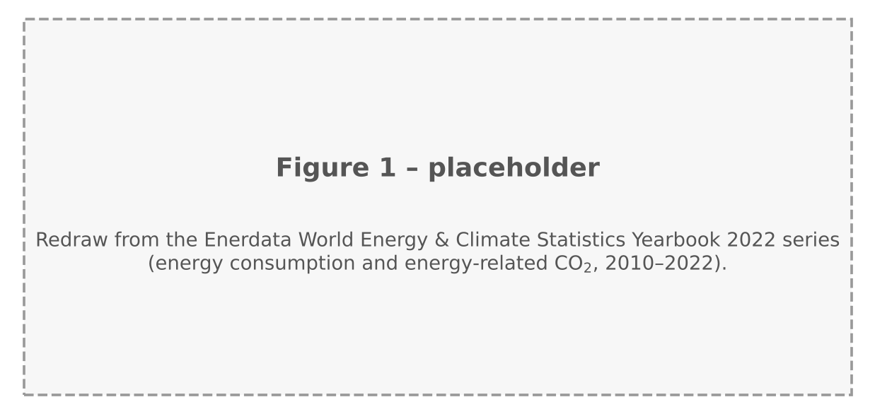
Fig. 1. Global energy consumption and energy-related CO₂ emissions, 2010–2022. Placeholder: to be redrawn from the Enerdata yearbook data cited in [1]; the underlying series were not part of the files provided.
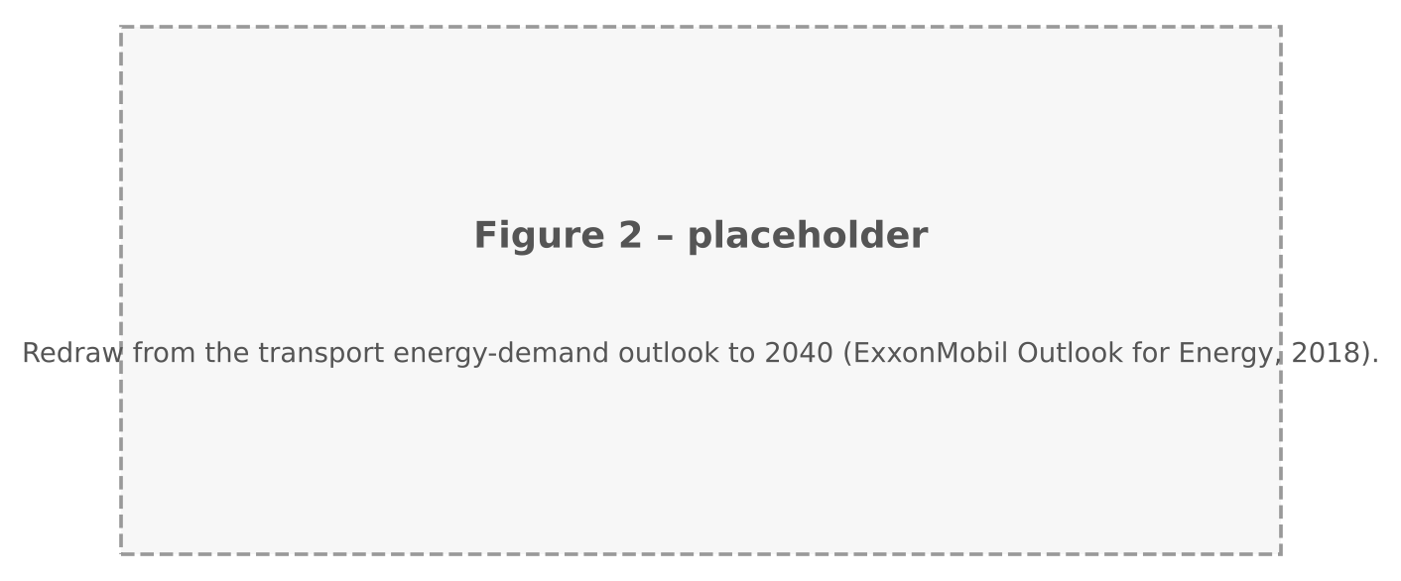
Fig. 2. Global transportation-related energy demand, 2000–2040. Placeholder: to be redrawn from the outlook data in [2].

1.2 From conventional to AI-driven fuel design: a paradigm shift
Conventional fuel design is an iterative loop (Fig. 3, left): (i) define the molecular structure or mixture; (ii) determine its physicochemical and combustion properties; (iii) relate these properties to engine performance, for example through a merit function; and (iv) refine the formulation under techno-economic and lifecycle constraints [4,7,8]. The functional-group chemistry behind these relations, for example the effect of oxygenated groups on low-temperature ignition and on trends in autoignition of biofuels, is well documented [9–11]. Structure–property relations are handled by group-contribution (GC) methods and linear quantitative structure–property relationship (QSPR) models, and detailed chemical kinetics supplies ignition delay time (IDT) and laminar burning velocity (LBV). The approach has well-documented limits: feedback is sequential and arrives only after expensive testing; development is largely trial and error; linear mixing rules fail for non-linear properties of blends; first-principles and kinetic modelling are costly and expert-dependent; and real fuels contain tens to hundreds of components, so the space of blends grows combinatorially [4].
Machine learning (ML) and deep learning offer three capabilities that address these limits (Fig. 3, right). First, fast property prediction, with speedups of three to more than five orders of magnitude over kinetic simulation reported for IDT and LBV (Section 2.3). Second, learned molecular representations that remove manual feature engineering. Third, generative models that enable inverse design, in which fuels are specified by target properties instead of being screened one at a time.
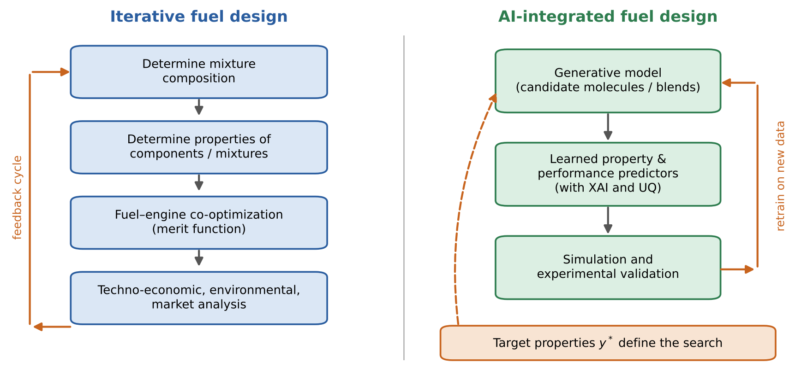
Fig. 3. Conventional (iterative) and AI-integrated fuel design loops. In the AI loop, a learned property predictor and a generative model replace the sequential evaluation steps, and experimental data feed back into the models. Schematic redrawn after the conceptual figure of [4].
Two recent reviews frame the field. Üstün et al. [12] gave the most exhaustive survey of forward prediction, covering more than 135 studies of eight ignition and flame properties (LBV, IDT, heat release rate (HRR), minimum ignition energy (MIE), flammability limits (FL), flash point (FP), yield sooting index (YSI) and cetane/octane numbers (CN/ON)). Their QSPR versus non-QSPR taxonomy and their comparison of algorithms, datasets and metrics are the reference for property prediction. Sarathy and Eraqi [4] set the prospective agenda: descriptor-based QSPR cannot support inverse design, differentiable molecular representations (graph neural networks (GNN), variational autoencoders (VAE), generative adversarial networks (GAN)) are needed, and UQ must accompany AI-driven design. Other recent reviews are narrower: data-driven combustion methods [13], hybrid CFD–ML approaches [14], ML-assisted molecule design [15] and artificial neural networks for alternative fuels [16].

1.3 Scope and contributions of this review
Existing reviews cover forward property prediction [12] or set a prospective agenda [4], but, to our knowledge, none follows the full chain from molecular representation to fuel–engine integration with an explicit analysis of the limits of each stage. This review fills that gap and makes three original contributions: a minimal validation protocol for AI-designed fuels (Box 1), requirements for fuel–engine digital twins with propagated uncertainty (Box 2), and a roadmap that links each limitation to a research direction (Fig. 12). Section 1.4 sets out the limitations that structure the review.

1.4 Limitations of conventional and AI-driven approaches
Conventional approaches (Section 1.2). (i) Feedback is sequential and the process is trial and error. (ii) GC and linear QSPR models handle non-linear mixtures poorly. (iii) First-principles and kinetic modelling need expertise and computing resources. (iv) Real fuels have too many components for exhaustive iteration.
AI-driven approaches. (i) Hand-crafted descriptors scale poorly to large compound libraries, and fixed fingerprints may lose structural information. (ii) Most studies screen isolated properties, while engine performance depends on their combined effects. (iii) High-accuracy models are opaque, and the interpretability–accuracy trade-off is unresolved. (iv) Datasets are small and noisy. (v) Few AI-designed fuels have been tested experimentally. (vi) Fuel–engine integration is largely missing: properties are intermediate quantities, and few studies carry predictions and their uncertainty through to combustion behaviour and engine performance.
These limits motivate the structure of this review. Representation and prediction (Section 2) examine (i) and (iv). Generation and validation (Section 3) examine (ii) and (v). XAI and UQ (Section 4) examine (iii) and extend to the reliability of designed fuels. Section 5 turns the combined gaps, including the integration gap (vi), into a research agenda, with 5.1–5.4 each tied to named limitations, and Section 6 draws the conclusions and closes with a call to action.

2. Molecular representation and property prediction: from QSPR to deep learning
Every AI-driven fuel design workflow starts by turning a molecule into a numerical object. The choice of representation sets the data requirements, the accuracy, the interpretability, and whether the model can later be inverted for design (Section 3). This section follows the progression from descriptors to learned representations (Section 2.1), then reviews prediction of physicochemical properties (Section 2.2) and combustion-specific properties (Section 2.3). All limitations are consolidated in Section 2.4.

2.1 Molecular descriptors and representation learning
Descriptors. Fuel molecules can be encoded at five levels of information content [4,12]: 0D (formula, molecular weight), 1D (counts of fragments or functional groups), 2D (atom and bond connectivity, topological indices), 3D (geometry, distances and angles) and 4D (conformational flexibility, dynamic and electronic information) (Fig. 5). An ideal descriptor correlates with the target, captures the essential structure, discriminates isomers, is cheap to compute and does not rely on experimental data. No universal descriptor satisfies all of these, so the choice is property-specific. The earliest QSPR work used group contributions and neural networks on calculated descriptors, for example for boiling points of alcohols [17], heat of combustion [18] and the laminar burning velocity of biofuels [19]. A group-based example for ignition is the functional-group descriptor for ignition propensity of large hydrocarbons [20]. Later work coupled GC with ML regression for cetane and octane numbers [21]. Descriptor selection has become a research topic of its own: systematic selection [22], sequential forward selection with topological indices [23] and molecular-dynamics-derived descriptors [24] all report improvements over fixed descriptor sets.

Fig. 5. Information content of molecular descriptors from 0D to 4D, with typical examples and computational cost.
String-based representations. The simplified molecular-input line-entry system (SMILES) [25] is compact and easy to generate. It is the standard input to sequence generators (Section 3.1) and has been used directly for heat-of-combustion prediction [26]. Its weaknesses are that one molecule can have many valid strings and that small string edits can produce invalid molecules. The InChI identifier gives a canonical alternative, and InChIKey embeddings have been used for multimodal prediction of combustion properties [27]. Extended-connectivity fingerprints (ECFP) [28] are fixed-length hashed substructure vectors. They are easy to generate, but hash collisions make them non-invertible, which limits their use in inverse design. Conjoint fingerprints, which combine several fingerprint types, have been used for tailor-made fuel design [29].
Graph-based representations. A molecule is a graph $G=\left(V,E\right)$ with atom features $x_{v}$ and bond features $e_{vw}$. Message-passing neural networks (MPNN) [30] update each atom state from its neighbours and then pool to a molecular vector:
mvt+1=w∈Nv​Mt​hvt,hwt,evw, hvt+1=Ut​hvt,mvt+1 1
$$\hat{y}=R​\left(\{h_{v}^{T}∣v∈V\}\right) \left(2\right)$$
Here $M_{t}$ is the message function, $U_{t}$ the node update, $T$ the number of message-passing steps and $R$ a permutation-invariant readout such as a sum or an attention-weighted sum (Fig. 6). Graph networks avoid hand-crafted features and learn the structure–property map end to end. Schweidtmann et al. [31] showed their value for fuel ignition quality, and a systematic comparison of learned representations [32] underpins many fuel applications. Variants include a directed MPNN with graph edge attention for biofuel-relevant species [33], graph machine learning for high-octane fuels coupled to design [34], a multi-level GNN with built-in explanation (“Chemomile”) [35] and a learned-graph transformer for diverse physicochemical properties (“LG-Transformer”) [36].
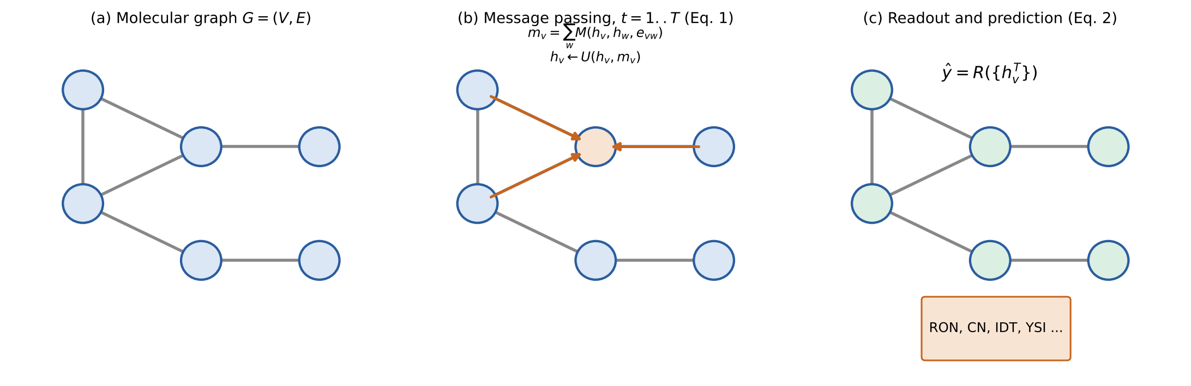
Fig. 6. Message passing on a molecular graph (Eqs. 1–2): atom states are updated from neighbours over $T$ steps, then pooled by a permutation-invariant readout into a property prediction.
Learned (pre-trained) representations. Mol2Vec learns substructure embeddings similar to Word2Vec [37], and the Seq2seq fingerprint learns an unsupervised embedding from SMILES [38]. Both exploit large unlabelled corpora, which helps where labelled fuel data are scarce [12].
Physics-informed representations. Physical knowledge can be built into the model. Kim et al. [39] designed a physics-informed GNN for cetane number and added a systematic data-quality analysis. Babaei et al. [40] combined group contribution methods with physics-informed neural networks. COSMO-RS-derived quantities have been used for high-energy-density fuels [41]. Such models extrapolate more plausibly outside the training set and are the bridge to the physics-informed learning discussed in Section 5.1.
Table 2. Comparison of molecular representations used for fuel property prediction.
Representation | Information content | Invertible for generation | Data needs | Interpretability | Typical fuel use
0D–1D descriptors, GC | Formula, group counts | Partly (groups) | Low | High | Ignition propensity [20]; CN/ON with ML regression [21]
2D topological indices | Connectivity | No | Low–medium | Medium | Property prediction with feature selection [22,23]
ECFP, conjoint fingerprints | Hashed substructures | No (collisions) | Medium | Medium | Tailor-made fuel design [29]
SMILES, InChI strings | Full 2D structure as text | Yes (SMILES) | Medium–high | Low | Heat of combustion [26]; multimodal IDT, CN/ON [27]
Molecular graph (MPNN, D-MPNN) | Atoms, bonds, learned features | Yes (graph decoders) | Medium–high | Low (post-hoc XAI) | Ignition quality [31]; biofuels [33]; high-octane design [34]
Learned embeddings (Mol2Vec, Seq2seq) | Pre-trained substructure or sequence features | Partly | Low (after pre-training) | Low | General molecular property tasks [37,38]
Physics-informed GNN, PINN-GC | Graph plus physical constraints | Partly | Lower | Medium | Cetane number [39]; GC-constrained models [40]
Transformer, learned graph | Learned graph plus attention | Partly | High | Low | Multi-property prediction [36]

2.2 Physicochemical property prediction: advances for pure compounds and mixtures
Pure compounds. A large body of work covers the properties that feed merit functions and fuel specifications. For heat of combustion and formation, early QSPR relied on electrotopological state indices [42], while recent models use SMILES directly [26] or interpretable algorithms; Maraschin et al. [43] combined SHAP with ML and identified C–H and aromatic C–C contributions (Section 4.1). Melting point and net heat of combustion were also modelled early with ML [44]. For density, viscosity and surface tension, probabilistic models for jet-fuel density [45] were followed by AI-based models for liquid hydrocarbons [46] and ML frameworks for biodiesel–alcohol blends [47]; Shao et al. [48] predicted critical jet-fuel properties with multiple ML models. A probabilistic mean QSPR (M-QSPR) model with Monte Carlo dropout, trained on 1,866 molecules to create pseudo-structures for 82 conventional and 50 synthetic jet fuels, predicted density with a mean absolute error (MAE) of about 2–6 kg/m³, flash point with an MAE of 3.46–3.49 K for conventional fuels (6.22–7.95 K for synthetic fuels), surface tension with 0.36–0.62 mN/m and heat of combustion with 0.09–0.12 MJ/kg, as reported in [12] for the model of [49]. Comparisons of ML algorithms against state-of-the-art physical models for fuel property prediction predate these studies [50]. Multi-property frameworks that cover several fuel types with one pipeline [51] and the LG-Transformer [36] point toward unified property predictors.
Mixtures. Predicting blend properties is harder because mixing is non-linear. Three strategies have emerged. First, mixture-aware ensembles: automated SuperLearner-type stacking was applied to density, vapour pressure, distillation curve and octane numbers of gasoline fuels [52]. Second, pooled GNNs: Leenhouts et al. [53] pooled component-level graph embeddings, weighted by composition, before the readout, so the model handles variable-size mixtures and can learn non-linear mixing. Third, surrogate-based approaches, in which a small surrogate mixture matches the target properties, for example n-component jet surrogates [54] and optimal molecule sets for aviation fuels [55], or GC×GC compositional data combined with SISSO [56].
Table 3a. Physicochemical property prediction: representative models and reported accuracy.
Property | Algorithm | Representation | Dataset | Reported metric | Ref.
Density, FP, surface tension, heat of combustion (jet fuels) | M-QSPR, MC-dropout NN | 2D pseudo-structures from GC×GC | 1,866 molecules; 82 conventional + 50 synthetic fuels | Density MAE ~2–6 kg/m³; FP MAE 3.46–3.49 K (conv.), 6.22–7.95 K (synth.); surface tension 0.36–0.62 mN/m; heat of combustion 0.09–0.12 MJ/kg | [12,49]
Density (jet fuels) | Probabilistic ML | Descriptors | [to verify] | [to verify] | [45]
Heat of combustion, formation | Interpretable ML with SHAP | Descriptors | [to verify] | [to verify] | [43]
Heat of combustion | ML from text | SMILES | [to verify] | [to verify] | [26]
Liquid hydrocarbon properties | AI regression | Descriptors | [to verify] | [to verify] | [46]
Density of biodiesel–alcohol blends | ML ensembles | Composition, T | [to verify] | [to verify] | [47]
Critical jet-fuel properties | Multiple ML models | [to verify] | [to verify] | [to verify] | [48]
Gasoline density, vapour pressure, distillation, octane numbers | SuperLearner (stacked ML) | Composition | [to verify] | [to verify] | [52]
Properties of fuel mixtures | Pooled GNN | Molecular graphs, composition-weighted pooling | [to verify] | [to verify] | [53]
Jet-fuel properties from GC×GC | SISSO (symbolic regression) | GC×GC composition | [to verify] | [to verify] | [56]

2.3 Combustion-specific property prediction
Yield sooting index (YSI). Sooting tendency has itself become a design target for sustainable fuels [57]. Models build on the Yale YSI database of more than 400 compounds [58]. St. John et al. used an ensemble of neural networks on 297 compounds (median absolute error of about 3 YSI units, R² = 0.9786), Abdul Jameel et al. an ANN on 265 pure compounds (R² = 0.99), and Gao et al. 255 oxygenated compounds (R² = 0.9872), as reviewed in [12]. Recent work examines how the choice of descriptors affects accuracy [59] and adds conformal prediction for calibrated intervals [60] (Section 4.2).
Ignition delay time (IDT) and laminar burning velocity (LBV). For IDT, ML models cover jet fuels at high temperature [61], and multimodal models use InChIKey embeddings with state variables [27]. Examples reviewed in [12] include an ANN for natural-gas blends trained on 1,624 points (900–2250 K, 0.5–60 bar, equivalence ratio 0.5–2) and a transfer-learning GCN that reaches R² > 0.99 by pre-training on small hydrocarbons and fine-tuning on larger ones. For LBV, models include GC-style approaches that explain the fuel-structure dependence [62], low-carbon fuels [63], ammonia/hydrogen/air mixtures, where GPR and ANN were most accurate [64], ammonia–oxygenated blends [65] and structure–thermophysical networks for oxygenates [66]. Speedups relative to kinetic simulation are large: about 1.5×10³ for a BPNN optimized by PSO and GA, about 2×10⁵ for a DNN on C₁–C₇ hydrocarbon–oxygen–argon IDTs, 9.5×10³–2.7×10⁴ for ammonia/hydrogen/air LBV and about 1.2×10⁴ for battery-vent-gas LBV, as reported in [12].
Cetane and octane numbers (CN/ON). This is the best-covered property family. ANN and neuro-fuzzy models [67–70], GC-based ML [21], GNNs [31,34,39] and descriptor-based models [23,71] all reach high accuracy. Reviewed examples include an ANN on 281 diverse fuels and blends with R² = 0.99 and MAE = 1.2, a multimodal QSPR–ANN model with R² = 0.99 and MAE = 1.35 for RON (382–630 samples per property), and an MLP for 110 synthetic fuels with R² = 0.921 combined with SHAP [12,27,71]. ANN models for the ignition quality of oxygenated fuels were also built on measured data [72]. As Section 2.4(iii) explains, such numbers mostly describe random splits and are not evidence of extrapolation.
Flash point, flammability limits and minimum ignition energy. For FP, GC combined with ANN reached R² = 0.98 on 1,378 pure components, and hybrid GCM-ANN-PSO models reached R² = 0.988 (MAE 6.2 K) on 505 organic compounds [12]. For FL, an SVM trained on 1,038 compounds reached R² = 0.979 for the lower flammability limit, gradient boosting reached R² of about 0.99, and a multitask DNN on DIPPR801 data gave R² of 0.94, 0.68, 0.88 and 0.53 for FP, autoignition temperature, LFL and UFL, respectively [12]. MIE is data-limited: the usual data sets hold 61–98 organic compounds, with R² of 0.80–0.88 for SVR and MLR models and about 98% accuracy for a MPNN in a binary classification at 30 mJ [12,73]. HRR models are mostly non-QSPR: physics-informed networks with embedded kinetic transformations, DNNs and LightGBM (R² = 0.992 on 12,060 samples) have been used [12].
Coupled and application-driven models. ML-QSPR models have been coupled with chemical kinetics for high-throughput fuel screening for ICEs [74] and used to accelerate the design of high-energy-density hydrocarbon fuels [75]. These applications already combine prediction with search, which anticipates Section 3.
Table 3b. Combustion-property prediction: representative models and reported accuracy. Values are taken from the review [12] unless another reference is given; the split type is not reported there for most entries.
Property | Algorithm | Representation | Dataset size | Split type | Reported metric | Ref.
YSI | Ensemble of NNs | Descriptors | 297 compounds | not specified in [12] | R² = 0.9786; median abs. error ~3 YSI units | [12]
YSI | ANN | Functional groups | 265 pure compounds | not specified in [12] | R² = 0.99 | [12]
YSI | ML with conformal prediction | Descriptors | [to verify] | [to verify] | [to verify] | [60]
IDT | ANN | T, P, composition | 1,624 points (natural-gas blends) | not specified in [12] | validity over 900–2250 K, 0.5–60 bar | [12]
IDT | ANN, GCN with transfer learning | Cantera-simulated data, graph | C1–C4 hydrocarbons | not specified in [12] | R² > 0.99 | [12]
IDT | Multimodal ANN | QSPR + InChIKey embeddings | [to verify] | [to verify] | [to verify] | [27]
LBV | GA-optimized ANN | T, P, φ | isooctane/air | not specified in [12] | R² = 0.991 | [12]
LBV | GPR, ANN | Mixture composition | NH₃/H₂/air | [to verify] | GPR, ANN best; speedup 9.5×10³–2.7×10⁴ | [64]
LBV | GPR (Matern 5/2) | Mixture composition | 75,000 points from 1D simulations | not specified in [12] | speedup ~1.2×10⁴ | [12]
CN/RON | ANN | NMR-derived groups, branching index | 281 fuels and blends | not specified in [12] | R² = 0.99; MAE = 1.2 | [12]
RON/MON/YSI | Gaussian DropConnect, BNN | Descriptors | 1,159 samples | not specified in [12] | RON MAE 3.0–3.4, MON MAE 2.5–2.6 | [12,76]
RON | Multimodal QSPR–ANN | QSPR + text embeddings | 382–630 per property | not specified in [12] | R² = 0.99; MAE = 1.35 | [12,27]
CN | MLP with SHAP | Descriptors | 110 synthetic fuels | not specified in [12] | R² = 0.921 | [12,71]
FP | ANN-GCM | Group contribution | 1,378 pure components | not specified in [12] | R² = 0.98 | [12]
FP | GCM + ANN + PSO | Group contribution | 505 organic compounds | not specified in [12] | R² = 0.988; MAE 6.2 K | [12]
FL (LFL) | SVM | Descriptors | 1,038 compounds | not specified in [12] | R² = 0.979 | [12]
FL (LFL/UFL) | GCM-ANN-PSO | Group contribution | 328 train, 90 test | held-out | avg. abs. rel. deviation 8.6% (LFL), 7.1% (UFL) | [12]
FP, AIT, LFL, UFL | Multitask DNN | Tree-LSTM on molecular structure | DIPPR801 | not specified in [12] | R² = 0.94, 0.68, 0.88, 0.53 | [12]
MIE | SVM, MLR | DFT/AM1 descriptors | 61 compounds (Calcote data) | 80/20 | R² = 0.835–0.861 | [12,73]
MIE | MPNN | SMILES | 98 compounds (GESTIS-DUST-EX) | not specified in [12] | 98% accuracy (binary, 30 mJ) | [12]
HRR | LightGBM | Thermocouple signals | 12,060 samples | not specified in [12] | R² = 0.992 | [12]
HRR | PINN | T, species, kinetic terms | NH₃/H₂/air flames | not specified in [12] | high accuracy across φ | [12]
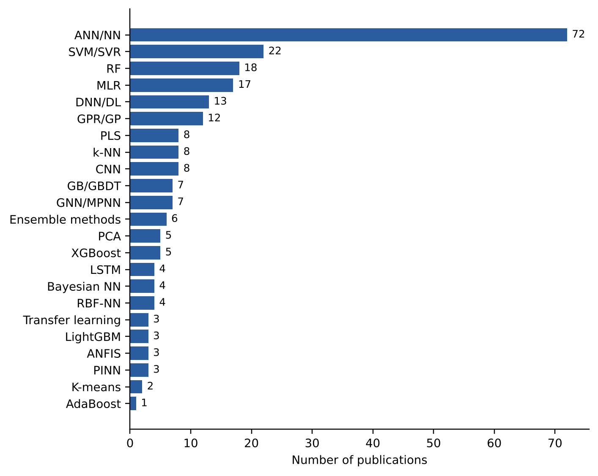
Fig. 7. Number of studies per ML algorithm for predicting ignition and flame properties (all eight properties combined). Data redrawn from Fig. 6 of [12] (open access, CC-BY 4.0).

2.4 Limitations in molecular representation and property prediction
(i) Data scarcity. Many QSPR models are trained on fewer than 1,000 samples, and for properties such as MIE the data sets hold only tens of molecules (61–98 compounds), which limits deep architectures [12]. Transfer learning, delta learning and pre-training (Section 5.1) mitigate this but do not remove it.
(ii) Heterogeneity, noise and bias. Measured values vary between laboratories and methods. Unstretched LBV data for CH₄/air differ by more than 10% between laboratories and methods, and CN data for identical compounds vary within and across techniques [12]. Metadata such as temperature, pressure, equivalence ratio and measurement method are often missing. Kim et al. [39] showed that data-quality screening changes model conclusions. Data sets are also biased toward hydrocarbons and a few oxygenate families.
(iii) Out-of-distribution extrapolation. Most models are validated with random splits. Fuel design needs extrapolation to new functional groups, larger molecules or novel blends, and random splits overestimate it. Üstün et al. [12] note that performance degrades when models extrapolate to conditions different from the training data. This weakness is central for Section 3, because generative models explore exactly the regions where predictors are least reliable.
(iv) Accuracy–interpretability trade-off. GNNs and transformers give the best accuracy but are opaque. Simple QSPR is transparent but cannot handle non-linear structure–property relations or mixtures. Interpretable alternatives such as SISSO [56] and XAI-augmented GNNs [35] exist but are not yet routine (Section 4.3).
(v) Benchmarking. R² values from different studies are not comparable, because data sets, splits, metrics and property definitions differ. There is no shared benchmark for fuel properties equivalent to those in drug discovery, and code and splits are rarely released.
Synthesis. These limits motivate Section 3, where differentiable representations enable inverse design while reproducing and amplifying predictor errors, and Section 4, where XAI and UQ address interpretability and reliability.

3. Molecular generation and inverse design: bridging properties to structures
Section 2 treated the forward problem, structure → property. Fuel design asks the reverse: which molecule or blend has the properties, or the engine performance, we want? This section reviews generative models for molecules (Section 3.1) and mixtures (Section 3.2), then the validation problems that decide whether generated candidates are credible (Section 3.3). Limitations are consolidated in Section 3.4.

3.1 Generative models for fuel molecule design
From generate-and-test to inverse design. In generate-and-test computer-aided molecular design (CAMD), candidates are built by rules and then screened by a predictor. Examples are rule-based biofuel generators [77], transformation-rule evolution for gasoline molecules with QSPR scoring [78] and structure generation coupled to thermodynamic predictors [5]. The search space is limited by the rules, and every candidate must be enumerated. Inverse design instead learns a map from target properties $y^{*}$ back to structures:
$$x^{*}=arg\min_{x∈X} ∥f_{θ}\left(x\right)-y^{*}∥ \text{s.t. }x \text{valid, synthesizable, safe} \left(3\right)$$
where $f_{θ}$ is the learned property predictor of Section 2 and $X$ is the chemical space. Generative models make this search tractable by turning the discrete space into a continuous or sequential one (Figs. 8 and 9).
Fuel design differs from drug discovery in ways that shape the choice of model. The chemical space of interest is usually small and dominated by C, H and O, so validity constraints are simpler. Labelled data are scarcer, and many target properties (RON, IDT, LBV) are themselves outputs of models or of costly experiments. The objective is typically defined for a mixture operating in an engine, not for a single molecule. Deep-learning and knowledge-based CAMD methods have been reviewed from a unified perspective [79], and deep learning has been proposed to catalyze inverse molecular design more broadly [80]. Integrated design of biofuels together with their production pathways [81] shows that the objective can also include production, a dimension that most current generators omit.
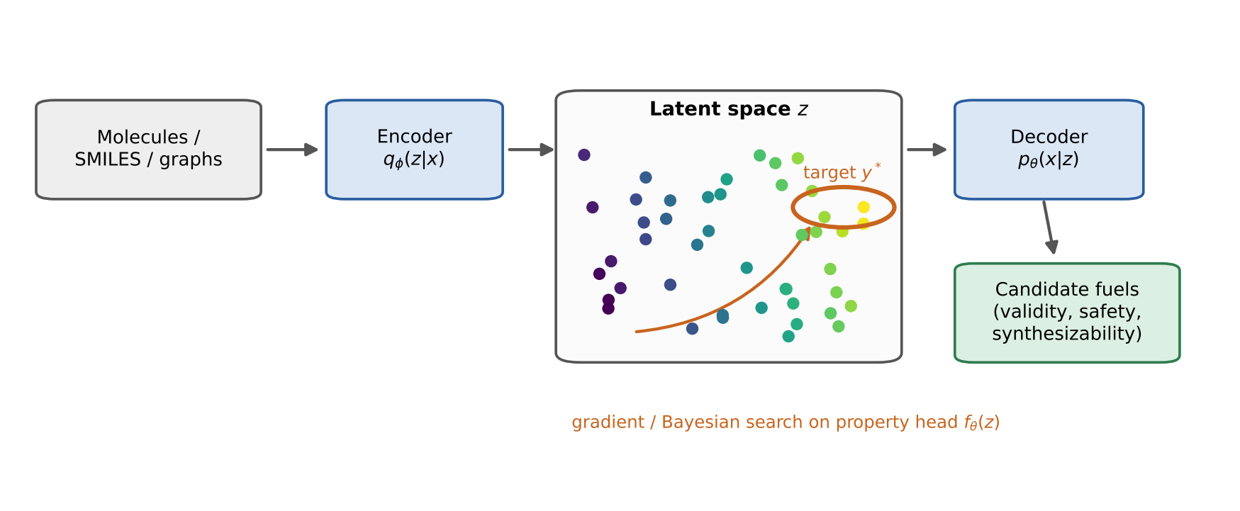
Fig. 8. Inverse design in a latent space: an encoder maps molecules to a continuous latent space organized by a property head; optimization moves toward the target region and a decoder returns candidate structures. Schematic after [4,82].
Variational autoencoders (VAE). A VAE [83] learns an encoder $q_{ϕ}\left(z∣x\right)$ and a decoder $p_{θ}\left(x∣z\right)$ by maximizing the evidence lower bound:
$$L_{ELBO}=E_{q_{ϕ}\left(z∣x\right)}​\left[logp_{θ}\left(x∣z\right)\right]-β D_{KL}​\left(q_{ϕ}\left(z∣x\right) ‖ p\left(z\right)\right) \left(4\right)$$
The latent space is continuous, so gradient-based or Bayesian optimization can navigate it, an idea that originates in automatic chemical design [82]. For fuels, graph-based VAEs with a property head were used for high-octane design [34], and latent-space generative models were used for hydrocarbon fuels and for mixtures [84]. Liu et al. [85] used ensemble learning for classification and regression of hydrocarbon fuels. The latent space is organized by the property head, which is the key to inversion. In practice the weight $β$ trades reconstruction quality against the smoothness of the latent space: a larger $β$ gives a more regular space in which interpolation yields valid structures, at the cost of blurrier reconstructions. The property head is trained jointly, so that nearby latent points have similar properties, and this is what lets gradient-based or Bayesian optimization move toward $y^{*}$. Graph decoders make valence constraints easier to enforce than string decoders, which can emit invalid SMILES (Section 2.1).
Generative adversarial networks (GAN). A generator $G$ maps noise $z$ to molecules, and a discriminator $D$ separates real from generated samples [86]:
$$\min_{G}\max_{D} E_{x∼p_{data}}​\left[logD\left(x\right)\right]+E_{z∼p\left(z\right)}​\left[log​\left(1-D\left(G\left(z\right)\right)\right)\right] \left(5\right)$$
Conditioning on target properties gives property-oriented generation. Liu et al. [87] used a conditional information-maximizing GAN (c-infoGAN) for reverse design of hydrocarbon fuels, where the information term keeps latent codes tied to properties. GANs are prone to mode collapse and unstable training, which matters for small fuel data sets.
Recurrent and sequence models. An LSTM generates SMILES token by token. Anufriev et al. [88] used one to generate novel high-knock-resistance fuels. Sequence models are simple and fast, but nothing guarantees chemical validity, and they inherit the SMILES ambiguities noted in Section 2.1.
Reinforcement learning (RL). An agent builds a molecule step by step and receives a reward that encodes property targets and constraints [89,90]. RL makes multi-property rewards easy to include, but it will exploit weaknesses in the reward predictor (Section 3.4).
Hybrid approaches. Combinations are now common: genetic algorithms augmented with ML surrogates [91], GNN-augmented optimization-based CAMD [92], generative deep-learning frameworks for fuels [93], an AI-based fuel designer tool for e-fuels [94] and de novo design of sustainable aviation fuels (SAF) [95].
These hybrid designs address two weaknesses of purely generative models. A genetic algorithm explores structure space with explicit mutation and crossover rules, and the ML surrogate replaces most of the expensive evaluations [91]. Optimization-based CAMD enforces constraints exactly, and a GNN replaces the hand-built predictor inside the optimization [92]. They trade some of the novelty of free generation for control and sample efficiency, which is often the right trade when labels are scarce.
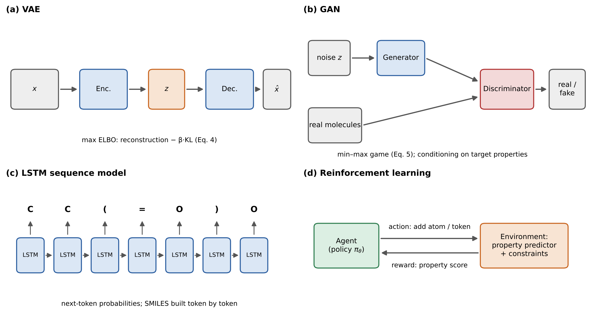
Fig. 9. The four generative families used in fuel design: (a) VAE, (b) GAN, (c) LSTM sequence model and (d) reinforcement learning with a property-based reward.
Table 4. Generative approaches for fuel design.
Family | Objective | Strengths | Weaknesses | Fuel examples
Rule-based generate-and-test | Enumerate candidates by transformation rules, score with QSPR | Interpretable; valid by construction | Limited by rules; enumerative | [5,77,78]
VAE | Learn a continuous latent space; optimize in it | Smooth latent space; gradient-based search; property head | Validity of decoded structures; posterior collapse | [34,82,84]
GAN (c-infoGAN) | Sample molecules conditioned on properties | Sharp samples; conditional control | Unstable training; mode collapse | [87]
LSTM | Autoregressive SMILES generation | Simple, fast | Invalid strings; weak global property control | [88]
Reinforcement learning | Reward-driven construction | Flexible multi-property rewards | Reward exploitation; sample-inefficient | [89,90] (general method)
Hybrid (GA + ML, GNN + optimization) | Search guided by learned surrogate | Sample-efficient; transparent search | Depends on surrogate accuracy | [91,92]
Integrated frameworks | Generation + prediction + optimization pipelines | End-to-end design | Validation rarely reported | [93–95]

3.2 Inverse design of fuel mixtures
Real fuels are blends, so a design method must produce compositions, not only molecules.
Latent mixing. Kuzhagaliyeva et al. [84] encoded each component in a shared latent space and defined the blend as a weighted combination:
zmix=i=1Nwi zi, i​wi=1, wi≥0 6
with the property predictor applied to $z_{mix}$. The operator is permutation-invariant and differentiable, so compositions can be optimized by gradient methods. It is an assumption, not a physical law (Section 3.4).
Surrogate-based formulation. A second route formulates a mixture of a few well-characterized components that matches the target properties of a real or desired fuel. Functional-group-based surrogate formulation reconstructs the chemical structure of real fuels from property targets [96,97], building on the functional-group descriptor for ignition propensity [20]. Surrogate design for gas-to-liquid diesel [98] and the experimental validation of a diesel surrogate [99] show what the validation step looks like for blends. These approaches are interpretable and cheap to validate, because the surrogate contains few components, but they search a smaller space than latent-space methods.
Merit functions and engine performance. Fuel quality is measured not by single properties but by a merit function. In the Co-Optima framework, the effect of fuel properties $p_{i}$ on engine brake efficiency $η_{b}$ is linearized around a reference fuel [4]:
$$\frac{Δη_{b}}{η_{b}}=\sum_{i=1}^{n}{\frac{1}{η_{b}}}\frac{∂η_{b}}{∂p_{i}}\left(p_{i}-p_{i,ref}\right) \left(7\right)$$
Several design studies optimize related merit functions: molecular design for maximum SI efficiency with predictive thermodynamics and ML [5], ML-driven screening of fuel additives [6], and synthetic electro-gasoline for ultra-lean-burn engines [100]. A related approach optimizes fuel formulations with 0D/1D ignition models, ML octane predictions, genetic algorithms and Gaussian-process optimization [101]. Simulation metamodels have been used to estimate gasoline performance in engines [102], target-oriented design of n-heptane–PODE₃–ethanol mixtures for homogeneous-charge autoignition has been demonstrated [103], and hybrid group extraction has been used to screen fuel properties for SI and CI engines [104].
Applications. Liu et al. [105] performed multi-objective blending with intelligent optimization algorithms. Wu et al. [106] used performance-driven fuel modulation to match combustion characteristics of conventional jet fuel, and BayeSAF combines Bayesian inference with descriptor-based ML to emulate and design alternative fuels [107]. Chen et al. [108,109] coupled ML with explainability (Section 4.1) for SI-engine fuels, and the FSC² project reports fuel design by ML and optimization [110].
Table 5. Mixture-design studies.
Study | Objective or merit function | Method | Validation reported
Kuzhagaliyeva et al. [84] | Mixtures with target properties | Latent mixing operator (Eq. 6) | [to verify]
Fleitmann et al. [5] | Maximum SI-engine efficiency | Predictive thermodynamics + ML | [to verify]
Nagaraja et al. [6] | Additives for SI efficiency | ML-driven screening | [to verify]
Nagaraja et al. [100] | Synthetic electro-gasoline, ultra-lean burn | AI-based reformulation | [to verify]
Liu et al. [105] | Multi-objective blending | Intelligent optimization algorithms | [to verify]
Wu et al. [106] | SAF matching conventional jet-fuel combustion | Surrogate formulation, performance-driven modulation | [to verify]
Liberatori et al. [107] | Alternative fuels / SAF | Bayesian inference + descriptor-based ML (BayeSAF) | [to verify]
Chen et al. [108] | Target-property fuels | ML + XAI | [to verify]
Chen et al. [109] | High-performance fuels, SI engines | AI-based design, case study | [to verify]

3.3 Validation and reliability challenges
The Rittig case. Rittig et al. [34] proposed high-octane candidates, including 2,2-dimethoxypropane. Experimental testing showed that its RON and octane sensitivity (OS) were lower than predicted. The case matters because it comes from a careful study and shows that a good held-out R² does not guarantee that the predictor holds for novel structures chosen because the model rated them highly. (The size of the discrepancy should be taken from the original paper.)
Other failure modes. Models trained on low-fidelity labels return confident but wrong values (Section 2.4(ii)). A valid molecule may not be feasible: it may be unstable, unavailable, toxic or impossible to produce at scale. Generators optimize the properties in their training set and ignore others, such as materials compatibility or lubricity. Finally, experimental loops are missing: few AI-designed fuels have been tested, while other fields show what verification can look like, for example AI-designed catalysts with experimental verification [111].
Independent physics-based checks are a practical part of validation. ML-QSPR models coupled with chemical kinetics have been used for high-throughput screening [74], and COSMO-RS-based design of high-energy-density fuels [41] gives a second, physics-based estimate. Agreement between independent estimators does not replace measurement, but disagreement is a cheap warning sign.
Box 1. Proposed minimal validation protocol (the authors’ proposal, not a published standard).
- Report held-out performance on scaffold or out-of-distribution splits, not only random splits.
- Attach calibrated uncertainty (Section 4.2) to every generated candidate and rank by risk-adjusted value.
- Check the applicability domain: reject or flag candidates outside the training distribution.
- Test candidates against independent predictors (different model families, or physics-based calculations such as kinetics or COSMO-RS).
- Test a representative subset experimentally, including at least one low-ranked control, and report negative results.
- Retrain with the new measurements and publish data, splits and code.

3.4 Limitations in molecular generation and inverse design
(i) Data scarcity. Generators need far more data than property predictors, yet labelled fuel data are scarce (Section 2.4(i)). Most models therefore rely on property heads trained on small sets.
(ii) Experimental validation gap. Very few AI-designed fuels have been tested, and fewer still in engines. Without feedback, claimed performance cannot be separated from predictor artefacts, as the Rittig case shows.
(iii) Individual properties versus overall performance. Most generators optimize one or a few properties, while engine performance depends on coupled properties and operating conditions. Merit functions such as Eq. (7) are linearizations around a reference fuel and may not hold for novel chemistries.
(iv) Predictor error propagation. Generators search for molecules that the predictor scores highly, so they exploit predictor errors. The more extensive the search, the more likely it ends in a region where the predictor is wrong, which links directly to Section 2.4(iii).
(v) Linear latent mixing assumption. Eq. (6) assumes that blends combine linearly in the latent space. This is a modelling choice, not a physical law, and it can fail for strongly non-ideal mixtures.
(vi) Synthesizability and safety. Generators rarely include synthetic accessibility, cost, toxicity, storage stability or handling hazards.
Synthesis. These limits motivate Section 4, where XAI and UQ make predictor behaviour and reliability visible, and Section 5, where the roadmap centres on closed-loop experimental validation.

4. Explainable AI and uncertainty quantification: toward trustworthy fuel design
Sections 2 and 3 showed that accurate predictors and capable generators exist, and also that high held-out accuracy does not make a design trustworthy. Two questions remain: why does the model predict what it predicts (XAI, Section 4.1), and how sure is it (UQ, Section 4.2)? Section 4.3 treats the accuracy–interpretability trade-off, and Section 4.4 consolidates the limitations.

4.1 Explainable AI for molecular and combustion properties
Explainability methods fall into two families: intrinsic methods, where the model is transparent (linear models, trees, symbolic regression), and post-hoc methods, which explain a trained black box (SHAP, LIME, PDP, ICE, ALE, attribution on graphs).
Shapley-based attribution. SHAP [112] assigns each feature $i$ its Shapley value, the average marginal contribution over feature subsets $S$ of the feature set $F$:
ϕi=S⊆F\{i}​S! F-S-1!F!fS∪{i}xS∪{i}-fSxS 8
Maraschin et al. [43] used SHAP to interpret ML models for heat of combustion and formation, and it pointed to C–H bonds and aromatic C–C bonds, consistent with chemical expectation. Suvarna et al. [113] applied explainable ML to biodiesel properties and fatty-acid profiles.
Graph-native explanation. For GNNs, attribution can be made at atom and substructure level. Chemomile [35] is a multi-level GNN whose explanation is part of the architecture. Perturbation-based explanations estimate atom-wise contributions by masking atoms or bonds and measuring the prediction change; the idea was introduced for drug discovery under the name “coloring molecules” [114] (Fig. 10).
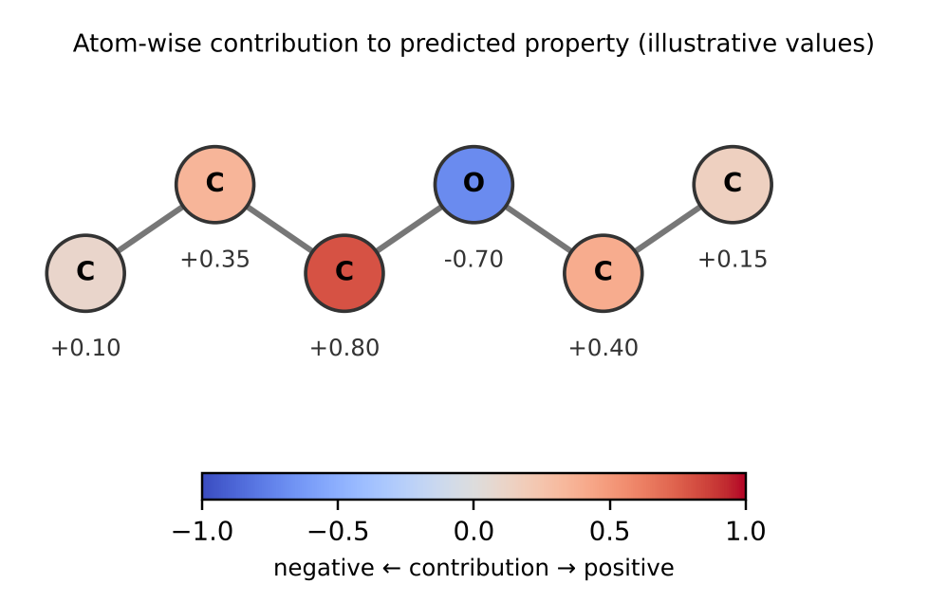
Fig. 10. Atom-level attribution on a molecular graph: contributions of individual atoms and bonds to a predicted property (illustrative schematic, not output of a trained model).
XAI for design. Chen et al. [29] combined conjoint fingerprints with explainable ML to design tailor-made fuels. Chen et al. [108] combined XAI with target-property-oriented design, with a DIPE–gasoline application optimized by SHAP-guided multi-objective search (NSGA-III with VIKOR). Lamens and Bajorath [115] reviewed XAI for molecular design in pharmaceutical research, the closest model for what fuel design could adopt.
Table 6. XAI methods used for fuel and molecular property models.
Method | Scope | Model class explained | Granularity | Fuel application | Ref.
SHAP | Global and local | Tree-based and other ML models | Feature (descriptor) | Heat of combustion and formation | [43]
SHAP | Global | Explainable ML | Feature | Biodiesel properties and fatty-acid profile | [113]
SHAP + multi-objective search | Global | ML property models | Feature | DIPE–gasoline blend optimization | [108]
Multi-level explainable GNN | Local, intrinsic | GNN | Atom, group, molecule | Combustion property prediction | [35]
Conjoint-fingerprint explanation | Global | ML on fingerprints | Substructure | Tailor-made fuel design | [29]
Perturbation-based attribution | Local | GNN | Atom, bond | Drug discovery (transferable to fuels) | [114]
Review of XAI for design | — | — | — | Pharmaceutical molecular design | [115]

4.2 Uncertainty quantification (UQ)
A prediction without an error bar cannot support decisions on blends, certification or engine tests. UQ separates two sources of uncertainty:
$$\underset{\text{total}}{\underset{⏟}{Var\left[y∣x\right]}}=\underset{\text{aleatoric}}{\underset{⏟}{E_{θ}\left[σ_{θ}^{2}\left(x\right)\right]}}+\underset{\text{epistemic}}{\underset{⏟}{{Var}_{θ}\left[μ_{θ}\left(x\right)\right]}} \left(9\right)$$
Aleatoric uncertainty is noise in the data, for example inter-laboratory scatter, and cannot be reduced by more data. Epistemic uncertainty comes from limited knowledge of the model parameters and shrinks with more data, especially in unexplored regions (Fig. 11). Generators need the epistemic part most, since it signals extrapolation [4].
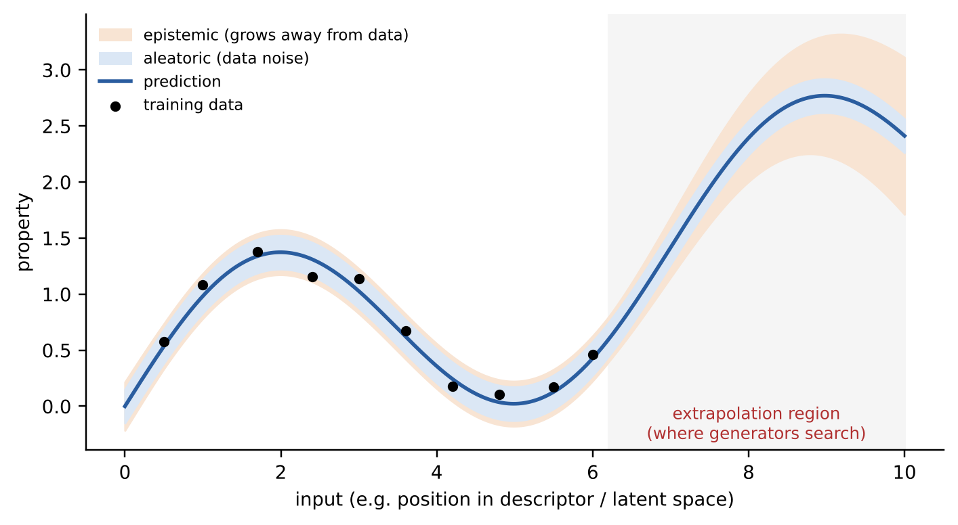
Fig. 11. Uncertainty in property prediction: aleatoric noise is constant across the input space, whereas epistemic uncertainty grows away from the training data. Illustrative schematic.
Bayesian and ensemble-style methods. Deep ensembles [116] train several networks and use their spread; they are robust but expensive. MC dropout keeps dropout active at inference; it is cheap but poorly distance-aware [117]. Bayesian neural networks (BNN) place distributions over weights, and Gaussian process regression (GPR) gives principled uncertainty but scales as $O\left(n^{3}\right)$ [12]. Fuel studies include Yalamanchi et al. [76], who quantified the uncertainty of a deep-learning model for RON, MON and YSI using Gaussian DropConnect and BNNs on 1,159 samples: both matched the baseline accuracy (MAE 3.0–3.4 for RON, 2.5–2.6 for MON) while providing intervals with 75–96% (Gaussian approach) and 69–95% (Bayesian approach) coverage [12]. Hall et al. compared probabilistic models for jet-fuel density and properties [45,118] and proposed the M-QSPR with Monte Carlo dropout [49]. Further examples are probabilistic deep learning for sustainable fuel design [119] and Bayesian inference in SAF design [107].
Distribution-free methods. Conformal prediction [120] gives intervals with guaranteed coverage under exchangeability. With nonconformity scores $s_{i}$ on a calibration set and miscoverage level $α$,
$$C_{α}\left(x\right)=\left\{y: s\left(x,y\right)≤{\hat{q}}_{1-α}\right\} \left(10\right)$$
where ${\hat{q}}_{1-α}$ is the $⌈\left(n+1\right)\left(1-α\right)⌉/n$ quantile of the calibration scores. Hosni et al. [60] used it for YSI prediction with uncertainty estimates. The guarantee is marginal and holds only when test data resemble the calibration data, which limits it for generative design (Section 4.4).
Implications for decisions. Calibrated confidence bounds allow risk-aware ranking of candidates, regulatory arguments (for example, whether a blend meets an octane specification with a stated probability) and active-learning loops that spend experiments where uncertainty is highest (Section 5.3).
Table 7. UQ methods in fuel research.
Method | Uncertainty captured | Cost | Distance-awareness | Calibration guarantee | Fuel application | Ref.
Deep ensembles | Epistemic (and aleatoric with variance heads) | High (several networks) | Moderate | None | General method; recommended for fuel design in [4] | [4,116]
MC dropout | Epistemic | Low | Poor | None | M-QSPR for jet-fuel properties | [49,117]
Gaussian DropConnect, BNN | Epistemic, aleatoric | Medium | Not guaranteed | Empirical coverage: 75–96% (DropConnect), 69–95% (BNN) | RON, MON, YSI (1,159 samples) | [12,76]
GPR | Epistemic, aleatoric | $$O\left(n^{3}\right)$$ | Good (kernel-based) | Model-based | LBV, other small data sets | [12]
Probabilistic models for density | Predictive distribution | Medium | Not reported | Assessed empirically | Jet-fuel density and properties | [45,118]
Conformal prediction | Predictive intervals | Low (post-hoc) | None | Marginal coverage under exchangeability | YSI | [60,120]
Bayesian inference with descriptor-based ML | Posterior over design variables | Medium–high | — | Model-based | Alternative fuels / SAF | [107]

4.3 Interpretability–accuracy trade-off
A recurring finding is that complex models (GNNs, transformers) achieve higher accuracy but are opaque, while simple models (multiple linear regression, decision trees) are transparent but less accurate. Three ways to reduce the gap are visible in the literature. First, descriptor selection: choosing descriptors strongly correlated with the target can improve interpretability without losing accuracy [22,23,59]. Second, symbolic regression: SISSO returns compact analytical expressions and has been used to predict jet-fuel properties from GC×GC data [56]. Third, intrinsically explainable architectures such as Chemomile [35] and physics-informed GNNs [39]. Even so, post-hoc XAI is rarely adopted in fuel CAMD. Most generative studies (Section 3) report accuracy and property targets but no attribution analysis, even though attribution could reveal whether a generator exploits a spurious feature.

4.4 Limitations of XAI and UQ for fuel design
(i) Model-level explanations, not physics. SHAP and similar methods explain the model, not the chemistry. A feature can be highly attributed because of data-set correlations. Agreement with chemical intuition, for example for C–H bond contributions, is encouraging but not proof of mechanism.
(ii) Low adoption in CAMD. Post-hoc explanation is rarely used in generative and design workflows, so design decisions are made without attribution checks.
(iii) Computational cost of UQ. GPR scales as $O\left(n^{3}\right)$ and deep ensembles multiply training and inference costs. Both are difficult to combine with large generative searches that evaluate millions of candidates.
(iv) Lack of standardization. There are no shared UQ benchmarks for fuel properties, and studies report different metrics (coverage, interval width, calibration error, negative log-likelihood). Calibration is rarely checked on out-of-distribution data.
(v) Aleatoric versus epistemic. In practice the two are hard to separate. Measurement noise, label inconsistencies (Section 2.4(ii)) and model misspecification all enter, and heteroscedastic noise models are rarely used.
(vi) Distance-awareness. MC dropout and many ensembles do not reliably increase their uncertainty far from the training data [117], so they can be confidently wrong in the very regions that generators explore. Conformal guarantees are marginal and also weaken under distribution shift.
(vii) Integration gap. XAI and UQ are applied to single properties. Attributions and error bars are not carried from the molecule to combustion behaviour and engine performance, and the merit function of Eq. (7) is deterministic, so the uncertainty of a fuel’s predicted engine benefit is rarely stated. Section 5.2 returns to this gap.
Synthesis. XAI and UQ are necessary but not yet sufficient. They motivate Section 5, which turns them into directions: physics-informed and multimodal models, standardized benchmarks and closed-loop experimental validation.

5. Emerging trends, challenges and future perspectives in AI-driven fuel molecular design
Sections 2–4 closed with limitations: scarce and heterogeneous data, poor extrapolation, predictor errors that generators exploit, a validation gap, and XAI and UQ that remain model-level and are not yet connected to engine performance. This section turns each of them into a research direction. Section 5.1 treats physics-informed and chemistry-aware models (limitations 2.4(iii) and 4.4(i)), Section 5.2 multiscale integration from molecules to engines (4.4(vii)), Section 5.3 autonomous and closed-loop discovery (3.4(ii) and 3.4(iv)), and Section 5.4 data infrastructure and industrial deployment (2.4(i), 2.4(v) and 4.4(iv)).

5.1 Physics-informed and chemistry-aware AI
Limitations addressed: 2.4(iii) extrapolation and 4.4(i) model-level explanations.
Physics-informed machine learning. Broader reviews of ML in combustion studies are available [121]. Physics can enter as architecture, as features or as a loss term. For a network $u_{θ}$ that should obey a governing equation $N\left[u\right]=0$ (a kinetic rate law or a thermodynamic constraint), the physics-informed loss is
$$L=L_{data}+λ L_{phys}, L_{phys}=\frac{1}{N_{c}}\sum_{j=1}^{N_{c}}{∥}N\left[u_{θ}\right]\left(x_{j}\right)∥^{2} \left(11\right)$$
where $x_{j}$ are collocation points and $λ$ balances the terms. Fuel examples include group-contribution-constrained networks [40], physics-informed GNNs for cetane number [39], neural ODEs for ammonia combustion [122], neural networks for hydrocarbon chemistry in turbulent reacting flows [123], ML-accelerated chemistry in bluff-body hydrogen flames [124], deep-network optimization of an ammonia–hydrogen mechanism [125], virtual-chemistry formalisms [126] and adaptive chemistry reduction [127].
Chemical constraints. Chemical knowledge can restrict what a model predicts or generates. In generation, valence and validity constraints are easier to enforce with graph decoders than with string decoders (Section 3.1), and transformation-rule generators limit candidates to chemically meaningful edits [78] or to biofuel structures reachable by defined routes [77]. In prediction, group-contribution constraints keep a network consistent with additive structure–property knowledge [40]. For reaction pathways, neural-ODE models of ammonia combustion keep the structure of rate equations [122], and a generalised virtual-chemistry formalism standardizes thermodynamics, kinetics and transport [126].
Thermodynamic consistency. Predicted properties should respect thermodynamic limits, for example that a blend property tends to the pure-component value as its composition tends to one. Thermodynamics-based estimates already serve as independent checks or design inputs: COSMO-RS for high-energy-density fuels [41] and predictive thermodynamics in the efficiency-driven design of Fleitmann et al. [5]. We suggest that mixture models such as the latent mixing of Eq. (6) be tested against such limits and, where possible, constrained by them, since linear latent mixing is an assumption (Section 3.4(v)).
What this changes, and what it does not. Constraints narrow the space of admissible predictions, so they can improve behaviour outside the training family (2.4(iii)). They also make explanations easier to relate to mechanism, because an attribution that violates a known constraint is a warning sign (4.4(i)). They do not replace validation: a constrained model can still be wrong, and its explanations remain model-level.
Data-efficient companions. Three further strategies reduce the need for labelled data and are usually combined with the constraints above.
Foundation and large pre-trained models. The LG-Transformer [36] predicts diverse physicochemical properties with one model, a step from single-property predictors toward general fuel-property engines. Pre-training on large unlabelled corpora followed by fine-tuning on small fuel data sets addresses the scarcity problem of Section 2.4(i). It does not address bias or extrapolation, and it makes UQ more important, since large models fail silently.
Transfer and delta learning. Models trained on abundant, cheap labels (calculated properties or a related fuel class) are corrected or fine-tuned on scarce, accurate ones. A transfer-learning GCN for IDT [12] and molecular-dynamics-guided models [24] are examples of the first stage.
Multimodal learning. Bounaceur et al. [27] combined QSPR descriptors with text embeddings of InChIKey, and reached R² = 0.99 with MAE = 1.35 for RON in the reviewed study [12].
Large language models (LLM). Alshehri [128] fine-tuned LLMs to extract fuel properties from text concurrently, which could speed up the construction of the databases that Section 2 identified as the bottleneck. Extraction errors would add another source of label noise, so they need the same validation as any data source.

5.2 Multiscale AI integration from molecules to engines
Limitation addressed: 4.4(vii) integration gap, together with 3.4(iii).
The chain. The properties predicted, explained and bounded in Sections 2–4 are intermediate quantities. A fuel is useful only through the chain molecule → fuel properties → combustion behaviour → engine performance, and each link can be modelled by ML:
$$η=F_{eng}​\left(F_{comb}​\left(F_{prop}\left(x\right), s\right), e\right) \left(12\right)$$
where x is the molecule or blend composition, s the thermodynamic state, e the engine design and operating condition, and η the engine-level metric such as brake efficiency.
Molecule → fuel properties. This link is the subject of Section 2: structure-based predictors with reported speedups of up to several orders of magnitude over simulation [12], and the representations that make inverse design possible [4].
Fuel properties → combustion. ML replaces or accelerates kinetic and flame computations. Examples are IDT and LBV surrogates [12], neural-ODE and neural-network chemistry for ammonia, hydrocarbon and hydrogen flames [122–124], reduced and virtual chemistry [126,127], and ML-QSPR models coupled with chemical kinetics for high-throughput screening [74]. [to add: AI-based combustion-modelling references (Gürgen, Oğuz, Canakci, Shivakumar, Hosseini, Tosun, Menon); bibliographic details not yet provided.]
Combustion → engine. Hybrid CFD–ML approaches for alternative fuels have been reviewed [14]. The Co-Optima merit function (Eq. 7) is the established link from fuel properties to spark-ignition efficiency [4,134]. Design studies already use engine-related objectives directly [5,6,100], with simulation metamodels [102], 0D/1D ignition models combined with ML octane predictions [101], and engine-hardware co-optimization for a hydrogen engine [132]. Engine-level ML models often take engine variables such as speed and load as inputs and omit fuel properties. Including them is the condition for joint fuel–engine optimization.
Digital twins and real-time use. Fast surrogates make on-board use possible: a data-driven model that estimates cetane number in real time for engine control is one component [135]. A fuel–engine digital twin would chain the surrogates above and update them from measured data. Box 2 lists the requirements we consider necessary.
Box 2. Requirements for a fuel–engine digital twin (the authors’ proposal, not a published standard).
(1) A fuel-property module with calibrated, distance-aware uncertainty and an applicability-domain flag (Section 4.2). (2) A combustion surrogate validated against detailed kinetics over the operating window. (3) An engine-level model that takes fuel properties as inputs. (4) End-to-end propagation of uncertainty from molecule to engine metric (Eq. 13). (5) Assimilation of measured engine data, with monitoring for drift and distribution shift. (6) An explanation layer showing which fuel properties drive the predicted metric. (7) A traceable record of model versions, data and validation, to support certification.
Uncertainty propagation. Each surrogate in the chain adds its own error. To first order, and assuming independent property errors, the uncertainty in an engine metric follows from the property uncertainties through the sensitivities already contained in the merit function of Eq. (7):
$$σ_{η}^{2}≈\sum_{i=1}^{n}{{\left(\frac{∂η}{∂p_{i}}\right)}^{2}}σ_{p_{i}}^{2} \left(13\right)$$
where σᵢ denotes the uncertainty of property pᵢ. Correlations among properties would add cross terms. Learned potentials such as [131] show how ML can bridge quantum-chemical accuracy and larger-scale simulation. Every such bridge adds an uncertainty that has to be carried forward, and this is not yet routine in fuel design.

5.3 Autonomous fuel discovery and closed-loop design
Limitations addressed: 3.4(ii) experimental validation gap and 3.4(iv) predictor-error propagation.
AI + simulation. A generative model proposes candidates, an ML surrogate screens them, and a kinetic, thermodynamic or molecular-dynamics calculation gives an independent, physics-based estimate for the survivors (Box 1, item 4). Building blocks exist: ML-QSPR with chemical kinetics [74], COSMO-RS-based design [41] and molecular-dynamics-guided ML [24]. An independent estimate catches errors specific to the surrogate at a cost far below experiment.
AI + experiment. The target workflow is generate → screen (UQ-aware) → simulate → test → retrain (Fig. 12). Acquisition functions that use epistemic uncertainty select the most informative candidates, and at least one low-ranked control tests the predictor’s ranking. Closed loops exist in materials and catalysis [111] but have not yet been demonstrated systematically for fuels.
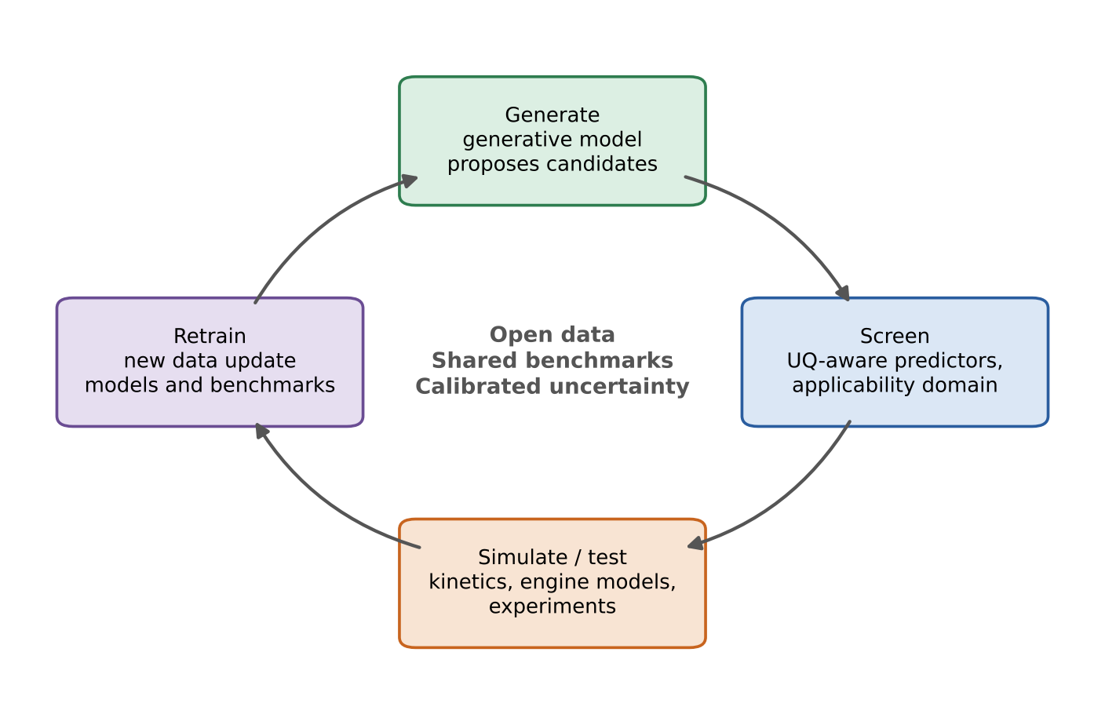
Fig. 12. Closed-loop roadmap for AI-assisted fuel design: generate, screen with uncertainty-aware predictors, simulate, test experimentally, and retrain on the new data.
Automated validation and agents. Parente et al. [129] describe the “augmented combustion scientist”, moving from data-driven science to agentic AI, and related reviews cover autonomous discovery in organic photovoltaics [130]. For fuels, an agent could propose molecules, call predictors, query databases, request UQ and schedule experiments. Safety, provenance and human oversight need to be designed from the start. Autonomy should not outrun validation: an agent that optimizes against a poorly calibrated predictor finds its weaknesses faster than a person would.
The Rittig case as a test of the loop. Rittig et al. [34] proposed 2,2-dimethoxypropane as a high-octane candidate, and its measured RON and octane sensitivity were lower than predicted (Section 3.3). In a closed loop this measurement is a training example, not a dead end: it is added to the data, the predictor is retrained, and the region around that structure receives higher epistemic uncertainty. The workflow of Fig. 12 and Box 1 turns such discrepancies into information, but only if they are measured and reported, which is why negative results belong in the call to action (Section 6).

5.4 Data infrastructure and industrial deployment
Limitations addressed: 2.4(i) data scarcity, 2.4(v) benchmarking and 4.4(iv) lack of standardization.
Databases. Building blocks exist but are fragmented: the Yale YSI database [58], DIPPR801 and the ReSpecTh library for property and kinetic data [12], and the FAA National Alternative Jet Fuel Test Database and the Co-Optima fuel-property database [4]. They differ in format, metadata and coverage, and none was designed as a benchmark for generative design.
Standardization. Üstün et al. [12] recommend (1) publishing raw measurements alongside processed values, (2) comprehensive metadata on conditions, calibration and uncertainty, (3) standardization across laboratories, and (4) larger annotated public databases. We add that property data should carry measurement method and uncertainty so that aleatoric terms can be learned (Section 4.2), and that UQ benchmarks should be defined together with property benchmarks.
Reproducibility. Shared splits (including scaffold, chemical-family and out-of-distribution splits), shared metrics for accuracy and calibration, and released code and trained models are needed. Üstün et al. [12] point to open repositories and computational platforms for this purpose. Without them, reported R² values cannot be compared (2.4(v)).
Industrial deployment. Industrial use requires models that are fast enough for screening and control, robust to distribution shift, accompanied by an applicability-domain statement and traceable for certification. A model with uncalibrated uncertainty cannot support a specification claim (Section 4.2). The digital twin of Section 5.2 is the industrial form of the whole pipeline, and it inherits every limitation above. Its credibility depends more on data and calibration than on architecture.

6. Conclusions
This review followed the chain from molecular representation to trustworthy inverse design and fuel–engine integration. The main conclusions are as follows.
- Prediction is mature. ML predicts physicochemical and combustion properties (CN/ON, YSI, IDT, LBV, FL, FP, MIE) from structure. Many studies report R² above 0.97 on held-out data, and speedups over kinetic simulation range from about 10³ to 2×10⁵ [12]. Neural networks are by far the most used algorithm (72 of the studies counted in [12], Fig. 7), followed by SVM/SVR, random forest and multiple linear regression, with GNNs and GPR increasingly used.
- Generation is promising but unproven. VAEs, GANs, LSTMs, RL and hybrid methods now propose molecules and blends, but few AI-designed fuels have been tested, and the Rittig case shows how predictor errors reach the design.
- XAI and UQ link the two. Attribution methods (SHAP, multi-level GNN explanations) and uncertainty methods (conformal prediction, ensembles, BNNs) show where a model can be trusted. They are still rarely integrated into design workflows and are not yet standardized.
- Fuel–engine integration is the frontier. Properties are intermediate quantities. Chaining property, combustion and engine surrogates with propagated uncertainty, and eventually fuel–engine digital twins, is the step that connects molecular design to engine performance. It is largely undemonstrated for fuels (Section 5.2).
- The challenges are shared across the pipeline: scarce and heterogeneous data, extrapolation beyond the training distribution, the accuracy–interpretability trade-off, missing benchmarks and limited experimental feedback.
- The way forward combines physics-informed models, transfer and delta learning, multimodal and foundation models, open benchmarks and closed-loop validation, with co-design of fuel and engine as the end goal.
- A call to action. We recommend that the combustion community: (1) publish open, standardized data sets with metadata and measurement uncertainty; (2) adopt shared benchmarks for property prediction, generation and UQ, with out-of-distribution splits; (3) require calibrated uncertainty and an applicability-domain statement for every predicted or generated fuel; (4) test AI-designed candidates experimentally, including engine tests, and report negative results (Box 1); and (5) release code, splits and models with each study.
The contribution of this review is a roadmap for AI-assisted fuel design that treats explainability, uncertainty and experimental validation as design requirements.

Declaration of competing interest
[to be completed]

Acknowledgements
[to be completed]

References
[1] Enerdata, World Energy & Climate Statistics – Yearbook 2022, World Energy Consumption Statistics, Enerdata, 2022.
[2] ExxonMobil, Outlook for Energy: A View to 2040, 2018.
[3] Pitsch, H., The transition to sustainable combustion: Hydrogen- and carbon-based future fuels and methods for dealing with their challenges. Proceedings of the Combustion Institute, 2024. 40(1-4).
[4] Sarathy, S.M. and B.A. Eraqi, Artificial intelligence for novel fuel design. Proceedings of the Combustion Institute, 2024. 40(1-4).
[5] Fleitmann, L., et al., Molecular design of fuels for maximum spark-ignition engine efficiency by combining predictive thermodynamics and machine learning. Energy & fuels, 2023. 37(3): p. 2213–2229.
[6] Nagaraja, S.S., et al., Machine learning-driven screening of fuel additives for increased spark-ignition engine efficiency. Proceedings of the Combustion Institute, 2024. 40(1-4).
[7] Dahmen, M. and W. Marquardt, Model-based design of tailor-made biofuels. Energy & Fuels, 2016. 30(2): p. 1109–1134.
[8] Lockwood, K.S., et al., Advances in predictive chemistry enable a multi-scale rational design approach for biofuels with advantaged properties. Sustainable Energy and Fuels, 2022. 7.
[9] Rotavera, B. and C.A. Taatjes, Influence of functional groups on low-temperature combustion chemistry of biofuels. Progress in Energy and Combustion Science, 2021. 86.
[10] Bu, L., et al., Understanding Trends in Autoignition of Biofuels: Homologous Series of Oxygenated C5 Molecules. Journal of Physical Chemistry A, 2017. 121(29): p. 5475–5486.
[11] Ahmed, S., et al., Understanding fundamental effects of biofuel structure on ignition and physical fuel properties. Fuel, 2024. 358.
[12] Üstün, C.E., et al., Machine Learning Applications for Predicting Fuel Ignition and Flame Properties: Current Status and Future Perspectives. Energy and Fuels, 2025. 39(28): p. 13281–13314.
[13] Wilk-Jakubowski, J.L., et al., Data-driven computational methods in fuel combustion: A review of applications. Applied Sciences, 2025. 15(13): p. 7204.
[14] Quaye, E.K., et al., A review of hybrid computational fluid dynamics and machine learning approaches for the combustion of alternative fuels. Journal of the Energy Institute, 2026. 124.
[15] Zhang, X., et al., Machine Learning Assisted Molecule Design of Fuel. Progress in Chemistry, 2024. 36(4): p. 471–485.
[16] Nanlohy, H.Y., S. Marianingsih, and F. Utaminingrum, A Review of the artificial neural network’s roles in alternative fuels: Optimization, prediction, and prospects. Mechanical Engineering for Society and Industry, 2024. 4(Special Issue 3): p. 513–534.
[17] Li, Q., X. Chen, and Z. Hu, Quantitative structure-property relationship studies for estimating boiling points of alcohols using calculated molecular descriptors with radial basis function neural networks. Chemometrics and Intelligent Laboratory Systems, 2004. 72(1): p. 93–100.
[18] Cao, H.Y., et al., Quantitative structure-property relationship study for predicting heat of combustion of liquid hydrocarbon. Ranshao Kexue Yu Jishu/Journal of Combustion Science and Technology, 2009. 15(3): p. 266–272.
[19] Hechinger, M. and W. Marquardt, Targeted QSPR for the prediction of the laminar burning velocity of biofuels. Computers and Chemical Engineering, 2010. 34(9): p. 1507–1514.
[20] Dussan, K., et al., Chemical functional group descriptor for ignition propensity of large hydrocarbon liquid fuels. Proceedings of the Combustion Institute, 2019. 37(4): p. 5083–5093.
[21] Li, R., et al., Machine learning regression based group contribution method for cetane and octane numbers prediction of pure fuel compounds and mixtures. Fuel, 2020. 280: p. 118589.
[22] Comesana, A.E., et al., A systematic method for selecting molecular descriptors as features when training models for predicting physiochemical properties. Fuel, 2022. 321.
[23] Cheng, L., et al., Predicting Fuel Properties through Sequential Forward Selection (SFS) Enhance Ensemble Machine Learning with Topological Index Selection. Industrial and Engineering Chemistry Research, 2025. 64(9): p. 4669–4684.
[24] Freitas, R.S.M., et al., Towards predicting liquid fuel physicochemical properties using molecular dynamics guided machine learning models. Fuel, 2022. 329.
[25] Weininger, D., SMILES, a chemical language and information system. 1. Introduction to methodology and encoding rules. Journal of chemical information and computer sciences, 1988. 28(1): p. 31–36.
[26] Garrett, B., J. Tang, and X. Chen. Predicting Heat of Combustion from SMILES with Machine Learning. in 2025 Intermountain Engineering, Technology and Computing, IETC 2025. 2025.
[27] Bounaceur, R., et al., Development of an Artificial Intelligence Model to Predict Combustion Properties, With a Focus on Auto-Ignition Delay. Journal of Engineering for Gas Turbines and Power, 2024. 146(6).
[28] Rogers, D. and M. Hahn, Extended-connectivity fingerprints. Journal of chemical information and modeling, 2010. 50(5): p. 742–754.
[29] Chen, Y., et al., Explainable machine learning assisted design of tailor-made fuels using conjoint fingerprints. Energy Conversion and Management, 2024. 322.
[30] Gilmer, J., Schoenholz, S.S., Riley, P.F., Vinyals, O., Dahl, G.E., Neural message passing for quantum chemistry, in Proceedings of the 34th International Conference on Machine Learning (PMLR 70). 2017. p. 1263–1272. [to verify]
[31] Schweidtmann, A.M., et al., Graph Neural Networks for Prediction of Fuel Ignition Quality. Energy and Fuels, 2020. 34(9): p. 11395–11407.
[32] Yang, K., et al., Analyzing learned molecular representations for property prediction. Journal of chemical information and modeling, 2019. 59(8): p. 3370.
[33] Han, X., et al., Directed message passing neural network (D-MPNN) with graph edge attention (GEA) for property prediction of biofuel-relevant species. Energy and AI, 2022. 10.
[34] Rittig, J.G., et al., Graph machine learning for design of high‐octane fuels. AIChE journal, 2023. 69(4): p. e17971.
[35] Kang, B. and B.J. Sung, Chemomile: Explainable Multi-Level GNN Model for Combustion Property Prediction. Journal of Physical Chemistry A, 2025. 129(7): p. 1880–1889.
[36] Zhang, J., et al., LG-Transformer: learned-graph transformer framework enabling diverse physicochemical properties prediction toward fuel design. Nature Communications, 2026. 17(1).
[37] Jaeger, S., Fulle, S., Turk, S., Mol2vec: unsupervised machine learning approach with chemical intuition. Journal of Chemical Information and Modeling, 2018. 58(1): p. 27–35.
[38] Xu, Z., Wang, S., Zhu, F., Huang, J., Seq2seq Fingerprint: An Unsupervised Deep Molecular Embedding for Drug Discovery, in Proceedings of the 8th ACM International Conference on Bioinformatics, Computational Biology, and Health Informatics. 2017, ACM. p. 285–294.
[39] Kim, Y., et al., Physics-informed graph neural networks for predicting cetane number with systematic data quality analysis. Proceedings of the Combustion Institute, 2023. 39(4): p. 4969–4978.
[40] Babaei, M.R., et al., Physics-Informed Neural Networks with Group Contribution Methods. Journal of Chemical Theory and Computation, 2023. 19(13): p. 4163–4171.
[41] Fu, J. and S.Q. Turn, Design of High-Energy-Density fuels based on COSMO-RS. Fuel, 2026. 419.
[42] Cao, H.Y., et al., Prediction of the net heat of combustion of organic compounds based on atom-type electrotopological state indices. Journal of Loss Prevention in the Process Industries, 2009. 22(2): p. 222–227.
[43] Maraschin, M., T.D. Metzka Lanzanova, and N.P. Gonçalves Salau, Predictions of heat of combustion and formation by interpretable machine learning algorithms. Fuel, 2025. 390.
[44] Saldana, D.A., et al., On the rational formulation of alternative fuels: Melting point and net heat of combustion predictions for fuel compounds using machine learning methods. SAR and QSAR in Environmental Research, 2013. 24(4): p. 259–277.
[45] Hall, C., et al., Predictive Capability Assessment of Probabilistic Machine Learning Models for Density Prediction of Conventional and Synthetic Jet Fuels. Energy and Fuels, 2021. 35(3): p. 2520–2530.
[46] Virt, M., et al., An Artificial Intelligence Approach to Predict Physical Properties of Liquid Hydrocarbons. Periodica Polytechnica Chemical Engineering, 2024. 68(4): p. 561–570.
[47] Mohammad, S.I., et al., Thermophysical properties of used frying oil biodiesels blended with alcohols: Robust machine learning frameworks for density prediction. Industrial Crops and Products, 2025. 236.
[48] Shao, Y., et al., Comprehensive accurate prediction of critical jet fuel properties with multiple machine learning models. Chemical Engineering Science, 2025. 304.
[49] Hall, C., Creton, B., Rauch, B., Bauder, U., Aigner, M., Probabilistic mean quantitative structure-property relationship modeling of jet fuel properties. Energy & Fuels, 2022. 36: p. 463–479.
[50] Hall, C., et al. Machine learning algorithms for fuel property prediction in comparison with state of the art physical models. in Proceedings of the 16th International Conference on Stability Handling and Use of Liquid Fuels. 2019.
[51] Li, R., et al., Machine learning-quantitative structure property relationship (ML-QSPR) method for fuel physicochemical properties prediction of multiple fuel types. Fuel, 2021. 304: p. 121437.
[52] Mohan, B., Alsaleh, F., AlRamadan, A.S., Almbdal, S., Al-Ammari, A., Saihati, Z., Voice, A., Badra, J., In silico estimation of density, vapor pressure, distillation curve, and octane numbers of gasoline fuels using machine learning. Fuel, 2025. 399: p. 135640.
[53] Leenhouts, R.J., et al., Property prediction of fuel mixtures using pooled graph neural networks. Fuel, 2025. 381.
[54] Abraham, A., et al., Evaluation of n-component surrogate mixtures formulated for jet fuel physicochemical property predictions. Chemometrics and Intelligent Laboratory Systems, 2025. 263.
[55] Radaideh, M.I., et al. Optimal Sets of Molecules to Predict Aviation Fuel Properties. in SAE Technical Papers. 2025.
[56] Dong, Z., et al., SISSO-Based Interpretable Machine Learning for Predicting Jet Fuel Properties From GC × GC Data: A New Approach to Structure–Property Relationship Modeling. Advanced Theory and Simulations, 2026. 9(9).
[57] Pfefferle, L.D., et al., Sooting tendencies: Combustion science for designing sustainable fuels with improved properties. Proceedings of the Combustion Institute, 2024. 40(1-4).
[58] Das, D.D., et al. Measurements and prediction of sooting tendencies of pure hydrocarbons. in 10th U.S. National Combustion Meeting. 2017.
[59] Wang, Q.D., et al., Effect of Molecular Descriptors on the Development of Machine Learning Models for the Prediction of Yield Sooting Index. ACS Omega, 2025. 10(46): p. 56555–56565.
[60] Hosni, Z., et al., Predictive Modeling of Yield Sooting Index Using Machine Learning with Uncertainty Estimation. ACS Omega, 2025. 10(24): p. 25336–25349.
[61] Yao, Q., et al., Probing the Prediction of High-Temperature Ignition Delay Times of Jet Fuels via Machine Learning Approaches. Results in Engineering, 2025. 28.
[62] vom Lehn, F., et al., Exploring the fuel structure dependence of laminar burning velocity: A machine learning based group contribution approach. Combustion and Flame, 2021. 232.
[63] Shahpouri, S., et al., Laminar Flame Speed modeling for Low Carbon Fuels using methods of Machine Learning. Fuel, 2023. 333.
[64] Üstün, C.E., et al., Applying machine learning techniques to predict laminar burning velocity for ammonia/hydrogen/air mixtures. Energy and AI, 2023. 13: p. 100270.
[65] Udaybhanu, G., et al., Data-Driven Modeling of Laminar Flame Speed in Ammonia–Oxygenated Fuel Blends Using Machine Learning. Energy and Fuels, 2026. 40(22): p. 12032–12047.
[66] Abdul Jameel, A.G., Predicting Laminar Burning Velocities of Oxygenated Fuels Using a Structure–Thermophysical Neural Network Framework. Combustion Science and Technology, 2026.
[67] Sennott, T., et al. Artificial neural network for predicting cetane number of biofuel candidates based on molecular structure. in ASME 2013 Internal Combustion Engine Division Fall Technical Conference, ICEF 2013. 2013.
[68] Kessler, T., et al., Artificial neural network based predictions of cetane number for furanic biofuel additives. Fuel, 2017. 206: p. 171–179.
[69] Guo, Z., et al., Predicting cetane numbers of hydrocarbons and oxygenates from highly accessible descriptors by using artificial neural networks. Fuel, 2017. 207: p. 344–351.
[70] Baghban, A. and M. Adelizadeh, On the determination of cetane number of hydrocarbons and oxygenates using Adaptive Neuro Fuzzy Inference System optimized with evolutionary algorithms. Fuel, 2018. 230: p. 344–354.
[71] Freitas, R.S.M. and X. Jiang, Descriptors-based machine-learning prediction of cetane number using quantitative structure–property relationship. Energy and AI, 2024. 17.
[72] Abdul Jameel, A.G., et al., Predicting Ignition Quality of Oxygenated Fuels Using Artificial Neural Networks. SAE International Journal of Fuels and Lubricants, 2021. 14(2).
[73] Wang, B., et al., Prediction of minimum ignition energy from molecular structure using quantitative structure-property relationship (QSPR) models. Industrial and Engineering Chemistry Research, 2017. 56(1): p. 47–51.
[74] Li, R., et al., Integrated machine learning-quantitative structure property relationship (ML-QSPR) and chemical kinetics for high throughput fuel screening toward internal combustion engine. Fuel, 2022. 307.
[75] Wen, L., et al., Accelerating the Design of High-Energy-Density Hydrocarbon Fuels by Learning from the Data. Molecules, 2023. 28(21).
[76] Yalamanchi, K.K., et al., Uncertainty quantification of a deep learning fuel property prediction model. Applications in Energy and Combustion Science, 2023. 16: p. 100211.
[77] Dahmen, M., et al., Towards Model-Based Identification of Biofuels for Compression Ignition Engines. SAE International Journal of Fuels and Lubricants, 2012. 5(3): p. 990–1003.
[78] Cai, G., Z. Liu, and L. Zhang, Transformation rule-based molecular evolution for automatic gasoline molecule design. Chemical Engineering Science, 2022. 263.
[79] Alshehri, A.S., R. Gani, and F. You, Deep learning and knowledge-based methods for computer-aided molecular design—toward a unified approach: State-of-the-art and future directions. Computers & Chemical Engineering, 2020. 141: p. 107005.
[80] Alshehri, A.S. and F. You, Deep learning to catalyze inverse molecular design. Chemical Engineering Journal, 2022. 444: p. 136669.
[81] Hechinger, M., A. Voll, and W. Marquardt, Towards an integrated design of biofuels and their production pathways. Computers and Chemical Engineering, 2010. 34(12): p. 1909–1918.
[82] Gómez-Bombarelli, R., et al., Automatic chemical design using a data-driven continuous representation of molecules. ACS central science, 2018. 4(2): p. 268.
[83] Kingma, D.P., Welling, M., Auto-encoding variational Bayes. arXiv preprint arXiv:1312.6114, 2013.
[84] Kuzhagaliyeva, N., et al., Artificial intelligence-driven design of fuel mixtures. Communications Chemistry, 2022. 5(1).
[85] Liu, R., et al., Ensemble learning directed classification and regression of hydrocarbon fuels. Fuel, 2022. 324.
[86] Goodfellow, I., Pouget-Abadie, J., Mirza, M., Xu, B., Warde-Farley, D., Ozair, S., Courville, A., Bengio, Y., Generative adversarial nets. Advances in Neural Information Processing Systems, 2014. 27. [to verify]
[87] Liu, R., et al., Property-Oriented Reverse Design of Hydrocarbon Fuels Based on c-infoGAN. Journal of Chemical Information and Modeling, 2025. 65(11): p. 5469–5480.
[88] Anufriev, S., P. Hellier, and N. Ladommatos, Generation of Novel Fuels Optimized for High-Knock Resistance with a Long Short-Term Memory Model. Energy and Fuels, 2025. 39(27): p. 13044–13053.
[89] Olivecrona, M., Blaschke, T., Engkvist, O., Chen, H., Molecular de-novo design through deep reinforcement learning. Journal of Cheminformatics, 2017. 9: p. 48.
[90] Popova, M., Isayev, O., Tropsha, A., Deep reinforcement learning for de novo drug design. Science Advances, 2018. 4(7): p. eaap7885.
[91] Kneiding, H. and D. Balcells, Augmenting genetic algorithms with machine learning for inverse molecular design. Chemical Science, 2024. 15(38): p. 15522–15539.
[92] Zhang, S., et al., Augmenting optimization-based molecular design with graph neural networks. Computers and Chemical Engineering, 2024. 186.
[93] Yalamanchi, K.K., et al., Generative Deep Learning Framework for Inverse Design of Fuels. arXiv preprint arXiv:2504.12075, 2025.
[94] Virt, M. and M. Zöldy, An AI-based fuel designer tool for sustainable E-fuel development: Methodology, Validation, and Optimization. Energy and AI, 2025. 21.
[95] Freitas, R.S.M., et al., An AI-driven de novo design and optimisation of sustainable aviation fuels. Energy and AI, 2026. 25.
[96] Won, S.H., et al., Reconstruction of chemical structure of real fuel by surrogate formulation based upon combustion property targets. Combustion and Flame, 2017. 183: p. 39–49.
[97] Nates, S., et al. Surrogate formation based on chemical functional group analysis. in 2018 Spring Technical Meeting of the Eastern States Section of the Combustion Institute, ESSCI 2018. 2018.
[98] Choudhury, H.A., et al., Designing a Surrogate Fuel for Gas-to-Liquid Derived Diesel. Energy and Fuels, 2017. 31(10): p. 11266–11279.
[99] Weber, J., H.W. Won, and N. Peters. Experimental validation of a surrogate fuel for diesel. in SAE Technical Papers. 2007.
[100] Nagaraja, S.S., et al., Synthetic Electro Gasoline Fuel Design for Ultra Lean Burn Engine: An AI-Powered Approach for Fuel Reformulation. Energy and Fuels, 2025. 39(35): p. 16940–16955.
[101] Mueller, J., Kim, N., Lapointe, S., McNenly, M.J., Sjöberg, M., Whitesides, R., Chapter 2 – Optimization of fuel formulation using adaptive learning and artificial intelligence, in Artificial Intelligence and Data Driven Optimization of Internal Combustion Engines, J. Badra, P. Pal, Y. Pei, S. Som (Eds.), Elsevier, 2022.
[102] Carvalho, R.N.D., G.B. Machado, and M.J. Colaço, Estimating gasoline performance in internal combustion engines with simulation metamodels. Fuel, 2017. 193: p. 230–240.
[103] Li, R., et al., Target-Oriented Fuel Design for the Homogeneous Charge Autoignition Combustion Mode: A Case Study of a n-Heptane-PODE 3 -Ethanol Mixture. 2. Identification of a Functional Configuration of Fuel Components. Energy and Fuels, 2019. 33(1): p. 31–49.
[104] Chen, Y., et al., Machine learning-based screening of fuel properties for SI and CI engines using a hybrid group extraction method. Applied Energy, 2024. 366.
[105] Liu, R., et al., Multi-objective Design of Blending Fuel by Intelligent Optimization Algorithms. Transactions of Tianjin University, 2024. 30(3): p. 221–237.
[106] Wu, Y., et al., Surrogate fuel formulation and performance-driven fuel modulation for sustainable aviation fuels: Strategies to match combustion characteristics of conventional jet fuel. Combustion and Flame, 2026. 283.
[107] Liberatori, J., et al., BayeSAF: Emulation and design of sustainable alternative fuels via Bayesian inference and descriptors-based machine learning. Fuel, 2026. 419.
[108] Chen, Y., et al., Machine learning-based design of target property-oriented fuels using explainable artificial intelligence. Energy, 2024. 300.
[109] Chen, Z., et al., Design of novel high-performance fuels with artificial intelligence: Case study for spark-ignition engine applications. Applications in Energy and Combustion Science, 2025. 23.
[110] Ackermann, P., et al., FSC2 Fuel Design via Machine Learning and Optimization. Kraftstoffe für die Mobilität von Morgen (Band 40), 2026: p. 9.
[111] Pourian, A., et al., AI-designed hierarchical SAPO-34 catalyst breakthrough with experimental verification. Journal of Materials Chemistry A, 2025. 13(36): p. 30554–30575.
[112] Lundberg, S.M., Lee, S.-I., A unified approach to interpreting model predictions, in Advances in Neural Information Processing Systems 30. 2017. [to verify pages]
[113] Suvarna, M., et al., Predicting biodiesel properties and its optimal fatty acid profile via explainable machine learning. Renewable Energy, 2022. 189: p. 245–258.
[114] Jiménez-Luna, J., et al., Coloring Molecules with Explainable Artificial Intelligence for Preclinical Relevance Assessment. Journal of Chemical Information and Modeling, 2021. 61(3): p. 1083–1094.
[115] Lamens, A. and J. Bajorath, Explainable artificial intelligence for molecular design in pharmaceutical research. Chemical Science, 2026. 17(3): p. 1411–1422.
[116] Lakshminarayanan, B., Pritzel, A., Blundell, C., Simple and scalable predictive uncertainty estimation using deep ensembles. Advances in Neural Information Processing Systems, 2017. 30.
[117] Liu, J., Lin, Z., Padhy, S., Tran, D., Bedrax-Weiss, T., Lakshminarayanan, B., Simple and principled uncertainty estimation with deterministic deep learning via distance awareness. Advances in Neural Information Processing Systems, 2020. 33: p. 7498–7512.
[118] Hall, C., et al., Comparison of probabilistic jet fuel property models for the fuel screening and design. Fuel, 2023. 351.
[119] Freitas, R.S.M., et al., Pathways to sustainable fuel design from a probabilistic deep learning perspective. Advances in Applied Energy, 2025. 19.
[120] Vovk, V., Gammerman, A., Shafer, G., Algorithmic Learning in a Random World. Springer, 2005.
[121] Zheng, Z.H., et al., Progress in the Application of Machine Learning in Combustion Studies. ES Energy and Environment, 2020. 9: p. 1–14.
[122] Saito, M., et al., Data-driven simulation of ammonia combustion using neural ordinary differential equations (NODE). Applications in Energy and Combustion Science, 2023. 16.
[123] An, J., et al., Explore artificial neural networks for solving complex hydrocarbon chemistry in turbulent reactive flows. Fundamental Research, 2022. 2(4): p. 595–603.
[124] Zhang, M., et al., Investigation of stabilization regimes and flame structure in bluff-body turbulent H2/N2 flames with machine-learning accelerated chemistry. International Journal of Hydrogen Energy, 2025. 188.
[125] Xu, X., et al., A Deep Neural Network-Based Approach for Optimizing Ammonia–Hydrogen Combustion Mechanism. Energies, 2025. 18(22).
[126] Préteseille, M., et al., A generalised virtual chemistry formalism with standardised thermodynamics, kinetics and complex transport properties. Combustion Theory and Modelling, 2026. 30(5): p. 596–624.
[127] Ghasemi, A., M. Derksen, and J.B.W. Kok, CSP-inspired adaptive chemistry reduction for combustion simulations without tabulation. Combustion Theory and Modelling, 2026. 30(3): p. 331–358.
[128] Alshehri, A.S., Fine-Tuning Large Language Models for the Efficient and Concurrent Extraction of Fuel Properties. Applied Sciences (Switzerland), 2026. 16(7).
[129] Parente, A., Z.X. Chen, and S. Deng, The “augmented combustion scientist”: Shifting from data-driven science to agentic AI. Proceedings of the Combustion Institute, 2026. 42.
[130] Ismaeel, S., S. Manzoor, and M.Z. Sabir, Toward autonomous discovery in small-molecule organic photovoltaics: A review integrating artificial intelligence and machine learning within the molecular design landscape. Organic Electronics, 2026. 154: p. 107424.
[131] Behler, J. and M. Parrinello, Generalized neural-network representation of high-dimensional potential-energy surfaces. Physical review letters, 2007. 98(14): p. 146401.
[132] Menaca, R., et al., Data-driven co-optimization of piston and pre-chamber in a heavy-duty hydrogen engine. International Journal of Hydrogen Energy, 2025. 189.
[133] Zhang, J., et al., Research on the state-of-the-art of efficient and ultra-clean ammonia combustion: From combustion kinetics to engine applications. Applied Energy, 2025. 391: p. 125886.
[134] Szybist, J.P., et al., What fuel properties enable higher thermal efficiency in spark-ignited engines? Progress in Energy and Combustion Science, 2021. 82: p. 100876.
[135] Pal, A., et al., Data-driven real-time fuel cetane estimation and control design for multifuel UAVs. Applied Energy, 2024. 367: p. 123336.

