**UART**

UART (Universal Asynchronous Receiver-Transmitter) is a widely used communication protocol that allows for serial communication between devices. It is commonly used for transmitting and receiving data between microcontrollers, sensors, and other peripheral devices in embedded systems.

Asynchronous Communication: UART is an asynchronous protocol, which means that the transmitter and receiver do not share a common clock signal. Instead, they rely on the use of start and stop bits to frame each data byte. The start bit indicates the beginning of a data byte, while the stop bit(s) mark the end.

Serial Data Format: UART transmits data in a sequential bit-by-bit manner. Each data byte typically consists of a start bit, followed by 8 data bits (or fewer), and finally, one or more stop bits. The data bits are usually transmitted least significant bit (LSB) first.

**Interface diagram:**

Device-2

Device-1

* For smaller distance and lower data rate UART is suitable.
* VCC & Ground for both the devices should be in same level.

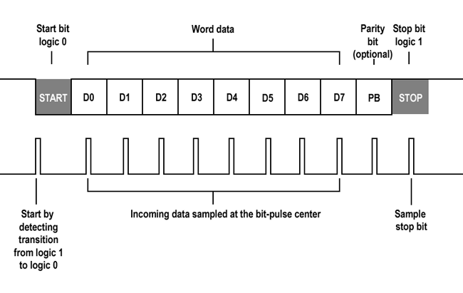

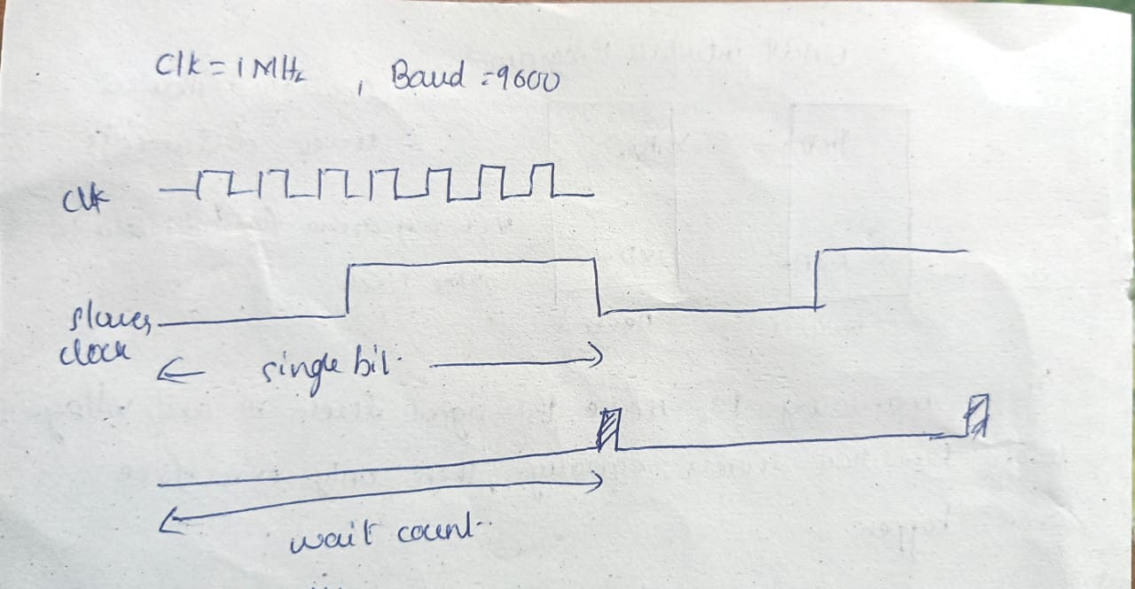

* Wait count = clk/baud rate

**UART Transmitter:**

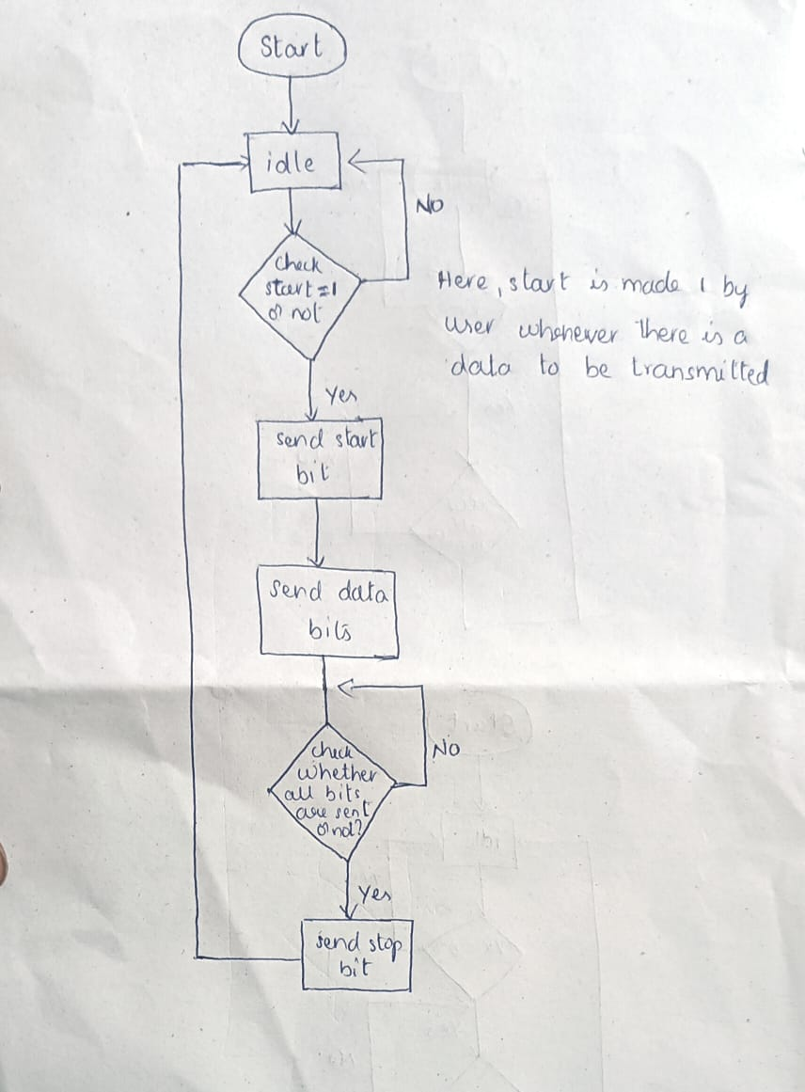

**UART Receiver:**

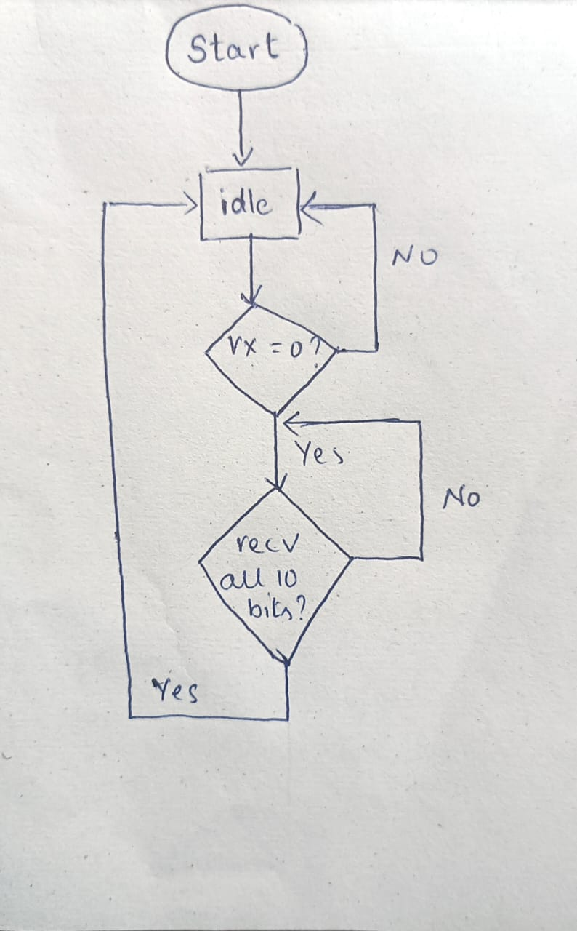

**Simulation Result:**

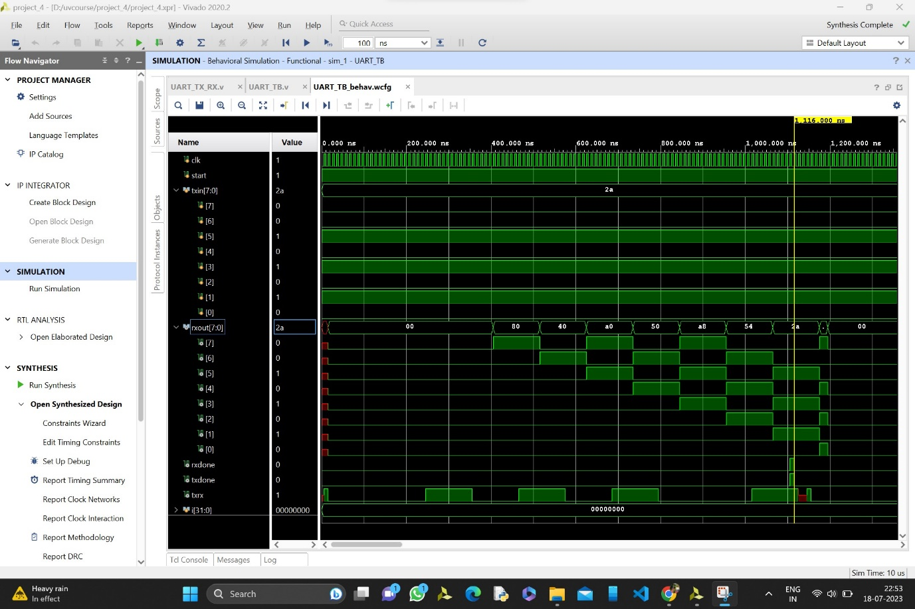

**Output:** Here, txin is equal to rxout.