WEB SECURITY TESTING REPORT
Project: Express REST API with PostgreSQL security controls
Final status: Tasks 1-14 implemented; key tests verified successfully

1. Project summary
This training project applies input validation, parameterized SQL queries, bcrypt password hashing, JWT authentication, role authorization, IDOR ownership checks, Helmet, restricted CORS, rate limiting, safe error handling, XSS controls, and secure logging. No real .env file or database credential is included in the submission.

2. Initial security review
Finding | Risk | Treatment
SQL injection | Critical | Changed all database input to parameterized queries.
Password exposure | Critical | bcrypt hashing and explicit safe response fields.
Missing authorization | High | Admin/customer middleware and 401/403 separation.
IDOR | High | Owner ID comparison before private records are returned.
Weak validation / XSS | High | Zod validation, limits, sanitization and Helmet CSP.
Secret leakage | High | .env ignored; example values are blank.
Unlimited login attempts | Medium | Login-specific rate limiter returns 429.

3. Required Postman tests
# | Test | Expected | Result
1 | Register new customer | 201 | PASS
2 | Duplicate email | 409 | PASS
3 | Valid login and JWT | 200 | PASS
4 | Wrong password | 401 | PASS
5 | Protected route without token | 401 | PASS
6 | Invalid token | 401 | PASS
7 | Customer attempts admin action | 403 | PASS
8 | Admin adds product | 201 | PASS
9 | Negative price | 400 | PASS
10 | Invalid email | 400 | PASS
11 | Unowned user IDOR | 403 | PASS
12 | Login attempt limit | 429 | PASS
13 | Unknown endpoint | 404 | PASS
14 | No password_hash in response | 200 | PASS
15 | Helmet response headers | 200 | PASS

4. Verified security evidence
The login evidence confirms that a JWT is returned while its value is hidden. The profile evidence confirms that password_hash is absent. The Helmet evidence shows Content-Security-Policy, X-Content-Type-Options and X-Frame-Options.
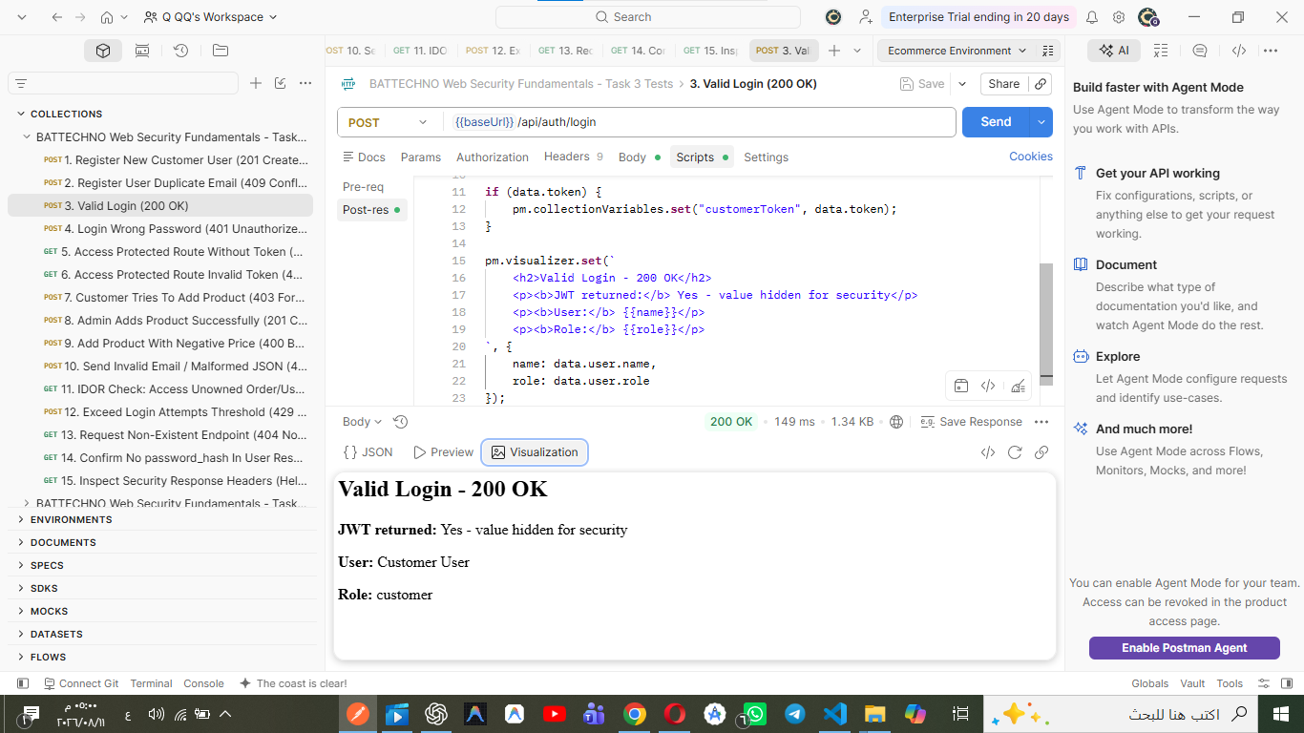
Figure 1 - Valid login: JWT returned with the value hidden.
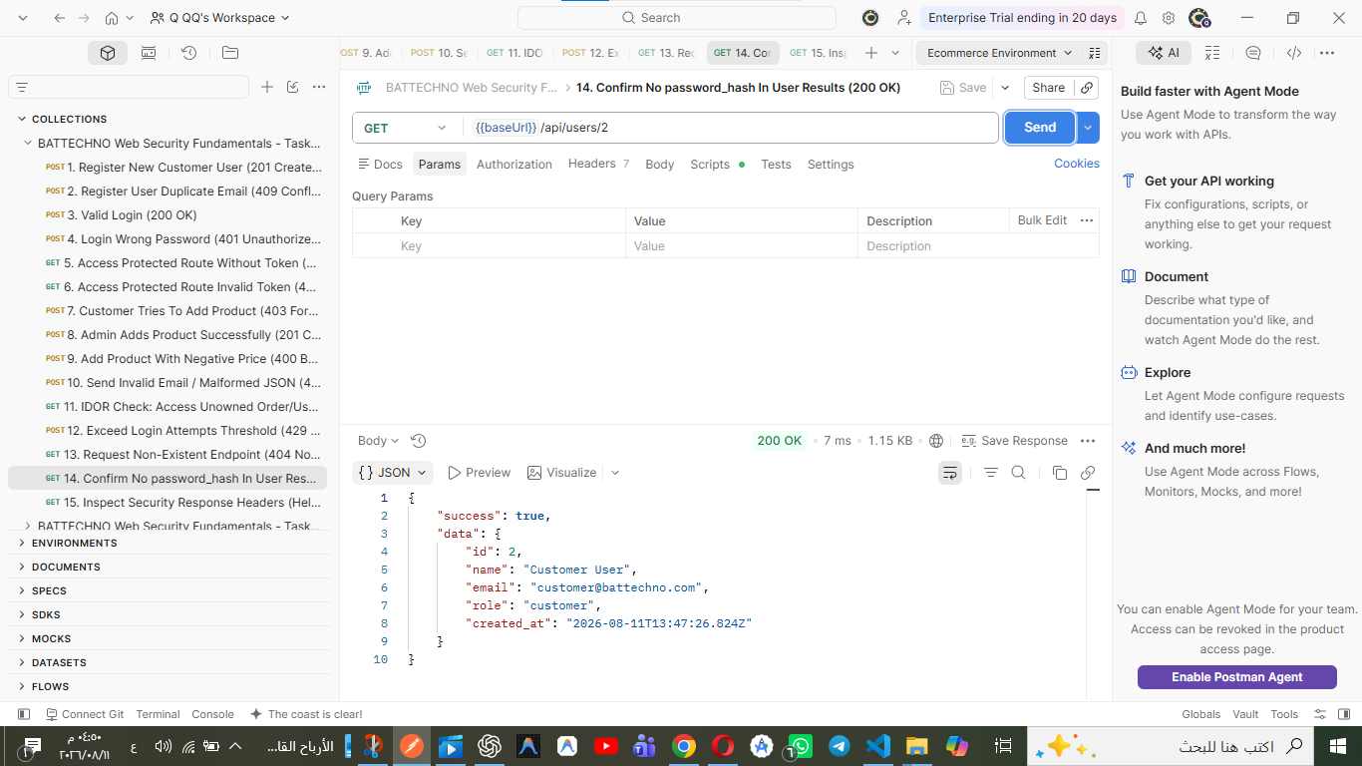
Figure 2 - User profile response without password_hash.
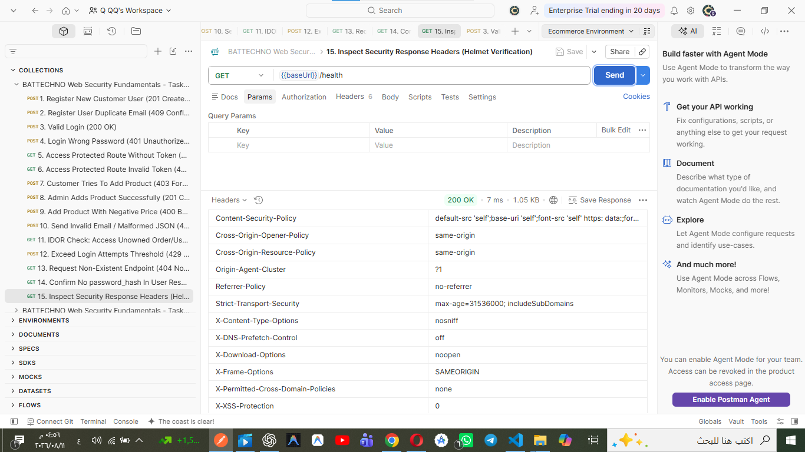
Figure 3 - Helmet security response headers.

5. Acceptance checklist
[x] API security controls do not disable the required functions.
[x] Parameterized queries, bcrypt and JWT are implemented.
[x] Role and ownership checks protect sensitive records.
[x] 401, 403, 404, 409 and 429 are used for the correct cases.
[x] Passwords, password hashes, SQL details and stack traces are not returned.
[x] Helmet, CORS and rate limiting are enabled.
[x] Postman JSON and real screenshots are included.
[x] .env and node_modules are excluded from the submission.

6. Final note
The GitHub URL is an external submission item. Add the repository URL to GITHUB_LINK.txt after pushing the same clean project folder. Do not push .env or replace the blank values in .env.example.

