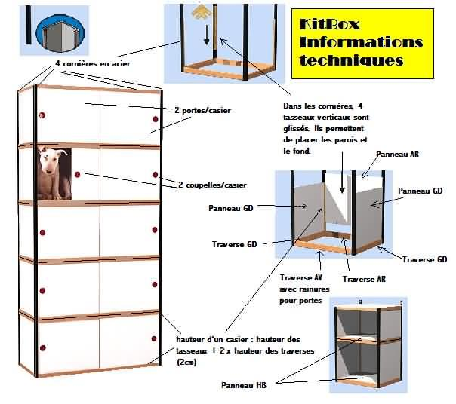

Height of a shelf: height of battens + 2 x height of crossbar(2 cm)

back panel

In the angle irons, 4 battens are placed.

4 angle bar in steel

4 steels angle irons

front crossbar

with

back crossbar

left crossbar

left panel

right crossbar

right panel

2 knop/ doors

2 doors/ cabinet = shelf

Armoire= a cabinet

Tiroir= drawer