**UNIVERISTY OF ENGINEERING AND TECHNOLOGY,**

**LAHORE**



**DEPARTMENT OF MECHATRONICS AND CONTROL ENGINEERING**

**MCT-313L Hydraulics and Pneumatics** **and MCT-338L Embedded Systems-II**

**Tiva-Controlled Lifter with Dual-Channel Valve (DCV) System for Enhanced Manipulation**

**Submitted by: 2021_MC_17**

**2021_MC_26**

**2021_MC_36**

**2021_MC_85**

**2021_MC_86**

**Submitted to: Dr. Ali Raza and Mr. Shujat Ali**

**Date: 9 Jan 2024**

|  |  |
| --- | --- |
| **TABLE OF CONTENTS**  **ABSTRACT** | **………………………………..3** |
| **Introduction**  **Background**  **Objectives** | **………………………………..4** |
| **System Design Overview**  **Rack and Pinion Mechanism** | **………………………………..4** |
| **Texas Instruments' Tiva Microcontroller**  **Power Supply Configuration**  **Utilization of 5/3 Directional Control Valve (DCV) for Rotational Movements**  **Integration of 5/2 Directional Control Valve (DCV) for Lifting Operations** | **………………………………..5** |
| **Overall Hydraulic working** | **………………………………..6** |
| **I/O Configuration for Control and Coordination**  **Output Pins (Relay Control)**  **Input Pins (Button Control)**  **Specific Functions** | **………………………………..6** |
| **Interrupt Handling**  **Dynamic Control**  **Debouncing** | **………………………………..7** |
| **Performance and Testing of the Advanced Mini Crane System**  **Load Capacity:**  **AC Motor Load Handling**  **Functional Testing:**  **Dynamic Control Evaluation**  **Reliability and Robustness** | **………………………………..7** |
| **Total Cost and Future Enhancements** | **………………………………..8** |
| **Conclusion** | **………………………………..8** |

**ABSTRACT**

This paper proposes a lifter designed with an advanced control system to maximize the handling and manipulation of materials. The lifter has a dual-channel valve (DCV) arrangement; a 5/2 DCV is used for lifting, while a 5/3 DCV is used for rotational duties. Relays enable the incorporation of Texas Instruments' Tiva microprocessor, which provides accurate and instantaneous control over the lifter's functions, hence augmenting its flexibility and responsiveness.

The 5/2 DCV system of the lifter allows for effective pneumatic or hydraulic control during lifting, and the 5/3 DCV allows for accurate rotational movements. The lifter can be used for jobs that need simultaneous lifting and rotating because of the smooth synchronization between these two systems. The lifter's overall performance is improved by Tiva microprocessor technology, which provides flexibility and ease of integration into a variety of industrial processes. The lifter's capacity to perform intricate moves and react quickly to external commands makes it an invaluable tool for applications requiring a high level of efficiency and precision.

In conclusion, the lifter that has been presented is a versatile instrument that can be used in a variety of industrial applications. Its 5/2 and 5/3 DCV system, which is controlled by Tiva microcontroller technology, provides a state-of-the-art solution for obtaining greater precision in material handling and manipulation.

**Introduction**

**Background**

In response to the challenge of advancing a project from our Hydraulics and Pneumatics Applications textbook, our team undertook the enhancement of a lifter, transforming it into a versatile mini crane. Our innovation was made possible by the original lifter, which served as the foundation for it. We then developed a rack and pinion mechanism and a 5/3 Directional Control Valve (DCV) through careful design. This clever integration gives the lifter the capacity to spin and establishes it as a very versatile micro crane that can perform a variety of jobs.

An essential component of this sophisticated lifter-mini crane's operation and management is the Tiva microcontroller from Texas Instruments. The Tiva microcontroller serves as the lifter's central nervous system, allowing accurate and real-time control of the numerous hydraulic and pneumatic components. It is interfaced with the lifter's control systems by relays. The continuous connection between the 5/2 DCV, which controls vertical motion, and the 5/3 DCV, which governs rotating movements, is ensured by this integration.

**Objectives**

Enhance Lifter Functionality:

Integrate a rack and pinion mechanism to enable controlled rotational movements.

Implement a 5/3 Directional Control Valve (DCV) to facilitate precise rotational control of the lifter.

Optimize Vertical Motion:

Introduce a 5/2 DCV system to enhance the lifter's efficiency in controlled up and down motions.

Integrate an AC motor-driven rod for precise vertical control and manipulation of lifted items.

Seamless Coordination with Tiva Microcontroller:

Utilize Texas Instruments' Tiva microcontroller to serve as the central control unit for the lifter.

Ensure effective communication between the Tiva microcontroller, rack and pinion mechanism, and DCVs through the implementation of reliable relays and communication protocols.

**System Design Overview**

The system design of our advanced mini crane involves the integration of key components to ensure control.

**1. Rack and Pinion Mechanism:**

The introduction of a rack and pinion mechanism forms the backbone of the rotational capabilities of the mini crane. This mechanical arrangement ensures controlled and precise rotational movements, allowing the mini crane to perform a variety of tasks beyond simple lifting.

**2. Texas Instruments' Tiva Microcontroller:**

The Tiva microcontroller serves as the central control unit, interfacing with various components to ensure coordinated and efficient operation. It generates signals that actuate the relays, controlling the flow of power to the DCVs and the AC motor.

**3. Power Supply Configuration:**

The system relies on four external power supplies, each catering to specific voltage requirements:

3.3 V Supply for Tiva Microcontroller:

This low-voltage supply ensures the proper functioning of the Tiva microcontroller, allowing it to generate signals for relay activation.

5 V Supply for Relays via LM7805 Voltage Regulator:

The relays, crucial for energizing the DCVs, are powered by a stable 5 V supply achieved through an LM7805 voltage regulator.

24 V, 1 A Supply for DCVs:

The 24 V supply provides the necessary power to activate and control the DCVs, facilitating both rotational and vertical movements.

220 V Supply for AC Motor:

The AC motor, responsible for driving the rod and manipulating items during lifting operations, is powered by a standard 220 V supply.

**Utilization of 5/3 Directional Control Valve (DCV) for Rotational Movements:**

The decision to incorporate a 5/3 DCV for controlling the rotational movements of the mini crane was driven by its unique feature of a middle rest position (P0). This design characteristic allows the mini crane to retain its midway position when the operation is stopped. Unlike conventional DCVs that return to their initial position, the 5/3 DCV's middle rest position enhances operational flexibility.

**Benefits:**

Midway Position Retention: The 5/3 DCV ensures that the mini crane can pause and maintain its current position without necessitating a return to the starting point when the operation is halted.

Improved Operational Efficiency: The middle rest position facilitates smoother transitions between rotational movements, enhancing overall operational efficiency.

**Integration of 5/2 Directional Control Valve (DCV) for Lifting Operations:**

For lifting operations, where the motion is binary—either lifting or at rest—a simplified 5/2 DCV was deemed optimal. This choice streamlines the lifting process, providing a straightforward control mechanism for the vertical motion of the mini crane.

**Benefits:**

Efficiency in Vertical Motion: The lifting process inherently involves only two states—lifting or resting. The 5/2 DCV simplifies the control, ensuring swift and efficient vertical motion.

Precise Control: The binary nature of lifting operations allows for precise control over the lifter's upward and downward movements.

**Overall Hydraulic working**

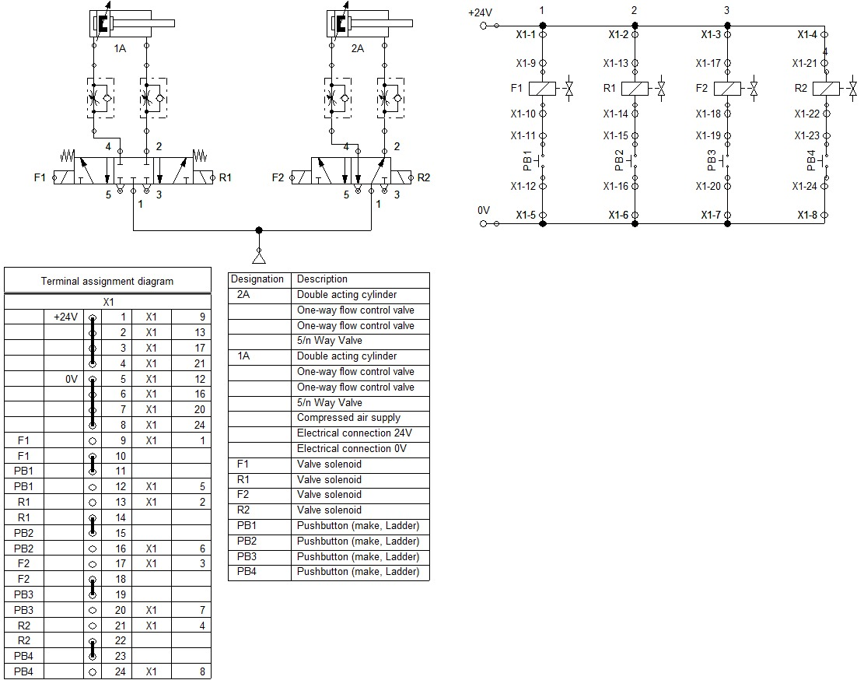

**I/O Configuration for Control and Coordination**

In our advanced mini crane system, we have strategically configured the GPIO pins of Port B to facilitate effective control and coordination. This configuration includes 8 pins, with the first 4 serving as output pins connected to relays, and the last 4 functioning as input pins for button control. The allocation of specific functions to each pin ensures seamless control over the directional control valves (DCVs), enhancing the versatility of the mini crane. The detailed pin assignments and their corresponding functions are outlined below:

**Output Pins (Relay Control):**

PB0, PB1, PB2, and PB3 are configured as digital output pins, controlling the relays connected to the directional control valves (DCVs).

**Input Pins (Button Control):**

PB4, PB5, PB6, and PB7 serve as digital input pins, receiving signals from buttons that dictate specific actions.

**Specific Functions:**

* PB4 input corresponds to PB0 output, controlling the forward motion of the 5/3 DCV.
* PB5 input corresponds to PB1 output, controlling the reverse motion of the 5/3 DCV.
* PB6 input corresponds to PB2 output, controlling the forward motion of the 5/2 DCV.
* PB7 input corresponds to PB3 output, controlling the reverse motion of the 5/2 DCV.

**Interrupt Handling:**

External interrupts on PB4, PB5, PB6, and PB7 trigger the GPIOB_Handler function, enabling real-time response to button presses.

**Dynamic Control:**

The mini crane's behavior is dynamically controlled based on the state of the buttons, allowing for versatile and user-friendly operation.

**Debouncing:**

The delay_ms(5000) function introduces a delay of 5000 milliseconds (or 5 seconds) after clearing the interrupt flags. This duration is chosen to provide sufficient time for mechanical bouncing to settle before evaluating the button's state.

Following the delay, the control logic checks the state of the button (pressed or released) and executes the corresponding actions accordingly. The delay allows the system to wait for the physical button to settle into a steady state before proceeding with further processing.

**Performance and Testing of the Advanced Mini Crane System**

The performance and testing phase of the advanced mini crane system involves evaluating its functionality, responsiveness, and load-bearing capabilities. Rigorous testing ensures that the system meets design specifications and operates reliably in various scenarios.

**1. Load Capacity:**

The mini crane is designed to handle a maximum load of 500 grams for the arm. This load limit ensures safe and efficient operation without compromising the structural integrity of the system. Testing involves verifying that the crane can lift and maneuver loads within this specified range.

**2. AC Motor Load Handling:**

The AC motor responsible for lifting is designed with a load capacity that is less the maximum load of the arm. This provides a safety margin, ensuring the motor operates comfortably within its capacity for an extended lifespan. We lost one AC motor due to our load testing experiments and for safety purposes we can say that the max ac moto load is about 100 grams. Testing involves assessing the motor's performance under different load conditions to ensure stability and reliability.

**3. Functional Testing:**

Each component of the mini crane, including directional control valves (DCVs), relays, and the Tiva microcontroller, undergoes functional testing. This includes checking the forward and reverse motions of both the 5/3 DCV and the 5/2 DCV. Testing involves verifying that the system responds accurately to user inputs and performs the intended actions.

**4. Dynamic Control Evaluation:**

The dynamic control mechanism, facilitated by external interrupts and button presses, is thoroughly evaluated. Testing involves simulating various user scenarios to ensure that the mini crane responds promptly and accurately to control inputs. The debouncing delay implemented in the code helps maintain stable control, preventing unintended triggers.

**5. Reliability and Robustness:**

The mini crane undergoes testing under diverse conditions, including continuous operation and varying load conditions. This phase assesses the reliability and robustness of the system, ensuring it can withstand extended usage and challenging scenarios without encountering issues.

**Total Cost and Future Enhancements**

The total cost of developing the advanced mini crane system amounted to Pkr 6000, encompassing materials, and components. This investment ensured the integration of robust and reliable components, meeting design specifications and safety standards. Looking towards future enhancements, a potential upgrade involves the incorporation of a pneumatic motor to control the sway of the string attached to the AC motor during lifting operations. This enhancement aims to further refine the precision and stability of the mini crane, reducing oscillations and enhancing overall control. By introducing pneumatic control for sway, the system could achieve smoother and more controlled lifting motions, contributing to increased efficiency and versatility in handling diverse loads. This future enhancement aligns with our commitment to continuous improvement and innovation, positioning the mini crane as an adaptable solution for evolving lifting challenges in various applications.

**Conclusion**

In conclusion, the development of the advanced mini crane system has yielded a sophisticated and versatile solution for controlled lifting operations. With a total investment of Pkr 6000, the system showcases a meticulous integration of components, emphasizing reliability, safety, and user-friendly operation. The utilization of directional control valves (DCVs) and a Tiva microcontroller, coupled with a rack and pinion mechanism, has resulted in a system capable of precise and dynamic control. The implementation of external interrupts and button-based user interaction enhances the mini crane's responsiveness and adaptability. Rigorous testing, including load capacity assessments and functional evaluations, ensures that the system meets design specifications. Looking ahead, the prospect of incorporating a pneumatic motor to control string sway presents a promising avenue for future enhancements, aligning with our commitment to continuous innovation. The mini crane stands as a testament to our dedication to engineering excellence, providing a reliable and efficient solution for a wide range of lifting applications.