Part 1:

1-

2-

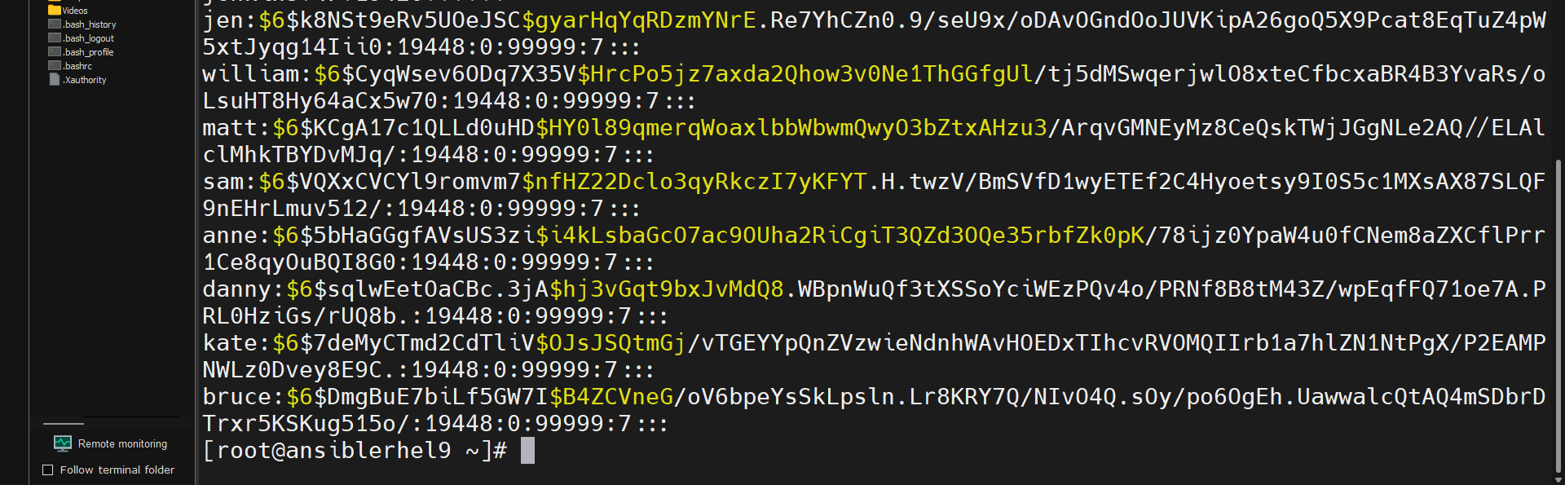

3-

4-

5-

Part 2:

1-3 ( grep nobody | /etc/passwd )

4-

Part 3:

1-

2-

3-

Part 4:

1-

2-

3-

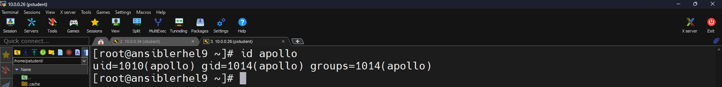

4-

5-

6-

7-

What to do with this group id in our system?

8-

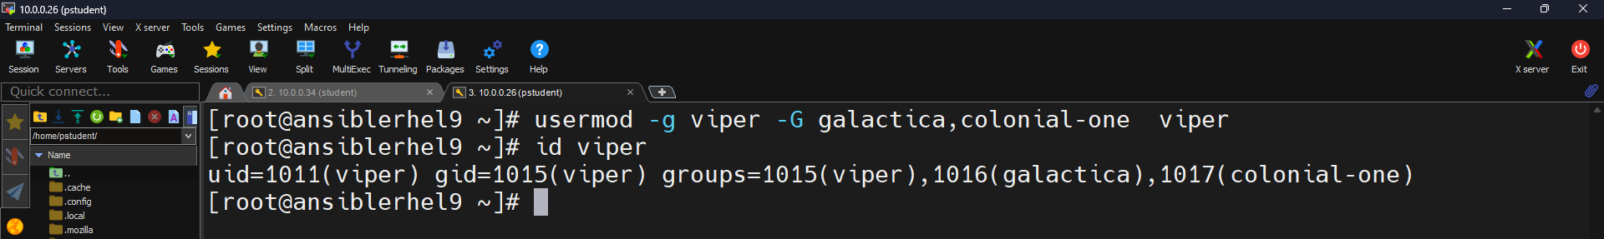

9-

10-

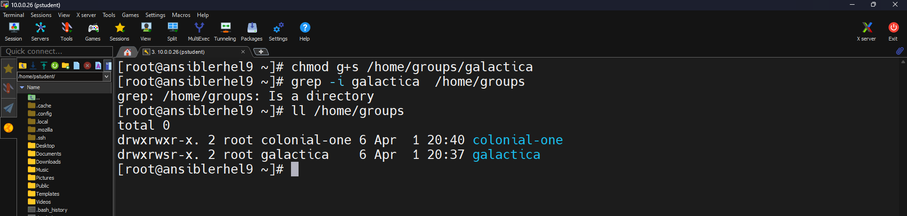

11-

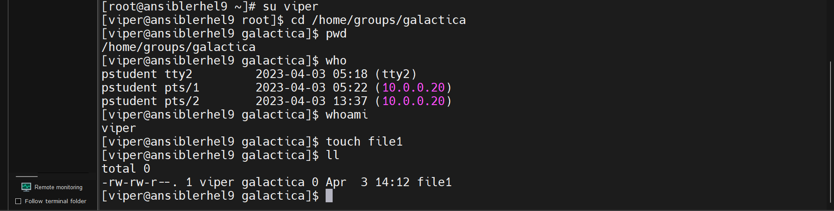

12-

