Part 1:

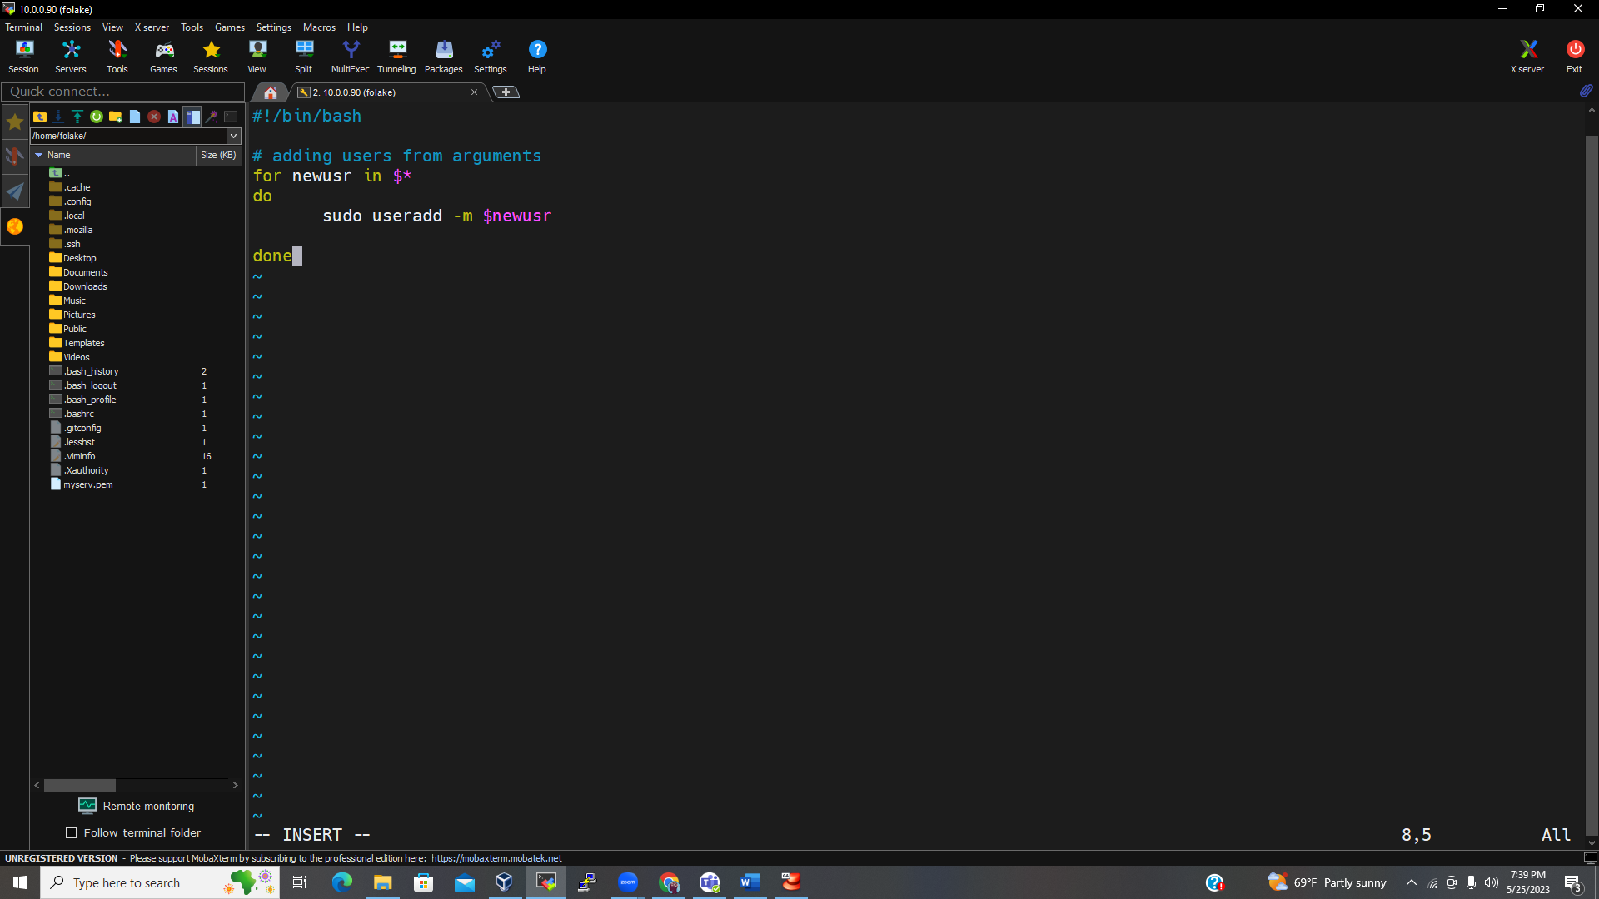

Here in rhel 9 the script needs to be run as root because the passwd command uses the standard input option

Part 2

Deleting users

