**Project 18**

**Part 1: Stratis**

In this lab, you're a sysadmin who needs to understand what Stratis is, and how it can be implemented, on your server systems for storage use. You'll install Stratis, prepare disks for use in a Stratis pool, create a pool and filesystem, and then mount and check function on that filesystem using stratis command line tools.

You'll then add more disk space into the Stratis pool, take a snapshot of the Stratis filesystem before deleting a file, and then restore the filesystem via mounting the snapshot.

Red Hat Exam Requirements Covered:

**Manage layered storage**.

Access a shell prompt and issue commands with correct syntax.

**Prerequisite:**

Add 3 disk with 2G each to your rocky 8 server.

**Tasks 1:** Create and Mount a Stratis Pool and Test Functionality

1. Query for available disks.
2. Install Stratis and its tools. Make sure statisd service is running .
3. Prepare disks for use in Stratis.
4. Create a Stratis pool pool_linux and filesystem fs_linux on disk1.
5. Create mountpoint /mnt/stratisfs
6. Mount and confirm its function well.

**Tasks 2:** Persistently Mount and Monitor a Stratis Filesystem

1. Confirm Stratis pool and filesystem function.
2. Configure Stratis storage to be available persistently.
3. Confirm Stratis storage will be persistent.
4. Use Stratis utilities to gather pool and filesystem information.

**Tasks 3:** Grow, Snapshot, and Recover a Stratis Filesystem

1. Verify Stratis storage space.
2. Add space to the Stratis pool pool_linux and filesystem fs_linux by extend them with the rest of disk2 and disk3.
3. Create directory dir1 and file1 inside mountpoint /mnt/stratisfs
4. Snapshot the Stratis pool_linux fs_linux storage with snapshot name fs_linux-snapshot.
5. Mount the snapshot on mountpoint /mnt/snapshot and verify the snapshot
6. Delete data from /mnt/stratisfs and use the snapshot to recover.
7. Validate your work survive reboot

**Part 2: Managing Storage Using LVM on VDO on RHEL 8**

In this lab, you are a sysadmin who has been told to go check out "that VDO thing" that everyone is talking about, and find out how to set it up, how it works with disks and LVM, and what happens when you copy data to a VDO-based filesystem.

You'll be verifying VDO is working, creating a VDO volume, and then using that VDO volume as the basis for an LVM volume, which will contain an XFS filesystem and eventually some test data. You're looking to see what happens when multiple copies of the same or similar data is put on the disk, and from there, get an idea of how good the compression and deduplication works.

As an added bonus, you'll be using a script that automates the copying of multiple similar data sets, and you'll also be building a quick log file that will help you keep track of the statistics you are getting from your experiment.

Prerequisite:

Add two disks of 5GB to your rocky 8 servers

**Tasks1**: Setting Up an XFS Filesystem via LVM on a VDO Volume

1. Verify VDO is installed.
2. Create a VDO volume on first disk with a size of 15GB.
3. Configure the VDO volume as an LVM physical volume.
4. Create a Volume Group on top of your VDO volume.
5. Create a Logical volume with 100% free space.
6. Create an XFS filesystem.
7. Mount the filesystem persistently on /mnt/data/vdo_data1.
8. View VDO and filesystem statistics.
9. Make sure your VDO filesystem survive reboot.

**Tasks 2**: Investigate Space Savings on a VDO-based Filesystem

1. Create a script to test the space savings.

Note: Duplicate your screen to view results

Screen 1: run below command

#watch vdostats --human-readable

1. Use the script to copy 100 instances of data on screen 2.

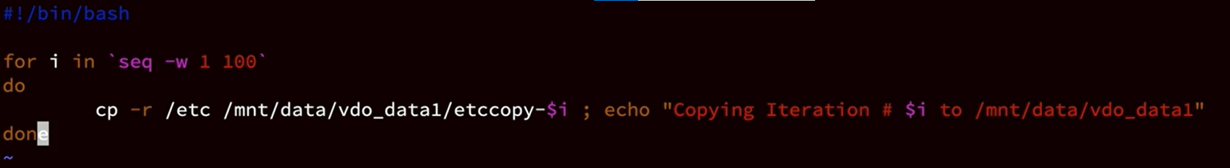

1. View the space savings on the Filesystem.