**Task 1**

1-3

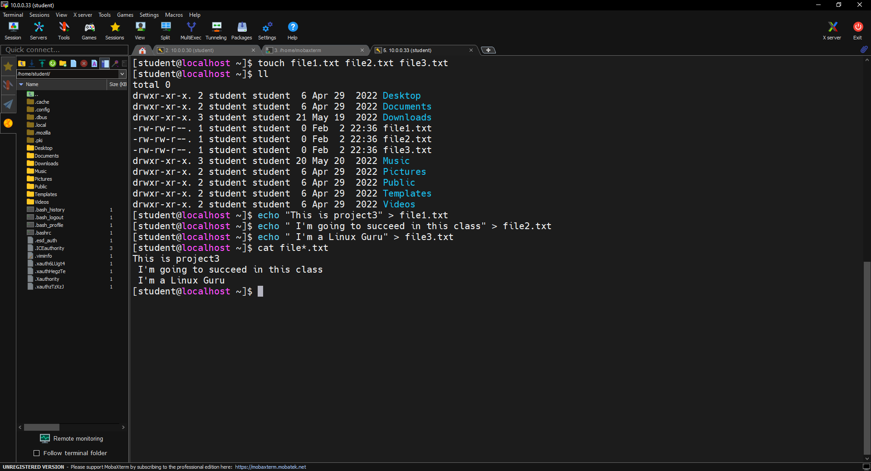

4-6

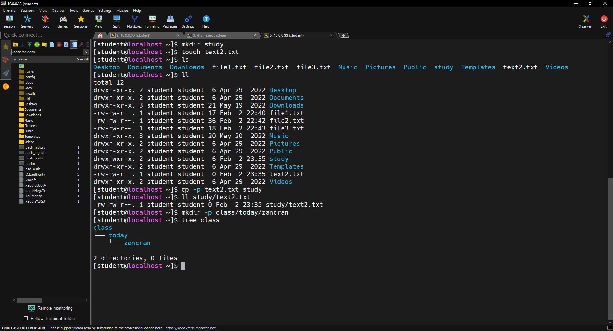

7-

8- I used sudo to move rename.txt because only the owner (root) of the mount point directory **mnt** has writing permission on mounted filesystems or devices.(drwxr-xr-x)

9-

10-

empty /tmp/

11-

12-

13- do not have to use -a for the second group ( a is for append)

14- do not have to use -n

15-

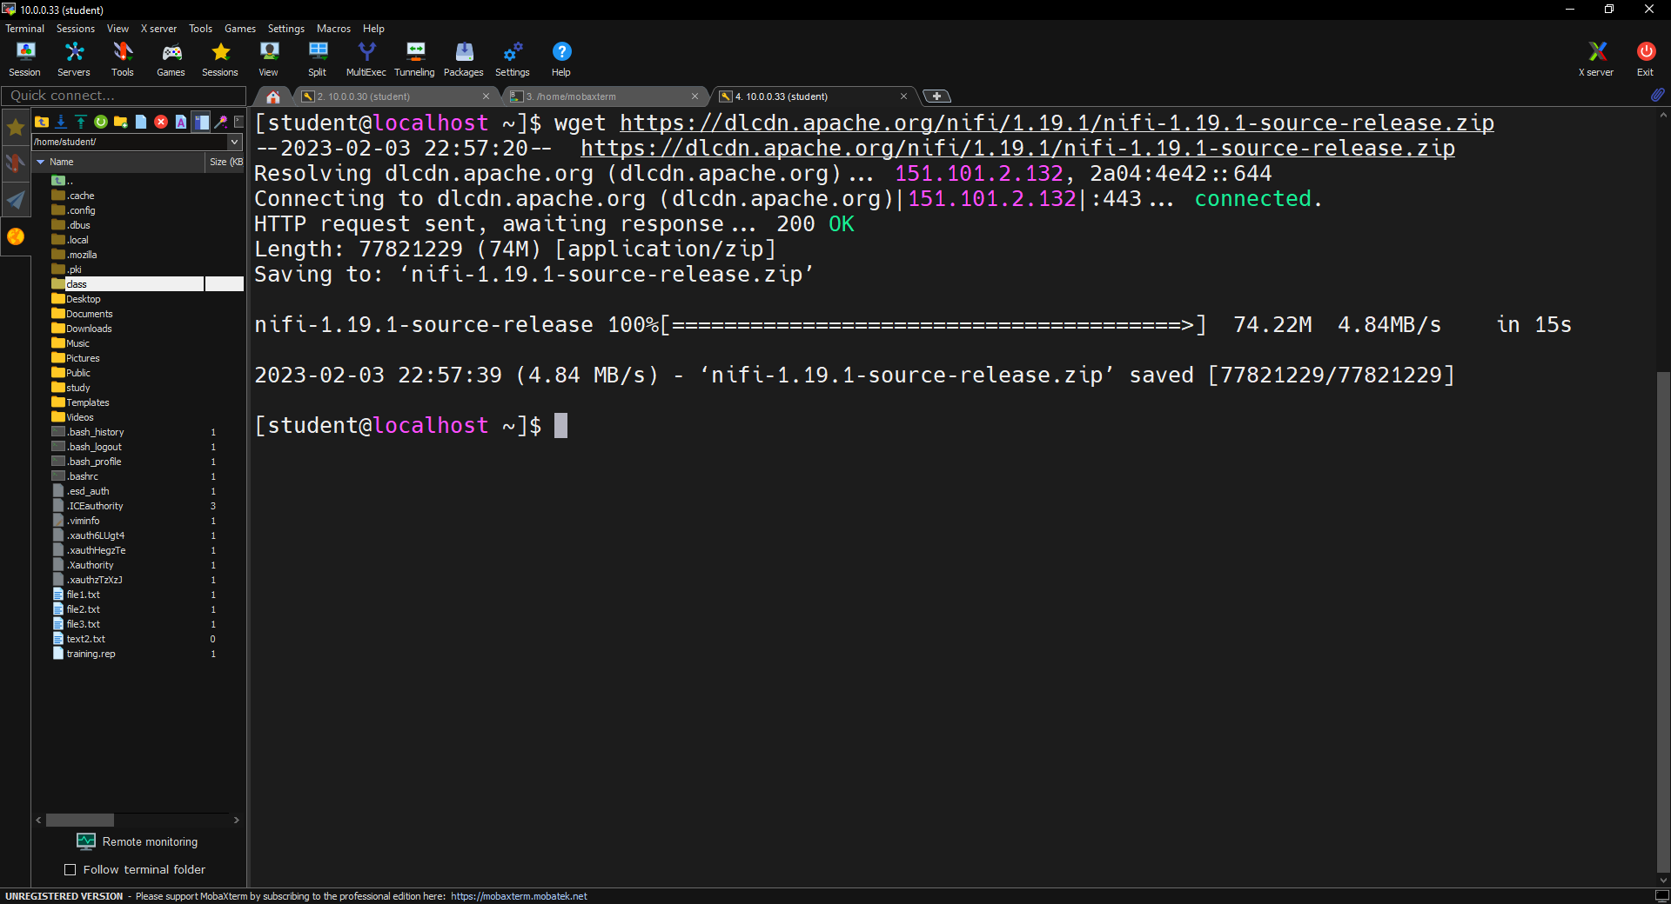

16-

Use winscp or mobaxterm download button

**Task 2**

1-

Encrypted password school1

2-

**Kernel: (what is linux kernel redhat)**

It is a low-level operating system handling files, disks, networking, and other necessities. The kernel is indispensable for a working Linux system.

**IP:**

It provides packet addressing and routing within a network of end system hosts (PC, laptop, mobile devices, servers, ..etc.). For data to be sent from one IP network to another, it must be forwarded by a router or an intermediate system.

**Default gateway:**

It is the IPv4 address of a router to which packets destined for a remote network should be sent by default. Most hosts are configured with a default gateway parameter.

**DNS:**

Domain name system servers provide host and domain names resolution to their IP addresses and are essential for locating resources on the internet.

**Router:**

It is a device or system using internet protocol to interface the private LAN and the public WAN. Where a switch forwards a frame using MAC addresses (hardware), a forward router packets around an internetwork using IP addresses.

**Subnet:**

Like the internet, the subnet is a network inside a network, making the network more efficient. It allows network traffic to travel a shorter distance without passing through unnecessary routers to reach its destination. Thus, the subnet mask is configured with the IPv4 address.

3-

Switches are modern hardware network devices designed to fix the collision domain issue experienced with legacy network hubs. In effect, the circuitry in the hub repeats an incoming transmission from a computer attached to one port across all the ports. Unlike hubs, ethernet switches can decode each frame and identify the source and destination MAC addresses.

4-

# ping 192.168.1.25

5-

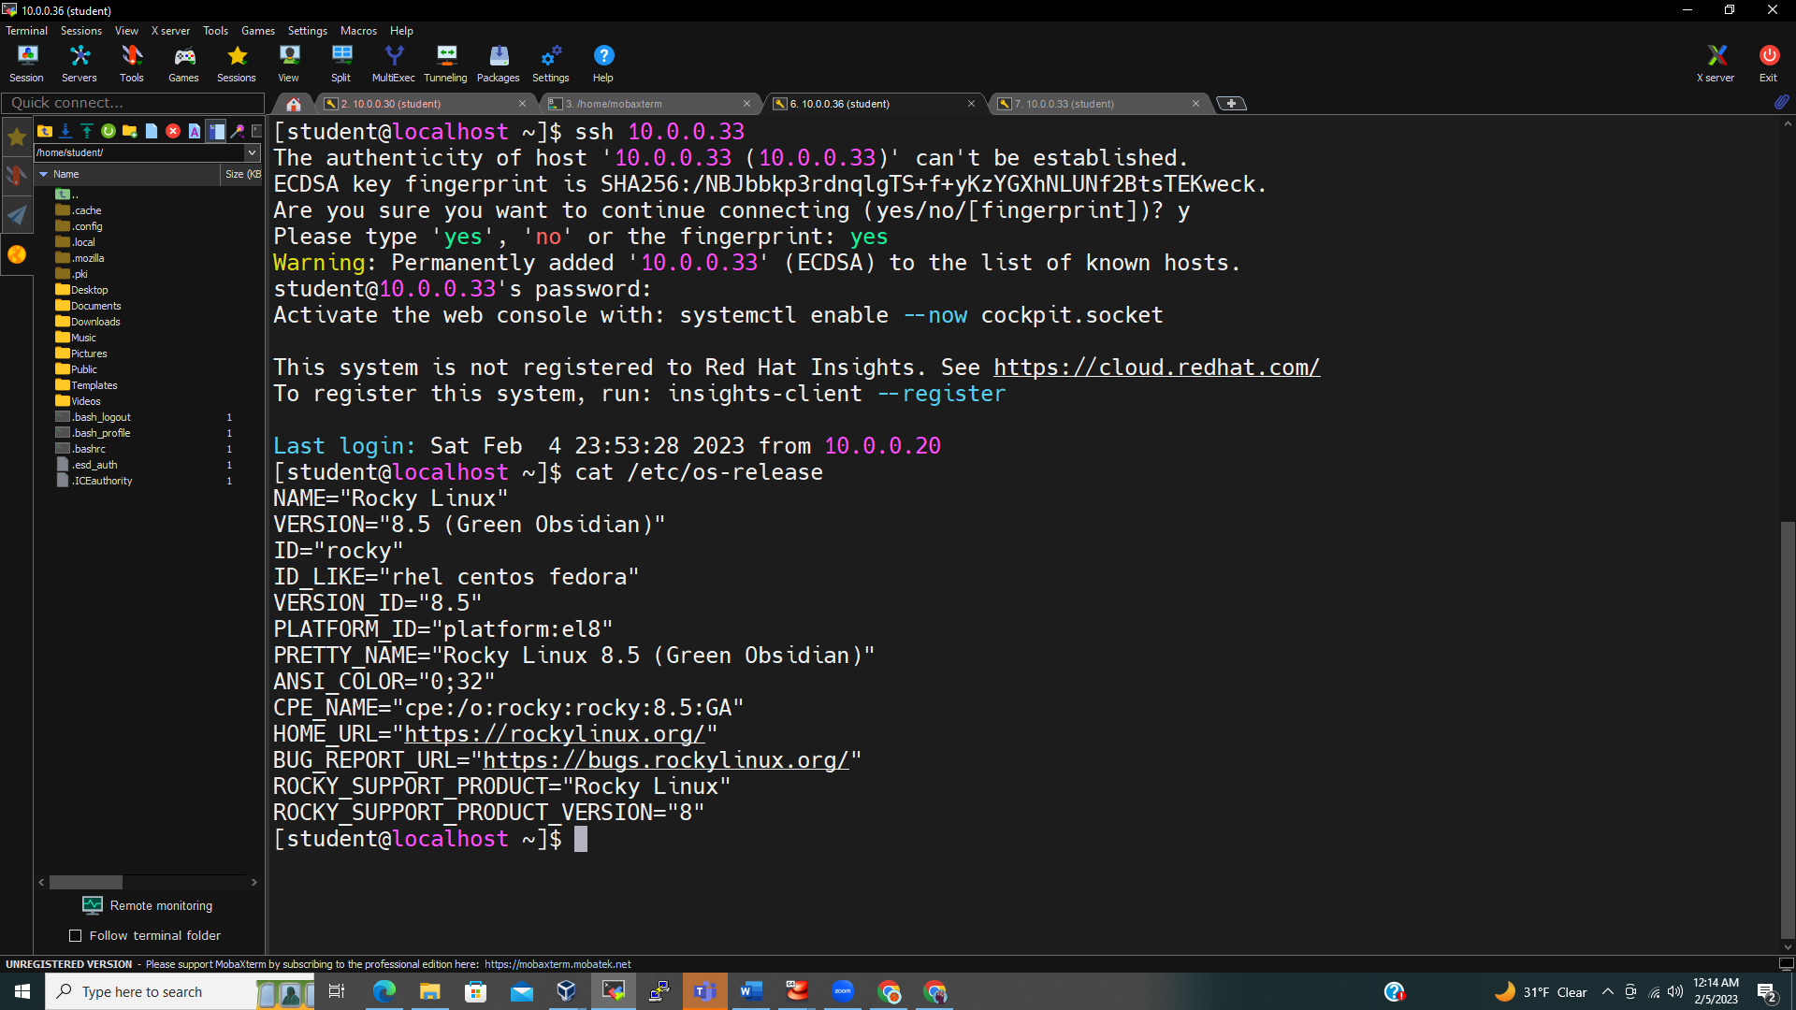

6-

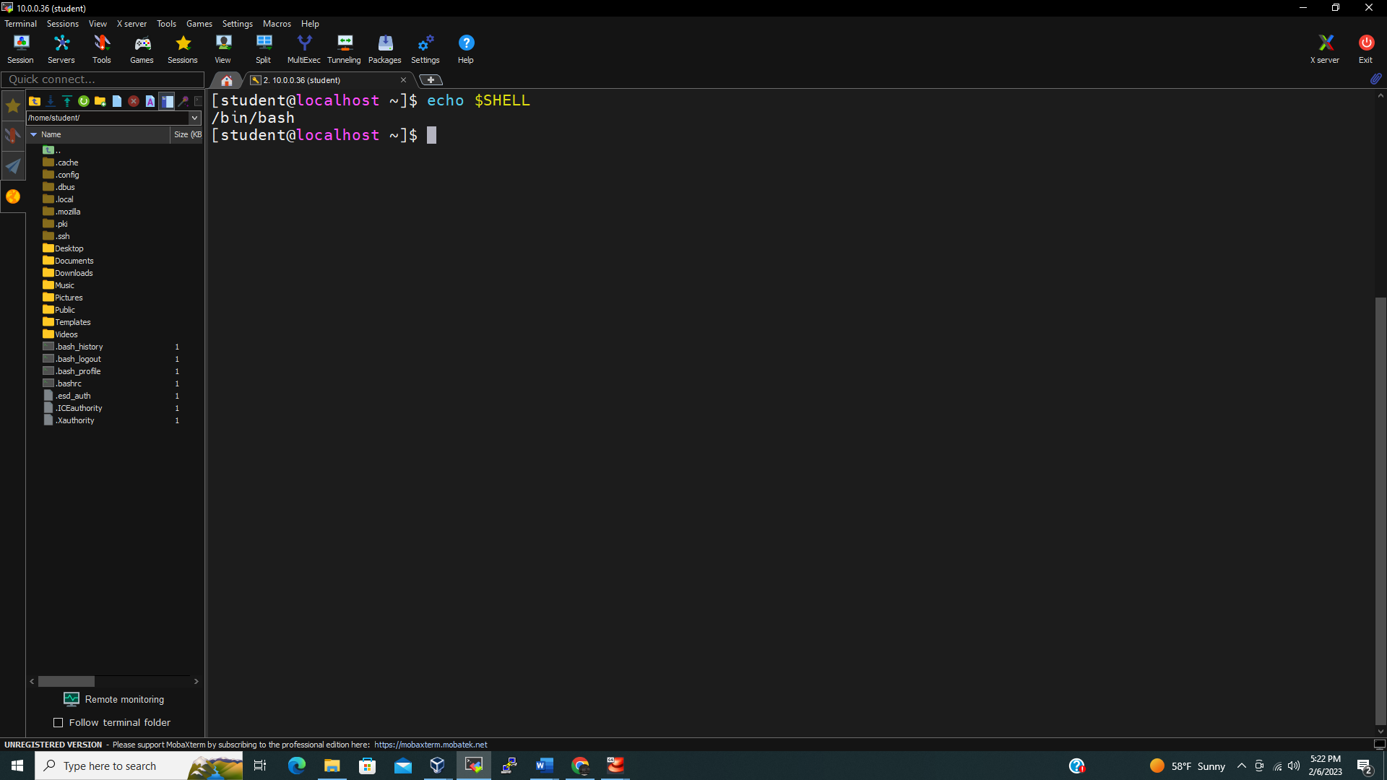

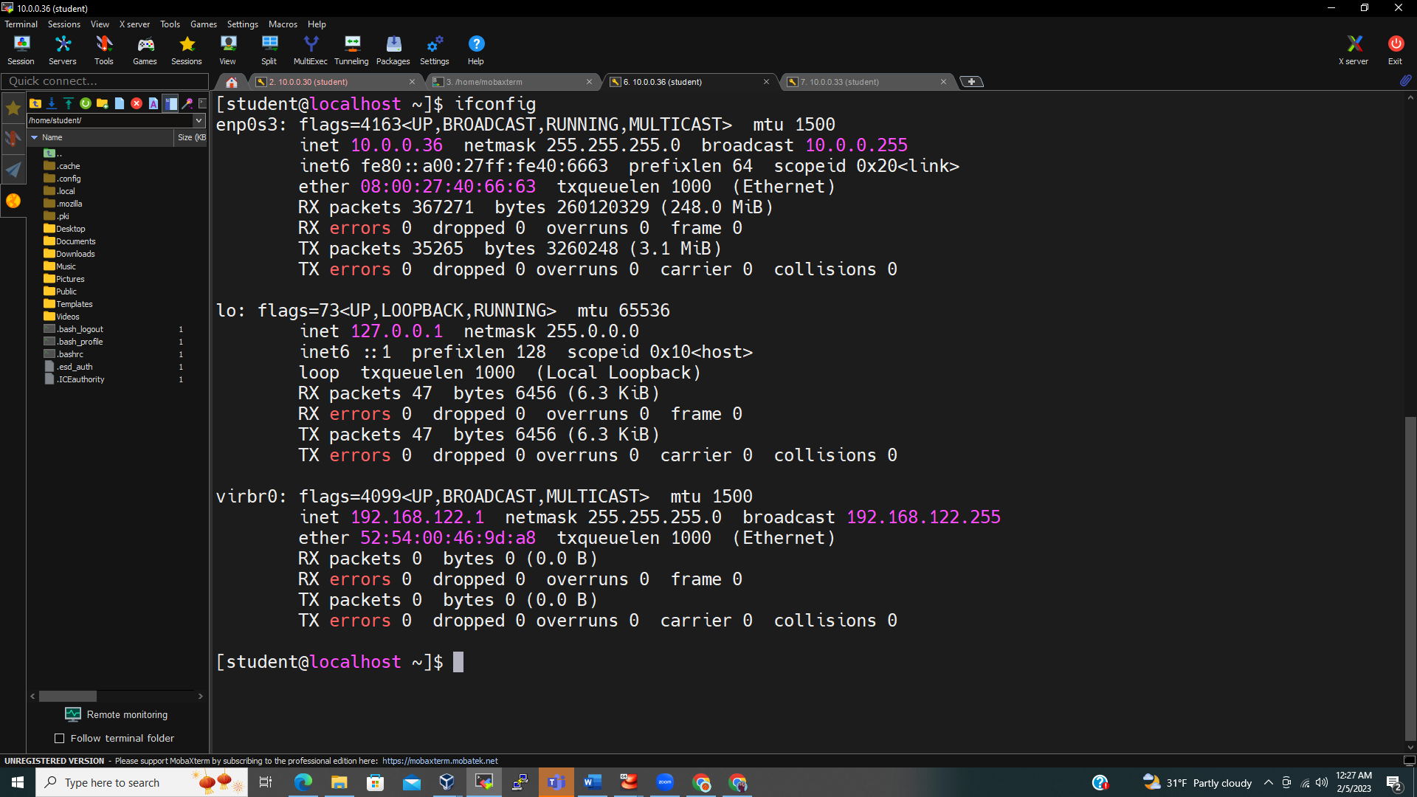

Rhel.project3.com IP 10.0.0.33 differ from 172.156.42.170, which appears to be a public IP. The rhel.project3.com IP 10.0.0.33 is among the class A private address range. (The first octet value 10 is between 0-127). The number of hosts is , with n number of host bits. The mask 255.255.255.0 has 8 zeros bits as host bits. Hence, the total number of host is

