Part 1: Linux Essential tools

1. Cat /etc/os-release

There are lot of release files in the system, but here we want to identify the release files related to the Linux distribution.

View previous listed releases files (configuration, systems, security).

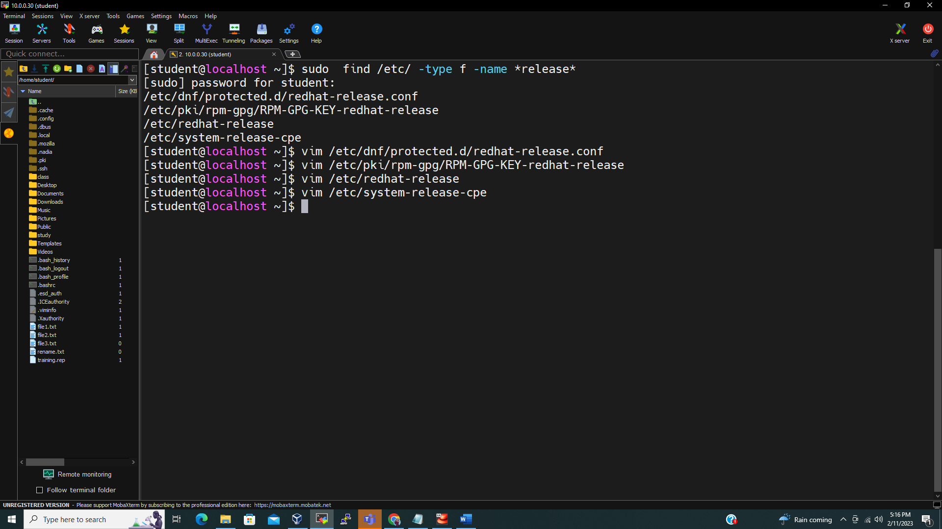

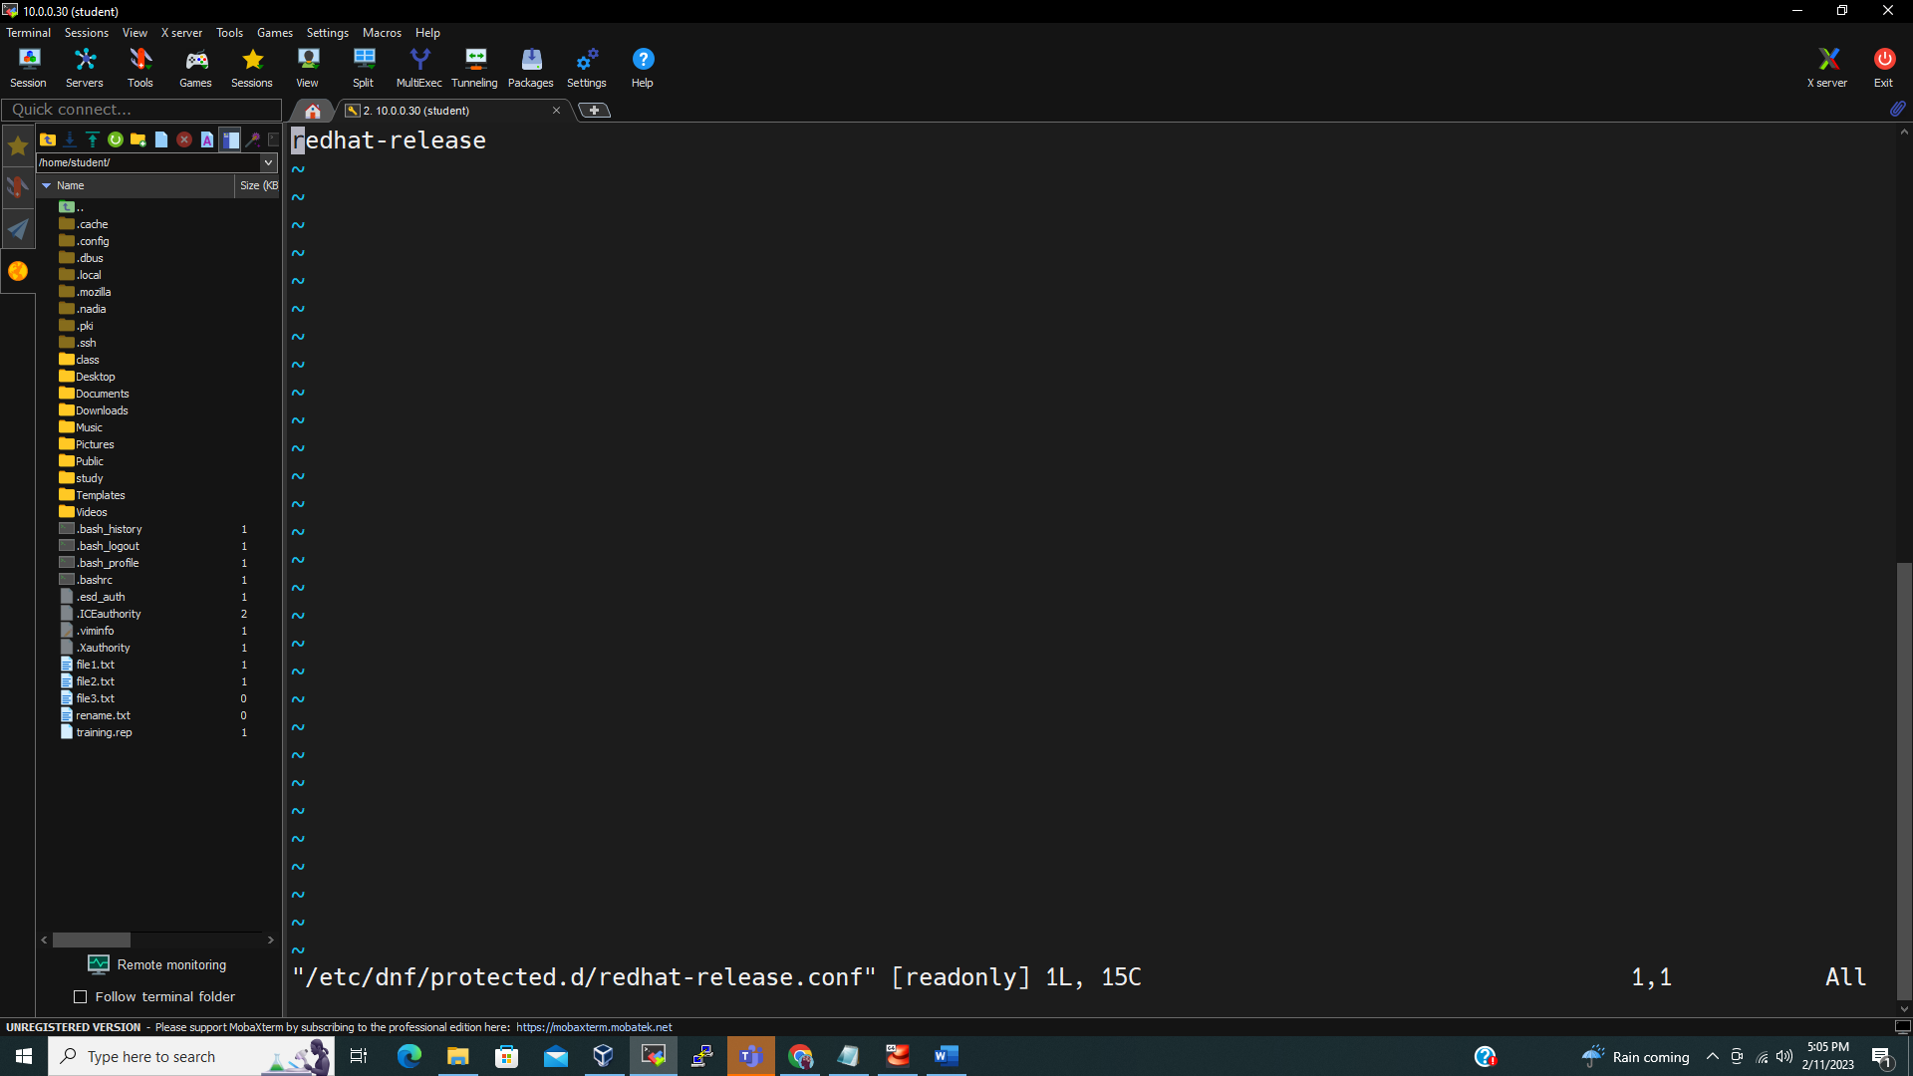

2-

View issue files (pre-login message and identification file).

1. Uname -r

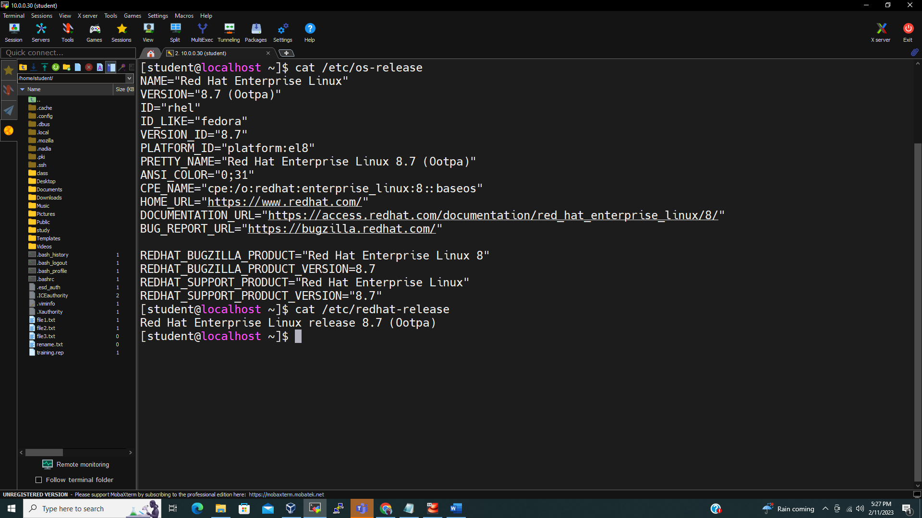

4-

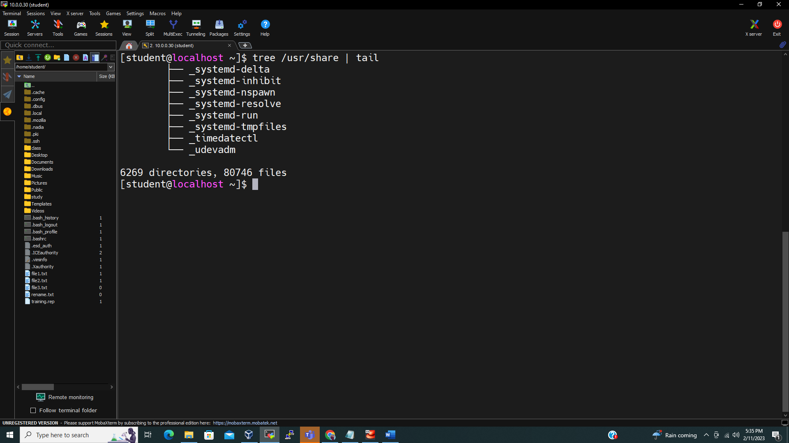

5-

6-

I switch to root user to write on /var.

7- for date you need to format date with D

uname -a

View Project4.txt

Part 2 : Getting hardware information from command line

1-

Lscpu for the cpu speed

Free -h | grep -i Mem ( how much ram installed)

Free -h | grep -i swap ( how much swap used)

Dmidecode | grep -i version

View hw_questions.txt

