Part 1

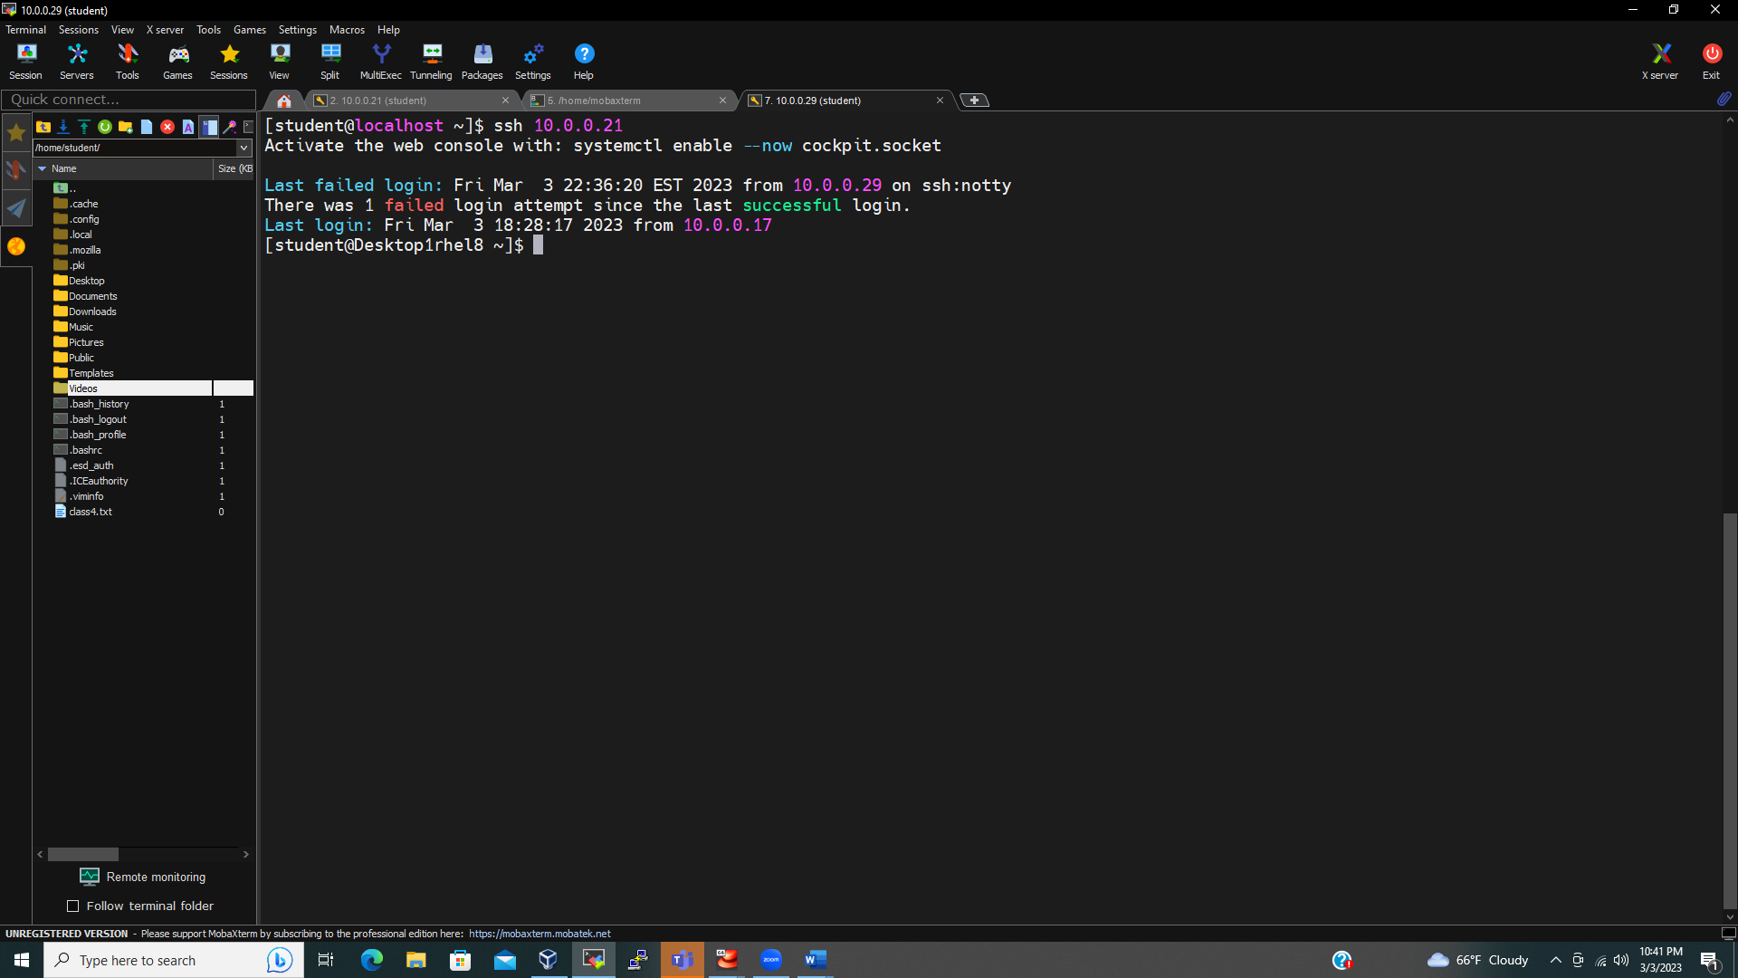

Part 2:

1-3

4-5

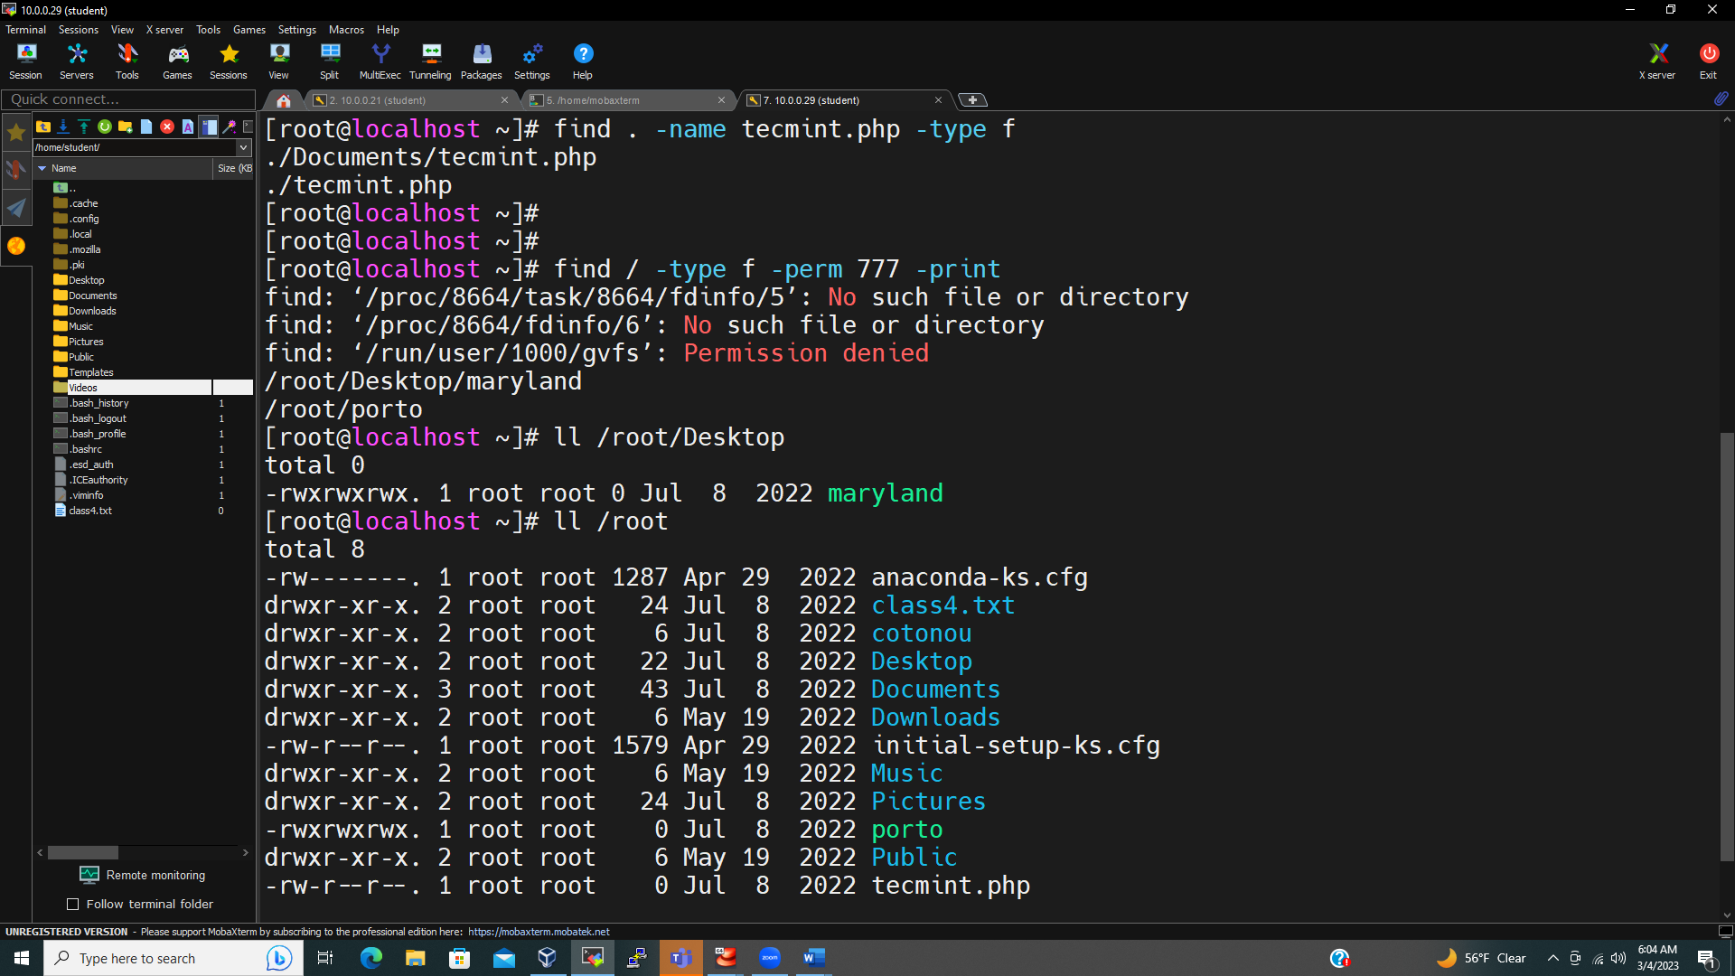

6-

7-8

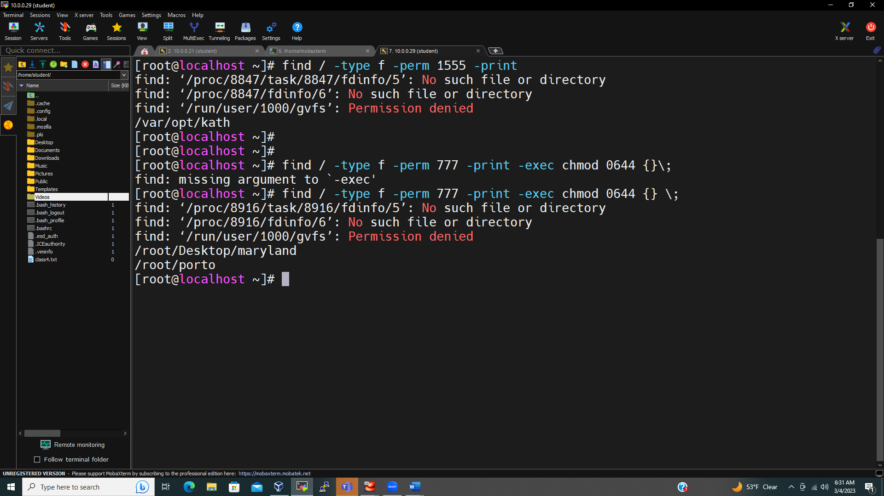

9-

10-

