Integration of Autopsy with Existing Company Software
Prepared for Byron Williams, general manager
by Karl Smink, Zaq Widdows, and Joseph Sommer, software analytics dept.
April, 2017
SeemsLegit training company

To ensure maximum cohesion and value of the new software we discussed, it is imperative for both the new platform and the existing one to be stable, secure, and reliable.

During the next quarter, please collaborate with our software security experts on site to ensure our existing platform is being held similar standards. This will prevent production delays and reduce headache and hassle for everyone involved on the project. These items should be considered before integration can begin:
- Up front cost
- Labor costs for dedicated maintenance specialists
- Potential for failure and how those failure(s) could affect the company

With our training budget reduced for the next year, the graphical nature of Autopsy will prove useful. Its low learning curve will also help to reduce investigative delays during the initial integration period. We have provided specifics and recommendations within this report that you should review before moving forward.

Executive Summary

While we found several concerning errors within this version of the Autopsy software, we believe they can be fixed with relative ease. The software is fairly concice on the user's end, and its usability is on par with other, similar programs.
As a personal project to appease our curiosity, we ran Autopsy over an old camera SD card to see what we could uncover. We managed to restore pictures and video taken in 2009, which was 8 years ago! This card has not been excessively used, but it has been erased and overwritten several times since then, so we were impressed that it was able to recover those files.
If you plan to integrate Autopsy 3.0.8 into our existing software packages, we highly suggest you allow the development team to correct the errors we have outlined below.

Autopsy v3.0.8
https://github.com/sleuthkit/autopsy/releases?after=autopsy-3.1.0

1. Introduction
  - Purpose
The purpose of this report is to analyze the viability of integrating Autopsy v3.0.8 with existing company software.

  - Scope
While exploring this option, it is important to consider the platform's security for corporate use.

  - Method
Data used in this report was collected using the Static Analysis tool FindBugs and the Metrics Analysis tool SciTools.

  - Limitations
- No direct contact with Autopsy programmers/developers
- Abundance of “false positives,” as with any static analysis tool

2. Findings
  - FindBugs Static Analysis Metrics <Figures 1-4>
- 1476 total weaknesses
- 560 “major bugs”
- 63% correctness
- 29.5% Path Traversal incorrectness
- 11.7% Null Pointer Dereference
- 1.4% Dodgy Code
- 1.4% Improper Synchronization
- 0.2% Uncontrolled Recursion
- 0.4% Bad Practice
- 0.2% Style Incorrectness

  - FindBugs Security Concerns <Figures 5-7>
- External input to form the pathname to a file/directory
- Lack of data sanitation
- Potential file-inclusion attacks

Regarding the security issue displayed in Figure 5: The best way to sanitize data against potential file-inclusion attacks is to prevent the execution of the “..” character, which bumps the executing program into what should be the restricted parent directory. Sanitizing the “/” character is not practical, as it is needed to navigate down to specific files.

  - FindBugs Targeted Analysis
Figure 6 shows a potential valid pointer dereference but it does not check to ensure that pointer's value is not NULL. This can lead to memory leaks and potential race conditions, as well as the accumulation of “junk data” if the program is perpetually running. Java's garbage collection may be automatic, but it does not clean up memory until the current context changes.

Figure 7 shows the software trying to exclusively use a shared resource, but without sharing or preventing sharing with other threads and/or processes. Industry standard API's can help to synchronize the code, but a Semaphore might work equally well.

  - FindBugs Overview and Figures
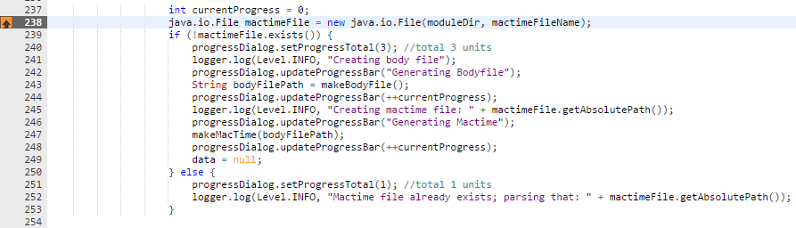
Figure 5
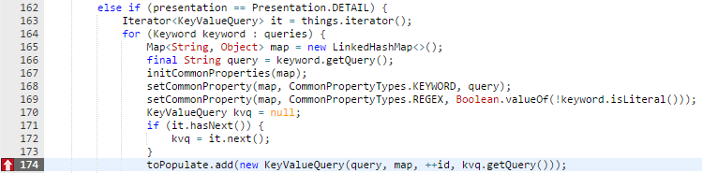
Figure 6
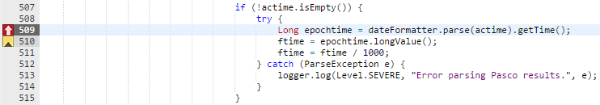
Figure 7

  - SciTools Understand Metrics – Analysis of “timeline.java”
- Complexity:
  - Max Nesting: 3
  - “Cyclomatic complexity of 137, with a max of 11”
  - 27 “Overly complex functions”
- Coupling
  - Each of the 486 files has an average of 2.5 classes
- Cohesion
  - Unable to identify from report
  - 6 instances of unreachable code (files that do not use part of their code are not cohesive?)
- Size
  - Number of lines: 113579 (-13911 blank lines)
  - Number of classes: 1197

  - SciTools Targeted Analysis
- Complexity:
  - A max nesting of 3 ensures that no function's time complexity exceeds O(x(n³))
  - “Conditional Complexity” refers to large conditional logic blocks. Object-oriented approaches can help to reduce complexity by means of decorator, strategy, or state.
- Coupling:
  - Inheritance is important in large-scale projects, and inheriting unnecessary classes and functions can slow down testing and parsing time.
  - “Data Clumps” refers to large sections of similar data that should be 'rolled up' into a larger class at a higher hierarchical state.
- Cohesion:
  - Unreachable code is a side effect of refactoring, but needs to be deleted as it affects complexity and can increase testing and parsing time.
  - Dead Code refers to any code that isn't being used. This can include unreachable code.
- Size:
  - Number of lines is often the fastest way to ballpark a system's complexity and size. Standard coding practices allow us to estimate by line, since it is not common practice to place multiple, separate instructions on the same line.
  - Unable to identify common smell based SOLELY on size. Many smells that mentioned size always attributed the actual problem to complexity and cohesion.

3. Evaluation / Conclusions
- Data-driven examples
- The two tools seems to have both listed separate items in need of correction. It is possible that the smells from “timeline.java” could have contributed to the overall scan returned by FindBugs, but we have found no direct links.
- Recommendations for improvement
  - Refactor to reduce number of classes
  - Correct null pointer dereferencing
  - Use semaphores and other similar practices to prevent concurrency issues

It seems to us that SciTools and FindBugs don't seem to have the same sense of scale and scope as the other. This completely disjoint set of properties made it difficult to directly compare the results produced by the programs.
While we did agree with many of the errors found by the software, some of them seemed to be completely nonsensical in nature, and we believe these to be among the false positives. On a brighter note, many of the errors found did turn out to be relevant, necessary fixes, and the amount of time needed to find and review those cases pales in comparison to the time it would have taken to review the code manually.

