**The E-Learning Platform**

# Purpose of the document

The purpose of this document is to propose an architecture for the online e-learning platform. It will also include all the assumptions involved as well the constraints and dependencies of the project. Moreover, some use cases have also been given in this document to describe the architecture with more precision.

# Proposed Architecture

The proposed architecture is based on popular three-tier architecture. At the very bottom layer, the data related services will be hosted. The second layer is the business logic layer where all the control will be done on the data using a programming language. The very top layer is the presentation layer. On this layer, there shall be interfaces which the users will utilize to control the application. Following is the detailed explanation of the proposed architecture from bottom to the top.

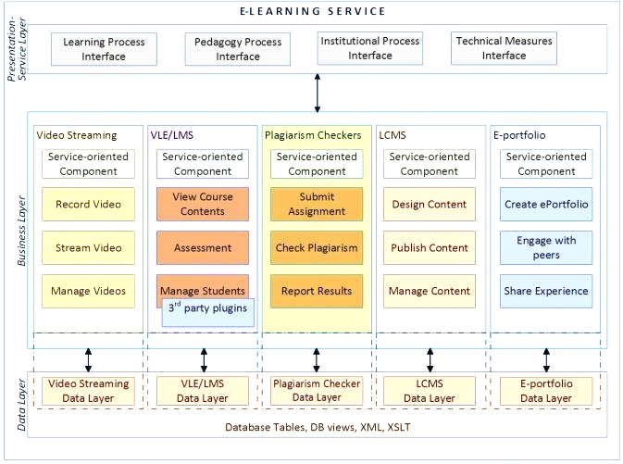

Figure 1 Proposed Architectural Design of E-Learning Platform

## Data Layer

At the very bottom of the architecture, there is data layer. Any e-learning system or to safely say any dynamic system is incomplete without data. The data, therefore, needs to be meticulously stored as well. To do this, some of the technologies shall be leveraged. The very technology that will be used is a database engine. Moreover, for the clarity, different modules have been made of data layer for the different modules of business layer.

### Database engine

The database engine shall be the primary technology where most of the data will be stored. The choice of database will be decided later after conducting feasibility study of different available choices. However, to give an idea, if the project stakeholder decides to go with a no-SQL database, MongoDB shall be the top on the priority list. If it is decided that a relational database engine is to be used, then MySQL would be on the surpassing all other on appropriate databases’ list.

### XML

The uses of Extensible Markup Language (XML) are many. However, for the purpose of this project, the primary usage will be storing the configurations, both the user’s entered and system related.

## Business Layer

The business layer is divided into different sections based upon the functionalities it offers. For instance, the video streaming is one of the modules of the system, therefore, its business logic shall be loosely coupled with all the different modules so that development as well as the management of the system is made easy. Following are some of the modules of the business layer and their functions.

1. **Video Streaming**
   1. Record Video
   2. Stream Video
   3. Manage Video
2. **Virtual Learning Environment (VLE) / Learning Management System (LMS)**
   1. View Course Contents
   2. Assessment
   3. Manage Students
3. **Plagiarism Checker**
   1. Submit Assignment
   2. Check Plagiarism
   3. Report Result
4. **Learning Content Management System (LCMS)**
   1. Design Content
   2. Publish
   3. Manage Content
5. **E-Portfolio**
   1. Create e-portfolio
   2. Engage with peers
   3. Share experiences

## Presentation Layer

There shall be following interfaces. All these interfaces shall be accessible on the basis of the rights of the user.

1. **Learning Process Interface**

Shall be used by both the students and staff (including faculty members). The students can manage their courses, track their progress, view their results, can locate the learning resources, etc. While the teachers can monitor and manage the same, but of all the students of their courses. The admin staff can, however, manage the students of entire institution or of some departments, and can monitor teacher’s progress as well.

1. **Pedagogy Process Interface**

This interface is mainly based on interaction with Learning Content Management System (LCMS). The users will design, develop, publish, and manage learning content using this interface.

1. **Institutional Process Interface**

All the institutional related tasks shall be performed on the basis of this component. For instance, tracking a student’s performance, enrolling him / her into a course, etc. all shall be done using this interface.

1. **Technical Measures Interface**

All the technical measures, such as ensuring security, can be done using this interface. The technical measure interface also includes tasks such as assigning roles to users, revoking rights etc.

# Constraints

1. To build a General Data Protection Regulation (GDPR) compliant system.
2. The system shall be reliable and should be available at all times.
3. The performance of the system should be very high.
4. The built system should be easy to use.
5. The data stored in the system shall be encrypted.
6. The integrity of the data shall be protected at all costs.
7. Unauthorized accesses shall be prevented at all levels, and if breached a log must be maintained thereafter.

# Use Cases

Following are some of the use cases of the system.

## Student Use Case

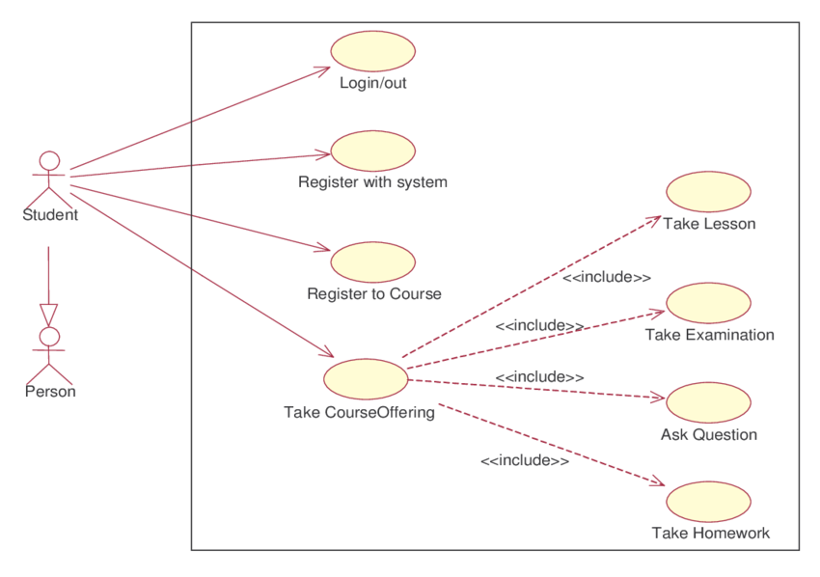

Figure 2 Student Use Case

## Teacher Use Case

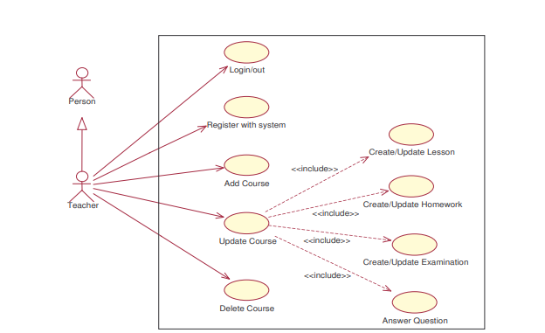

Figure 3 Teacher Use Case

## System Administrator Use Case

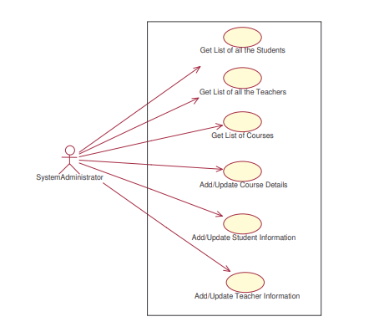

Figure 4 System Administrator Use Cases