## When a case is uploaded

1. If you’ve set your notification preferences accordingly, you will receive an email notifying you of a new case in BiometOS. Click on the embedded link to be taken to the BiometOS website.

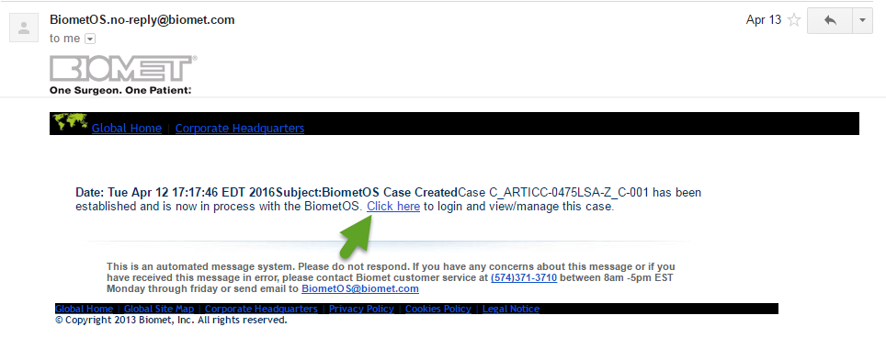

1. You will be taken to the BiometOS login page. Enter your username and password.

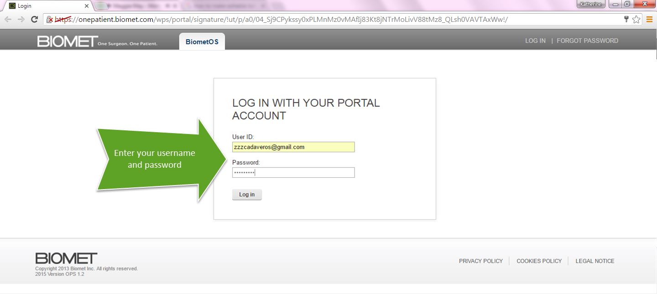

1. Once you successfully log in, you will be able to see all cases associated with you.

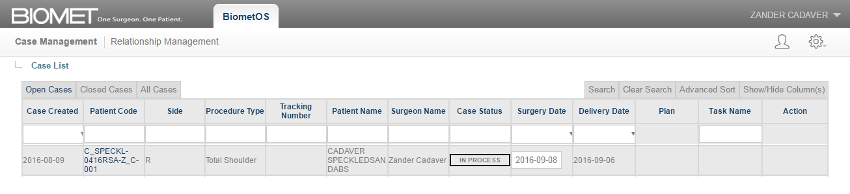

## How to confirm and change a surgery date

## Every case in your case list will have an assigned surgery date of 20-business days from the time the images arrive. Please verify the surgery date for every case.

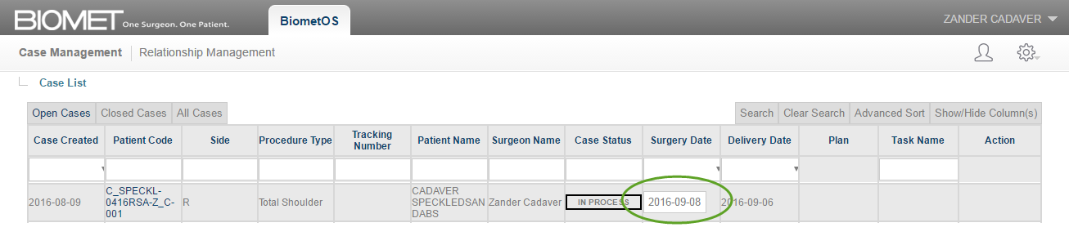

1. If the surgery date is farther out than the one assigned, you can change it by clicking on surgery date field. A calendar pop up will appear.

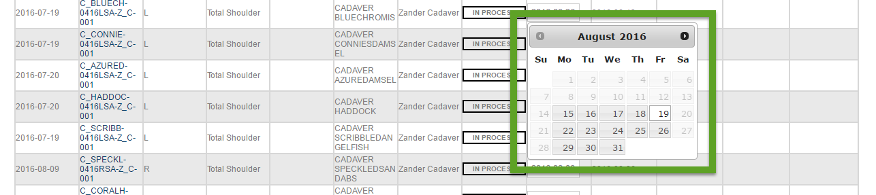

1. Navigate the pop up by clicking on the arrow next to the month and year. Once you identify the correct month, click on your preferred date.

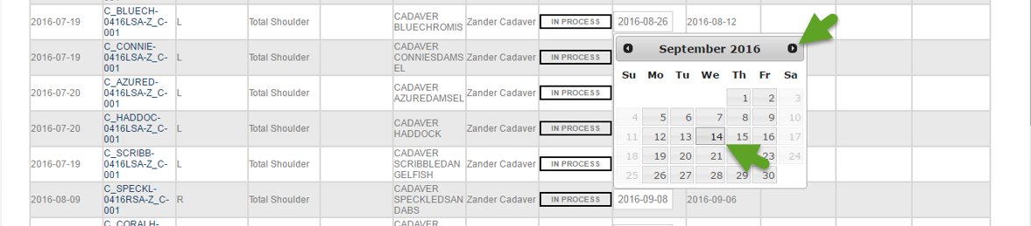

1. Once the date is selected, the new surgery date will be displayed.

