**HOW TO CLEAR YOUR CACHE AND COOKIES**

For Internet Explorer:

1. Click on the safety tab upper right hand corner of webpage.
2. Select “Delete Browsing History”
3. Make sure boxes “Preserve Favorites website data, temporary internet files, cookies, and history” are checked.

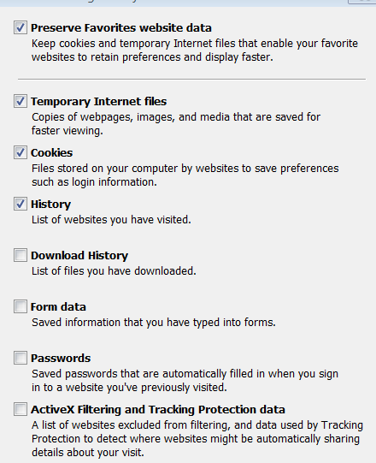

1. Click on delete

For Google Chrome

1. Click on  icon upper right hand corner of webpage.
2. Select History, then History again
3. Select clear browsing data
4. Make sure these boxes are selected:

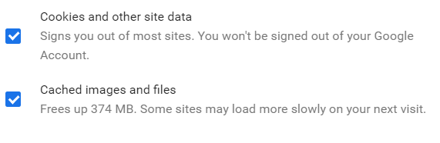

For FireFox:

1. Select  icon upper right hand corner of webpage.
2. Select History then clear recent history
3. Make sure the boxes “ Browsing and Download History and Cache is selected

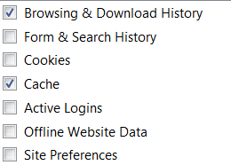

1. Select Clear Now

For Safari:

