**Instructions on Reviewing a Surgical Plan in SOMS**

The Signature Planning Suite **must** be installed.

Log into SOMS. The box below should display in the upper portion of the Landing Page.

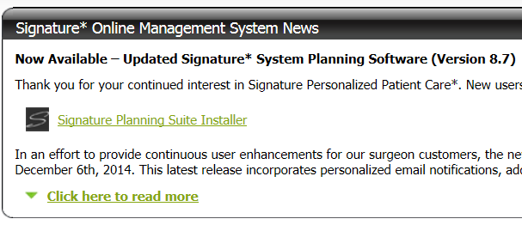

**If the above box does not appear**, click on the Signature Logo in the upper, left-hand corner.



**This will take you back** to the Landing Page. Now click on the Signature Planning Suite Installer link. Loading will take a few minutes and create the following icon on your Desktop.

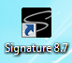

Next, go to your case list.

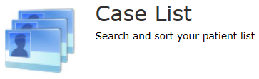 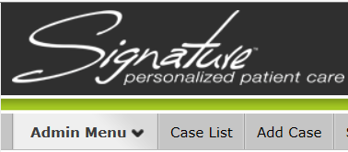

Click on the desired case (patient).



On the Case Info screen, click on “Approved Signature Software Plan” in the lower, right-hand corner.

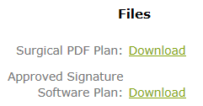

**The surgical plan will *automatically* populate in the Planning Suite.**