**Expedite your Transfer with PowerShare**



Utilize your account access to immediately share images and reports.

**Go** to[**www1.nuancepowershare.com**](http://www1.nuancepowershare.com) and **Login.**

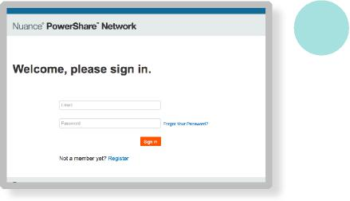

**1**

**NOTE:** If you do not know your password, select **Forgot Your Password?** for reset instructions.

**NOTE:** If this is your first time logging in, you will need to click **Accept** to accept the Terms of Use.

**2** After logging in, click **Upload Images**.

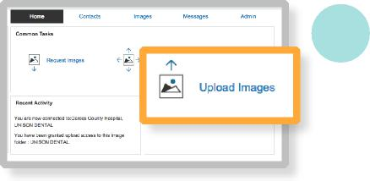

When you are prompted to run the

**PowerShare Java Web Start Uploader** application,

click **Run**.

**NOTE:** You must have Java version 1.7.21 or higher installed on your computer to upload DICOM images. Java 8 Update 91 is recommended for optimal performance.

**3** A new Uploader window will display. From the dropdown list, select the account you would like to upload to : **Zimmer Biomet.** Then select from Browse and Upload : **Choose Folder**



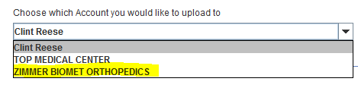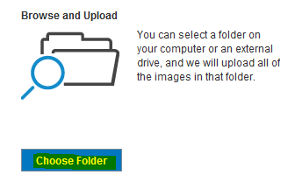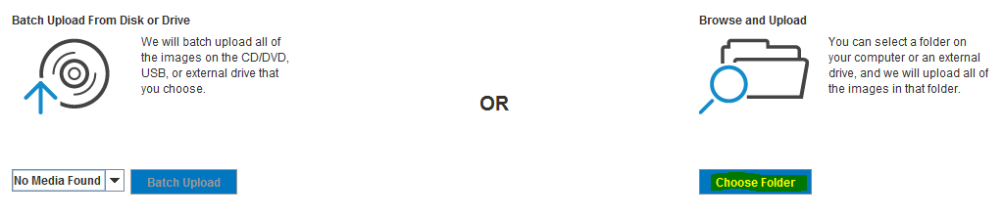

***...continued next page***

**Questions? Call 1-866-809-4746**

|  |  |
| --- | --- |
|  | © 2015 Nuance Communications, Inc. All rights reserved. |

**Expedite your Transfer with PowerShare**



Utilize your account access to immediately share images and reports.

**Select the specific study or studies you wish to upload by clicking on them. You can upload DICOM, Non-DICOM or a combination of both image types in a single upload. Non-DICOM images can be found on the Other Images Tab.**

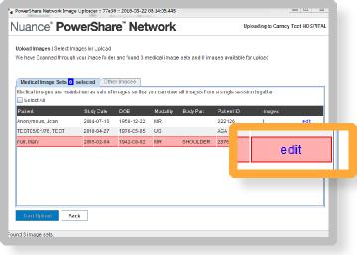



**4**

**NOTE: Red indicates that the study is missing required information and must be edited.**

**NOTE: Non-DICOM images will require you to select the image and then the Add Image Details button to add required patient information.**

**Your upload progress will be displayed. You may now**

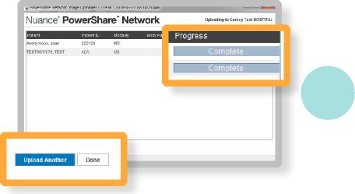

**5 select to Upload Another or Done.**

**Once complete, both you and the requesting site will be able to view the images.**

|  |  |  |
| --- | --- | --- |
|  |  | **We will work with your site to configure a PowerShare Accelerator**  ***enabling you to send directly from your PACS and save valuable time on your next transfer.*** |

**Questions? Call 1-866-809-4746**

|  |  |
| --- | --- |
|  | **© 2015 Nuance Communications, Inc. All rights reserved.** |