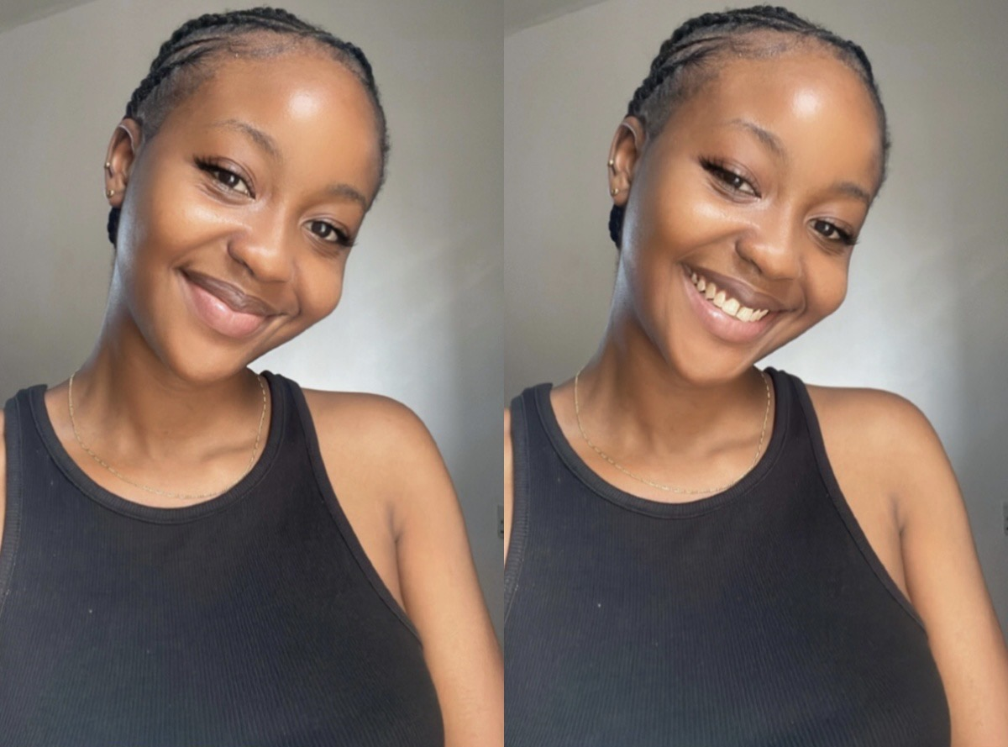

Zoey Alli | 012345678 | Zeegirl@gmail.com

# About me

I enjoy coding, it is a fun to grow mentally.

# Work experience

**Z.B properties** *Jan 2022-July 2024*My experience at Z.B properties as front developer was quite adventrous. I worked as intern python and front end developer.

# Skills

innovative

* problem-solving
* Python
* HTML, CSS, Javascript
* React.js