1. Data specification supplement
1.1 Dataset
The number of categories and the label distribution used for training and independent testing are shown in Figure S1 and Figure S2. These datasets provide a solid foundation for developing the multi-label classification model in this study, enabling more accurate prediction and analysis of mRNA localization across various cellular compartments. As shown in Figure S1(a), the dataset constructed in this study consists of 18 different categories, with significant differences in the number of samples across categories, exhibiting a pronounced long-tail distribution. The category with the most samples in the training dataset has 6774, while the category with the smallest samples has only 319. Additionally, the sample sizes for other categories also show varying degrees of differences: the second largest category contains 3037 samples, less than half of the largest category. Half of the categories contain fewer than 600 samples, while the remaining categories have sample counts ranging between 1000 and 1800. The proportion of labels in the independent test set shown in Figure S1(b) is similar to that in the training set.
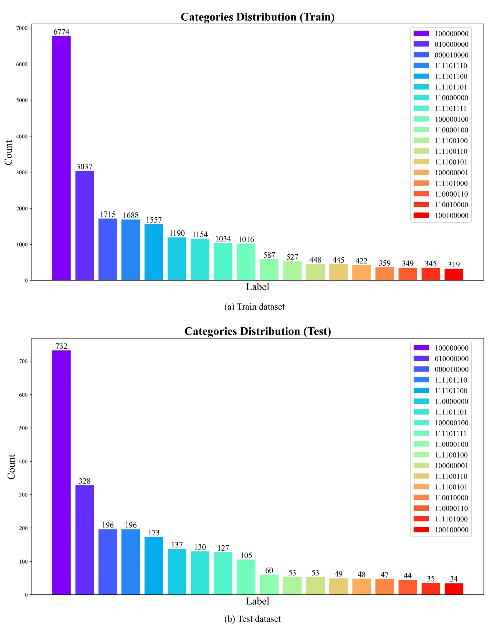
Fig. S1. Category distribution of training and test datasets.
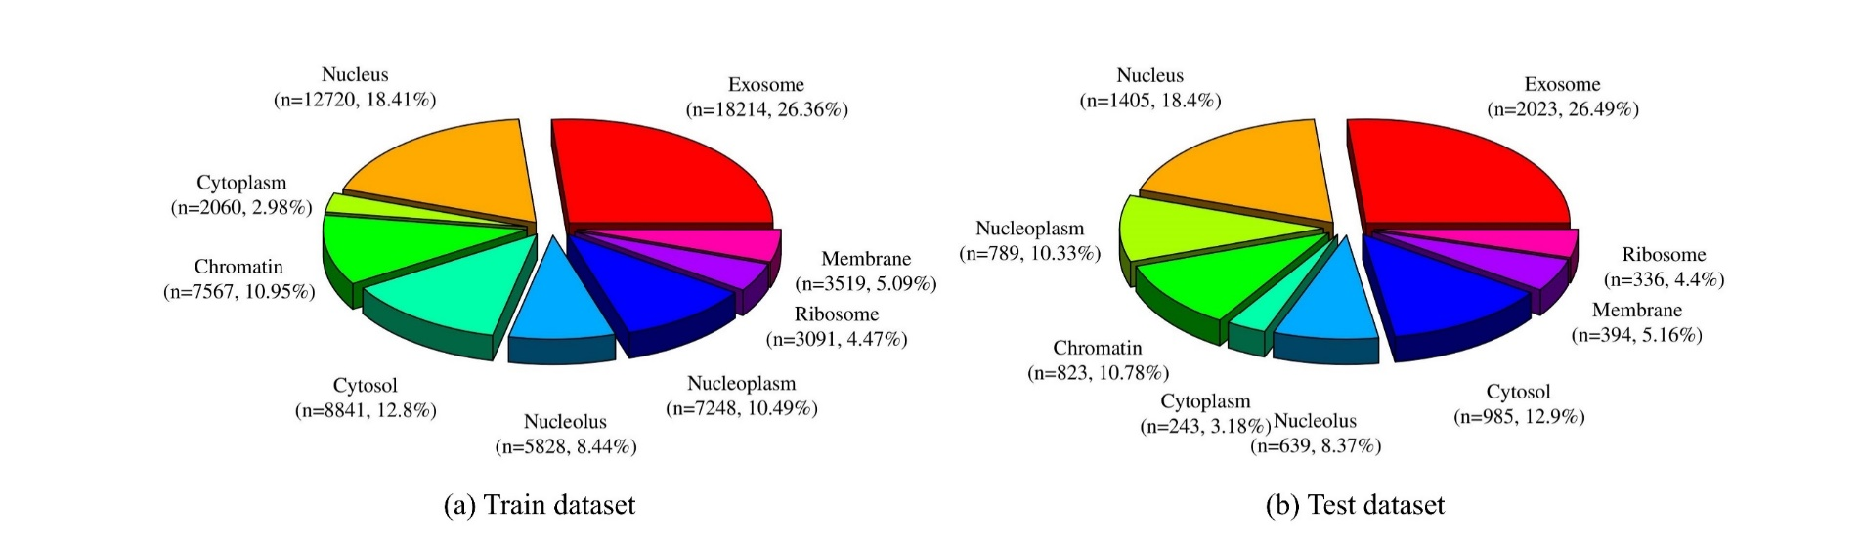
Fig. S2. Label distribution of training and test datasets.
According to Figure S2(a), we can clearly observe a significant imbalance in the label distribution within the dataset. The main category in the dataset, Exosome, accounts for 26.36%, while Nucleus also accounted for 18.41%, with these two categories together comprising nearly half of the dataset. Following these are Cytosol at 12.8% and Chromatin at 10.95%, both of which have substantial sample sizes, though notably smaller than the leading categories. The proportions of Nucleoplasm and Nucleolus are 10.49% and 8.44%, respectively, indicating a moderate amount of data. The sample size of relatively small categories such as Membrane (5.09%), Ribosome (4.47%), and Cytoplasm (2.98%) has significantly decreased, reflecting the long-tail distribution characteristic of the dataset. This extreme distribution of categories not only illustrates the heterogeneity of the dataset in terms of coverage of categories, but also suggests that a few categories may be overlooked during data analysis or model training due to insufficient samples. Additionally, it is shown in Figure S2(b) that the label distribution in the independent test set constructed for this study is similar to that in the training set.

2. Theoretical research supplement
2.1 Explanation of Tree-based models
Tree-based models are a powerful family of machine learning algorithms that have been widely adopted due to their ability to handle both categorical and continuous data, as well as their inherent interpretability. Over time, these models have evolved significantly, with improvements in accuracy, computational efficiency, and robustness through various ensemble methods. Tree-based models, particularly decision trees, random forests, gradient boosting machines (GBM), and their advanced variants, have become fundamental tools in machine learning and data science.
To provide a comprehensive overview of the evolution and characteristics of tree-based models, the following table summarizes the key features, years of introduction, and typical use cases of the most popular tree-based algorithms.

TABLE S1 Summary of Popular Tree-Based Models.
Model | Year Introduced | Core Idea | Key Features | Use Cases
Decision Tree | 1986 | Partitions data by recursively splitting features based on their values to build a tree structure. | Simple, interpretable, but prone to overfitting. | Classification and regression, small to medium-sized datasets, interpretability.
Random Forest | 2001 | Uses bagging to construct multiple decision trees, then aggregates the results (voting or averaging). | Reduces overfitting, parallelizable, robust to noise. | High-dimensional datasets, general-purpose tasks, large datasets with missing values.
Gradient Boosting (GBM) | 1999 | Builds trees sequentially, each correcting the residuals (errors) of the previous tree. | High accuracy, but slower training, sensitive to overfitting without proper tuning. | Tasks requiring high predictive accuracy, e.g., finance, insurance.
XGBoost | 2014 | Optimized GBM with regularization (L1 & L2), parallelization, and efficient handling of missing values. | High performance, reduces overfitting, supports GPU acceleration, and provides model interpretability. | Large-scale datasets, machine learning competitions (e.g., Kaggle), predictive analytics.
LightGBM | 2017 | Uses histogram-based algorithms for faster training and lower memory usage. | Fast training speed, low memory consumption, suitable for large datasets and sparse data. | Large-scale data, real-time applications, recommendation systems.
CatBoost | 2017 | Optimized for categorical features, using efficient gradient calculation and reducing overfitting. | Native support for categorical features, robust to noise, reduces the need for extensive preprocessing. | Datasets with many categorical variables, ranking, and recommendation tasks.

2.2 Configuration for Loading UTR-LM
Below are the detailed parameters of UTR-LM provided by the official website of UTR-LM [1]:
TABLE S2
detailed parameters of UTR-LM.
Name | Num Layers | Hidden Size | Num Heads | Intermediate Size | Num Parameters (M) | FLOPs (G) | MACs (G) | Max Num Tokens
UTR-LM | 6 | 128 | 16 | 512 | 1.21 | 0.35 | 0.18 | 1022

In this study, a Dell workstation equipped with a 4090 graphics card (24G VRAM) was used to load the large model for feature extraction, utilizing the Pytorch deep learning framework, with the maximum sequence length loaded being 8000. During the extraction process, it was observed that 16GB of the 24GB VRAM was almost fully utilized in most cases. Consequently, we recommend using a graphics card with at least 16GB of VRAM to load this pre-trained model. Additionally, if the loaded sequence length exceeds the scope of this study, such as beyond 8000, the VRAM requirements will be even higher.

2.3 Detailed Explanation for Contrastive Representation Learning
Contrastive representation learning is an essential concept in the field of self-supervised learning, where the goal is to learn representations from data without relying on explicit labels[2]. By learning to distinguish between similar and dissimilar samples, the model can discover useful feature representations that are transferable to downstream tasks such as classification, retrieval, and more [2-5].
The fundamental idea is to optimize a contrastive loss function, which operates on pairs of samples:
- Positive Pairs: These are samples that are semantically similar. For example, in the case of images, this could include different augmented views of the same object or image.
- Negative Pairs: These are samples that are unrelated or belong to different categories. The model's task is to maximize the distance between these dissimilar samples.
Key Features of Contrastive Learning:
- Loss Function: Typically, contrastive loss or triplet loss is used, which evaluates the similarity between samples and adjusts the model accordingly.
- Self-Supervised Learning: This method doesn't require labeled data. Instead, it learns to discriminate based on the inherent structure of the data, making it highly useful in scenarios where labeled data is scarce.
Advantages of Contrastive Learning:
- It can produce highly discriminative representations, which are useful for transfer learning to various downstream tasks.
- It is highly scalable to large datasets, as it can learn from massive amounts of unlabeled data, enabling better feature extraction and representation learning.
In this study, we introduce an enhancement to the traditional N-pair loss by incorporating multi-class contrastive learning, which improves both the model's generalization ability and convergence speed. This advancement plays a significant role in improving the performance of the model, especially in complex classification tasks.

2.4 Detailed Explanation for clustering algorithm
The fundamental idea behind clustering is to group data points into distinct clusters based on their inherent similarities, while ensuring that data points from different clusters are as dissimilar as possible. This unsupervised learning technique allows models to discover the underlying structure in data without the need for labeled information [6].
Cluster Formation: Clustering algorithms aim to identify groups of data points that exhibit similar characteristics, such as patterns in their features or behaviors. For example, in a customer segmentation task, clustering might group customers with similar purchasing habits or preferences. On the other hand, the algorithm also ensures that data points which differ significantly, such as customers from entirely different demographics, are placed in separate clusters. This approach allows the model to effectively categorize complex, high-dimensional data into meaningful subsets.
Key Features of Clustering:
- Distance Metrics: Clustering algorithms rely on distance metrics, such as Euclidean or cosine similarity, to measure how similar or different data points are from one another and assign them to appropriate clusters.
- Unsupervised Learning: Clustering does not require labeled data and instead uncovers patterns and relationships directly from the data, making it ideal for tasks where labeled information is scarce or unavailable.
Advantages of Clustering:
- Data Reduction: By grouping similar data points together, clustering helps to simplify large datasets and reduce their complexity, enabling more efficient analysis and modeling.
- Scalability: Many clustering algorithms, such as K-means and DBSCAN, can efficiently handle large datasets, making them suitable for a wide range of applications, from market analysis to anomaly detection.
- Flexibility: Clustering algorithms are versatile and can work with different types of data (numerical, categorical, or a mix of both), allowing them to be applied across various domains.
In this study, clustering is combined with contrastive learning to improve the representation of data, leading to enhanced model generalization and predictive performance, especially when dealing with imbalanced datasets and complex classification tasks.

2.5 Attention mechanism
The Attention mechanism is a foundational concept in modern deep learning, widely applied in fields such as natural language processing (NLP), computer vision, and time-series analysis. Its central principle is to enhance the model's ability to process input data by dynamically focusing on the most relevant elements, assigning varying weights based on the importance of each element to the current task. Unlike traditional architectures that treat all inputs equally, Attention mechanisms prioritize specific components of the input sequence or features, thereby capturing critical dependencies and improving the model's efficiency[7].
Mathematically, the mechanism operates by computing weighted sum of input features, where the weights represent the relevance of each feature to the current context. This is typically achieved using queries ($Q$), keys ($K$), and values ($V$), as formalized in the widely adopted scaled dot-product Attention formula:
 | $$Attention(Q,K,V)=softmax\left(\frac{QK^{T}}{\sqrt{d_{k}}}\right)V$$ | (1)

Here, $Q$ represents the feature of interest, $K$ captures the contextual relationships, and $V$ provides the corresponding values. The softmax operation normalizes the weights, while $\sqrt{d_{k}}$ ensures stability by scaling the dot-product scores.
The advantages of the Attention mechanism are manifold. First, it allows models to capture long-range dependencies within sequences, addressing limitations of traditional recurrent models. Second, by focusing computational resources on relevant input segments, it enhances both interpretability and computational efficiency. Notably, Attention forms the core of Transformer architectures, such as BERT and GPT, which have achieved state-of-the-art performance in numerous NLP tasks. In computer vision, Attention aids in identifying critical regions in images, thereby improving object detection and image recognition accuracy.
By integrating the Attention mechanism into machine learning models, researchers have achieved significant advancements in both predictive accuracy and the interpretability of complex tasks. Its ability to model complex relationships across data elements has cemented its role as an indispensable tool in the development of advanced learning algorithms.
3. Experimental material supplement
3.1 Subspace Configuration Strategy
As shown in Figure S3, when oversampling methods are applied in subspaces, the MaxOS and MedOS oversampling methods are significantly better than the undersampling to MedDS and MinDS undersampling methods in terms of Accuracy, Absolute-True, Absolute-False, and Aiming. Specifically, the MaxOS and MedOS methods achieved the highest Accuracy values of 0.5127 and 0.5185, respectively. They also recorded the highest Absolute-True values of 0.2356 and 0.2399, the lowest Absolute-False values of 0.2256 and 0.2240, and the highest Aiming values of 0.7589 and 0.7609. And among all undersampling methods, the best values of these four metrics were 0.5061, 0.1763, 0.2363, and 0.6826, respectively. These results indicate that oversampling methods can significantly enhance the predictive accuracy of the model[8].
It is particularly noteworthy that, when using undersampling methods, the Coverage metric exhibited an opposite trend compared to the other four metrics. The MedDS and MinDS methods achieved Coverage values of 0.7372 and 0.8115, respectively, whereas the best Coverage value among all oversampling methods was only 0.6613. Coverage represents the average proportion of true labels that are covered by the predicted labels, indicating that undersampling methods help the model to predict a broader range of label categories, thereby enhancing the model's generalization ability and robustness.
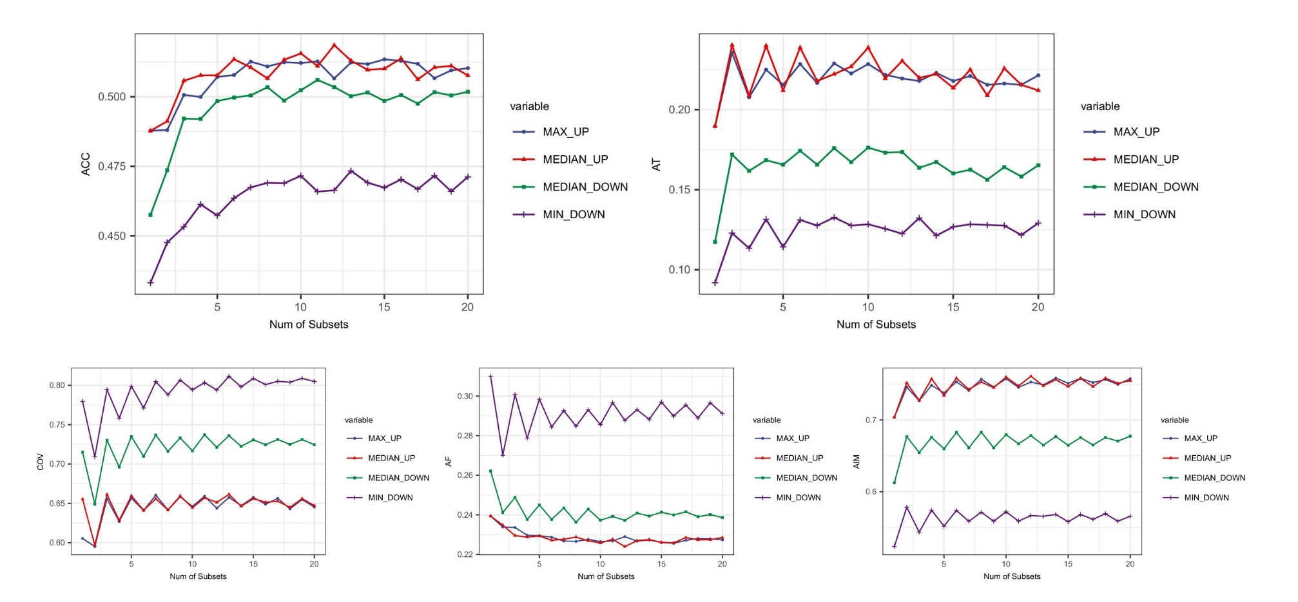
Fig. S3. The relationship between the number of subsets and the result of multiple label classification.

3.2 Analysis of the Effectiveness of Multi-Category Contrastive Representation Learning Features for Clustering Methods
As described in the supplementary materials, the number of clusters was determined using two methods. The elbow method evaluates the within-cluster sum of squares and identifies the point where the reduction rate significantly slows down, indicating the optimal number of clusters. The contour coefficient method measures the quality of clustering by comparing the cohesion within clusters and the separation between clusters, with the optimal number being the one that maximizes the contour coefficient. Both methods, as shown in Figure S4, suggest seven clusters.
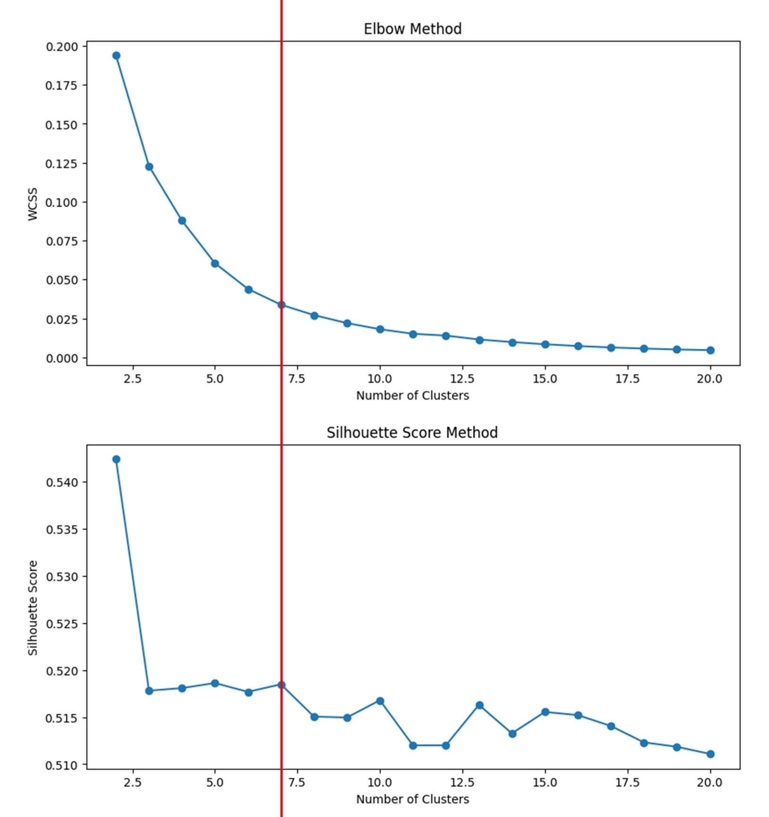
Fig. S4. Elbow Method and Silhouette Score Method.
TABLE S3
effect of the number of clusters on MbscLoc
Clusters | Accuracy | Absolute_true | Absolute_false | Aiming | Coverage
1 | 0.5131 | 0.2191 | 0.2257 | 0.7482 | 0.6559
2 | 0.5121 | 0.2261 | 0.2253 | 0.7489 | 0.6599
3 | 0.5129 | 0.2226 | 0.2272 | 0.7472 | 0.6565
4 | 0.5128 | 0.2159 | 0.2260 | 0.7444 | 0.6619
5 | 0.5136 | 0.2218 | 0.2268 | 0.7455 | 0.6623
6 | 0.5091 | 0.2175 | 0.2276 | 0.7422 | 0.6569
7 | 0.5141 | 0.2269 | 0.2252 | 0.7470 | 0.6589
8 | 0.5113 | 0.2182 | 0.2275 | 0.7443 | 0.6586
9 | 0.5152 | 0.2263 | 0.2260 | 0.7498 | 0.6596
10 | 0.5115 | 0.2148 | 0.2277 | 0.7458 | 0.6596
11 | 0.5118 | 0.2183 | 0.2281 | 0.7437 | 0.6607
12 | 0.5128 | 0.2155 | 0.2265 | 0.7440 | 0.6606
13 | 0.5133 | 0.2218 | 0.2266 | 0.7477 | 0.6577
14 | 0.5114 | 0.2230 | 0.2272 | 0.7449 | 0.6576
15 | 0.5122 | 0.2191 | 0.2272 | 0.7460 | 0.6589
16 | 0.5129 | 0.2167 | 0.2263 | 0.7416 | 0.6626
17 | 0.5125 | 0.2218 | 0.2263 | 0.7445 | 0.6589
18 | 0.5107 | 0.2218 | 0.2285 | 0.7453 | 0.6559
19 | 0.5105 | 0.2214 | 0.2269 | 0.7432 | 0.6557
20 | 0.5116 | 0.2155 | 0.2262 | 0.7445 | 0.6598

3.3 Comparison of MBSCLoc with Existing Subcellular Localization Methods
MBSCLoc was compared with several existing models including Iloc-mRNA, mRNALoc, mRNALocator, Wang’s model, DM3Loc, DAmiRLocGNet, Allocator and Clarion on the same independent test by Clarion[9-16]. This comparison encompassed both multi-label tasks and single-label prediction models. As detailed in Table S1, MBSCLoc exhibited excellent performance in predicting subcellular localization for Chromatin, Cytoplasm, Exosome, Membrane, Nucleolus, Nucleoplasm, and Ribosome. The accuracy achieved by MBSCLoc across these nine label positions was superior to that of most existing models. This indicates that even as a multi-label classifier, MBSCLoc maintains strong predictive and generalization capabilities, outperforming models that predict fewer or single labels. However, since some of the data from this independent test dataset may been used in the training of other models, the predictive performance for certain metrics was slightly lower than that of several other models.

TABLE S4
Compare results with accuracy of individual labels in different models on the same independent test dataset
Localization | iLoc-mRNA | mRNALoc | mRNALocator | Wang’s | DM3loc | Clarion | DAmiRLocGNet |  | Allocator | MBSCLoc
Chromatin | N.A. | N.A. | N.A. | N.A. | N.A. | 0.8147 | N.A. | N.A. |  | 0.7375
Cytoplasm | N.A. | 0.5488 | 0.3890 | 0.8710 | N.A. | 0.9129 | 0.8641 | N.A. |  | 0.9214
Cytosol | N.A. | N.A. | N.A. | 0.6781 | 0.5737 | 0.7977 | N.A. | 0.6563 |  | 0.6980
Exosome | N.A. | N.A. | N.A. | 0.1618 | 0.7000 | 0.9210 | 0.6828 | 0.9880 |  | 0.8475
Membrane | N.A. | N.A. | N.A. | N.A. | 0.7092 | 0.8915 | N.A. | 0.8083 |  | 0.8970
Nucleolus | N.A. | N.A. | N.A. | N.A. | N.A. | 0.8374 | 0.9329 | N.A. |  | 0.8043
Nucleoplasm | N.A. | N.A. | N.A. | N.A. | N.A. | 0.8074 | N.A. | N.A. |  | 0.7408
Nucleus | N.A. | 0.5518 | 0.5742 | 0.6013 | 0.6952 | 0.7923 | 0.7978 | 0.7362 |  | 0.7066
Ribosome | 0.7341 | N.A. | N.A. | 0.8142 | 0.6903 | 0.8474 | N.A. | 0.7145 |  | 0.8673
N.A.: non-applicable

3.4 Interpretation of Subcellular Localization Mechanism in UTR Region Based on Biological Analysis
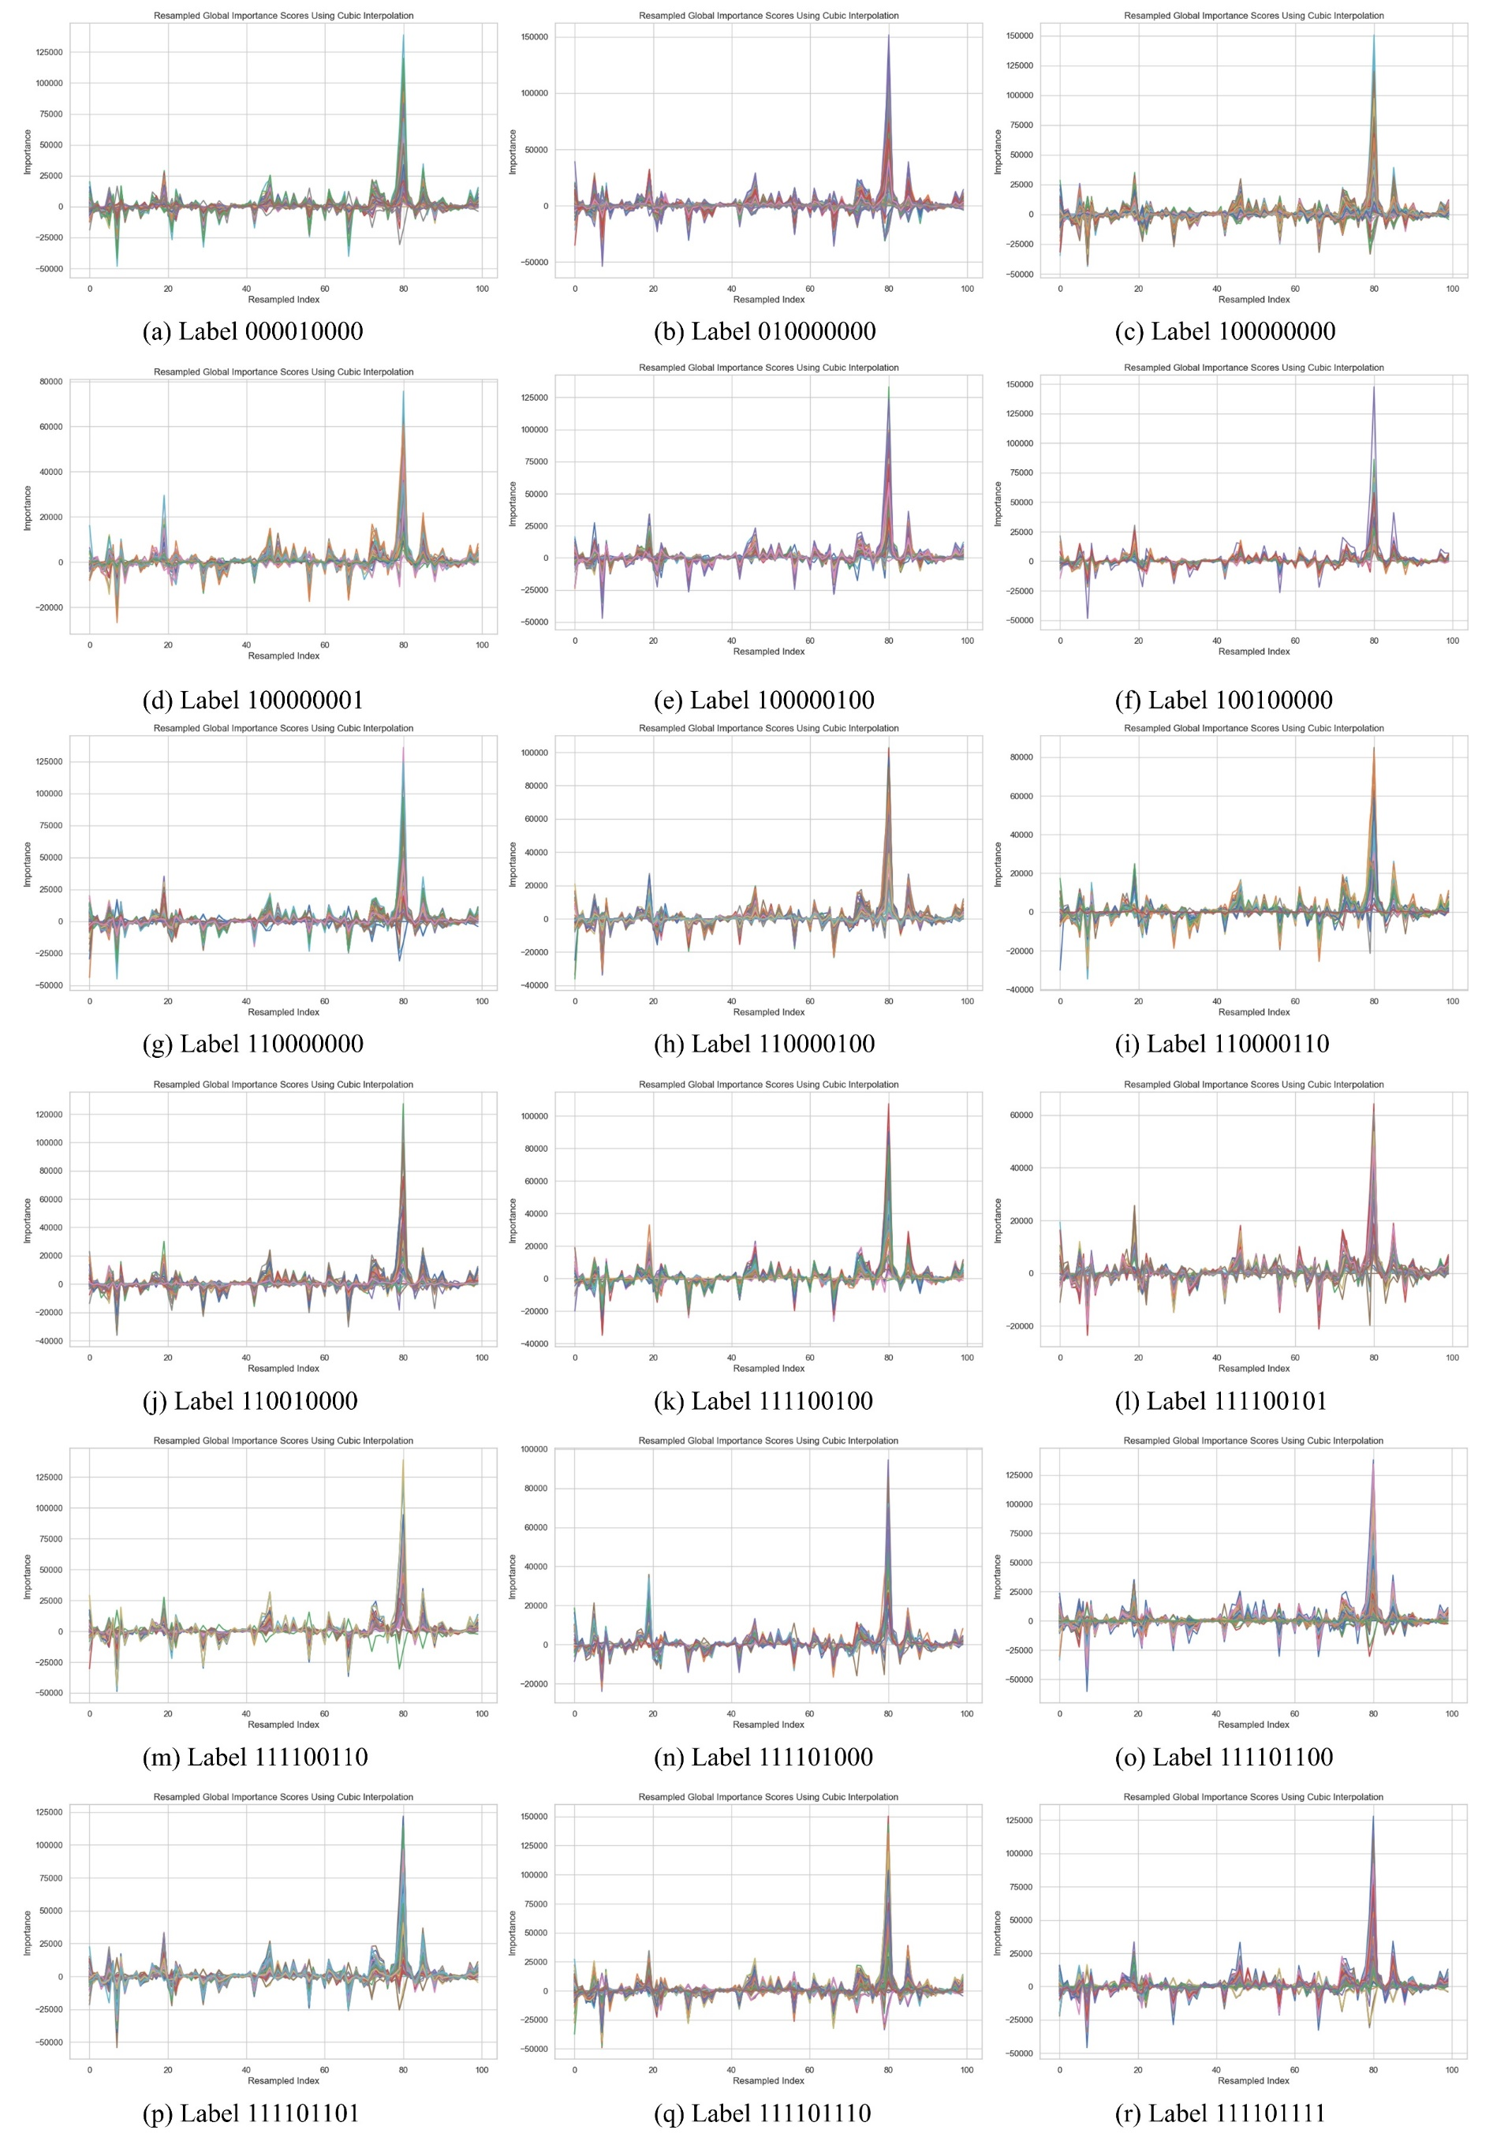
Fig. S5. Global importance scores of 18 categories derived from Tree-SHAP and outputs of UTR-LM.

3.5 Application of Sampling Algorithms
As illustrated in Figure S6, it is the overall flowchart of the specific algorithm applied on the training dataset. Figure S6(a) illustrates the clustering results obtained by constructing sample pairs from the original data, inputting them into the contrastive representation learning space, and combining them with features and hierarchical clustering methods after contrastive representation learning. Afterwards, based on the clustering results shown in Figure S6(a), traverse each label in Figure S6(b) and samples randomly selected from each cluster, ensuring that none of the nine labels are omitted. Finally, as depicted in Figure S6(c), the construction of the subspace is completed. The number of subspaces is set to 13 and visualized the results using MinDS sampling algorithm.
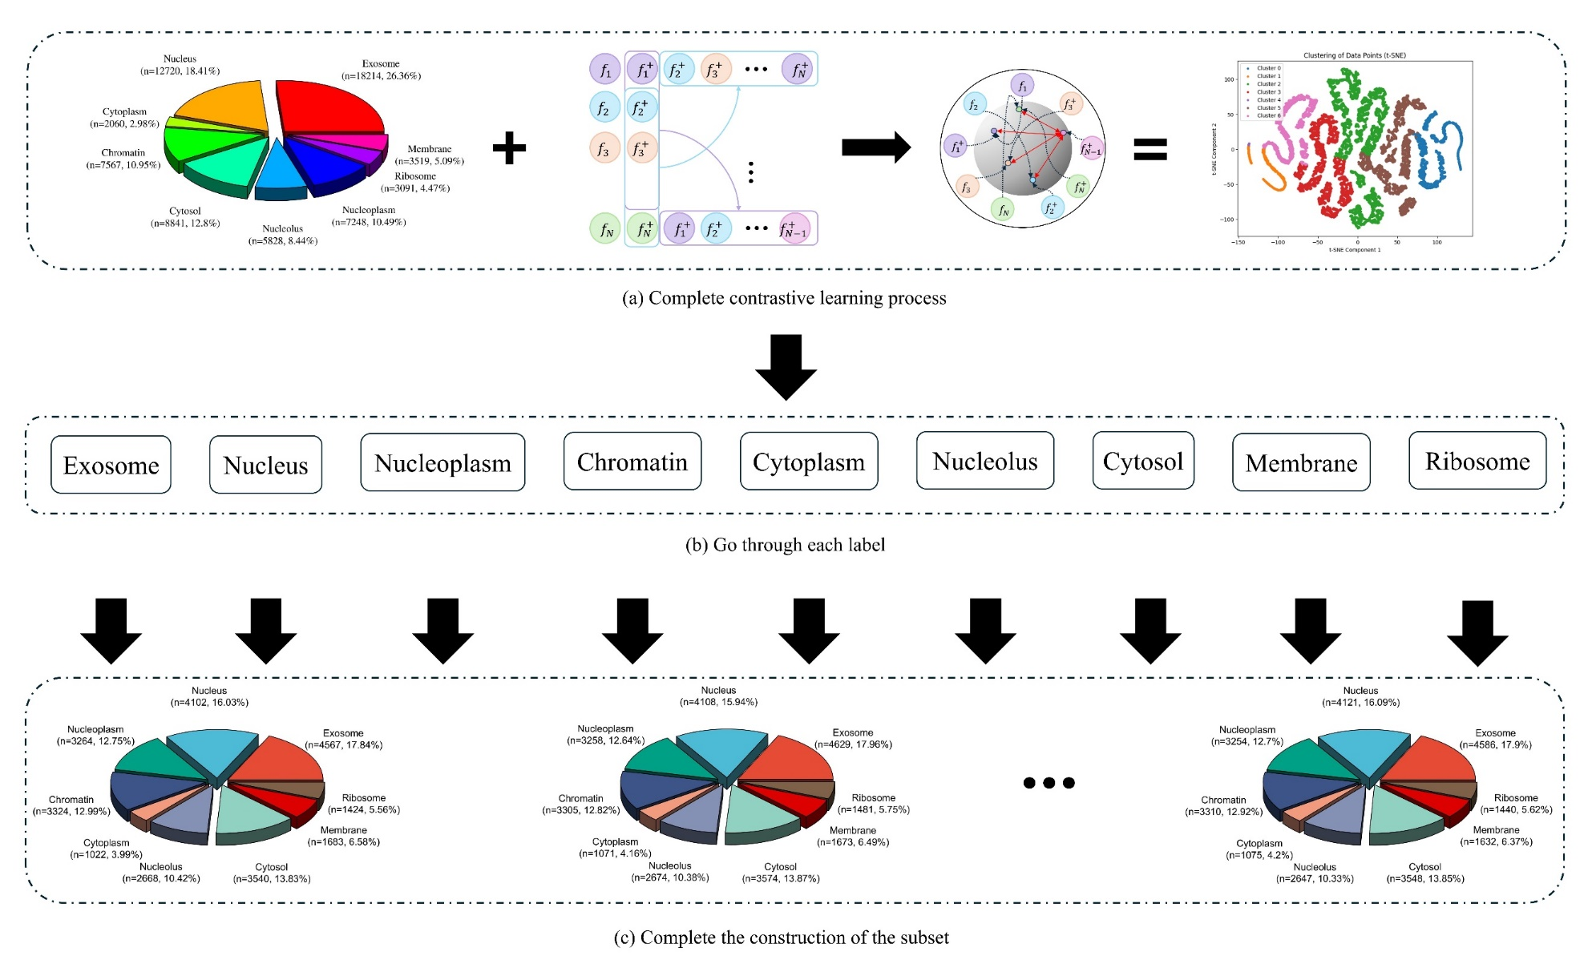
Fig. S6. Subspace construction process and internal change

References:
[1] Y. Chu et al., "A 5′ UTR language model for decoding untranslated regions of mRNA and function predictions," vol. 6, no. 4, pp. 449-460, 2024.
[2] P. Khosla et al., "Supervised contrastive learning," vol. 33, pp. 18661-18673, 2020.
[3] F. Wu, X. Jing, S. Shan, W. Zuo, and J. Yang, "Multiset feature learning for highly imbalanced data classification," in National Conference on Artificial Intelligence, 2017.
[4] C. Huang, Y. Li, C. C. Loy, and X. J. I. Tang, "Deep Imbalanced Learning for Face Recognition and Attribute Prediction," no. 11, 2020.
[5] DingJiaqi, XuJunhai, WeiJianguo, TangJijun, and GuoFei, "A multi-scale multi-model deep neural network via ensemble strategy on high-throughput microscopy image for protein subcellular localization," 2023.
[6] A. J. A. S. Berger, "Agglomerative clustering of a search engine query log," 2000.
[7] A. Vaswani et al., "Attention Is All You Need," 2017.
[8] K.-C. J. M. B. Chou, "Some remarks on predicting multi-label attributes in molecular biosystems," vol. 9, no. 6, pp. 1092-1100, 2013.
[9] L. Jing, Z. Lichao, H. Shida, G. Fei, and Z. J. B. i. B. Quan, "SubLocEP: a novel ensemble predictor of subcellular localization of eukaryotic mRNA based on machine learning," 2021.
[10] C. Tianyu et al., "RNALocate v2.0: an updated resource for RNA subcellular localization with increased coverage and annotation," 2021.
[11] D. Wang et al., "DM3Loc: multi-label mRNA subcellular localization prediction and analysis based on multi-head self-attention mechanism," vol. 49, no. 8, pp. e46-e46, 2021.
[12] Y. Bi et al., "Clarion is a multi-label problem transformation method for identifying mRNA subcellular localizations," vol. 23, no. 6, p. bbac467, 2022.
[13] Z. Y. Zhang et al., "iLoc-miRNA: extracellular/intracellular miRNA prediction using deep BiLSTM with attention mechanism," (in eng), Brief Bioinform, vol. 23, no. 5, Sep 20 2022.
[14] T. Bai, K. Yan, and B. Liu, "DAmiRLocGNet: miRNA subcellular localization prediction by combining miRNA-disease associations and graph convolutional networks," (in eng), Brief Bioinform, vol. 24, no. 4, Jul 20 2023.
[15] J. Cai, T. Wang, X. Deng, L. Tang, and L. J. B. g. Liu, "GM-lncLoc: LncRNAs subcellular localization prediction based on graph neural network with meta-learning," vol. 24, no. 1, p. 52, 2023.
[16] G.-H. Yuan, Y. Wang, G.-Z. Wang, and L. J. B. i. b. Yang, "RNAlight: a machine learning model to identify nucleotide features determining RNA subcellular localization," vol. 24, no. 1, p. bbac509, 2023.

