Finalize website content

- Collect Website Content

– Find images / normalize format/size

– Draft website text

– Make a list of any external links

First update

For my website:

Way 1

It’s a Portfolio website with clean and brief style. Including some of my previous projects. And there should be one home page. And there will be some tag: personal introduction, communicate access, and work of 2016, 2017,2018 etc.

Way 2

Make a more interesting and interactive website like 【<http://rosa-menkman.blogspot.com/2010/02/glitch-studies-manifesto.html>】. And there can be more animation and mouse can interact with them. There will be a lot of shapes, and inside is my work.

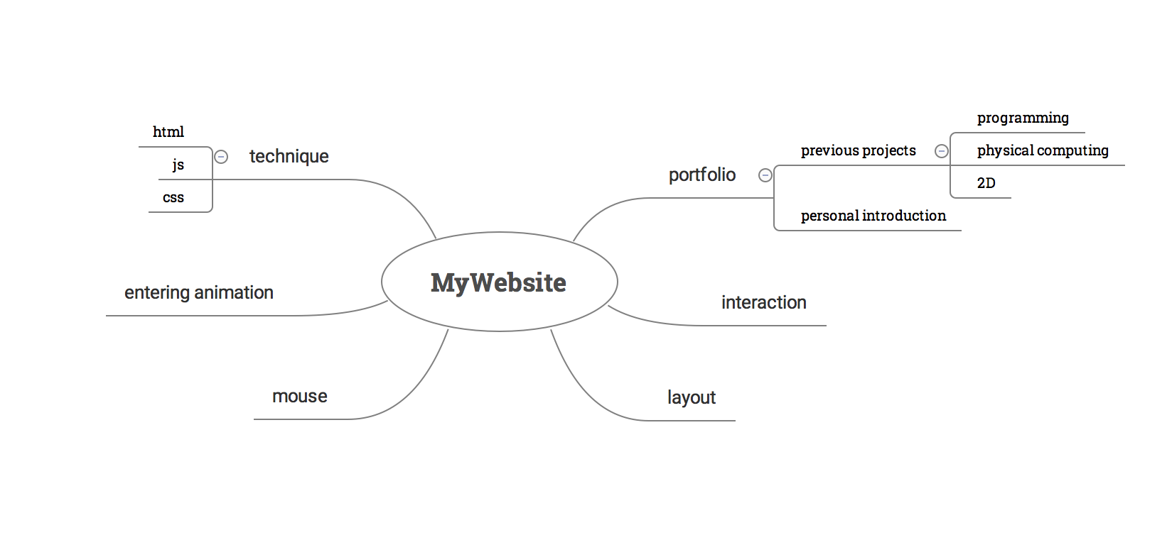

Second update

Content collecting:

1. Work
2. some processing sketch work, either in the format of gif or find a way to put on website.
3. 2D work, image, photography
4. installation work
5. Personal intros, photo, text

Draft website text:

Bill Zhou was born in Hangzhou China in 1997, currently studying in SIVA, and major in technoetic art.

About me, contact, works and projects, home(page)

External links

https://zhoubicheng.wordpress.com