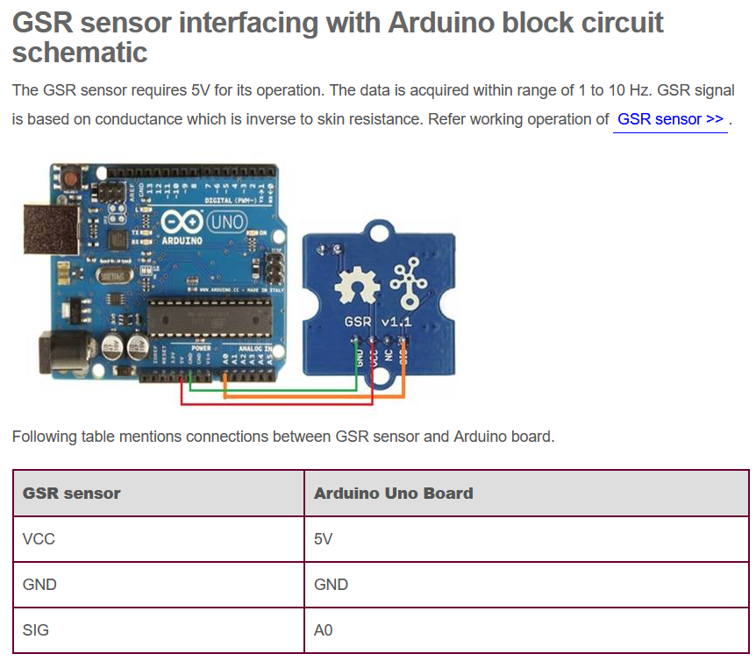

[Source: GSR Interfacing with Arduino Controllers](https://www.rfwireless-world.com/Terminology/GSR-sensor-interfacing-with-Arduino-Code-and-schematic.html)

Sparkfun Pulse Oximeter is more complex than the above GSR board as it interfaces with the Arduino over I2C.

The board shown is the full Pulse Oximeter. It has a total of 6 pins that need to be connected. 3v3 and Gnd are exactly what they sound like, SCL and SDA form the I2C link to the Arduino (see I2C wiring for Arduino below), and RST and MFIO do not need to be used directly by the end user but must be connected to 2 Digital Arduino pins so the library can control them. The SDA and SCL pins must be connected to the respective SDA and SCL pins on the arduino. I2C works via addressing. This means theoretically, you can have more than one I2C device on a given I2C communication channel. For our project, we will only have the 1 I2C device per arduino, so its unlikely for us to need to deal with this.

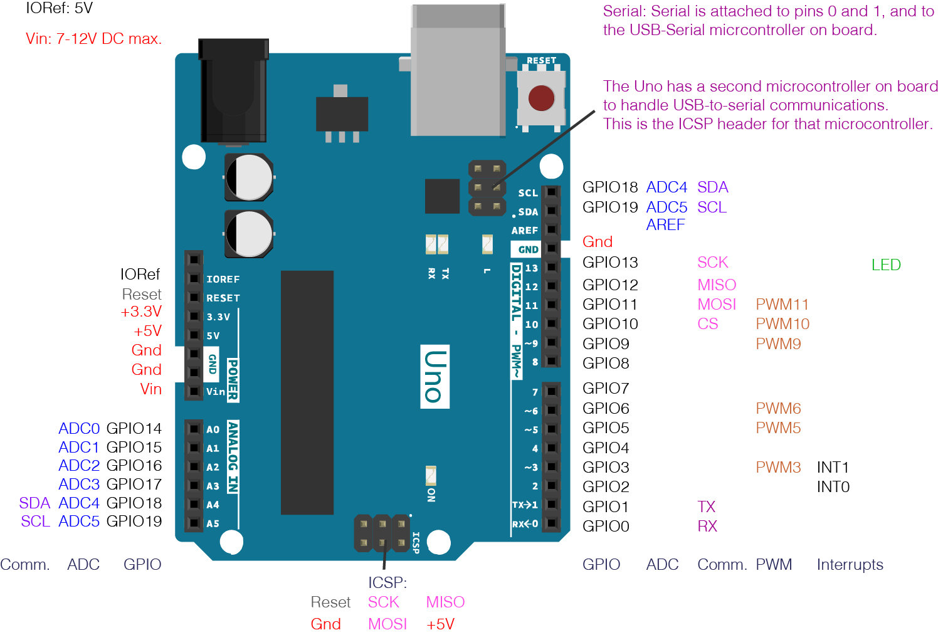

Once the appropriate connections are made, most of the complexity of the sensor is handled by the provided library. Below is an example of how you would configure the library initially for use. DEF_ADDR is the I2C address used by the sensor. This value should most likely only be what is displayed below, however, another look at the sensor documentation could reveal otherwise. resPin and mfioPin are the digital pins on the Arduino that the respective pins described above are connected to. These values can vary as long as they are updated in the code appropriately. In order to properly pull data from the sensor, you must use <SparkFun_Bio_Sensor_Hub_Library.h>. Examples on how to properly pull data are provided in the source link below.

[Source: SparkFun Pulse Oximeter and Heart Rate Monitor Hookup Guide](https://learn.sparkfun.com/tutorials/sparkfun-pulse-oximeter-and-heart-rate-monitor-hookup-guide/all#hardware-hookup)

[Code Examples: SparkFun_Pulse_Oximeter_Heart_Rate_Sensor](https://github.com/sparkfun/SparkFun_Pulse_Oximeter_Heart_Rate_Sensor)