Customer Segmentation
Analysis Report

RFM-Based K-Means Clustering for Targeted CRM Strategy

Prepared for: Marketing & CRM Teams
Data Analytics Department
June 2026

Table of Contents

Executive Summary
This report analyzes 2,000 customers and 47,836 transactions using RFM modeling and K-Means clustering to identify naturally occurring customer segments. The analysis reveals four distinct groups with dramatically different behaviors, values, and needs.
The key finding is a classic Pareto distribution: 24.4% of customers (VIP segment) generate 86.1% of total revenue ($7.3M out of $8.5M). Meanwhile, 29.2% of customers (At Risk / Lost) have essentially stopped engaging, contributing only 1.2% of revenue.
Key Findings:
- VIP (489 customers, 24.4%): 22 orders average, $14,920 per customer, 86.1% of revenue — the business's lifeblood
- Dormant (606 customers, 30.3%): 81 days since last purchase, 5.3 historical orders — the largest recall opportunity
- Standard (321 customers, 16.1%): Active (12 days recency) but low value ($1,076/customer) — needs ARPU growth
- At Risk / Lost (584 customers, 29.2%): 182 days inactive, 1.2 orders average — minimal ROI for recall investment
The actionable priority: recall Dormant customers (606 people, $735K historical revenue) while protecting VIPs. The loss of a single VIP ($14.9K average lifetime value) is equivalent to losing 89 At Risk customers.

1. Methodology

1.1 RFM Model
RFM (Recency, Frequency, Monetary) is the most widely used customer value model in CRM analytics. It reduces customer behavior to three fundamental dimensions:
- Recency: Days since last purchase (lower = more engaged)
- Frequency: Total number of orders (higher = more loyal)
- Monetary: Total lifetime spending (higher = more valuable)
These three metrics were computed from 47,836 transactions spanning 365 days. Key summary statistics:
Metric | Min | Median | Max | Skewness
Recency (days) | 1 | 75 | 364 | 1.36
Frequency (orders) | 1 | 5 | 58 | 2.29
Monetary ($) | $6 | $580 | $119,471 | 5.44

The extreme right-skew in Monetary (5.44) required log(1+x) transformation before clustering. Without this step, K-Means would be dominated by a few top spenders and fail to capture meaningful behavioral patterns.

1.2 Preprocessing Pipeline
Three-step preprocessing was applied to ensure fair clustering:
- Log transformation: Reduced Monetary skewness from 5.44 to 0.04
- StandardScaler: Normalized all features to mean=0, std=1 (equal weighting)
- K selection: Elbow Method + Silhouette Score dual validation
The Silhouette Score peaked at k=2 (0.45), but business judgment overrode mathematical optimality — 2 clusters (good vs. bad) cannot drive differentiated marketing strategy. We selected k=4 for actionable segmentation.

1.3 K-Means Clustering
K-Means iteratively assigns each customer to the nearest cluster centroid, minimizing within-cluster distance. This unsupervised approach discovers natural customer groupings without requiring labeled training data.
Parameters: k=4, random_state=42, max_iter=300. Cluster names were auto-assigned by ranking median values:
Cluster | Median Recency | Median Frequency | Median Monetary
VIP | 14 days | 19 orders | $10,811
Dormant | 67 days | 4 orders | $925
Standard | 9 days | 4 orders | $832
At Risk / Lost | 174 days | 1 order | $110

2. Segment Profiles
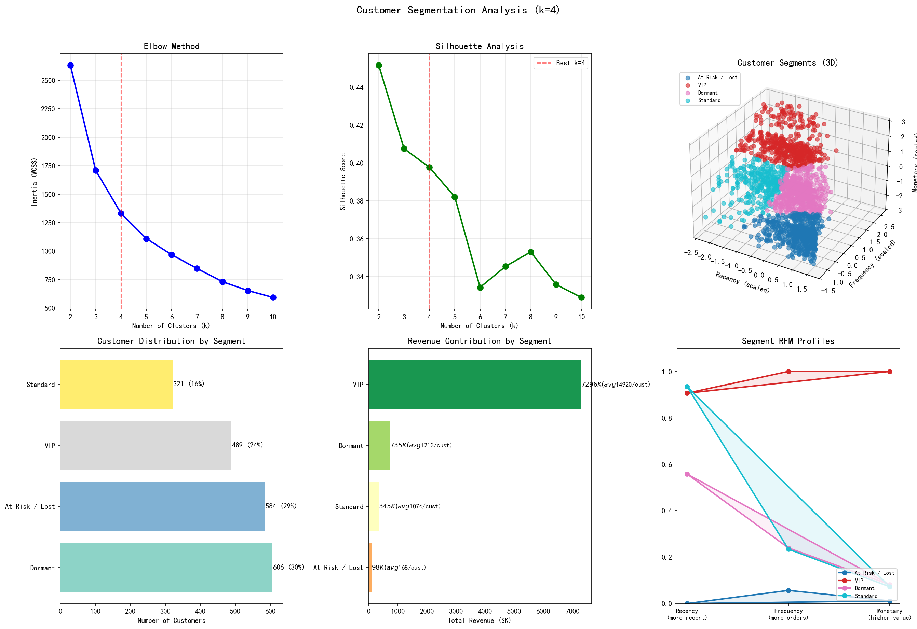
Figure 1: 6-in-1 segmentation dashboard — Elbow method, Silhouette analysis, 3D scatter plot, segment distribution, revenue share, and cluster radar chart.

2.1 VIP (489 customers, 24.4%)
These are the business's core customers. They purchase frequently (22 orders average), spend heavily ($14,920/customer), and return regularly (median 14 days since last purchase).
Metric | Value
Recency | 17.1 days (range: 1-109)
Frequency | 22.0 orders (max: 58)
Monetary | $14,920 average
Avg Order Value | $541
Revenue Share | 86.1% ($7,295,843)
Total Items | 219 avg per customer

Strategy: Protect, don't grow.
VIPs should be shielded from aggressive marketing. Every lost VIP costs $14.9K — equivalent to losing 89 At Risk customers. Priority actions: dedicated account managers, early access to new products, loyalty program with tangible rewards, and proactive check-ins when recency exceeds 30 days.

2.2 Dormant (606 customers, 30.3%)
These customers have purchase history (5.3 orders average) but have been inactive for an average of 81 days. They represent the highest-ROI recall opportunity — they've proven willingness to buy but simply stopped returning.
Metric | Value
Recency | 80.6 days
Frequency | 5.3 orders
Monetary | $1,213 average
Avg Order Value | $227
Revenue Share | 8.7% ($734,887)

Strategy: Recall with targeted incentives.
Dormant customers have proven purchase patterns — they just need a nudge. Recommended actions: "We miss you" email campaign ($10-$15 discount), product category reminders based on purchase history, and time-limited offers creating urgency. Even a 10% reactivation rate recovers ~61 customers and $73K in future value.

2.3 Standard (321 customers, 16.1%)
Active shoppers (only 12 days since last purchase) but lower order frequency and spend. They're engaged with the platform but haven't become heavy buyers.
Metric | Value
Recency | 12.0 days
Frequency | 5.1 orders
Monetary | $1,076 average
Avg Order Value | $206
Revenue Share | 4.1% ($345,362)

Strategy: Grow basket size, not frequency.
They already visit often — the lever is getting them to spend more per visit. Recommended: cross-sell recommendations at checkout, free-shipping thresholds ($250+), "complete the look" bundles, and VIP membership teasers showing what they're missing at higher spend levels.

2.4 At Risk / Lost (584 customers, 29.2%)
These customers have essentially abandoned the platform: 182 days average inactivity, only 1.2 lifetime orders. They're one-time buyers who never returned.
Metric | Value
Recency | 182.2 days
Frequency | 1.2 orders
Monetary | $168 average
Avg Order Value | $139
Revenue Share | 1.2% ($98,011)

Strategy: Minimal investment.
With only 1.2 lifetime orders and $139 average order value, the ROI on recall campaigns is likely negative. Recommended: one automated re-engagement email, then exclude from marketing spend. Do not invest paid retargeting on this segment — allocate that budget to Dormant recall instead.

3. Revenue Concentration Analysis
The revenue distribution across segments reveals extreme concentration — a pattern consistent with the Pareto Principle but even more pronounced than typical e-commerce benchmarks.
Segment | Customers | Revenue | Revenue %
VIP | 489 (24.4%) | $7,295,843 | 86.1%
Dormant | 606 (30.3%) | $734,887 | 8.7%
Standard | 321 (16.1%) | $345,362 | 4.1%
At Risk / Lost | 584 (29.2%) | $98,011 | 1.2%
TOTAL | 2,000 (100%) | $8,474,103 | 100%

Key insight:
The business is heavily dependent on a small core of VIP customers. While this concentration is common in e-commerce, it creates significant business risk — even a 5% VIP churn rate (24 customers) would cost $358K in lost revenue. For comparison, losing all 584 At Risk customers costs only $98K.

3.1 Customer Lifetime Value by Segment
Estimated average CLV per segment, ranked:
Segment | Avg CLV | CLV Ratio vs At Risk
VIP | $14,920 | 88.8x
Dormant | $1,213 | 7.2x
Standard | $1,076 | 6.4x
At Risk / Lost | $168 | 1.0x

4. CRM Action Plan
Based on the segment profiles, we recommend a differentiated marketing strategy with specific actions, budgets, and expected outcomes for each segment.

4.1 VIP: Protection Program
Priority P0 — Highest urgency, highest ROI
- Dedicated account management for top 100 VIPs (those above $25K lifetime spend)
- Automated alert when any VIP exceeds 30 days without purchase (currently all within 109 days)
- Exclusive early access to new products and seasonal collections
- Tiered loyalty program: Platinum ($25K+), Gold ($10K-$25K), Silver (<$10K)
- Estimated cost: $15K/year for loyalty program operations
- Protected revenue: $7.3M (86.1% of total business)

4.2 Dormant: Recall Campaign
Priority P1 — Largest ROI opportunity
- Send "We miss you" email with $10 off next purchase (cost: ~$6,060 if all respond)
- Product recommendation based on purchase history categories
- 48-hour flash sale with countdown urgency
- A/B test: discount vs. free shipping vs. new arrivals announcement
- Expected reactivation rate: 10-15% based on industry benchmarks for 60-90 day dormants
- Estimated ROI: $73.5K - $110K in recovered revenue vs. ~$6K campaign cost

4.3 Standard: Basket Growth
Priority P2 — Steady-state growth
- Cross-sell widget at checkout: "Customers who bought X also bought Y"
- Free shipping threshold set at $250 (currently most orders below this)
- "Complete the look" bundle discounts on multi-item purchases
- VIP preview: show what they unlock at higher spend tiers
- Target: increase average order value from $206 to $250 (+21%)
- Potential incremental revenue: $105K/year from AOV uplift

4.4 At Risk: Minimal Intervention
Priority P3 — Low investment, low expectation
- One automated re-engagement email: "We've got new arrivals you might like"
- Exclude from paid retargeting campaigns (negative ROI expected)
- Re-evaluate in 90 days: if recency >270 days, move to inactive list
- Estimated cost: <$50 for automated email
- Expected impact: <5% reactivation (~29 customers, ~$4,900)

4.5 Campaign Budget Summary
Campaign | Est. Cost | Est. Return | ROI Multiple
VIP Protection | $15,000/yr | $7.3M protected | N/A (retention)
Dormant Recall | $6,060 | $73K-$110K | 12x-18x
Standard AOV Growth | $5,000 | $105K/yr | 21x
At Risk Re-engage | $50 | $4,900 | 98x
TOTAL | $26,110 | $183K-$220K | 7x-8x

Appendix: Technical Details

Programming Environment
- Python 3.9 with pandas, numpy, scikit-learn, matplotlib
- Data: 47,836 synthetic e-commerce transactions across 2,000 customers
- RFM computation from transaction-level data with groupby aggregation
- K-Means clustering via sklearn.cluster.KMeans (k=4, random_state=42)
- Visualization: matplotlib 3D scatter, seaborn radar, dual validation plots

Key Metrics Definitions
- Silhouette Score: Measures how well-separated clusters are (-1 to +1, >0.25 usable)
- Elbow Method: Plots inertia (within-cluster SSE) vs. k to find diminishing returns
- Log Transformation: log(1+x) to normalize right-skewed distributions
- StandardScaler: Z-score normalization (mean=0, std=1)

Preprocessing Statistics
Feature | Original Skewness | After log(1+x)
Recency | 1.36 | -0.37
Frequency | 2.29 | 0.42
Monetary | 5.44 | 0.04

Limitations & Next Steps
- Synthetic data may not capture real-world seasonality and market dynamics
- Recommend quarterly re-segmentation with fresh transaction data
- Segment stability should be monitored — check if 10%+ of customers shift clusters each quarter
- A/B testing is essential before full-scale CRM campaign rollout
- Consider adding product category affinity to enrich segment profiles
- Future: apply the same methodology to country-level sub-segments for geo-targeting

Files Delivered
- step1_rfm_clustering.py — Full analysis pipeline (reproducible)
- data/customer_segments.csv — All 2,000 customers with cluster assignments
- data/online_retail.xlsx — Raw transaction data (47,836 records)
- reports/Customer_Segmentation_Report_June2026.docx — This report
- charts/01_customer_segmentation.png — 6-in-1 visualization dashboard

— End of Report —

