1. **Description:**

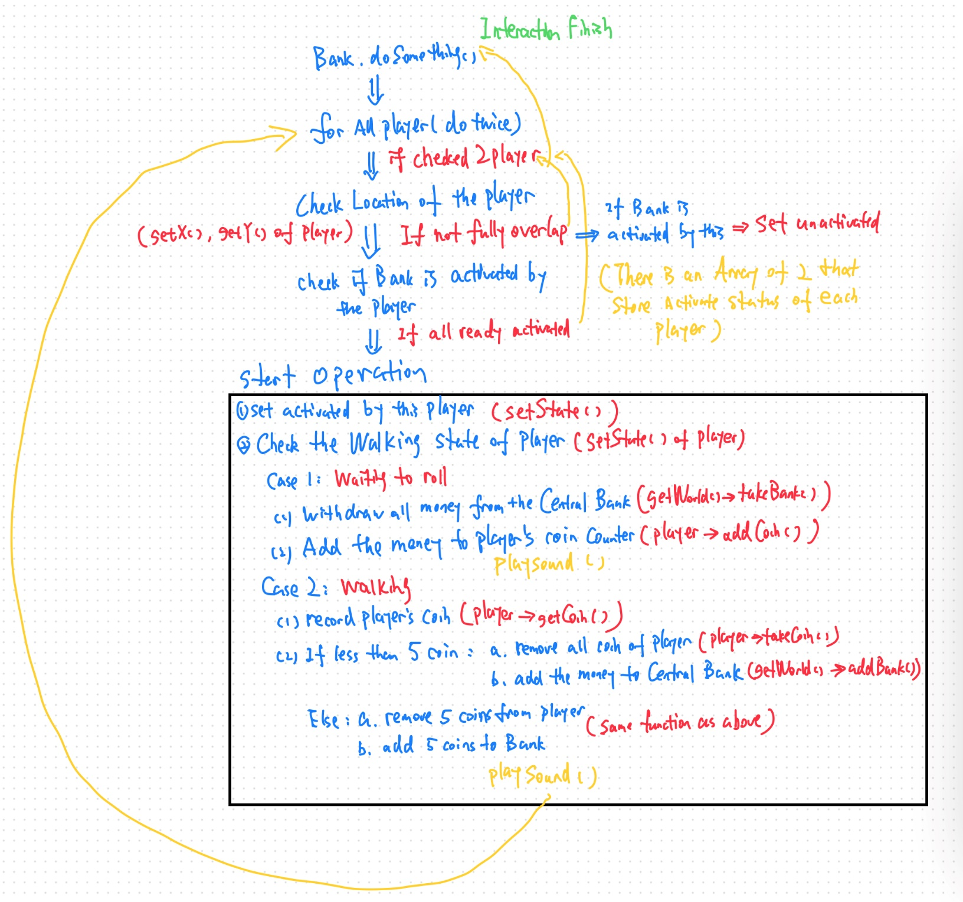**The interaction of a player avatar and a bank square start at the doSomething() function of the bank square, and do the following steps**

**Unless specified, the function called (written in red) is member function of the BankSquare class**

1. **Unfulfilled functionality: all functionalities are fulfilled.**
2. **Assumption:** the direction of an moveable actor that it came from is not specified when it is teleport. So when it is teleported to a fork, I just assume the opposite direction of the walking direction (e.g., if walking direction is right, then opposite is left) that is randomly picked is the direction it came from.