Zachery Channer CST 2406

**Company Description**

Company Name – “F.O.R.W.A.R.D. INC.”

The name of my company “F.O.R.W.A.R.D. INC.”is an acronym for “Focusing On Real World Advancement, Reaching Demands. This company specializes in sports merchandizing, providing products such as apparel, footwear, and materials for different types of sports played throughout the world. We are even making forays into the emerging world of wearable tech. Globally, we have approximately 60 thousand employees, with an extended number of employees through our contract factories. Headquartered in New York City, we are located in virtually every major city in the world. We have our own warehouses located throughout the world, as well as major retail chains who sell our variety of products. We receive approximately 10 thousand orders for our various products daily. This equates to 7 orders per minute. Our revenue for the fiscal year 2015 was $7.7 billion. We have a wide range of different types of clients. We rely on shipping companies such as UPS, FedEx, and USPS as well as shipping companies in other countries. We also rely on local retail stores that sell our merchandise. Our challenges include other sportswear companies such as Adidas, Puma, UnderArmour.

**Scope Definition(Expand)**

In our current system customers request and order what merchandise they would want ,A proposed information system would help the company get a better grasp of the sports merchandising trends.The company needs this because it can increase sales, increase customer satisfaction, stabilize throughput, decrease order processing time. Estimated time for the system to be designed, implemented, and installed would be about 2.5 years. Estimated cost for the system to be designed, implemented, and installed would be about $16 million. We would need to hire a small group of system designers and system builders to commence formation of the system.

**Problem Analysis(System Improvement Objectives)(List Problem, SIO, How to Solve)**

|  |  |  |
| --- | --- | --- |
| **Problem** | **SIO** | **How to Solve** |
| Decrease in Customer Satisfaction/Loyalty | Increase satisfaction/Loyalty | Introduce rewards/Points System as incentive |
| Sales/Revenue decline among various products | Increase Sales/Revenue | Offer more bundle/package deals |
| Inventory of certain products are going unsold. | Stabilize Throughput on Certain Products | Use customer feedback to make decisions on the fate of products. |
| Complaints on length of Order Processing | Decrease Order processing time | Decrease data entry |
| Limited quantity of raw materials to manufacture products | Expand raw material Supplier options | Enlist highest rated suppliers of raw material. |

**Requirements Analysis**

**Client features** –

1. Review and Ratings of Various items

2. Check Loyalty Points

**Supplier features**–

1. Login to Update Information
2. Submit Invoice

**Admin features –**

1. Add, remove, modify User and employee accounts
2. Modify Priority of Existing Order

**Analysis features –**

1. Summarize Sales activity by Region.
2. Summarize Client Feedback.

**Logical Design**

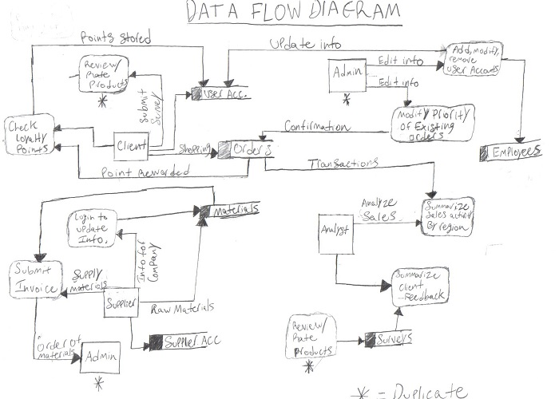

**Decision Analysis**

*Technical Feasibility* – All the necessary technology is in place to allow the proposed system to run smoothly. The technology that is used to implement the new system is fairly proven. The system can be implemented using the current technology we have in place. Although, reports for the analytics may have to be printed at double the pace. Our employees IT employees also have the proper expertise to ensure smooth transition and operation of the proposed system.

*Operational Feasibility –* The implemented system would ultimately be measured in terms of increase of revenue and throughput. The current day-to-day operations would change slightly for employees for the system to be implemented. The clients would not resist the changes as all they would need to do is fill out reviews of products. They would also be welcome to the loyalty points system as it would give them numerous benefits.

*Economic Feasibility –* In terms of economic feasibility, few new professionals would be hired to implement the new system. A small amount of paid training sessions would be used for the employees. There would be new hardware & software in that there will be database servers and software that accompanies these servers. Maintenance would be supplied yearly for these servers and software. Programmers would be hired to implement and test client software.

*Schedule Feasibility –* In terms of schedule feasibility, the system is estimated to be completely implemented over the span of two years. This includes the learning curve of the employees and professionals. We strongly believe it would not take long for all the end users to get familiar with the system.

**Physical Design & Integration**

***ERD***

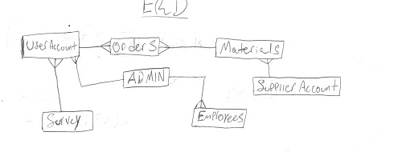

***Table Definitions***

|  |
| --- |
| **USER ACCOUNT** |
| (fk)int user_id |
| char user_name |
| char street |
| char city |
| char state |
| char zip |
| int loyalty_pts |
| (fk)int pair_id |

|  |
| --- |
| **ORDERS** |
| int order_id |
| number order_date |
| char description |
| (fk)int user_id |
| int order_qty |
| int price |
| (fk)int ship_date |

|  |
| --- |
| **SUPPLIER** |
| int suppier_id |
| char supplier_name |
| char supplier_location |
| (fk)int mat_qty |

|  |
| --- |
| **MATERIALS** |
| int mat_id |
| char description |
| (fk)int mat_qty |
| int price |
| (fk)int ship_date |

|  |
| --- |
| **SURVEY** |
| (fk)int user_id |
| int feedback_num |
| int rating |
| char review |

|  |
| --- |
| **ADMIN** |
| int admin_id |
| char admin_name |
| int admin_password |
| (fk)int pair_id |

|  |
| --- |
| **EMPLOYEES** |
| int emp_id |
| char emp_name |
| int emp_password |
| (fk)int pair_id |
| char emp_title |

***Method Signature***

1. String getSurvey(int user_id);
2. int getLoyaltyPoints(int user_id);
3. int getAccInfo(int supplier_id);
4. int getInvoice(int supplier_id);
5. String getClientFeedback (int feedback_num);
6. String getOrderStats(int order_id)
7. String editAccount (int pair_id)
8. String editOrderPriority (int order_id)

***Interface Specification***

All user interactions will take place on GUI (graphical user interfaces) for display and input of information.11

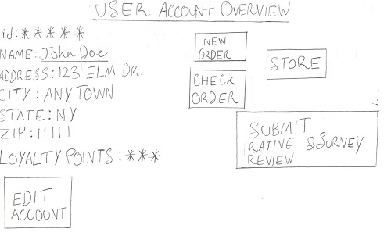

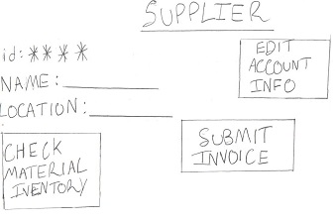

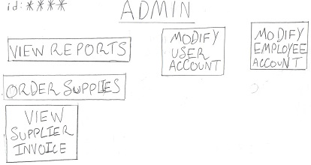

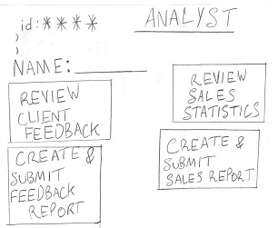

**Construction & Testing**

*Test Driven Development*

**Clients**: 1) In submitting reviews and ratings for products, tests would be conducted to make sure customer input is stored properly. Tests would be conducted to make sure the survey is saved to its rightful user account so the customer would not have to submit a second review on a product.

2) In checking loyalty points, tests would be conducted to make sure that the correct amount of loyalty points are given after a customer purchase. Tests would be conducted to make sure the loyalty points can be accessed and used on future purchases by the customers.

**Suppliers:** 1) Tests would be conducted to make sure the suppliers are able to properly login to update the information on their material. Tests would also be conducted to make sure the information would correspond to their inventory and be updated by the minute.

2) Tests would be conducted to make sure the invoices are correctly created for the company in that invoices would be created for specific materials ordered by the company. Test would also be conducted to make sure the invoices are correctly made available to the company in a timely manner.

**Admin:** 1) Tests would be conducted to make sure that the proper commands are used by the admin to modify user and employee accounts. Tests would also be conducted to make sure that the information that is altered is automatically updated to its rightful account.

2) Tests would be conducted to make sure the admin can easily modify the priority of a clients order, whether high or low to determine the speed of order processing time. Tests would also be conducted to make sure the order priority is also viewable by the client.

**Analysis:** 1) Tests would be conducted to make sure analysts have access to statistics of the orders made around the world. Tests would also be conducted to make sure analysts are able to create reliable and useful reports based on the sales activity by region and distribute them to the admins.

2) Tests would be conducted to make sure analysts are able to access customer feedback provided through their surveys. Tests would also be conducted to make sure analysts are able to create reliable and useful reports based on client feedback and distribute them to the admins.

**Installation & Delivery**

In the finished system, each of the functional requirements is implemented through easy to use GUI (graphical user interface) for each of the 4 external users. The client will be able to successfully review and rate products by submitting a survey. They will also be able to check, keep track of, and use loyalty points that they have been rewarded from ordering products from us. The suppliers will be able to login and update the information of the account of raw materials they have will us. They will also be able to submit an invoice to us for the order of raw materials we order from them. The Admin will be able to successfully add, modify, or remove user accounts as a means of properly maintaining the user database. The Admin will also be able to efficiently modify the priority of existing orders in order to improve order processing time, and the clients would be made aware of this modification to their order. The Analysts will be able to efficiently summarize sales activity by region and create reports and supply them to the admin in order to make future business decisions. The Analysts will also be able to summarize client feedback supplied by surveys and create reports to give to the admin in order to make decisions about specific products. All external agents will be properly trained to use the new and improved system.