**Lost Hope**

*by Nisarg Patel*

You thought it was just a tale told to young children to scare them. Never did you think you’d actually stumble upon the entrance to the Forgotten Labyrinth. As you survey the entrance, you remember the story your mother told you... In the world before, there was a terrible battle between the light and dark, it was called the Era of Antimony. The heroes of the realm fought against the swaths of minions controlled by an unknown dark force, whose name has been lost to time. Some of his minions, called the Cultists of Malus, sought to seek this dark power for themselves. They bound this dark force to a pocket dimension, slowly leeching his life force, and created an automaton of solid marble to guard the secret. When the heroes found out that the darkness had been locked away and stripped of its power, they sought to kill it while it was weak. The foolish heroes gathered their armies and launched a crusade into the labyrinth; however, they were all lost within the maze, and they lost all hope as the magic of the Cultists slowly drove them mad. Legend says that the Cultists and the darkness are still fighting for dominance within the walls of the Forgotten Labyrinth, and if either win, they will come to throw the world back into the dark ages. However, if a hero, should he be worthy, could navigate the treacherous labyrinth and kill the two legendary foes, he would be rewarded with great riches and save the world from a terrible inevitable fate...The entrance seems to be locked, so you walk around the area to explore and look for clues, and possibly a key. After a while of searching, you find a pillar of marble, crumbling on the top, with moss and vines growing along its sides. you go to scrape the vines off, hoping to see some preserved text, but as soon as you touch it, the rest of the pillar crumbles and topples over. You slowly back up, not wanting to damage it more, and you hear a soft rumbling coming from the entrance. When you run back to check where they noise is coming from, you notice the door slowly opening on its own. Shocked, you silently stare into the foreboding dark corridors for several minutes, when suddenly the doors start to close again...this is your chance...this is your chance at glory, to save the world, and you don’t have much time to make the choice. At the last second, you jump into the Forgotten Labyrinth and barely make it in as the doors fully close. As if the Labyrinth somehow knew it had a visitor, flames grow from torches, illuminating the hall, and whatever shred and you feel the last shreds of hope you held slowly dissipate as you see the horrors of the Forgotten Labyrinth.

Map 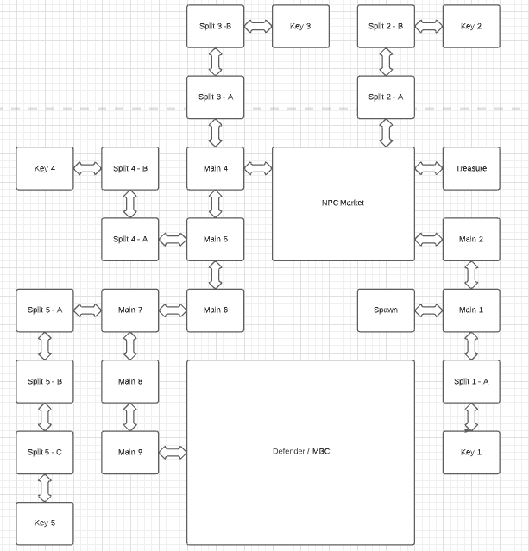­­

Notes:

There will be a total of 3 bosses –

1. The Cultists of Malus will appear in the treasure room if the player has 3 out of the 5 keys in their inventory when they enter. Upon defeating the Cultists, the player will be able to use the keys to open the safe. When they do, they will get an item that will be used to unlock the pocket dimension to fight the Void Entity after defeating the Marble Colossus. The Cultists of Malus will drop legendary gear for the Necromancer class.
2. The Marble Colossus is the automaton created by the Cultists to guard the entrance to the pocket dimension that traps the Void Entity. The Marble Colossus will drop legendary gear for the Paladin Class.
3. The Void Entity is the final boss, to fight it, players will be transported to a pocket dimension that exists outside of time (this allows the player to redo the dungeon if they win, since it will return them to the starting dimension at the moment they decided to enter the Forgotten Labyrinth). The Void Entity will drop legendary gear for the Trickster Class.

Classes –

There will be 3 classes a player can choose from – Necromancer, Paladin, and Trickster. Each class will use unique weapons, abilities and armors, accessories can be used universally by any class.

Necromancer –

The necromancer will be a long range class, that shoots projectiles from a staff, and drains the lifeforce of enemies using the skulls of the defeated. The necromancer wears silk robes to make sure they have the freedom to cast intricate spells. Necromancer will have the highest attack range, at the cost for low constitution.

Paladin –

The paladin is a straight forward class, uses melee weapons and adorns heavy chainmail armors. They pray for divine intervention with the use of their anointed seals, allowing them to be temporarily powered up in battle. The paladin will have the strongest defenses, as well as the hardest hitting shots, but at the lowest attack rate, low mobility, and low range.

Trickster –

The trickster has a set of magical throwing knives that return to their sheathes upon landing a strike, and with the use of glass prisms he is able to fake out his enemies by ‘creating’ copies of himself using the light. The trickster uses leather armors, and has rounded stats, falling in between the other two classes in terms of stats. Average range, average constitution, and average DPS.

Items -

Each player, after choosing their class, will get randomly given items for that class. They will receive a weapon of either tier 0, tier 1 or tier 2. The same will be for their ability and armor. Each player will start with a Tier 0 Ring. Each room defined as Split or Main will generate a random item (weapon, armor, ability, or accessory) that may or may not be for the selected class. In addition, each Split or Main type room can drop either 0, 1, or 2 Potions of Health. These are consumables that will be used during battle if the player needs them. Players can have just 1 of each item type equipped and up to any 8 item/potions in their inventory. Items can go from tier 0 up to tier 10. Tier 10 items are ‘legendary’ items and will only drop from their respective boss.

Market –

The market will spawn with 4 NPCs. Each is associated with a type of item, and will have trades on offer to swap out items for something that can be used for your class. Markets are not a guaranteed spawn. They also take up the size of 4 normal rooms (2x2) so there can be multiple ‘east’ exits, one from the lower end of the room, and the other from the upper end. Once you leave the market, the NPCs will de-spawn and they will not reappear again.

Keys –

Each split from the main path (the main path is the one that leads to the Marble Colossus) there will be a Key, or the Treasure Room. There are a total of 5 keys on the map, but only 3 are required to open the doors to the Treasure Room. Opening the Treasure Room, and collecting the keys are not required to beat the Marble Colossus, but are required to defeat the Void Entity.

Rooms –

There are a few basic room types:

1. Main Path Rooms – These rooms follow the main path to the Marble Colossus.
2. Split Path Rooms – These paths lead to either a Key Room, or the Treasure Room
3. Key Rooms – Simply contain a key.
4. Treasure Room – Holds a secret treasure, player must have at least 3 keys to enter this room.
5. MBC Room – The room containing the Marble Colossus, and the portal to the Void Entity

Both the Main path and Split path rooms will generate a random assortment of enemies when a player enters that room for the first time. These can include, but are not limited to; lost crusades, grotto slimes, golems, forgotten heroes, and the specter. If the player successfully manages to defeat (or survive) every enemy within a room, the room will generate a random set of loot for the player.

Combat –

Combat mechanics are simple, each enemy will have a difficulty indicator and the player will have a cumulative skill indicator, if the player’s skill exceeds the difficulty of the enemies, then they will succeed. However, if the player has a lower skill level than what is required to defeat their enemies, the result will be a Game Over. The players skill will be determined by their character level, fatigue, and the overall tiers of their equipment. The player can gain temporary skill by having Potions of Health in their inventory, which will be consumed if the player needed that skill gain to finish the fight successfully. At the end of each battle. Fatigue will count as a negative indicator, if Main/Key rooms are explored multiple times, the player’s fatigue counter will increase by 1. Splits are not counted in this because it is necessary to explore them at least 2 times since they will always lead to dead ends.

Flowcharts:

Flowchart for picking up items:

Flowchart for moving around the rooms:

pseudo code for validating directions:

#first we need to know which directions are valid, so we can consult the map dictionary

#the current room variable will always update whenever we move rooms, the default starting #assignment will be for the spawn room

valid_directions_1 = map_1[current_room]

#since the valid directions variable will access a dictionary of its own, we can select just the keys from it

valid_directions = valid_directions_1.keys()

#now we will display these directions to the user and ask them where to go. Since this process needs to continue until a valid direction is given, we will put it into a while loop with an exit flag variable

finished = False

while not finished:

user_direction = input (f”You can travel in these directions {valid_directions}, where would you like to go?”).lower()

#then we check against all of the valid directions, and see if the user input matches them

if user_direction in valid_directions:

finished = True

#if there is no match, we send the user back to the start

else:

print(“That is not a valid direction”)

continue

#once a direction has been confirmed we are ready to load up the information for the new room!