The October 13, 2020 commit for dtk-tools (a6870ba52fd2ef69de83f7215c00e02666f9c0e6) was used for the HBHI BDI project.

Some changes were made to the scripts locally, but not PR'd to the main branch. These include

* Change in some scripts used for calibration:
  + calibtool/LL_calculators.py (changes to work with different format for reference data / simulation results)  
    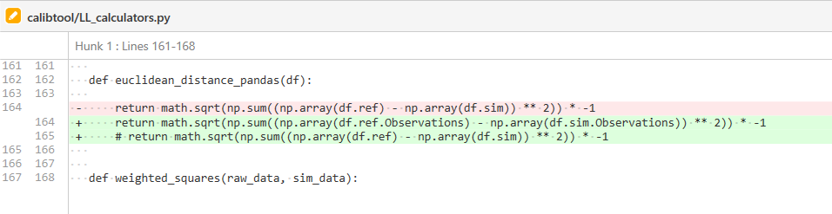
  + calibtool/algorithms/OptimTool.py (add additional tuning parameter to control size of jumps)  
    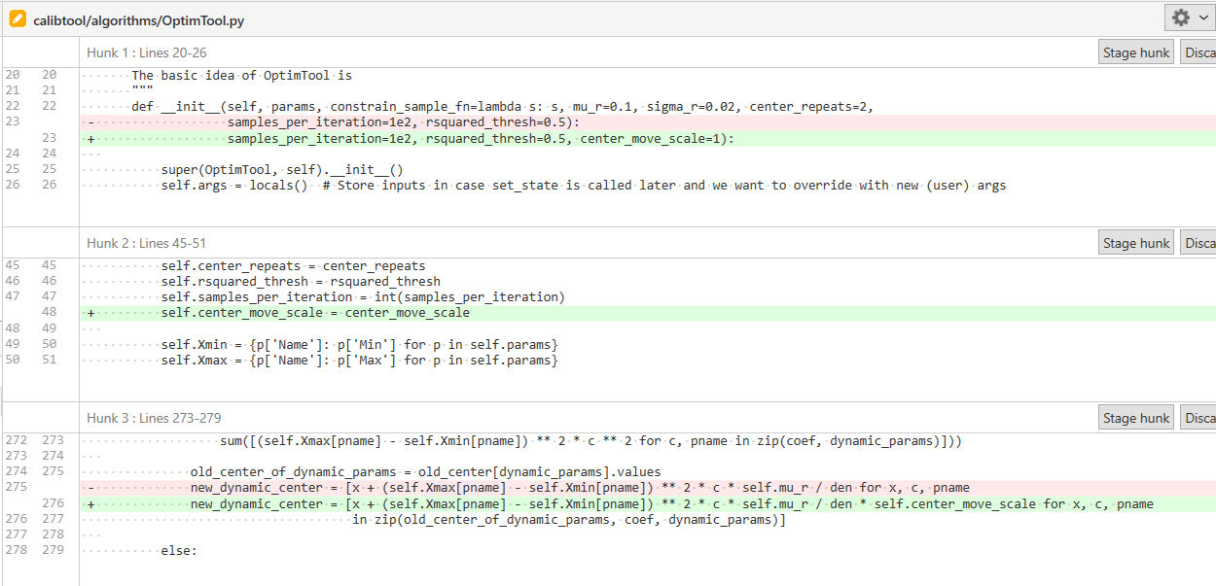
* Change in ITN function to allow for BDI-specific community-based distribution inputs (a new way of distributing nets so that they aren’t given in duplicate). HOWEVER, these changes weren’t ultimately used because the net do-not-allow-duplicate feature is buggyish given the order of discarding nets and checking whether someone already has a net.
  + dtk/interventions/itn_age_season.py  
    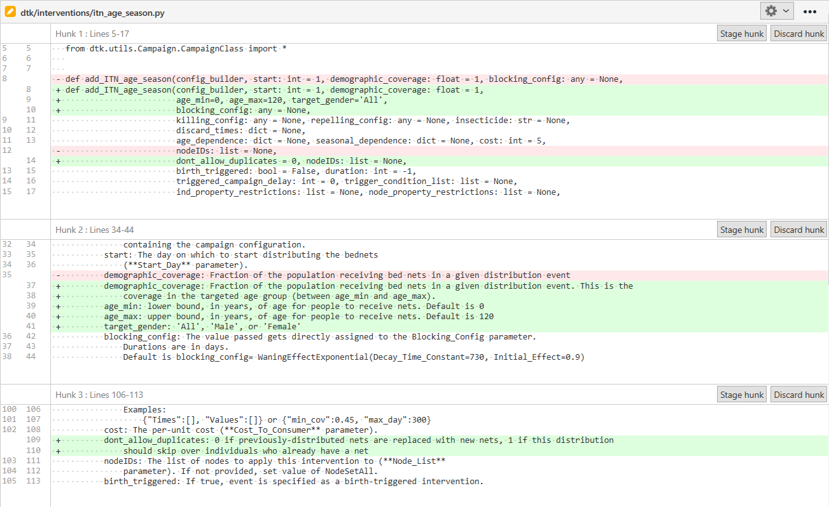  
    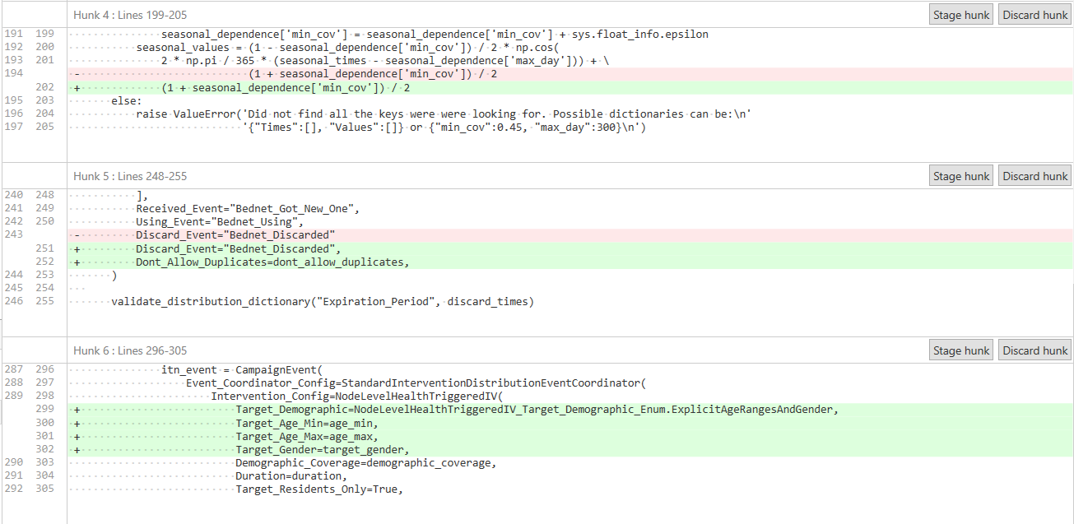  
    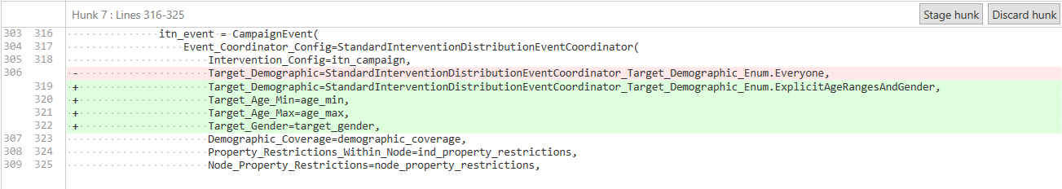

For the RTS,S work, I need to update to the latest version of dtk-tools, so I’m deleting these changes but saving a copy of the changed scripts in myChanges_dtk-tools/20210827