IEEEXtreme Türkiye Kampı: Gün 2
AGEOF

Problem
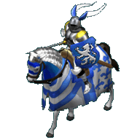
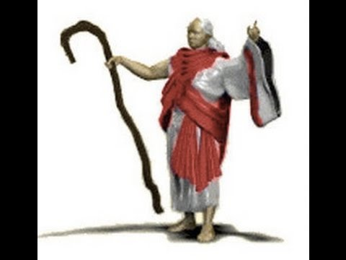

Necmi, who plays Age of Empires 2 against the computer, installs a new game mod. In this mode, monks can cast 3 types of spells. There is one monk in the game(Figure 1) and this is the only character that Necmi can play with. In addition to monk, there are N paladins(Figure 2) Some of the paladins are in Necmi’s teams while some of the paladins are in opponent team. Paladins are numbered from 0 to N-1. Necmi finds out that he can cast following spells with following keys:

F Key: All the paladins that have number between i and j are converted to Necmi’s team.
E Key: All the paladins that have number between i and j are converted to opponent team.
I Key: All the paladins that have number between i and j are converted to inverse team. (If in Necmi’s team converted to opponent team, if in opponent team converted to Necmi’s team)

Necmi select paladin ranges and casts a spell. From time to time he askes how many of the paladins in a range [i, j] is in his team.

What you are asked is, when Necmi’s spells and questions are given, after each question, printing the answer to the question.

Input
Input contains several cases. The first line of the input denotes the number of test cases(T)
In each case, there are two parts. The first part gives the teams of paladins. Giving 1 for a paladin denotes that the paladin is in Necmi’s team; while givind 0 denotes that the palading is in opponent team. Paladin teams will be given as strings. But the strings are cut in several pieces. First line of a test gives the piece count(M). For each piece there exists two lines. The first of these lines denotes the number of repeats(C) while second denotes the piece itself. You must repeat each piece given number of times and append them.
The second part denotes the spells and questions. The first line of the second part denotes the number of commands(Q). In the next Q lines there exists for different types of commands:
F i j: In [i,j] convert all paladins to Necmi’s team.
E i j: In [i,j] convert all paladins to opponent’s team.
I i j: In [i,j] convert all paladins to inverse team.
S i j: Print how many of the paladins in range [i,j] are in Necmi’s team.

1<=T<=5 1<=M<=100 1<=C<=200 1<=Q<=1000 1<=PALADIN_COUNT<=1000000
Output
For each case, print the results of questions in order.
For each case start with Case t: “ denoting the test number.(In a seperate line) After that, for each question print “Q#:” (the number of the question) and print the answer to the questions. (Check sample output)

Sample Input
2
2
5
111
2
0101
5
F 3 5
E 7 7
S 0 5
I 1 15
S 0 22
1
3
1010
4
S 0 5
S 1 7
I 8 9
S 7 10

Sample Output
Case 1:
Q1: 6
Q2: 7
Case 2:
Q1: 3
Q2: 3
Q3: 2

Sample Explanation (For the first case only)
Input contains two cases as given in the first line.
The number 2 denotes that we are going to use two pairs of lines, each of which denotes a single to-be-repeated string. The first pair is 5 and “111”. So, we should repeat “111” 5 times to generate “111111111111111”. The second pair is 2 and “0101”. So, we now have “11111111111111101010101”. We have 23 paladins in total.
The first command says that press F key for paladins in range [3,5]. Result: 11111111111111101010101
The second command says that press E key for paladins in range [7,7]. Result: 11111110111111101010101
The third command is a question. How many paladins in range [0,5] are in Necmi’s team?: 6
The forth command says that press I key for paladins in range [1,15]. Result: 10000001000000011010101
The fifth command is a question. How many paladins in range [0,22] are in Necmi’s team?: 7

Time Limit
C/C++/Java: 1 sec, Python: 2 secs

