IEEEXtreme Türkiye Kampı: Gün 2
KABLOLAR

Problem
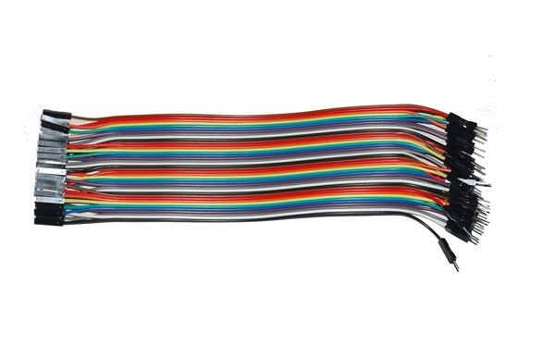
Necmi finds the cables that his brother Memoli uses for his Logic Design course.(check the figure) Necmi loves this cables. He takes them, connects them and makes figures out of them. Necmi loves making circles using more than one cable a lot.
There a 4 types of cables that Necmi found. Cable with one end female one and male(MF and FM), two ends male (MM) and two ends female (FF).
When connecting cables, female ends connect to male ends.
What you are asked is, when the cable types that Necmi found are given, determine if a circle with more than one cable can be constructed or not.

Input
Input will contain several cases.
The first line of the input will denote the number of test cases.(T)
For each case, in a line, at most 50 cables are given.(MF, FM, MM or FF)
1<=T<=700
Output
For each case, if a circle can be constructed print “DAIRE”. If not, print “DAIRE YOK”.

Sample Input
4
FF FF FF FF
MM MF FF MM
MF MF MF FF
MF MF MF MF

Sample Output
DAIRE YOK
DAIRE YOK
DAIRE YOK
DAIRE

Time Limit
C/C++/Java: 0.5 secs, Python: 1 secs

