IEEEXtreme Türkiye Kampı: Gün 2
STERN
Problem
In number theory, Stern-Brocot tree is a tree that is used to generate all non-negative rational numbers.
The tree can be constructed in the following way:
Starting from 0/1 and 1/0 (0 and infinity) write the mediant of neighbouring numbers between them. Redo the same action for the new list. Do the same thing until infinity.
Mediant of a/b and c/d is (a+c)/(b+d).
For example, after 3 steps following numbers are generated:
0/1 1/0
0/1 1/1 1/0
0/1 1/2 1/1 2/1 1/0

All this operations can be shown as a tree:
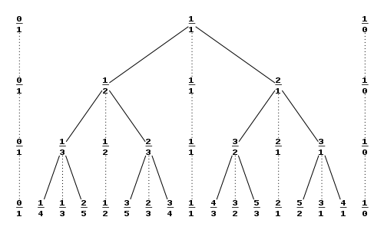
Each number in this tree can be shown with left and right move sequences starting from 1/1.

https://en.wikipedia.org/wiki/Stern%E2%80%93Brocot_tree

What you are asked is when the left,right instructions are given, finding the number that corresponds to the number.
Input
Input will contain several cases.
First line of the input denotes the number of test cases.(N)
In the next N lines strings that denotes the right and left moves are given. Right move is encoded as ‘R’, left move is encoded as ‘L’.
0 <= N <= 10000 1 <= PATH_LENGTH <= 90

Output
For each case, print the number after traversing the tree in ‘a/b’ form.

Sample Input
3
RLRL
RR
LRR

Sample Output
8/5
3/1
3/4

Time Limit
C/C++/Java: 1 secs, Python: 2 secs

