

2/11/2022

Database Project

Clinic database management f

Prepared by: - Abel Hailemichael

Contents

**Chapter 1: Introduction** 2

1.1 Background information 2

1.2 statement of the problem 2

1.3 Scope of the project 3

1.4 Objective 3

1.4.1 general objective 3

1.4.2 specific objective 3

1.5 Methodology 4

1.5.1 Data collection methods 4

1.5.2 Development tools 4

1.6 benefits and beneficiaries of the new system 5

**Chapter 2: Database Design** 6

2.1 conceptual database design 6

2.1.1 Entity description 6

2.1.2 Entity Attributes description 6

2.1.3 Entity Relationship description 6

2.2 Logical database design 7

2.2.1 Entity relationship diagram 7

2.2.1 E-R relation/table mapping 8

2.2.2 Validate model using normalization 8

**Chapter 3: Implementation** 9

Creating the database 9

Creating the relations 9

Inserting sample data 10

Sample data 10

# **Chapter 1: Introduction**

## 1.1 Background information

With the advent of computers and its related technology, in which everything needs to be done efficiently and effectively the existences of Automated Clinic Record become necessary. Unfortunately, according to the survey we conducted, the student’s clinic of Addis Ababa University, specifically the college of natural and computational science, still uses pen and paper to handle its data. Even though on each student’s portal there is a ‘clinic service’ and a ‘my clinic service history’ page, only 14.3% of the students we surveyed know the existence of the pages but these students also claim that these pages are never updated at all. Keeping the record of personal health history of students while they are away from home is an essential responsibility of the university. In addition, students must be well aware of their own health so they can use that information to traceback any future cases or during emergencies.

If this automation becomes successful it will be an easier way to retrieve student’s records without any difficulty. And it will also solve the flaws of manual system such as the problem of misplacement or missing record.

## 1.2 statement of the problem

The manual system of record keeping and filling system in Ethiopian clinics have over the years proved inefficient. There had been incident of misplaced documents, not able to retrieve long consult patients’ records, loss of records or files, alteration of information etc, which mostly result in unnecessary delay of treatment and therefore patients get trouble. This problem also exists in our university’s clinic. This problem persisted for a very long time and is worrisome to the clinic management. Our project came up with the best option to tackle this problem

### 1.3 Scope of the project

The general scope of the project will focus on the college of natural and computational science student’s clinic in Addis Ababa University. The specific scopes include the following

* A database system will be introduced to manage the student’s clinic information and daily activity.
* The database can be accessed by both students and nurses. Where only nurses can update or manipulate the database.

## 1.4 Objective

### 1.4.1 general objective

The general objective of our project is to automatize the paper-based data handling system of Addis Ababa University clinic.

### 1.4.2 specific objective

Here are specific objectives to achieve the above general objective:

* Identify problems of the existing data handling system
* Evaluate the use of automatized data handling system
* Identify and analyze the requirements that must be involved in the system
* Choose the most appropriate technology tools for automatizing the existing system of data handling
* Design and implement the automatized system

## 1.5 Methodology

### 1.5.1 Data collection methods

For this project, we conducted a questionnaire regarding students’ experience and opinion on the clinic’s current data handling system. we also used observation and interview to gather more information about the students’ clinic.

### 1.5.2 Development tools

#### Tools for Written Documentation

We intend to use:

* Microsoft office Word 2016
* Visio Professional

#### Tools for the Implementation Phase

* MySQL: - Is preferred since it is robust in managing large databases and has a lot of community support.

#### Tools for Modeling

* Entity-relation conceptual model: - During the analysis and design phase, E-R conceptual model will be used for the graphical representation of some system concepts of the project using Microsoft Visio 2016.
* Visual studio Code: - We use this code editor because it is very powerful and has an easy-to-use interface.

#### Operating Systems

On which this project will be configured:

* Windows: - This project can easily be configured on Windows operating system. For running this project on Windows operating system, you will have to install MySQL on your system.
* Linux: - We can run this project also on all version of Linux

## 1.6 benefits and beneficiaries of the new system

Some benefits of automatized data handling system for clinics are:

* Using automation to replace manually intensive tasks that are better done by machine can be a big-time saver,
* Using Automation nurses will easily access the required information when needed,
* Automation tools are not subject to human error or fatigue, so they can help provide a consistent basis of care activities,
* Automation can help get nurses and patients connected more efficiently,
* Automation empowers health providers to offer better services,
* Technology used to automate processes can also deliver a wealth of data in a continuous feedback loop that can be used for performance improvement and optimization.

beneficiaries of this system include:

* Students: Students can get treatment efficiently
* Nurses: Nurses can give treatments to Students efficiently with no delay and it will be easier for them to store and retrieve data whenever they want

# **Chapter 2: Database Design**

## 2.1 conceptual database design

### 2.1.1 Entity description

|  |  |
| --- | --- |
| **Entity** | **Description** |
| Student | Registered students of college |
| Medicine | Treatment that is given to the student |
| Pharmacist | Pharmacists who work in the clinic pharmacy |
| Lab Test | Test that is done by Lab technician |
| Lab Technician | Employees who work in college clinic laboratory |
| Health professional | Employees who work in college clinic i.e. could be nurse/doctor |

### 2.1.2 Entity Attributes description

|  |  |
| --- | --- |
| **Entities** | **Attribute Description** |
| Student | Student ID, StName, age, Dept, mob_num, DOB, emerCont_name, emerCont_mobnum, |
| Medicine | Medicine_id, medicine_name |
| Pharmacist | employee_id, mob_num, name |
| Lab Test | test_no, test_name, test_result |
| Lab Technician | employee_id, mob_num, name |
| Nurse/Doctor | employee_id, name, mob_num |
| **Note:-** name and StName are the only composite attributes, age is the only derived attribute the rest of the attributes are all normal. | |

### 2.1.3 Entity Relationship description

|  |  |  |  |
| --- | --- | --- | --- |
| **Attribute** | **Relationship type** | **Cardinality** | **Participation** |
| Student – Lab_test – Health professional - Medicine | Treate | N: n:m:M | .------ |
| Medicine - Pharmacist | Give | N:1 | P:F |
| Lab_test – Lab Technician | Perform | N:1 | P:F |

## 2.2 Logical database design

### 2.2.1 Entity relationship diagram

Figure 1Entity relationship diagram for CNCS students' clinic

### 2.2.1 E-R relation/table mapping

Figure 2Logical database design for CNCS students' clinic

### 2.2.2 Validate model using normalization

Our Logical data model is already in first normal form since each cell in all the tables is single-valued and entries in a column (attribute, field) are of the same kind.

Our Logical data model is already in second normal form since all relations are in the 1NF and there isn’t any Partial Dependency in any of the relations.

Our Logical data model is already in third normal form since it is in 2NF and there are no transitive dependencies between a primary key and non-primary key attribute in any of the relations.

# **Chapter 3: Implementation**

## Creating the database

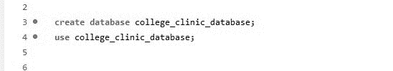

## Creating the relations

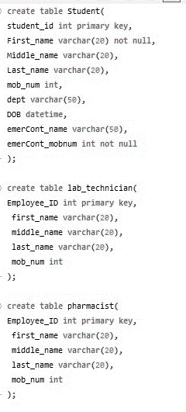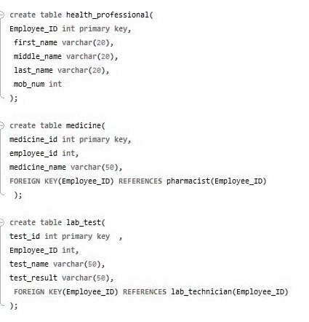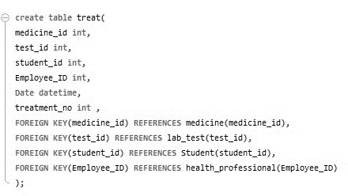

## Inserting sample data

|  |  |  |
| --- | --- | --- |
|  |  | |
|  |  | |
|  | |  |
|  | | |

## Sample data

