SUTMS — Database Design (ERD)
Paper design — not yet built. For team review before Stage 3 (Database Design).

Purpose
This document captures the entity-relationship design for SUTMS before anything gets built. It's meant to be reviewed and agreed on as a team — everyone should understand every table here, since the whole system depends on it (Stage 3 of the build plan). Nothing in this doc has been implemented yet.

Entity-Relationship Diagram
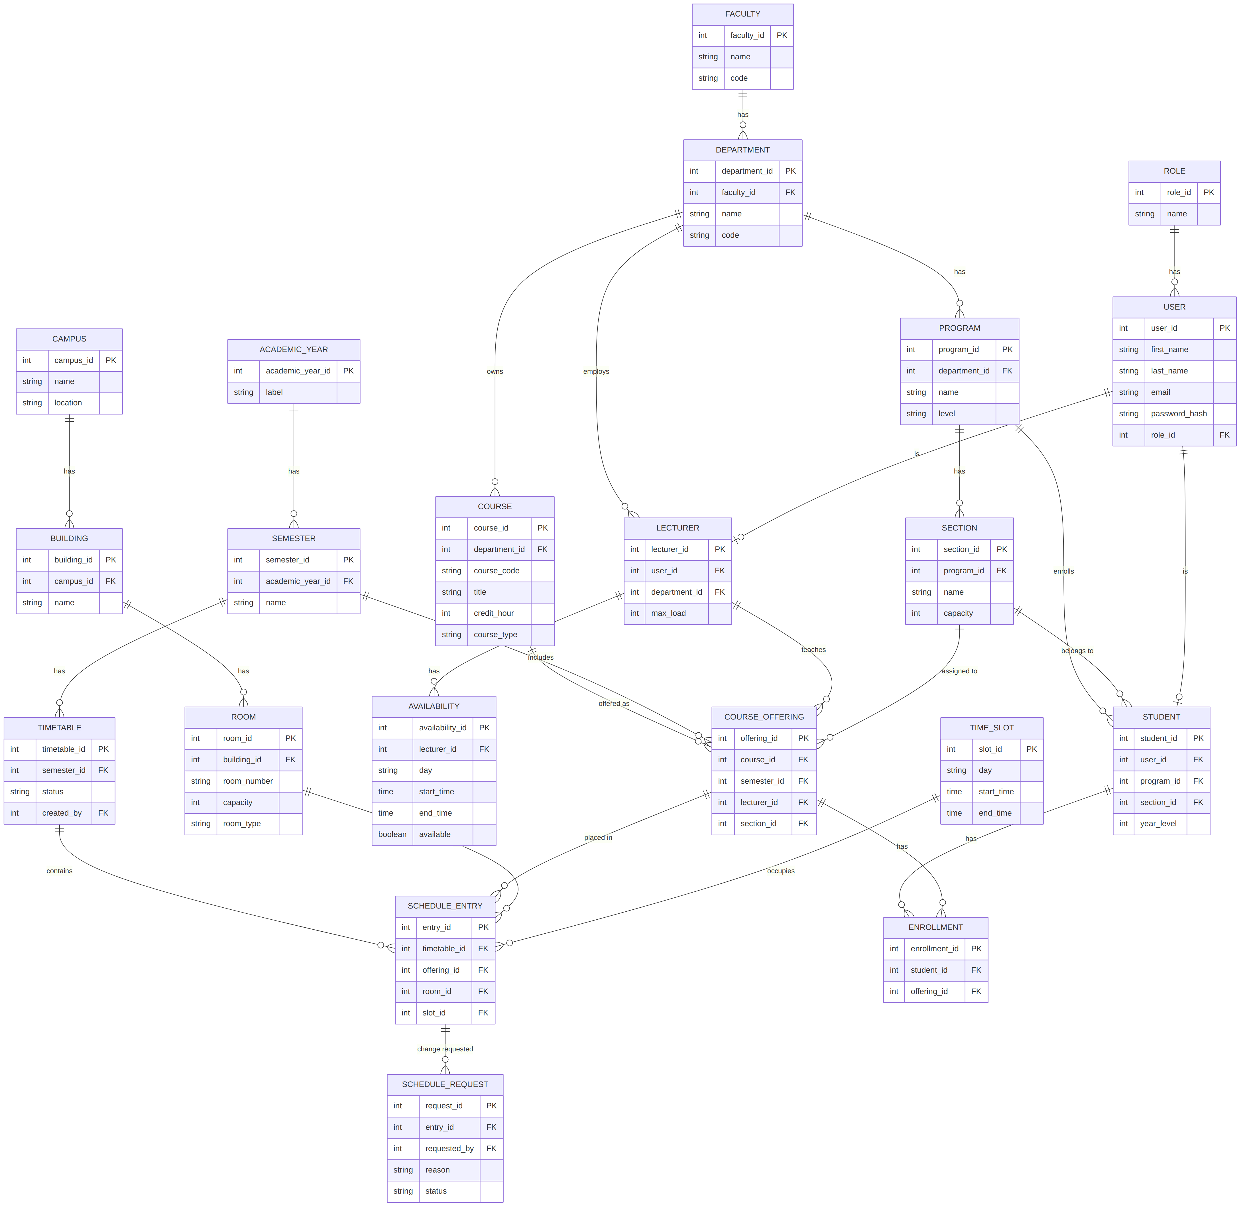

Entity Groups

Organizational hierarchy
- FACULTY — the college level (AAU CNCS itself, for our pilot). One row for now.
- DEPARTMENT — belongs to a faculty (CS, Math, Physics, Statistics, etc.).
- PROGRAM — a degree program within a department (e.g. BSc Computer Science).
- COURSE — belongs to a department, not a program directly — this lets multiple programs share the same course pool instead of duplicating course records.
- SECTION — a cohort of students within a program (e.g. "CS-3A"). Has a capacity used for room-capacity conflict checks.

People
- ROLE — admin, department head, lecturer, student. Kept as its own table rather than a string on user, so roles can be extended without code changes.
- USER — base account: name, email, password hash, role. Everyone (admin, lecturer, student) is a user first.
- STUDENT — extends user; adds program, section, and year level.
- LECTURER — extends user; adds department and max teaching load.
- AVAILABILITY — a lecturer's available time windows. One lecturer has many availability rows — this is what Conflict Detection checks against.

Physical resources
- CAMPUS — kept as an open question — only needed if AAU CNCS spans more than one physical campus. Confirm with the team before building.
- BUILDING — belongs to a campus.
- ROOM — belongs to a building; has capacity and room type (lecture/lab) — used for capacity and cross-campus-travel conflict checks.

Time structure
- ACADEMIC_YEAR / SEMESTER — standard academic calendar hierarchy.
- TIME_SLOT — a fixed day + start/end time (e.g. Mon 9–11). Recommendation: use a small fixed set of slots rather than fully flexible times — this makes the OR-Tools scheduling model far simpler to build (see Team Conventions doc).

Scheduling core
- COURSE_OFFERING — a specific course, taught by a specific lecturer, to a specific section, in a specific semester. This is the thing that actually gets scheduled.
- TIMETABLE — a version of a semester's schedule — draft, published, or archived. Lets you generate and revise without destroying history (matches Module 4's publish/archive requirement).
- SCHEDULE_ENTRY — the heart of the schema: places one course offering into one room and one time slot, within one timetable version. Conflict detection scans this table for overlaps.
- SCHEDULE_REQUEST — a request to change a schedule entry (who asked, why, status). Gives manual edits an audit trail.
- ENROLLMENT — links a student to a course offering (not just a course) — this is what makes student-level conflict detection possible.

Constraint Coverage
How the schema supports each conflict-detection rule from the original scope:
Constraint | Tables involved
Lecturer can't teach two classes at once | LECTURER + SCHEDULE_ENTRY (via COURSE_OFFERING) + TIME_SLOT
Room can't host two classes at once | ROOM + SCHEDULE_ENTRY + TIME_SLOT
Section size vs room capacity | SECTION.capacity + ROOM.capacity, joined via COURSE_OFFERING + SCHEDULE_ENTRY
Student can't have overlapping required courses | STUDENT + ENROLLMENT + COURSE_OFFERING + SCHEDULE_ENTRY + TIME_SLOT
Cross-campus travel time | CAMPUS + BUILDING + LECTURER + SCHEDULE_ENTRY (if CAMPUS is kept)
Avoid certain slot types (e.g. afternoon theory) | COURSE.course_type + TIME_SLOT

Design Decisions Already Made
- Enrollment references COURSE_OFFERING, not COURSE directly — needed to know which specific offering a student is in, across semesters and lecturers.
- COURSE belongs to DEPARTMENT, not PROGRAM — courses are a shared pool; programs draw from it rather than owning courses exclusively.
- ROLE is a separate table, not a string field on USER.
- CAMPUS → BUILDING → ROOM is a separate tree from FACULTY → DEPARTMENT → PROGRAM — rooms are a shared resource pool across departments, not owned by one.
- Every table will get created_at / updated_at (see Team Conventions doc) — not shown in the diagram above to keep it readable, but a blanket rule.

Open Questions — Decide With the Team Before Building
- Single campus or multiple? Determines whether the CAMPUS table stays or gets dropped.
- Fixed time slots vs flexible start/end times? Recommendation: fixed, at least for v1.
- Do we need a PROGRAM_COURSE (curriculum) table mapping which courses belong to which program's degree plan? Not required for scheduling itself — only if we later want to validate degree-plan completeness. Can be added later without disrupting this design.
- SECTION.capacity should be treated as a stored maximum, not a live headcount — actual enrolled count should be derived by counting ENROLLMENT rows, not stored redundantly.

Status
This is a paper design only. Nothing here has been built. Once the open questions above are resolved as a team, this doc becomes the reference for Stage 3 (Database Design) — schema.sql and migrations get written from this, not the other way around.

