**Document to manually download ledger.html file or the program:**

**1. login to tallard’s account**

**2. go to the property you manage**

**3. click on the ‘payments’ tab on the left pane:**

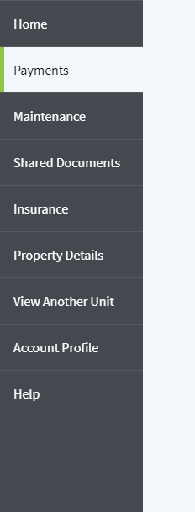

**4. on the right half side, find full account ledger button and click into it:**

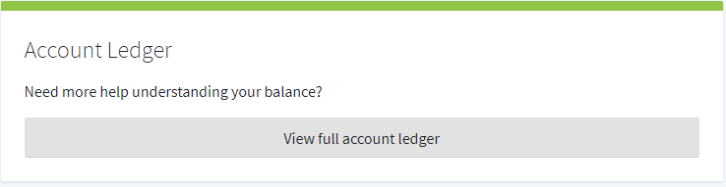

**Steps 5-11 are just suggestive steps, with the goal of saving the account ledger.html source file**

**You can do it with any ways you want, these steps are just how I did it which worked.**

**5. right click, then select ‘View page source’**

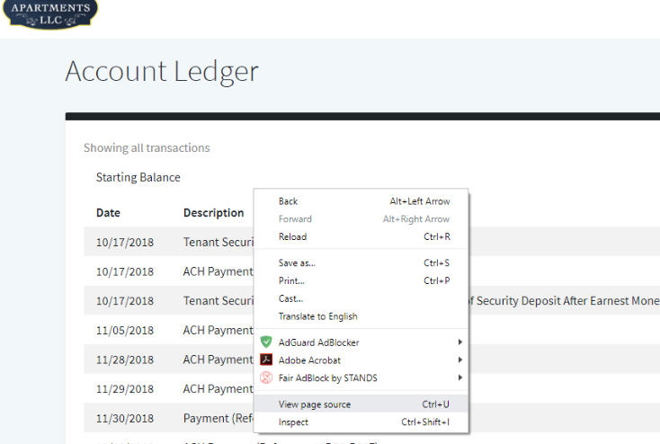

**6. another page will pop up, press ‘Ctr + A’ to select all, then ‘Ctr + C’ to copy to clip board.**

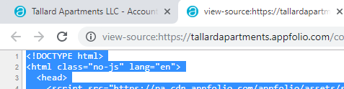 **(rest is hidden for security reasons, never post your account ledger online such as github etc.)**

**7. Go to ‘src’ folder**

**8. if there is already a ledger.html file in there, you must delete it (the file might not contain the right information)**

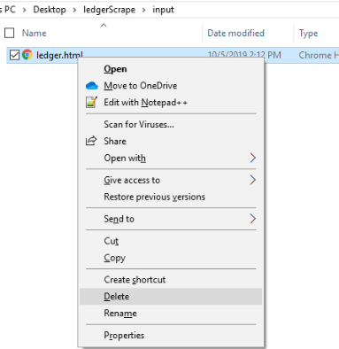

**9. create a new file and name it ledger.html**

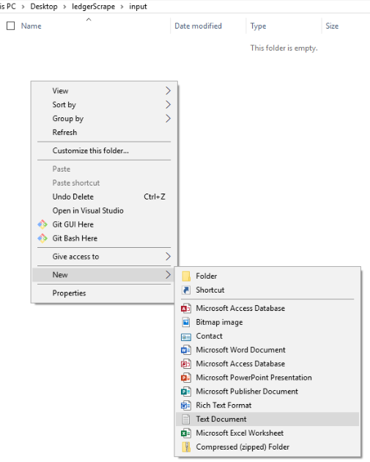

**It will ask you if you want to change the file extension, click yes**

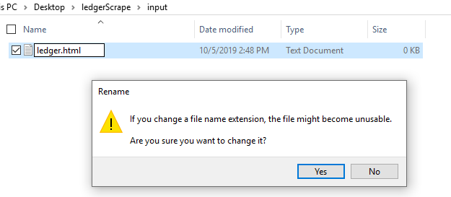

**10. You need to open it with a text editor of your choice, notepad++ is usually good**

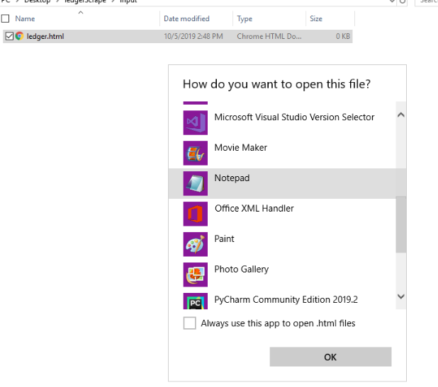

**11. paste the document from Tallards on your clipboard to the text editor then save it (Ctr + S).**

**12. Continue with the program**